Design Document for Expense Tracker

1. Data Flow Diagrams (DFDs)

Level 0 DFD (Context Diagram):

The Level 0 DFD provides an overview of the entire system, showing the interaction between the user and the system.

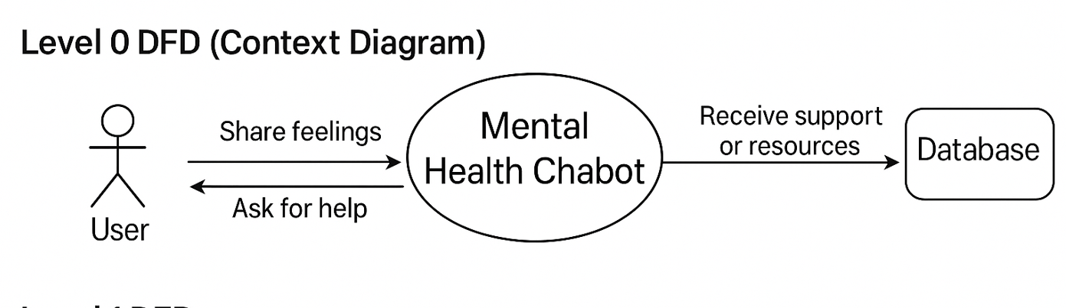

**Explanation:**

* The user interacts with the Mental Health Chatbot to share feelings, ask for help, and receive support or resources.
* The system processes input and retrieves responses from the database or AI models.

Level 1 DFD

This diagram breaks down the system into its core modules.

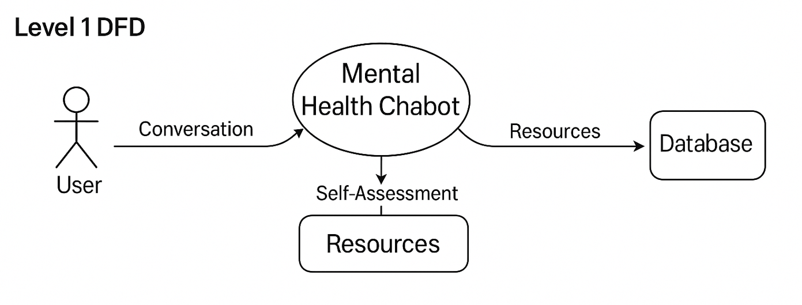

**Explanation:**

* The user can perform three main actions:
  + Start a conversation for emotional support.
  + Take mental health self-assessments.
  + Access mental health resources and suggestions.
* Each action interacts with the AI engine and the database.

2. UML Diagrams

2.1 Use Case Diagram

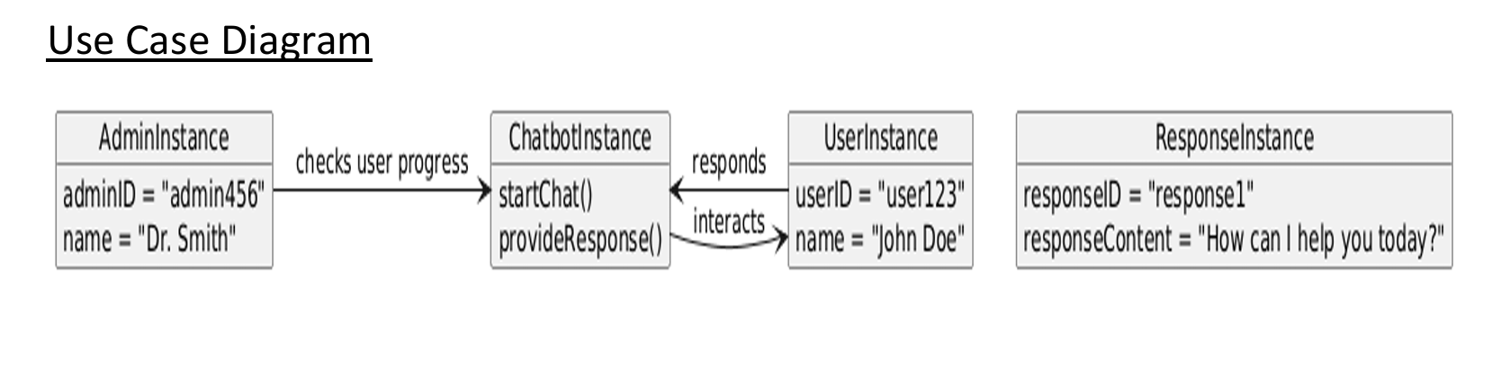

**Actors:**

* **User:** Interacts with all use cases.

**Explanation:**

* The user can chat with the bot, take mental health quizzes, view suggestions, and get emergency contact help.

2.2 Class Diagram

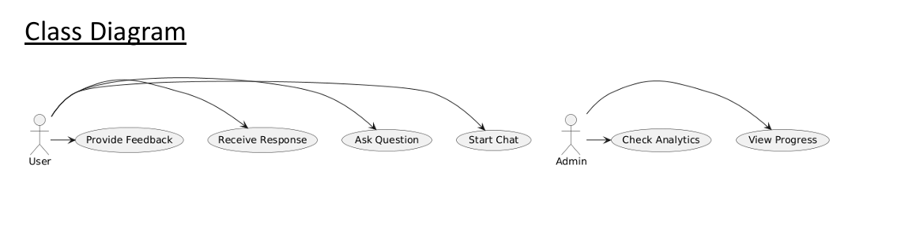

**Explanation:**

* The User class is associated with Conversation, Assessment, and Resource classes.
* Each user can have multiple conversations, take multiple assessments, and view multiple resources.

2.3 Sequence Diagram

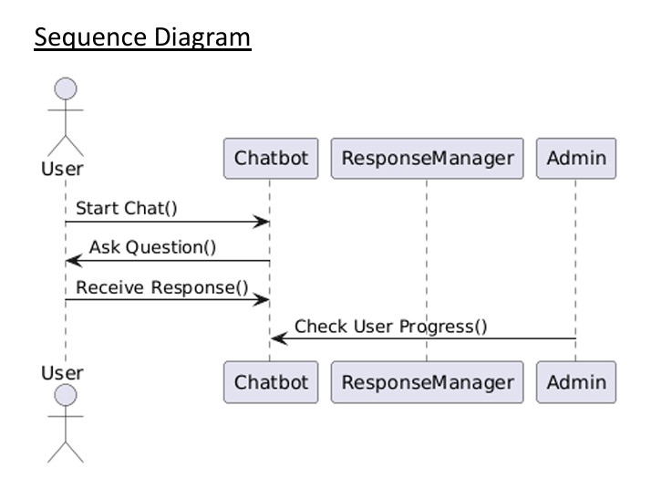

**Explanation:**

* This diagram shows the sequence of actions when a user starts chatting, shares feelings, and receives responses or suggestions from the chatbot.

Test Cases

**1. User Registration**

| **Test Case ID** | **Description** | **Input** | **Expected Output** |
| --- | --- | --- | --- |
| TC_REG_01 | Register with valid data | Name: Aman, Email: aman@example.com, Password: pass123 | Account successfully created, redirect to chat |
| TC_REG_02 | Register with existing email | Email already used | Show error: "Email already registered" |
| TC_REG_03 | Register with missing fields | Only Email provided | Show validation error for missing name and password |

**2. User Login**

| **Test Case ID** | **Description** | **Input** | **Expected Output** |
| --- | --- | --- | --- |
| TC_LOG_01 | Login with correct credentials | Email & Password | Redirect to dashboard, store token |
| TC_LOG_02 | Login with incorrect password | Valid email + wrong password | Show "Invalid credentials" |
| TC_LOG_03 | Login with expired token | Valid login, wait for expiry | Auto logout and message "Session expired" |

**3. Start Chat Session**

| **Test Case ID** | **Description** | **Input** | **Expected Output** |
| --- | --- | --- | --- |
| TC_CHAT_01 | Start a chat session | User: "I'm feeling low" | Bot responds with empathetic message |
| TC_CHAT_02 | Incomplete user input | Only "Feeling..." | Ask user to elaborate |
| TC_CHAT_03 | Offensive input detection | Abusive input | Bot responds with a warning and offers help links |

**4. Mental Health Self-Assessment**

| **Test Case ID** | **Description** | **Input** | **Expected Output** |
| --- | --- | --- | --- |
| TC_ASSESS_01 | Take an assessment test | Answer all questions | Show results and suggestions |
| TC_ASSESS_02 | Incomplete assessment | Submit without answering all | Show validation message |

**5. Access Resources**

| **Test Case ID** | **Description** | **Input** | **Expected Output** |
| --- | --- | --- | --- |
| TC_RES_01 | View resources | Click on "Resources" | List of articles, helplines displayed |
| TC_RES_02 | Broken resource link | Click on broken link | Show error: "Resource not available" |

**6. Session Management**

| **Test Case ID** | **Description** | **Input** | **Expected Output** |
| --- | --- | --- | --- |
| TC_SES_01 | Token expired | Wait for token expiry | Auto logout, redirect to login |
| TC_SES_02 | Manual token removal | Delete token | On page refresh, redirect to login page |

**7. Navbar Navigation**

| **Test Case ID** | **Description** | **Input** | **Expected Output** |
| --- | --- | --- | --- |
| TC_NAV_01 | Navigate using Navbar | Click Chat/Assessments/Resources | Route correctly to each page |
| TC_NAV_02 | Logout | Click logout | JWT removed, redirect to login page |

**8. Toast Notifications**

| **Test Case ID** | **Description** | **Trigger** | **Expected Output** |
| --- | --- | --- | --- |
| TC_TST_01 | Chat success | Send message | Show toast "Message sent!" |
| TC_TST_02 | Assessment completed | Submit answers | Show toast "Assessment completed!" |
| TC_TST_03 | Session expired | Token expired | Show toast "Session expired, please login again" |