KAMPONG SPEU SUGAR CO., LTD.
Estimated Sugar Production Summary Report
Crushing Season 2026–2027

1. Crushing Season Overview
The 2026–2027 crushing season is planned to start on 1 December 2026 and finish on 16 April 2027, a campaign of approximately 137 days (about 4.5 months).
Item | Value | Remark
Start of crushing | 01-Dec-2026
End of crushing | 16-Apr-2027
Season length | ≈ 137 days | ≈ 4.5 months
Finish of remelt sugar processing | 02-Sep-2027

2. Cane Crushing and Raw Sugar Production
A total of 2,300,000 tons of sugarcane is expected to be crushed, producing 253,000 tons of raw sugar at a recovery rate of 11.00%. This is equivalent to an average of roughly 16,800 tons of cane crushed and 1,850 tons of raw sugar produced per day over the season.
Item | Quantity (Ton) | Remark
Total cane crushed | 2,300,000.00
Total raw sugar produced | 253,000.00 | Yield 11.00%

3. Raw Sugar Allocation and Warehouse Capacity
Of the 253,000 tons of raw sugar, 124,950 tons (49.4%) will be further processed into white and refined sugar, while 128,050 tons (50.6%) will be kept as raw sugar in the warehouses.
Allocation | Quantity (Ton) | Share
Raw sugar to white & refined processing | 124,950.00 | 49.4%
Raw sugar to warehouse | 128,050.00 | 50.6%
Total raw sugar | 253,000.00 | 100%

Raw sugar warehouse capacity totals 110,000 tons, which is 18,050 tons short of the planned 128,050 tons to be stored. The excess quantity will require the purchase of jumbo bags for storage outside the standard warehouses. Packing of raw sugar into jumbo bags will run at 500 tons per day, starting on 1 March 2027 (about 36 packing days for the 18,050 tons).
Raw Sugar Storage | Capacity (Ton) | Remark
Raw Sugar Warehouse 1 | 45,000.00
Raw Sugar Warehouse 2 | 65,000.00
Total warehouse capacity | 110,000.00
Excess raw sugar — jumbo bags required | 18,050.00 | Action needed
Packing raw sugar | 500 Ton/Day
Start packing raw sugar | 01-Mar-2027 | ≈ 36 days

4. Finished Goods Production
From the 124,950 tons of raw sugar sent to processing, total finished goods production is estimated at 119,000 tons — 53,100 tons of refined sugar and 65,900 tons of white sugar (an overall conversion of about 95.2% from raw sugar input). Production capacity is 400 tons per day for refined sugar and 500 tons per day for white sugar, with remelt processing continuing after the crushing season and finishing on 2 September 2027.
Product | Quantity (Ton) | Share of Finished Goods
Refined sugar | 53,100.00 | 44.6% — 400 Ton/Day
White sugar | 65,900.00 | 55.4% — 500 Ton/Day
Total finished goods | 119,000.00 | 100%

5. Quota Sales and Remaining Stock
Quota sales are planned at 500 tons per day, totalling 66,500 tons over the season (equivalent to 133 selling days). After quota sales, 52,500 tons of finished sugar will remain in the warehouses.
Item | Quantity (Ton) | Remark
Total finished goods | 119,000.00
Quota sales (500 Ton/day) | (66,500.00) | 133 days
Remaining finished sugar in warehouse | 52,500.00

Finished (refined/white) sugar warehouse capacity totals 69,000 tons, which is sufficient to hold the 52,500 tons of remaining stock, leaving 16,500 tons of spare capacity.
Finished Sugar Storage | Capacity (Ton) | Remark
Refined Sugar Warehouse 1 | 22,000.00
Refined Sugar Warehouse 3 | 47,000.00
Total storage capacity | 69,000.00 | Spare ≈ 16,500 t
If sugar is not sold, warehouse full by | 29-Nov-2088 | Per planning sheet

6. Key Observations
1. Raw sugar storage shortfall: planned raw sugar stock (128,050 t) exceeds warehouse capacity (110,000 t) by 18,050 tons. Jumbo bags must be purchased in advance of the season to cover the excess.
2. Finished goods storage is adequate: remaining stock after quota sales (52,500 t) fits comfortably within the 69,000 t of refined/white sugar warehouse capacity.
3. Sales pace: at 500 t/day, quota sales absorb about 56% of finished goods production during the season; the remaining 52,500 t will need to be sold or exported after the season ends. Continuous sales are essential — if sugar is not sold, the finished sugar warehouses will eventually reach full capacity.
4. Yield assumption: the plan is based on an 11.00% raw sugar recovery rate on 2.3 million tons of cane; any variation in cane supply or recovery will change warehouse and bagging requirements proportionally.

7. Warehouse Layout — Production Planning 2027
The warehouse layout below shows the storage plan for the 2,300,000-ton cane estimate: Raw Sugar Warehouses of 45,000 t and 65,000 t; Refined Sugar Warehouse 1 (50 kg bags, 22,000 t); Warehouse 2 for raw sugar in jumbo bags of 1.10 t (24,000 t); Warehouse 3 for refined sugar (15,000 t) and white sugar (32,000 t), total 47,000 t; and three silos (H 10.50 m, D 42 m, safety level 10,000 m³, total 14,000 t). The 24,000 t of jumbo-bag capacity in Warehouse 2 covers the 18,050 t of raw sugar exceeding standard warehouse capacity.
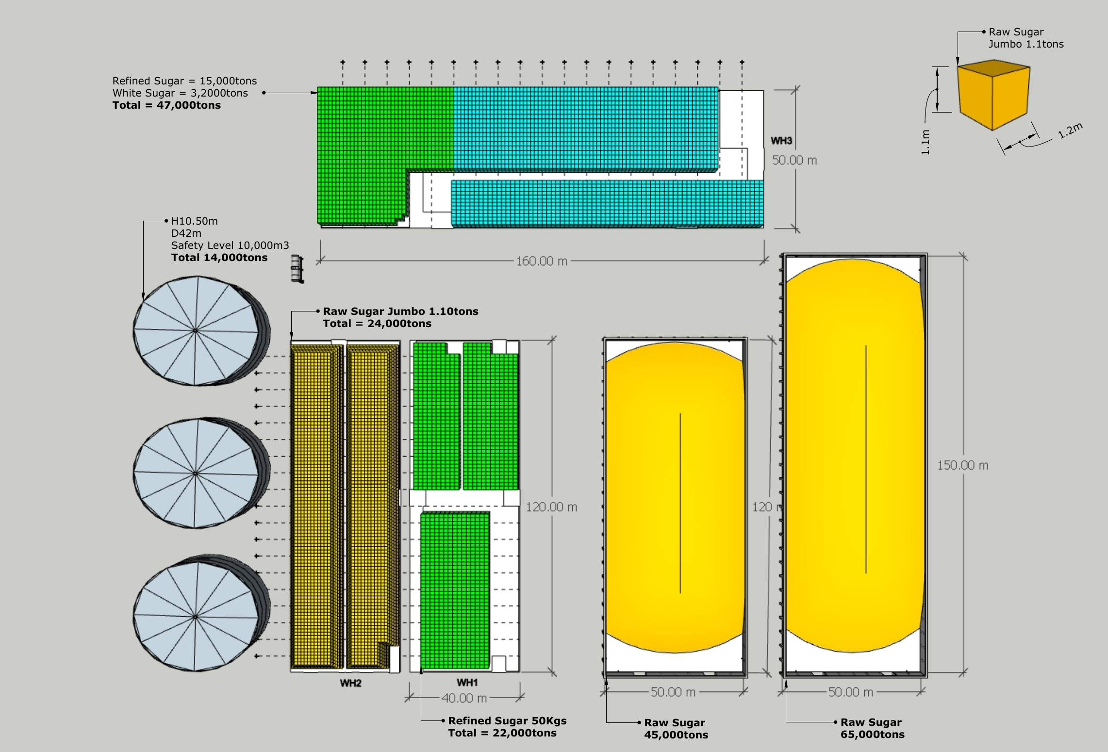
Figure 1: Warehouse Layout — Production Planning 2027, Estimated Cane 2,300,000 Ton

Prepared by:
Name: Hang Sovanna
Position: Finance Manager
Date: 16 July 2026

