**CURRICULUM VITAE**

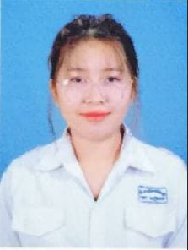Mss. SAO SEAVCHENG

Current address : National Road 5, Sangkat Svaypak, Khan Ruseykeo, Phnom Penh.

Tel : (855) 0887326092

Email : [saoseavcheng@gmail.com](mailto:saoseavcheng@gmail.com)

PERSONAL DATA

Name : SAO SEAVCHENG

Sex : Female

Nationality : Cambodian

Contact Number : (855) 0887326092

Date of Birth : April 04, 2003

Address : National Road 5, Sangkat Svaypak, Khan Ruseykeo, Phnom Penh.

EDUCATIONAL

2018-Now : Studied at Chea Sim Chamroeunroth High School.

LANGUAGE

Khmer : Good

English : Good

INTERESTS

: Leaning, reading book, communication.

OTHER SKILL

: Good communication

: Good interpersonal relation

: Good presentation

: High motivation, friendly and flexible