Предлог поена:

Коначно поена:

Интернет језици и алати 1: Испитни Пројекат

Датум:

Марко Шовић, ИТ153/17

**Питања**

**Пројекат**

**Кратак опис:следи пример који треба обрисати и убацити свој пројекат**

Применом HTML-аи CSS-а креиран је веб сајт на тему: Висока техничка школа струковних студија у Новом Саду. Сајт има 6 страница. Респонсиван је

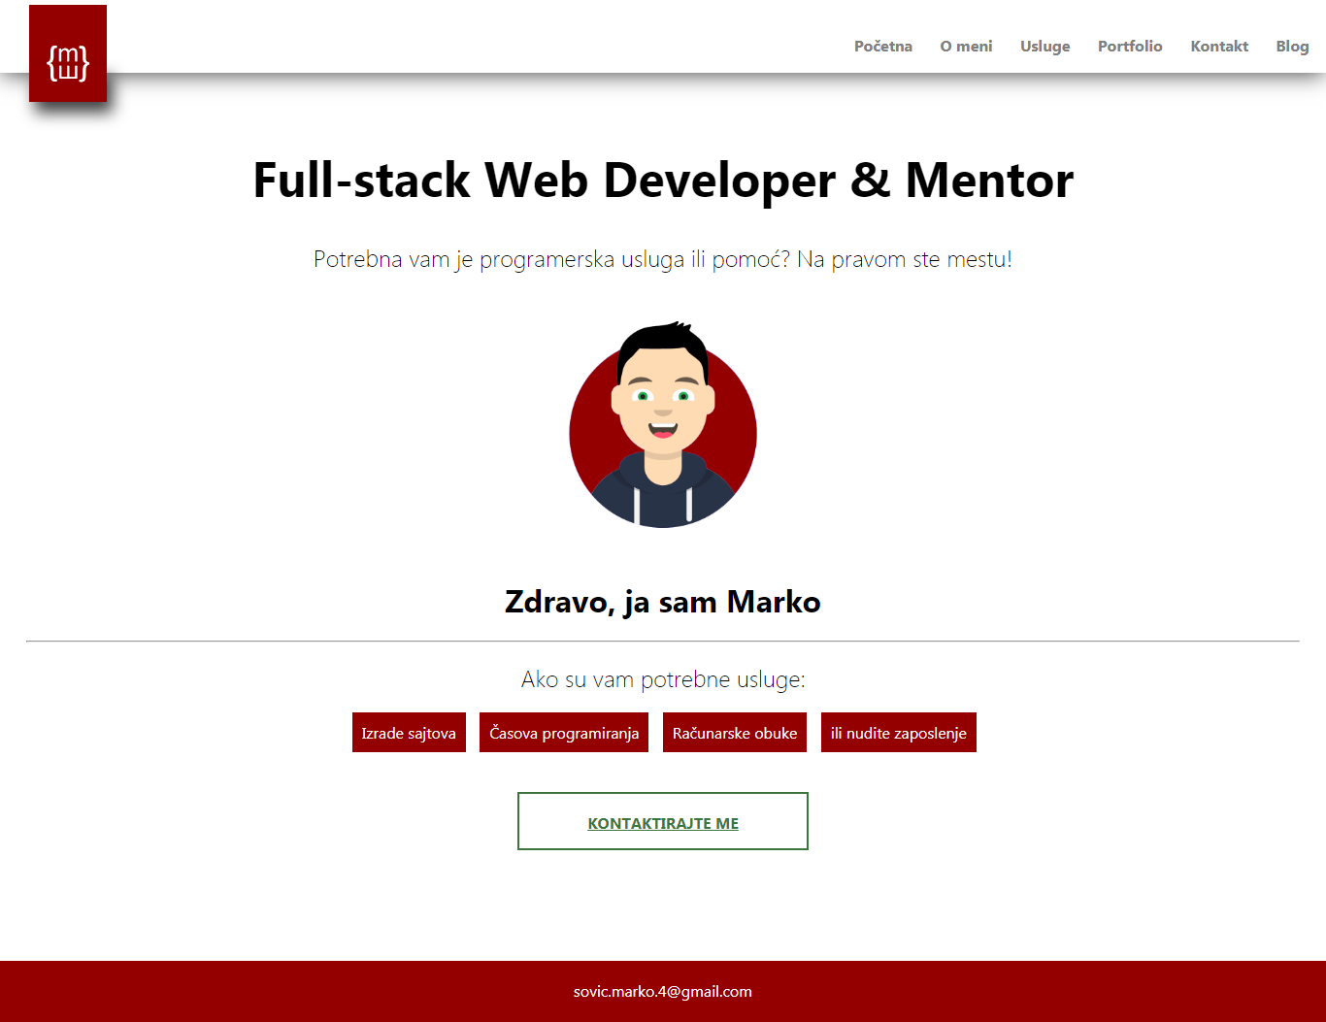

Слика1: Почетна страница

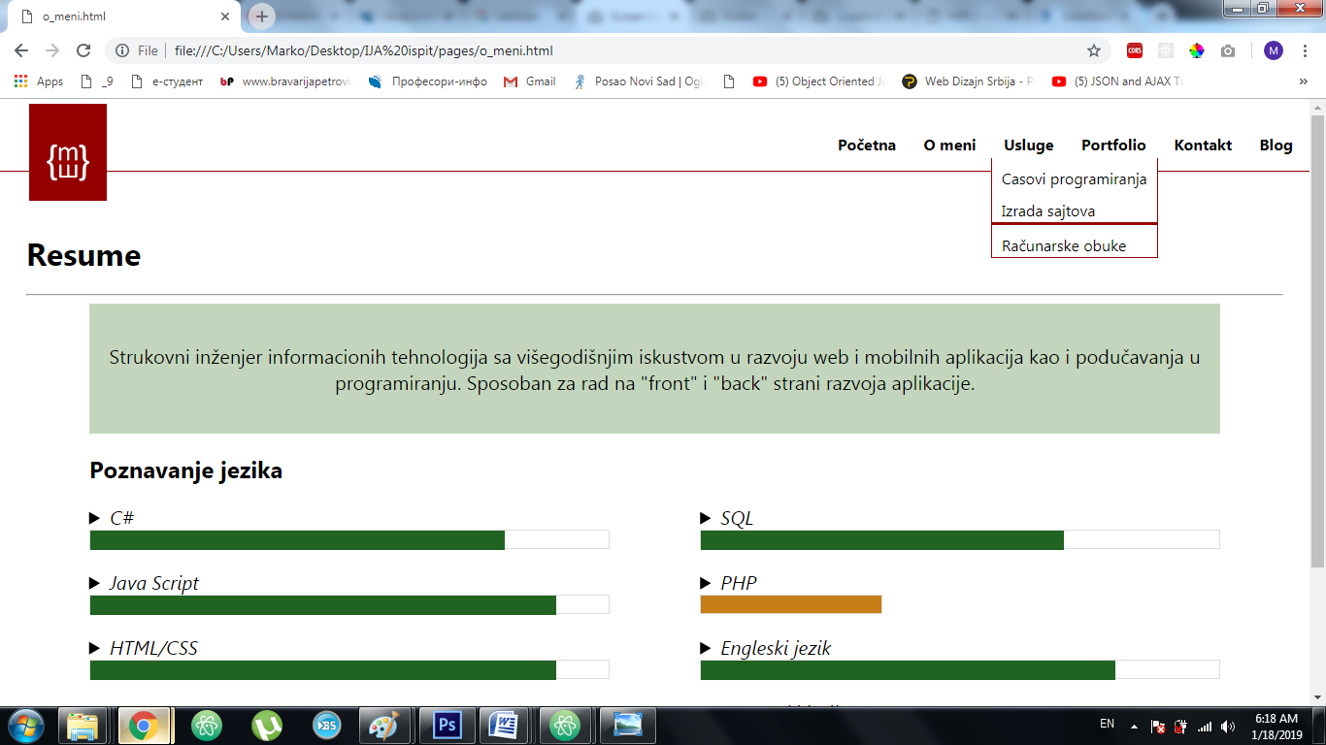

Слика: Страница „o_meni.html“ са приказом падајућег менија

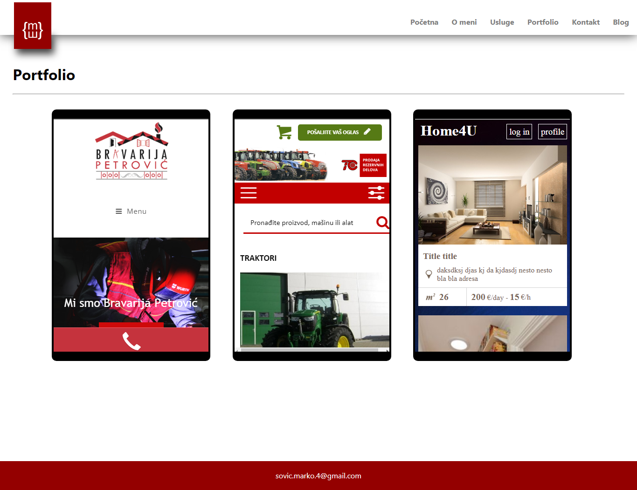

Слика3: Страница „portfolio.html“

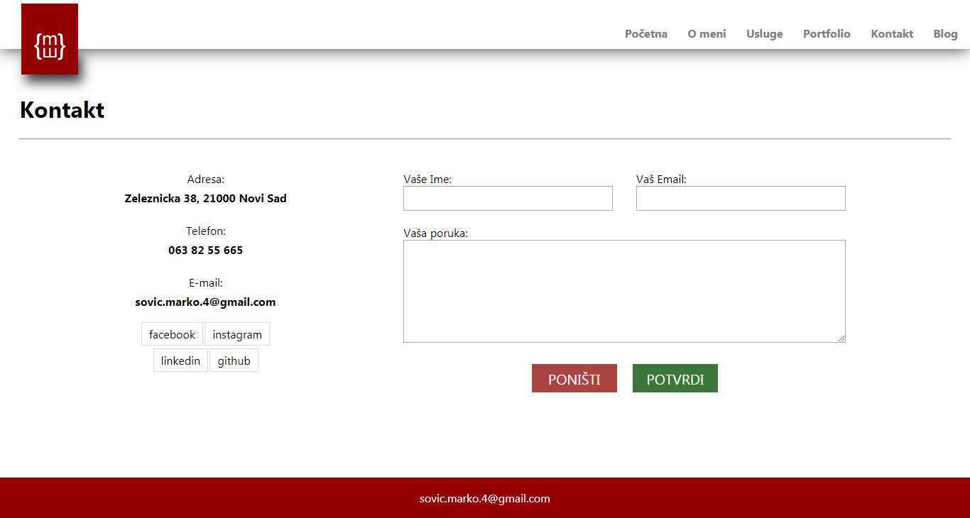

Слика4: Страница „kontakt.html“

|  |  |
| --- | --- |
| responsive.png | responsiveX.png |
| Слика5: Почетна страница „responsive“ | **Слика 6: Страница „o_meni.html“ са отвореном навигацијом** |

**Код:**

**HTML**

index.html

<!DOCTYPE html>

<html lang="en" dir="ltr">

<head>

<meta charset="utf-8">

<meta name="viewport" content="width=device-width, initial-scale=1.0">

<title></title>

<link rel="stylesheet" type="text/css" href="styles/main.css">

</head>

<body>

<header>

<div id="logo">

<img src="img/logo.png" alt="">

<div id="logo-shadow"></div>

</div>

<input type="checkbox" name="" value="">

<img class="click otvori" src="img/Hamburger.png" alt="">

<img class="click ponisti" src="img/ponisti.png" alt="">

<nav>

<ul>

<li><a href="index.html">Početna</a></li>

<li><a href="pages/o_meni.html">O meni</a></li>

<li class="usluge"><a>Usluge</a></li>

<ul class="usluge-drop">

<li><a href="pages/casovi_programiranja.html">Casovi programiranja</a></li>

<li>Izrada sajtova</li>

<li>Računarske obuke</li>

</ul>

<li><a>Portfolio</a></li>

<li><a href="pages/kontakt.html">Kontakt</a></li>

<li><a>Blog</a></li>

</ul>

</nav>

</header>

<main>

<div id="glavna-naslov">

<h1>Full-stack Web Developer & Mentor</h1>

<h2>Potrebna vam je programerska usluga ili pomoć? Na pravom ste mestu!</h2>

<img src="img/Untitled.png" alt="">

</div>

<div id="glavna-info">

<h1>Zdravo, ja sam Marko</h1>

<hr>

<h2>Ako su vam potrebne usluge:</h2>

<div class="info">

<div id="info-prvi">

Izrade sajtova

</div>

<div id="info-drugi">

Časova programiranja

</div>

<div id="info-treci">

Računarske obuke

</div>

<div id="info-cetvrti">

ili nudite zaposlenje

</div>

</div>

</div>

<a href="pages/kontakt.html" id="glavna-kontakt">

KONTAKTIRAJTE ME

</a>

</main>

<footer>

sovic.marko.4@gmail.com

</footer>

</body>

</html>

<!DOCTYPE html>

<html lang="en" dir="ltr">

<head>

<meta charset="utf-8">

<meta name="viewport" content="width=device-width, initial-scale=1.0">

<title></title>

<link rel="stylesheet" type="text/css" href="../styles/main.css">

</head>

<body>

<header>

<div id="logo">

<img src="../img/logo.png" alt="">

<div id="logo-shadow"></div>

</div>

<input type="checkbox" name="" value="">

<img class="click otvori" src="../img/Hamburger.png" alt="">

<img class="click ponisti" src="../img/ponisti.png" alt="">

<nav id="nav">

<ul>

<li><a href="../index.html">Početna</a></li>

<li><a href="o_meni.html">O meni</a></li>

<li class="usluge"><a>Usluge</a></li>

<ul class="usluge-drop">

<li><a href="casovi_programiranja.html">Casovi programiranja</a></li>

<li>Izrada sajtova</li>

<li>Računarske obuke</li>

</ul>

<li><a href="portfolio.html">Portfolio</a></li>

<li><a href="kontakt.html">Kontakt</a></li>

<li><a>Blog</a></li>

</ul>

</nav>

</header>

<main id="o-meni">

<h1>Resume</h1>

<hr>

<div class="info">

<div id="uvod">

<p>Strukovni inženjer informacionih tehnologija sa višegodišnjim iskustvom u razvoju web i mobilnih aplikacija kao i podučavanja u programiranju.

Sposoban za rad na "front" i "back" strani razvoja aplikacije.</p>

</div>

<h2>Poznavanje jezika</h2>

<div class="jezici">

<details>

<summary>C#</summary>

<p>Odlično poznavanje jezika, iskustvo izrade WPF i ASP MVC aplikacija</p>

<p>Godinu i po dana iskutva u držanju privatnih časova</p>

</details>

<div class="progres">

<div class="unutrasnji progres80"></div>

</div>

<details>

<summary>Java Script</summary>

<p> Lorem ipsum dolor sit amet, consectetur adipisicing elit, sed do eiusmod tempor incididunt ut labore et dolore magna aliqua. Ut enim ad minim veniam, quis nostrud exercitation ullamco laboris nisi ut aliquip ex ea commodo consequat. Duis aute irure dolor in reprehenderit in voluptate velit esse cillum dolore eu fugiat nulla pariatur. Excepteur sint occaecat cupidatat non proident, sunt in culpa qui officia deserunt mollit anim id est laborum.</p>

</details>

<div class="progres">

<div class="unutrasnji progres90"></div>

</div>

<details>

<summary>HTML/CSS</summary>

<p> Lorem ipsum dolor sit amet, consectetur adipisicing elit, sed do eiusmod tempor incididunt ut labore et dolore magna aliqua. Ut enim ad minim veniam, quis nostrud exercitation ullamco laboris nisi ut aliquip ex ea commodo consequat. Duis aute irure dolor in reprehenderit in voluptate velit esse cillum dolore eu fugiat nulla pariatur. Excepteur sint occaecat cupidatat non proident, sunt in culpa qui officia deserunt mollit anim id est laborum.</b></p>

</details>

<div class="progres">

<div class="unutrasnji progres90"></div>

</div>

</div>

<div class="jezici">

<details>

<summary>SQL</summary>

<p> Lorem ipsum dolor sit amet, consectetur adipisicing elit, sed do eiusmod tempor incididunt ut labore et dolore magna aliqua. Ut enim ad minim veniam, quis nostrud exercitation ullamco laboris nisi ut aliquip ex ea commodo consequat. Duis aute irure dolor in reprehenderit in voluptate velit esse cillum dolore eu fugiat nulla pariatur. Excepteur sint occaecat cupidatat non proident, sunt in culpa qui officia deserunt mollit anim id est laborum.</p>

</details>

<div class="progres">

<div class="unutrasnji progres70"> </div>

</div>

<details>

<summary>PHP</summary>

<p>Lorem ipsum dolor sit amet, consectetur adipisicing elit, sed do eiusmod tempor incididunt ut labore et dolore magna aliqua. Ut enim ad minim veniam, quis nostrud exercitation ullamco laboris nisi ut aliquip ex ea commodo consequat. Duis aute irure dolor in reprehenderit in voluptate velit esse cillum dolore eu fugiat nulla pariatur. Excepteur sint occaecat cupidatat non proident, sunt in culpa qui officia deserunt mollit anim id est laborum.</p>

</details>

<div class="progres progres35">

<div class="unutrasnji"></div>

</div>

<details>

<summary>Engleski jezik</summary>

<p> Lorem ipsum dolor sit amet, consectetur adipisicing elit, sed do eiusmod tempor incididunt ut labore et dolore magna aliqua. Ut enim ad minim veniam, quis nostrud exercitation ullamco laboris nisi ut aliquip ex ea commodo consequat. Duis aute irure dolor in reprehenderit in voluptate velit esse cillum dolore eu fugiat nulla pariatur. Excepteur sint occaecat cupidatat non proident, sunt in culpa qui officia deserunt mollit anim id est laborum.</p>

</details>

<div class="progres">

<div class="unutrasnji progres80"> </div>

</div>

<details>

<summary>Francuski jezik</summary>

<p> Lorem ipsum dolor sit amet, consectetur adipisicing elit, sed do eiusmod tempor incididunt ut labore et dolore magna aliqua. Ut enim ad minim veniam, quis nostrud exercitation ullamco laboris nisi ut aliquip ex ea commodo consequat. Duis aute irure dolor in reprehenderit in voluptate velit esse cillum dolore eu fugiat nulla pariatur. Excepteur sint occaecat cupidatat non proident, sunt in culpa qui officia deserunt mollit anim id est laborum.</b></p>

</details>

<div class="progres">

<div class="unutrasnji progres30"> </div>

</div>

</div>

</div>

<div class="clear"></div>

</main>

<footer>sovic.marko.4@gmail.com</footer>

</body>

</html>

<!DOCTYPE html>

<html lang="en" dir="ltr">

<head>

<meta charset="utf-8">

<meta name="viewport" content="width=device-width, initial-scale=1.0">

<title></title>

<link rel="stylesheet" type="text/css" href="../styles/main.css">

</head>

<body>

<header>

<div id="logo">

<img src="../img/logo.png" alt="">

<div id="logo-shadow"></div>

</div>

<input type="checkbox" name="" value="">

<img class="click otvori" src="../img/Hamburger.png" alt="">

<img class="click ponisti" src="../img/ponisti.png" alt="">

<nav id="nav">

<ul>

<li><a href="../index.html">Početna</a></li>

<li><a href="o_meni.html">O meni</a></li>

<li class="usluge"><a>Usluge</a></li>

<ul class="usluge-drop">

<li><a href="casovi_programiranja.html">Casovi programiranja</a></li>

<li>Izrada sajtova</li>

<li>Računarske obuke</li>

</ul>

<li><a href="portfolio.html">Portfolio</a></li>

<li><a href="kontakt.html">Kontakt</a></li>

<li><a>Blog</a></li>

</ul>

</nav>

</header>

<main id="portfolio">

<h1>Portfolio</h1>

<hr>

<div class="">

<div class="">

<iframe src="https://www.bravarijapetrovic.com/"></iframe>

</div>

<div class="">

<iframe src="http://polovnamehanizacija.rs/kategorija?ime=Traktori"></iframe>

</div>

<div class="">

<iframe src="file:///C:/stari%20projekti/Home4U%20html/home.html" width="" height=""></iframe>

</div>

</div>

<div class="clear"></div>

</main>

<footer>sovic.marko.4@gmail.com</footer>

</body>

</html>

<!DOCTYPE html>

<html lang="en" dir="ltr">

<head>

<meta charset="utf-8">

<title></title>

<meta name="viewport" content="width=device-width, initial-scale=1.0">

<link rel="stylesheet" type="text/css" href="../styles/main.css">

</head>

<body>

<header>

<div id="logo">

<img src="../img/logo.png" alt="">

<div id="logo-shadow"></div>

</div>

<input type="checkbox" name="" value="">

<img class="click otvori" src="../img/Hamburger.png" alt="">

<img class="click ponisti" src="../img/ponisti.png" alt="">

<nav id="nav">

<ul>

<li><a href="../index.html">Početna</a></li>

<li><a href="o_meni.html">O meni</a></li>

<li class="usluge"><a>Usluge</a></li>

<ul class="usluge-drop">

<li><a href="casovi_programiranja.html">Casovi programiranja</a></li>

<li>Izrada sajtova</li>

<li>Računarske obuke</li>

</ul>

<li><a href="portfolio.html">Portfolio</a></li>

<li><a href="kontakt.html">Kontakt</a></li>

<li><a>Blog</a></li>

</ul>

</nav>

</header>

<main>

<h1>Kontakt</h1>

<hr>

<div class="">

<div id="info">

<p>Adresa:</p>

<p><b>Zeleznicka 38, 21000 Novi Sad</b></p>

<p>Telefon:</p>

<p><b>063 82 55 665</b></p>

<p>E-mail:</p>

<p><b>sovic.marko.4@gmail.com</b></p>

<div class="">

<p class="linkovi"><a href="https://www.facebook.com/">facebook</a> <a href="https://www.instagram.com">instagram</a> </p>

<p class="linkovi"><a href="https://www.linkedin.com">linkedin</a> <a href="https://github.com/">github</a></p>

</div>

</div>

<form name="forma">

<div>

<p>Vaše Ime:</p>

<input type="text" name="ime" maxlength="15">

</div>

<div>

<p>Vaš Email:</p>

<input type="email" name="email" required>

</div>

<p>Vaša poruka:</p>

<textarea name="name" rows="8" cols="80"></textarea>

<input type="reset" name="" value="Poništi">

<input type="submit" name="" value="Potvrdi">

</form>

<div class="clear"></div>

</div>

</main>

<footer>sovic.marko.4@gmail.com</footer>

</body>

</html>

**CSS**

* {

box-sizing: border-box;

font-family: segoe UI;

}

body {

margin: 0px;

position: relative;

padding-bottom: 150px;

}

header {

width: 100%;

height: 12vh;

padding: 5px;

-webkit-box-shadow: 0px 3px 37px -2px rgba(0,0,0,0.75);

-moz-box-shadow: 0px 3px 37px -2px rgba(0,0,0,0.75);

box-shadow: 0px 3px 37px -2px rgba(0,0,0,0.75);

position: relative;

}

nav li:hover {

border-bottom: 3px solid #940000;

cursor: pointer;

}

header:hover {

border-bottom-color: white;

border-bottom: 1px solid #940000;

-webkit-box-shadow: none;

-moz-box-shadow: none;

box-shadow: none;

}

header:hover #logo-shadow {

-webkit-box-shadow: none;

-moz-box-shadow: none;

box-shadow: none;

}

header:hover nav > ul > li {

color: black;

}

header h1 {

color: #940000;

font-size: 40px;

}

#logo {

position: absolute;

left: 30px;

width: 80px;

height: 100px;

background: #940000;

text-align: center;

color: white;

z-index: 1

}

#logo img {

width: 60%;

display: block;

margin: auto;

margin-top: 40px;

}

#logo-shadow {

z-index: 2;

position: absolute;

bottom: 0px;

width: 100%;

height: 38px;

-webkit-box-shadow: 6px 11px 25px 0px rgba(0,0,0,0.75);

-moz-box-shadow: 6px 11px 25px 0px rgba(0,0,0,0.75);

box-shadow: 6px 11px 25px 0px rgba(0,0,0,0.75);

}

.click {

display: none;

position: absolute;

right: 20px;

top: 20px;

width: 50px;

}

.ponisti {

right: 20px;

top: 20px;

width: 35px;

display: none;

}

input[type="checkbox"] {

display: none;

width: 100%;

height: 100%;

z-index: 5;

opacity: 0;

position: absolute;

right: 20px;

top: 20px;

width: 40px;

height: 40px;

outline: 1px dashed green;

cursor: pointer;

}

input[type="checkbox"]:checked ~ nav{

display: block ;

}

nav {

display: block;

position: absolute;

right: 5px;

top: 20px;

}

nav a {

text-decoration: none;

color: inherit;

}

nav > ul {

list-style-type: none;

padding: 0px;

}

nav > ul > li {

display: inline;

border: 2px solid white;

padding: 10px;

padding-bottom: 1px;

color: gray;

font-weight: bold;

}

.usluge {

position: relative;

}

.usluge:hover + .usluge-drop {

display: block;

}

.usluge-drop {

display: none;

left: 170px;

top: 41px;

position: absolute;

list-style-type: none;

padding: 0px;

border: 1px solid #940000;

border-top: 0px;

}

.usluge-drop:hover {

display: block;

}

.usluge-drop li {

padding: 10px;

padding-bottom: 2px;

background-color: white;

}

main {

background-color: white;

width: 100%;

padding: 2%;

padding-top: 40px;

height: auto;

}

#glavna-naslov h1 {

font-size: 50px;

text-align: center;

}

#glavna-naslov h2 {

font-weight: lighter;

text-align: center;

}

#glavna-naslov img {

display: block;

margin: auto;

margin-top: 50px;

width: 15%;

}

#glavna-info {

margin-top: 50px;

width: 100%;

height: 200px;

}

#glavna-info h1 {

text-align: center;

}

#glavna-info h2 {

font-weight: lighter;

text-align: center;

}

#glavna-info .info {

width: 660px;

margin: auto;

}

#glavna-info div div {

display: inline-block;

background-color: #940000;

padding: 10px;

color: white;

margin-left: 10px;

}

@keyframes kontaktAnimacija {

from {font-size: 12px;}

to {font-size: 20px;}

}

#glavna-kontakt {

display: block;

font-weight: bold;

margin: auto;

margin-top: 20px;

border: 2px solid #3c763d;

color: #3c763d;

width: 300px;

height: 60px;

line-height: 60px;

text-align: center;

animation: kontaktAnimacija 2s;

animation-iteration-count: infinite;

}

@keyframes infoAnimacija {

from {background-color: white;}

to {background-color: #940000;}

}

#info-prvi,

#info-drugi,

#info-treci,

#info-cetvrti {

animation: infoAnimacija 2s;

}

#info-drugi {

animation-delay: 1s;

}

#info-treci {

animation-delay: 2s;

}

#info-cetvrti {

animation-delay: 3s;

}

#o-meni .jezici {

width: 46%;

display: inline-block;

}

#o-meni .jezici:last-of-type {

float: right;

}

#o-meni .info {

width: 90%;

margin: auto;

}

#o-meni .info #uvod {

background-color: #c3d6bd;

padding: 20px;

font-size: 20px;

text-align: center;

}

summary {

font-size: 20px;

font-style: italic;

}

.progres {

width: 100%;

height: 20px;

border: 1px solid gainsboro;

margin-bottom: 20px;

}

.unutrasnji {

height: 20px;

}

@keyframes progres90 {

from {width: 0%; background-color:red}

to {width: 90%; background-color:#216321}

}

.progres90 {

background-color: #216321;

width: 90%;

animation: progres90 2s;

}

@keyframes progres80 {

from {width: 0%; background-color:red}

to {width: 80%; background-color:#216321}

}

.progres80 {

background-color: #216321;

width: 80%;

animation: progres80 2s;

}

@keyframes progres70 {

from {width: 0%; background-color:red}

to {width: 70%; background-color:#216321}

}

.progres70 {

background-color: #216321;

width: 70%;

animation: progres70 2s;

}

@keyframes progres35 {

from {width: 0%; background-color:red}

to {width: 35%; background-color: #c57e16}

}

.progres35{

background-color: #c57e16;

width: 35%;

animation: progres35 2s;

}

@keyframes progres30 {

from {width: 0%; background-color:red}

to {width: 30%; background-color: #c57e16}

}

.progres30{

background-color: #c57e16;

width: 30%;

animation: progres30 2s;

}

#portfolio > div{

padding: 0px 60px;

}

#portfolio div div {

width: 340px;

overflow: hidden;

height: 540px;

border-right: 2px solid gray;

display: inline-block;

float: left;

margin: 2%;

border: 20px solid black;

border-width: 20px 4px;

border-radius: 10px;

margin-bottom: 100px;

}

#portfolio iframe {

width: 360px;

height: 510px;

overflow: hidden;

margin-left: -5px;

}

#info, form {

margin-top: 20px;

vertical-align: top;

width: 50%;

float: left;

display: inline-block;

}

#info {

width: 40%;

}

#info a {

padding: 5px 10px;

outline: 1px solid gainsboro;

text-decoration: none;

color: black

}

#info a:hover {

background-color: gainsboro;

}

#info p {

text-align: center;

}

#info > p:nth-child(even) {

margin-top: -10px;

margin-bottom: 25px;

}

#inf a {

margin: 10px !important;

}

form div {

display: inline-block;

width: 50%;

float: left;

}

form div p {

padding-left: 5%;

margin-bottom: 0px;

}

form > p {

padding-left: 2.5%;

margin-bottom: 0px;

}

form div input {

width: 90%;

height: 35px;

display: block;

margin: auto;

margin-bottom: 20px;

}

form textarea{

width: 95%;

margin: auto;

display: block;

padding-top: 5px;

}

input {

font-family: Segoe UI;

}

input[type="text"],

input[type="email"],

textarea

{

padding-left: 10px;

}

input[type="submit"],

input[type="reset"] {

width: 120px;

height: 40px;

font-size: 20px;

text-transform: uppercase;

border: 0px;

margin-top: 30px;

cursor: pointer;

}

input[type="submit"]:hover,

input[type="reset"]:hover {

color: black;

}

input[type="submit"]:active,

input[type="reset"]:active {

background: white;

outline: 0px;

}

input[type="submit"]:focus,

input[type="reset"]:focus {

outline: 0px;

}

input[type="submit"] {

background-color: #3c763d;

color: white;

float: right;

margin-right: 30%;

}

input[type="reset"] {

background-color: #a94442;

color: white;

float: left;

margin-left: 30%;

}

input[type="text"]:focus,

input[type="email"]:focus,

textarea:focus {

outline: 2px solid #3c763d;

}

.clear {

margin-top: 20px;

clear: both;

}

footer {

height: 10vh;

line-height: 10vh;

margin-top: 50px;

position: absolute;

bottom: 0px;

width: 100%;

background-color: #940000;

color: white;

text-align: center;

}

@media only screen and (max-width: 620px) {

.otvori {

display: block;

}

input[type="checkbox"] {

display: block;

}

input[type="checkbox"]:checked ~ .ponisti {

display: block !important;

}

input[type="checkbox"]:checked ~ .otvori {

display: none !important;

}

nav {

display: none;

width: 65%;

top: 45px;

}

nav ul{

width: 100%;

}

nav ul li {

display: block;

float: none;

text-align: center;

background: #940000;

height: 50px;

line-height: 50px;

margin: 0px;

padding: 0px;

color: white;

font-weight: lighter;

}

header:hover nav > ul > li {

color: white;

}

#glavna-naslov img {

width: 50%;

}

#glavna-info .info {

width: 98%;

margin: 0px;

}

#glavna-info div div {

display: block;

}

#glavna-kontakt {

margin-top: 200px;

}

#o-meni .jezici {

width: 100%;

display: block;

float: none;

}

}