- In the following folder, there are total 6 files that make the week 5 tasks run smoothly.
- The flow of the tasks runs as follows
Milestone3GoalsApplication.java GoalController.java GoalService.java GoalRepository.java DataBase (Workbench)

Milestone3GoalsApplication.java
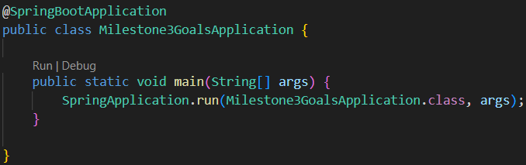
- This is the starting point where the spring boot runs.
  - @SpringBootApplication:
This is an annotations that combines configuration, componentscaning.
  - SpringApplication.run(...):
This is a function that starts the spring application over tomcat server on local port and connects to database.
application.properties
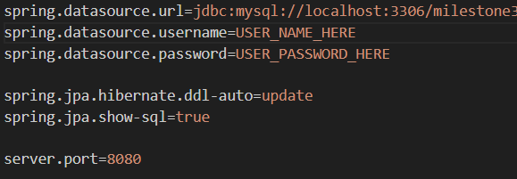
- This file controls database connection, JPA behavior, server settings.
  - spring.datasource.url
The value which goes into this JDBC term tells spring boot to connect to specific database given as value to this term.
  - spring.datasource.username & spring.datasource. password
The value which goes into this JDBC term helps spring boot to bypass the authentication in workbench
  - spring.jpa.hibernate.ddl-auto=update
Here the “update” value create and updates tables automatically without user involvement.
Goal.java
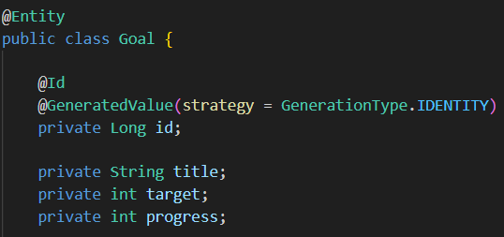
- This file represents the rows in database example: username, password, email etc.
  - @Entity && @Table(name=”goals”)
Here these 2 entities tries to create the table inside the database.
  - @Id && @GeneratedValue
Here these entities makes the value as a primary key inside the database.
- Here these entites tells the Hibernate to convert java objects to SQL rows.
GoalRepository.java
- Here the above line controls all the database operations that are as follows
  - Insert, update, select, delete
- Here this file communicates with Database by separating the logics of code.
GoalService.java
- Here this file contains and handles the logic of the code.
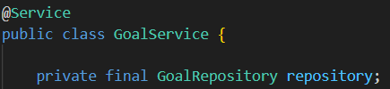
- This acts as a mediator in between the Controller and Database.
  - @Service
This annotation allows to register classes as spring beans.
  - “private final GoalRepository goalRepository;”
This line injects the repositories automatically via constructor.
- Here this file validates inputs, apply rules for status changes and updates, call repository methods.
GoalController.java
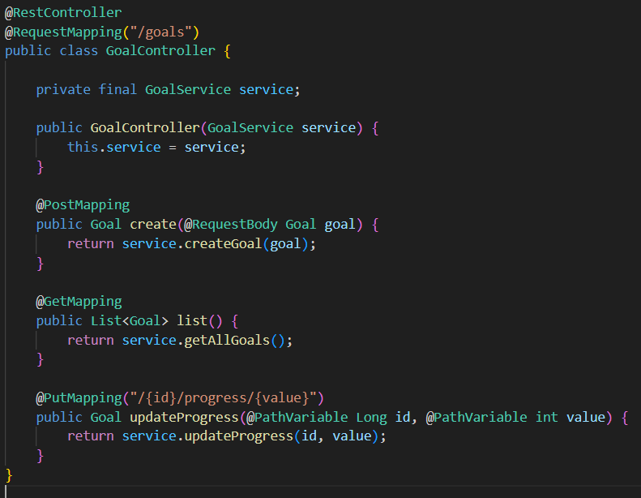
- This file exposes “REST API’s” where postman connects and performs actions.
  - @RestController
This annotation combines Controller and Response body returning JSON file automatically.
  - @RequestMapping("/api/goals")
This annotation handles POST, GET and PUT postman methods.

