Name – Sajag Agrawal

Reg No – 21BCT0438

Software Engineering Lab PostMAN API Testing

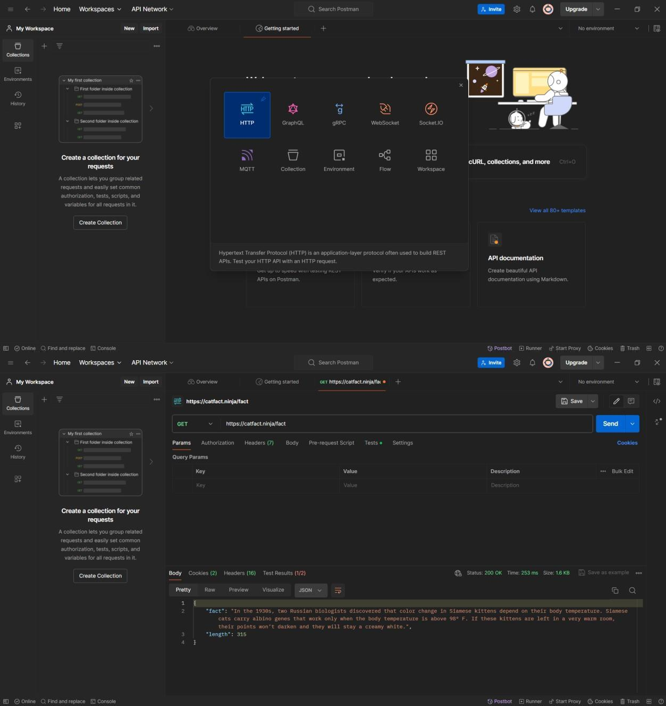

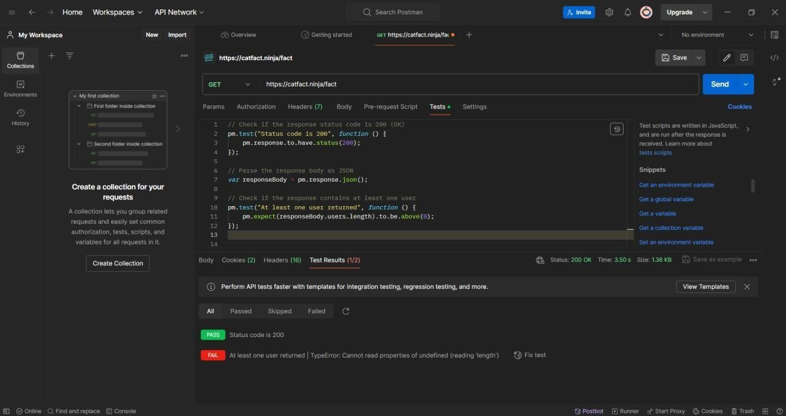

// Test script to validate the response from the API

// Check if the response status code is 200 (OK) pm.test("Status code is 200", function () {

pm.response.to.have.status(200);

});

// Parse the response body as JSON

var responseBody = pm.response.json();

// Check if the response contains the expected keys pm.test("Response contains expected keys", function () { pm.expect(responseBody).to.have.property('fact'); pm.expect(responseBody).to.have.property('length');

});

// Check the type of the values

pm.test("Response values have correct types", function () { pm.expect(responseBody.fact).to.be.a('string'); pm.expect(responseBody.length).to.be.a('number');

});

// Check the length of the fact

pm.test("Fact length is correct", function () {

pm.expect(responseBody.fact.length).to.equal(responseBody.length);

});

