**CSE421 Project-03**

**The map of Call of Duty: Mobile**

**Group-21**

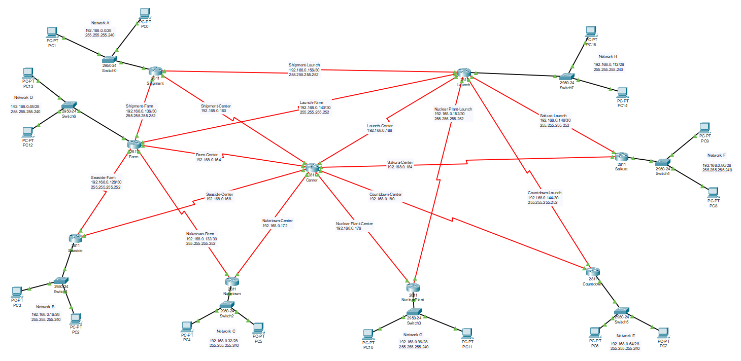

**IP Address Table:**

|  |  |  |  |
| --- | --- | --- | --- |
| **Network** | **Port** | **IP Address** | **Subnet Masks** |
| Shipment | FA0/0 | 192.168.0.1 | 255.255.255.240 |
| S0/0/0 | 192.168.0.157 | 255.255.255.252 |
| S0/1/0 | 192.168.0.161 | 255.255.255.252 |
| S0/3/1 | 192.168.0.138 | 255.255.255.252 |
| Farm | FA0/0 | 192.168.0.49 | 255.255.255.240 |
| S0/0/0 | 192.168.0.165 | 255.255.255.252 |
| S0/1/0 | 192.168.0.130 | 255.255.255.252 |
| S0/1/1 | 192.168.0.134 | 255.255.255.252 |
| S0/3/0 | 192.168.0.141 | 255.255.255.252 |
| S0/3/1 | 192.168.0.137 | 255.255.255.252 |
| Seaside | FA0/0 | 192.168.0.17 | 255.255.255.240 |
| S0/1/0 | 192.168.0.129 | 255.255.255.252 |
| S0/1/1 | 192.168.0.169 | 255.255.255.252 |
| Nuketown | FA0/0 | 192.168.0.33 | 255.255.255.240 |
| S0/1/1 | 192.168.0.133 | 255.255.255.252 |
| S0/2/0 | 192.168.0.173 | 255.255.255.252 |
| NuclearPlant | FA0/0 | 192.168.0.97 | 255.255.255.240 |
| S0/3/0 | 192.168.0.177 | 255.255.255.252 |
| S0/3/1 | 192.168.0.154 | 255.255.255.252 |
| Countdown | FA0/0 | 192.168.0.65 | 255.255.255.240 |
| S0/1/1 | 192.168.0.146 | 255.255.255.252 |
| S0/3/1 | 192.168.0.181 | 255.255.255.252 |
| Sakura | FA0/0 | 192.168.0.81 | 255.255.255.240 |
| S0/1/0 | 192.168.0.150 | 255.255.255.252 |
| S0/2/1 | 192.168.0.185 | 255.255.255.252 |
| Launch | FA0/0 | 192.168.0.113 | 255.255.255.240 |
| S0/0/0 | 192.168.0.158 | 255.255.255.252 |
| S0/0/1 | 192.168.0.189 | 255.255.255.252 |
| S0/1/0 | 192.168.0.149 | 255.255.255.252 |
| S0/1/1 | 192.168.0.145 | 255.255.255.252 |
| S/0/3/0 | 192.168.0.142 | 255.255.255.252 |
| S0/3/1 | 192.168.0.153 | 255.255.255.252 |
| Center | S0/0/0 | 192.168.0.166 | 255.255.255.252 |
| S0/0/1 | 192.168.0.190 | 255.255.255.252 |
| S0/1/0 | 192.168.0.162 | 255.255.255.252 |
| S0/1/1 | 192.168.0.170 | 255.255.255.252 |
| S0/2/0 | 192.168.0.174 | 255.255.255.252 |
| S0/2/1 | 192.168.0.186 | 255.255.255.252 |
| S0/3/0 | 192.168.0.178 | 255.255.255.252 |
| S0/3/1 | 192.168.0.182 | 255.255.255.252 |

**Network Address Table:**

|  |  |  |
| --- | --- | --- |
| **Network** | **IP Address** | **Subnet masks** |
| Topology | 192.168.0.0 | 255.255.255.0 |
| Shipment | 192.168.0.0 | 255.255.255.240 |
| Seaside | 192.168.0.16 | 255.255.255.240 |
| Nuketown | 192.168.0.32 | 255.255.255.240 |
| Farm | 192.168.0.48 | 255.255.255.240 |
| Countdown | 192.168.0.64 | 255.255.255.240 |
| Sakura | 192.168.0.80 | 255.255.255.240 |
| Nuclear Plant | 192.168.0.96 | 255.255.255.240 |
| Launch | 192.168.0.112 | 255.255.255.240 |
| Seaside – Farm | 192.168.0.128 | 255.255.255.252 |
| Nuketown – Farm | 192.168.0.132 | 255.255.255.252 |
| Shipment – Farm | 192.168.0.136 | 255.255.255.252 |
| Launch – Farm | 192.168.0.140 | 255.255.255.252 |
| Countdown – Launch | 192.168.0.144 | 255.255.255.252 |
| Sakura – Launch | 192.168.0.148 | 255.255.255.252 |
| Nuclear Plant - Launch | 192.168.0.152 | 255.255.255.252 |
| Shipment - Launch | 192.168.0.156 | 255.255.255.252 |
| Shipment-Center | 192.168.0.160 | 255.255.255.252 |
| Farm-Center | 192.168.0.164 | 255.255.255.252 |
| Seaside-Center | 192.168.0.168 | 255.255.255.252 |
| Nuketown-Center | 192.168.0.172 | 255.255.255.252 |
| Nuclear Plant-Center | 192.168.0.176 | 255.255.255.252 |
| Countdown-Center | 192.168.0.180 | 255.255.255.252 |
| Sakura-Center | 192.168.0.184 | 255.255.255.252 |
| Launch-Center | 192.168.0.188 | 255.255.255.252 |

**The Configuration of all Routers:**

**Launch:**

Router&gt;enable

Router#config t

Enter configuration commands, one per line. End with CNTL/Z.

Router(config)#ip route 192.168.0.96 255.255.255.240 s0/3/1

Router(config)#ip route 192.168.0.80 255.255.255.240 s0/1/0

Router(config)#ip route 192.168.0.80 255.255.255.240 s0/1/0

Router(config)#ip route 192.168.0.64 255.255.255.240 s0/1/1

Router(config)#ip route 192.168.0.140 255.255.255.252 s0/3/0

Router(config)#ip route 192.168.0.48 255.255.255.240 192.168.0.140

Router(config)#ip route 0.0.0.0 0.0.0.0 s0/3/0

Router(config)#ip route 0.0.0.0 0.0.0.0 s0/0/1 5

Router(config)#

**NuclearPlant:**

Router&gt;enable

Router#config t

Enter configuration commands, one per line. End with CNTL/Z.

Router(config)#ip route 192.168.0.112 255.255.255.240 s0/3/1

Router(config)#ip route 192.168.0.80 255.255.255.240 192.168.0.152

Router(config)#ip route 192.168.0.64 255.255.255.240 192.168.0.152

Router(config)#

Router(config)#

Router&gt;enable

Router#config t

Enter configuration commands, one per line. End with CNTL/Z.

Router(config)#ip route 0.0.0.0 0.0.0.0 s0/3/1

Router(config)#ip route 0.0.0.0 0.0.0.0 s0/3/0 5

**Sakura:**

Router&gt;enable

Router#config t

Enter configuration commands, one per line. End with CNTL/Z.

Router(config)#ip route 192.168.0.112 255.255.255.240 s0/1/0

Router(config)#ip route 192.168.0.64 255.255.255.240 192.168.0.148

Router(config)#ip route 192.168.0.96 255.255.255.240 192.168.0.148

Router(config)#

Router&gt;enable

Router#config t

Enter configuration commands, one per line. End with CNTL/Z.

Router(config)#ip route 0.0.0.0 0.0.0.0 s0/1/0

Router(config)#ip route 0.0.0.0 0.0.0.0 s0/2/1 5

**Countdown:**

Router&gt;enable

Router#config t

Enter configuration commands, one per line. End with CNTL/Z.

Router(config)#ip route 192.168.0.112 255.255.255.240 s0/1/1

Router(config)#ip route 192.168.0.80 255.255.255.240 192.168.0.144

Router(config)#ip route 192.168.0.96 255.255.255.240 192.168.0.144

Router(config)#

Router&gt;enable

Router#config t

Enter configuration commands, one per line. End with CNTL/Z.

Router(config)#ip route 0.0.0.0 0.0.0.0 s0/1/1

Router(config)#ip route 0.0.0.0 0.0.0.0 s0/3/1 5

**Shipment:**

Router&gt;enable

Router#config t

Enter configuration commands, one per line. End with CNTL/Z.

Router(config)#router rip

Router(config-router)#version 2

Router(config-router)#no auto

Router(config-router)#no auto-summary

Router(config-router)#network 192.168.0.0

Router(config-router)#network 192.168.0.136

//Router(config-router)#passive-interface fa0/0

Router(config-router)#default-information originte

^

% Invalid input detected at &#39;^&#39; marker.

Router(config-router)#default-information originate

Router(config-router)#end

Router#

%SYS-5-CONFIG_I: Configured from console by console

Router#copy run start

Destination filename [startup-config]?

Building configuration...

[OK]

Router#

Router&gt;enable

Router#config t

Enter configuration commands, one per line. End with CNTL/Z.

Router(config)#ip route 0.0.0.0 0.0.0.0 s0/3/1

Router(config)#ip route 0.0.0.0 0.0.0.0 s0/1/0 5

**Seaside:**

Router&gt;enable

Router#config t

Enter configuration commands, one per line. End with CNTL/Z.

Router(config)#router rip

Router(config-router)#version 2

Router(config-router)#no auto

Router(config-router)#no auto-summary

Router(config-router)#network 192.168.0.16

Router(config-router)#network 192.168.0.128

//Router(config-router)#passive-interface fa0/0

Router(config-router)#default-information originate

Router(config-router)#end

Router#

%SYS-5-CONFIG_I: Configured from console by console

Router#copy run strat

^

% Invalid input detected at &#39;^&#39; marker.

Router#copy run start

Destination filename [startup-config]?

Building configuration...

[OK]

Router#

Router&gt;enable

Router#config t

Enter configuration commands, one per line. End with CNTL/Z.

Router(config)#ip route 0.0.0.0 0.0.0.0 s0/1/0

Router(config)#ip route 0.0.0.0 0.0.0.0 s0/1/1 5

**Nuketown:**

Router&gt;enable

Router#config t

Enter configuration commands, one per line. End with CNTL/Z.

Router(config)#router rip

Router(config-router)#version 2

Router(config-router)#no auto

Router(config-router)#no auto-summary

Router(config-router)#network 192.168.0.32

Router(config-router)#network 192.168.0.132

//Router(config-router)#passive-interface fa0/0

Router(config-router)#default-information originate

Router(config-router)#end

Router#

%SYS-5-CONFIG_I: Configured from console by console

Router#copy run start

Destination filename [startup-config]?

Building configuration...

[OK]

Router#

Router&gt;enable

Router#config t

Enter configuration commands, one per line. End with CNTL/Z.

Router(config)#ip route 0.0.0.0 0.0.0.0 s0/1/1

Router(config)#ip route 0.0.0.0 0.0.0.0 s0/2/0 5

**Farm:**

Router&gt;enable

Router#config t

Enter configuration commands, one per line. End with CNTL/Z.

Router(config)#router rip

Router(config-router)#version 2

Router(config-router)#no auto

Router(config-router)#no auto-summary

Router(config-router)#network 192.168.0.48

Router(config-router)#network 192.168.0.132

Router(config-router)#network 192.168.0.128

Router(config-router)#network 192.168.0.136

Router(config-router)#network 192.168.0.140

Router(config-router)#network 192.168.0.112

Router(config-router)#network 192.168.0.140

//Router(config-router)#passive-interface fa0/0

Router(config-router)#default-information originate

Router(config-router)#end

Router#

%SYS-5-CONFIG_I: Configured from console by console

Router#copy run start

Destination filename [startup-config]?

Building configuration...

[OK]

Router#

Router&gt;enable

Router#config t

Enter configuration commands, one per line. End with CNTL/Z.

Router(config)#ip route 0.0.0.0 0.0.0.0 s0/3/0

Router(config)#ip route 0.0.0.0 0.0.0.0 s0/0/0 5

**Center:**

Router(config)#ip route 0.0.0.0 0.0.0.0 s0/1/0 5

Router(config)#ip route 0.0.0.0 0.0.0.0 s0/0/0 5

Router(config)#ip route 0.0.0.0 0.0.0.0 s0/1/1 5

Router(config)#ip route 0.0.0.0 0.0.0.0 s0/2/0 5

Router(config)#ip route 0.0.0.0 0.0.0.0 s0/3/0 5

Router(config)#ip route 0.0.0.0 0.0.0.0 s0/3/1 5

Router(config)#ip route 0.0.0.0 0.0.0.0 s0/2/1 5

Router(config)#ip route 0.0.0.0 0.0.0.0 s0/0/1 5