**LAB-5**

**/*Question 1: Create an abstract class Shape with abstract method calculateArea() and implement it in Circle and Rectangle.*/**

//Abstract class Shape

abstract class Shape{

//Abstract method

abstract double calculateArea();

}

// Circle class extends shape

class Circle extends Shape{

double radius;

Circle(double radius){

this.radius = radius;

}

double calculateArea(){

return Math.PI*radius*radius;

}

}

//Rectangule class extends shape

class Rectangle extends Shape{

double length;

double width;

Rectangle(double length,double width){

this.length = length;

this.width = width;

}

double calculateArea(){

return length*width;

}

}

//Main class

class AbstractDemo {

public static void main(String args[]){

Shape circle = new Circle(5.0);

Shape rectangle = new Rectangle(4.0,6.0);

System.out.println("Area of circle : "+circle.calculateArea());

System.out.println("Area of rectangle : "+rectangle.calculateArea());

}

}

**OUTPUT:**

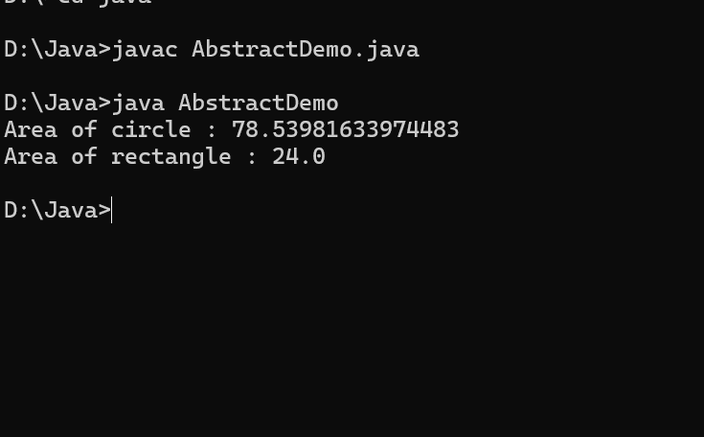

**/* Question 2: Create an interface Database with method connect() and implement it in MySQLDatabase and OracleDatabase.*/**

//Interface

interface Database {

//method

void connect();

}

class MySQLDatabase implements Database{

public void connect(){

System.out.println("Connecting to MySQLDatabase...");

}

}

class OracleDatabase implements Database{

public void connect(){

System.out.println("Connecting to OracleDatabase...");

}

}

public class InterfaceDemo{

public static void main(String args[]){

Database mysql = new MySQLDatabase();

Database oracle = new OracleDatabase();

mysql.connect();

oracle.connect();

}

}

**OUTPUT:**

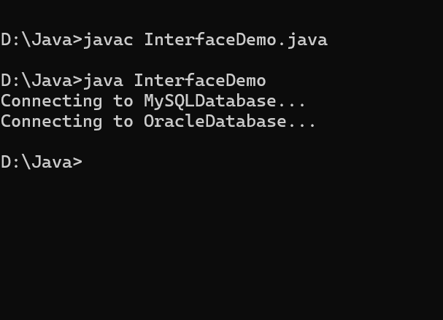

**/* Question 3: Real-time: Create an interface Payment with method pay() and implement it in classes UPI, CreditCard, NetBanking.*/**

interface Payment{

//Method to pay

void pay(double amount);

}

//UPI payment class

class UPI implements Payment{

public void pay(double amount){

System.out.println("Paid Rs."+amount+" using UPI.");

}

}

// Credit card Class

class CreditCard implements Payment{

public void pay(double amount){

System.out.println("Paid Rs."+amount+" using Creditcard.");

}

}

//Netbanking payment class

class Netbanking implements Payment{

public void pay(double amount){

System.out.println("Paid Rs."+amount+"using Netbanking.");

}

}

class PaymentDemo{

public static void main(String args[]){

// create different payment method objects

Payment upi = new UPI();

Payment cc = new CreditCard();

Payment netbanking = new Netbanking();

//Make payments using different methods

upi.pay(500.0);

cc.pay(2000.0);

netbanking.pay(1200.0);

}

}

**OUTPUT:**

