

Mitigate Effects of Data Noise on ML Model Training
and Inference for Robust Prediction

by
Sowdeshwar Survesha Kumaar
School of Electrical and Computer Science Engineering
The University of Queensland

Submitted for Master of Data Science Capstone 1

12th November 2025

Table of Contents
Executive Summary ........................................................................................................... 3
1.Introduction………............................................................................................................4
1.1 Background and Problem Context ............................................................................. 4
1.2 Project Aim, Scope, and Objectives ........................................................................... 5
1.3 Value, Expected Benefits, and Contributions .............................................................6
2. Literature Review and Theoretical Basis ..........................................................................8
3. Overview of the Methodology ......................................................................................10
3.1 Data Description ..................................................................................................... 12
3.2 Data Pre-processing ................................................................................................ 13
3.3 Noise Simulation ....................................................................................................15
3.4 Noise Mitigation .................................................................................................... 18
3.5 Model Training and Evaluation .................................................................................19
3.6 Scalability and Computational Design ......................................................................23
4. Data Interpretation and Results ....................................................................................25
4.1 Feature-Level Variability Analysis ........................................................................... 25
4.2 Yield Variability Analysis ......................................................................................... 28
4.3 Sample-Scale Model Performance ...........................................................................30
4.4 Upscaled Model Performance ..................................................................................31
4.5 Scalability Results and Performance Discussion ....................................................... 33
5. Conclusions and Recommendations ............................................................................ 36 5.1 Summary of Study ............................................................................................... 36
5.2 Achievement of Objectives ....................................................................................36
5.3 Key Outcomes ........................................................................................................ 37
5.4 Limitations of the Study .......................................................................................... 37
5.5 Recommendations ................................................................................................. 38
5.6 Overall Conclusion .................................................................................................. 38
References ...................................................................................................................... 39
Appendices .................................................................................................................... 40
Executive Summary
This project provides a thorough, end to end investigation into the way in which data noise decreases machine learning (ML) performance in large scale agricultural yield prediction systems, and how a specifically built noise aware pipeline can bring back model stability, accuracy, and interpretability. Modern agronomic datasets are often collected from heterogeneous sources commonly including sensors, environmental stations, and human observations, as a result these datasets have significant imperfections, such as sensor drift, random missingness at production or recording step, inconsistent measurement scale, and misreported or anomalous yield values [1] [2]. These imperfections create instability in feature distributions, overinflate variance, decrease correlation, and ultimately degrade ML inference performance. [3]

To address these issues, this work designs, implements, and validates a two-phase experimental pipeline for testing the hypothesis about how and what type of noise in data, undermine ML performance. The experimental pipeline begins in the first phase (100k row sample) with focus on controlled experimentation, where feature noise, and label noise are systematically simulated at 50% row level corruption in data using Gaussian jitter, multiplicative distortions, logit space perturbations, and structured extension of yield related corruption [4]. The second phase extends not only the study but the simulation pipeline to the entire 19 million agricultural records included in the study using distributed PySpark and SynapseML LightGBM [5]. Both phases employ a dual stage design for mitigation of noise that includes dual Bayesian Ridge iterative imputation + PCA based denoising for features, and Random Forest Residual Median Absolute Deviation (MAD) correction of the labels.

The evaluation of four regression models, Random Forest, XGBoost, LightGBM, and Bayesian Ridge were performed in the sample modelling process and the results demonstrate that tree-based ensembles have inherent robustness to noise in the data, with LightGBM having the best overall balance between accuracy, variance stability, computational efficiency, and scalability [6]. In extreme missingness (50%) context LightGBM's RMSE rises from 412 → 1604 and the RMSE returns to 513. Hence LightGBM was selected as the best model and is used for upscaling to the entire dataset. Following up on this work and preparing for potential applications in situational awareness for agricultural decision making, the pipeline handles 19M rows in ≈64 minutes. At its core, this project demonstrates a replicable large-scale framework for the simulation, mitigation, evaluation, and distributed training of noise in data pipelines. The results indicate that noise aware preprocessing can improve data reliability for the reliability of agronomic ML systems demonstrating a more trustable decision making in precision agricultural analytics.

1.Introduction
1.1 Background and Problem Context
The agriculture sector is increasingly moving toward data-driven decision making for forecasting crop yield, selecting cultivars of plants, and allocating resources [1]. Machine-learning (ML) models integrate sensor, weather, and phenotypic data together to create predictive outputs that support precision-agriculture initiatives. However, the accuracy, and ultimately the reliability, of these models are highly dependent on the quality of field data.
In practical agricultural applications, data collected from field sensors, weather stations, and human recordings are prone to be noisy, incomplete, or inconsistent. Sensor drift, equipment malfunction, environmental interference, and transcription errors produce feature noise random or systematic errors in the input variables [3]. Meanwhile, inaccurate or uncertain yield measurements produce label noise. These imperfections in space and time affect the generalization capability of ML models leading to biased or unstable predictions.
The consequences of such noise, spatial and temporal imperfections, are problematic for yield-prediction systems since even small numerical errors can lead to costly operational and management consequences. Predicting yield too low or too high can disrupt the supply chain planning, hamper fertilizer management, or impact market pricing. This calls for establishment of a noise-aware data-processing pipeline that can maintain model performance while accounting for imperfect data conditions and build trust in agricultural analytics.
Another challenge with multi-source datasets is heterogeneity when conducting field trials in geographically distinct areas, seasons or soil types that follow different measurement protocols. Such variations may cause differences in scale for feature scales or missing-value patterns. Heterogeneous data sources often increase inconsistency across studies, particularly when aggregated in downstream analytics leading to amplified multicollinearity among predictors. Therefore, a robust and scalable ML framework is necessary to handle the noise, missingness and heterogeneity to converge reliable crop yield prediction across field and regional scales. This project specifically focuses on bridging that gap by designing and validating a noise-aware machine-learning pipeline that simulates realistic data corruption, resolves it and evaluates recovery across multiple model families. The ultimate goal is to improve the quality of the robustness and interpretability of ML models designed for agricultural yield forecasting.
1.2 Project Aim, Scope and Objectives
The project proposes to design, implement, and evaluate an operationally scalable noise-awareness machine-learning (ML) pipeline that preserves predictive performance and interpretability while being exposed to possible errors or missing explanations in the ag-data set,that is corrupted. In consideration of practical computational limitations as well as experimental control, the project followed a two-phase implementation strategy:
1. Sample-level Phase (≈ 100 k rows): A sample of the data was extracted and then noise was introduced at a 50 % row-level-usage. This is the extreme situation of noise under which the robustness, selection and performance of the models were evaluated. Four regression models were tested: Random Forest, XGBoost, LightGBM, and Bayesian Ridge Regression. In this phase, LightGBM was identified as the most resilient to noise. [7] [6]
2. Full-scale Phase (≈ 19 M rows): The entire pipeline was then scaled up using PySpark 3.5 and SynapseM [5]. LightGBM in distributed mode was simulated of noises at 20%, 30%, and 50% row-level data corruption, to observe performance, recovery, and scalability within a production-scaled pipeline. The noise was simulated and controlled using the processes that represented what might occur in real settings using real-world data, such as sensors drifting with time, recording error, and random missingness.
Objectives
To achieve the above aim, the project followed the following objectives:
- Noise Simulation: Design and apply controlled, feature-aware noise functions with Gaussian additive, multiplicative jitter, logit-space distortions, and Missing Completely At Random (MCAR) masking, plus more controlled structured label perturbations such as yield zeroing, outlier scaling, and log-normal variation to measure sensitivities of the models. [4]
- Noise Mitigation: To create a two-stage mitigation framework
- stage 1, mitigation of features using Bayesian Ridge Iterative Imputation, and performance based on Principal Component [PCA]-based denoising,
- stage 2, mitigation of labels using Random Forest residual simulated Median Absolute Deviation [MAD] filtering.
- Model Evaluation: Assess the four candidate models under clean, noisy, and denoised conditions by means of the three-performance metrics - RMSE, MAE, and R² - with 10-fold cross-validation method. The evaluation was grouped according to TrialCode and Year in order to ensure a fair evaluation. [8]
- Scalability Validation: Execute and test the complete pipeline at the size of multi-million row datasets by means of distributed Spark while ensuring competence and reproducible performance.
- Interpretation and comparison: Examine the recovery of performance post-denoising and reduction of feature-variability, to determine the most robust and interpretable algorithm for real world agricultural deployment.
Collectively, these objectives provide a logical, evidence-based pathway from theoretical motivation to a practical demonstration of a robust design for machine-learning that can tolerate noisy data in a real-world agricultural context and at the same time addresses large scale crop-yield prediction.
1.3 Value, Expected Benefits, and Contributions
This research delivers both theoretical insight and practical value to agricultural data science by demonstrating how realistic noise simulation and systematic mitigation can be unified within one scalable machine-learning pipeline.
Theoretically, the work shows how ensemble learning, probabilistic regression, and statistical denoising can be integrated to measure and restore model robustness under imperfect data conditions—an aspect rarely addressed in prior agricultural modelling studies. The project’s dual-stage framework—Bayesian Ridge imputation with PCA-based reconstruction for features, and Random-Forest residual–MAD filtering for labels—illustrates how classical statistical methods can be adapted for large-scale distributed processing to suppress noise without losing interpretability. [9]
Methodologically, a two-phase implementation validated both scientific control and computational scalability. The 100 k-row pilot (50 % noise) provided controlled benchmarking, while the 19 M-row Spark-SynapseML deployment demonstrated near-linear runtime scaling and reproducibility on production-sized data.
Practically, the project benefits:
- Farmers and Agronomists: dependable, data-driven yield predictions to improve irrigation, fertiliser, and cultivar decisions.
- Researchers and Trial Providers: a modular pipeline for cleaning and harmonising multi-site datasets for cross-seasonal analysis.
- Agri-tech and Policy Planners: a scalable analytical architecture to embed yield forecasting into national food-security and climate-adaptation systems.
Empirical results confirmed that the proposed approach can recover 60–70 % of accuracy lost to 50 % noise, with LightGBM showing the best trade-off between accuracy, speed, and robustness. Spark execution achieved > 80 % latency reduction over single-node processing, proving the design’s efficiency. Beyond agriculture, the framework is transferable to other sensor-driven domains such as environmental monitoring and industrial IoT. In sum, this project has provided a robust, interpretable, and scalable ML pipeline that increases our confidence in data-driven agricultural analytics and lays the foundation for future predictive systems that are real-time, adaptive, and uncertainties aware.

2. Literature Review and Theoretical Basis
Prior works have reported that for the majority of agricultural ML studies assume clean data. However, experience suggests noise can be very common factors encountered when working with sensors, and data can also be heterogeneous or partially missing [1]. A study on crop-yield prediction methods and concluded that heterogeneous, partially missing sensor data sets continue to be a large barrier to field applications. A comprehensive survey of label noise was supervised in learning and gathered evidence showing that any noise, even at low corruption rates, may have a lower-effects on model accuracy and stability.
Ensembles have emerged as the favored methods to enhance robustness. Random Forests, for example, should be a modeling approach because they combine large numbers of decorrelated decision trees using bootstrap aggregation (bagging), in turn they provide an estimate of variance and combat overfitting caused by noisy inputs. Gradient-boosting is another candidate modeling framework designed with the spirit of robustness in mind, e.g., XGBoost [10] and LightGBM [6] fit residuals sequentially and have regularizers to combat noise and enhance prediction certainly when there is medium noise on features.
Concurrently, probabilistic regression solutions such as Bayesian Ridge Regression [9], entailing prior distributions on coefficients, also provides some consideration for uncertainty and multicollinearity. Bayesian Model gives motivation for a smoother parameter estimate and uncertainty quantification that can add value for reliability in agronomic settings. At the feature level, the Principal Component Analysis (PCA) approach [11] has been widely used to achieve dimensionality reduction and high-frequency noise suppression resulting in a reconstruction of the dominant variance structure of correlated environmental variables. Some transformations based on a PCA, when combined with iterative imputation, can take the form of an effective denoising transformation, offering a means to recover consistent patterns from partially corrupted datasets.
However, the agricultural ML field is lacking integrated frameworks that combines simulating realistic noise, systematic denoising, and evaluation of the denoising procedures. At a minimum, existing studies seldom quantify the recovery after a dataset has been corrupted or evaluate scalability for multi-million record datasets. The foundations of ensemble learning probabilistic regression, and statistical denoising to implement a Spark-based distributed pipeline that is able to run a large-scale, noise-aware yield prediction system were derived.

3. Overview of the Methodology
The methodology outlined in this project was developed to evaluate and improve the stability of crop-yield estimates across levels of simulated noise in the data.
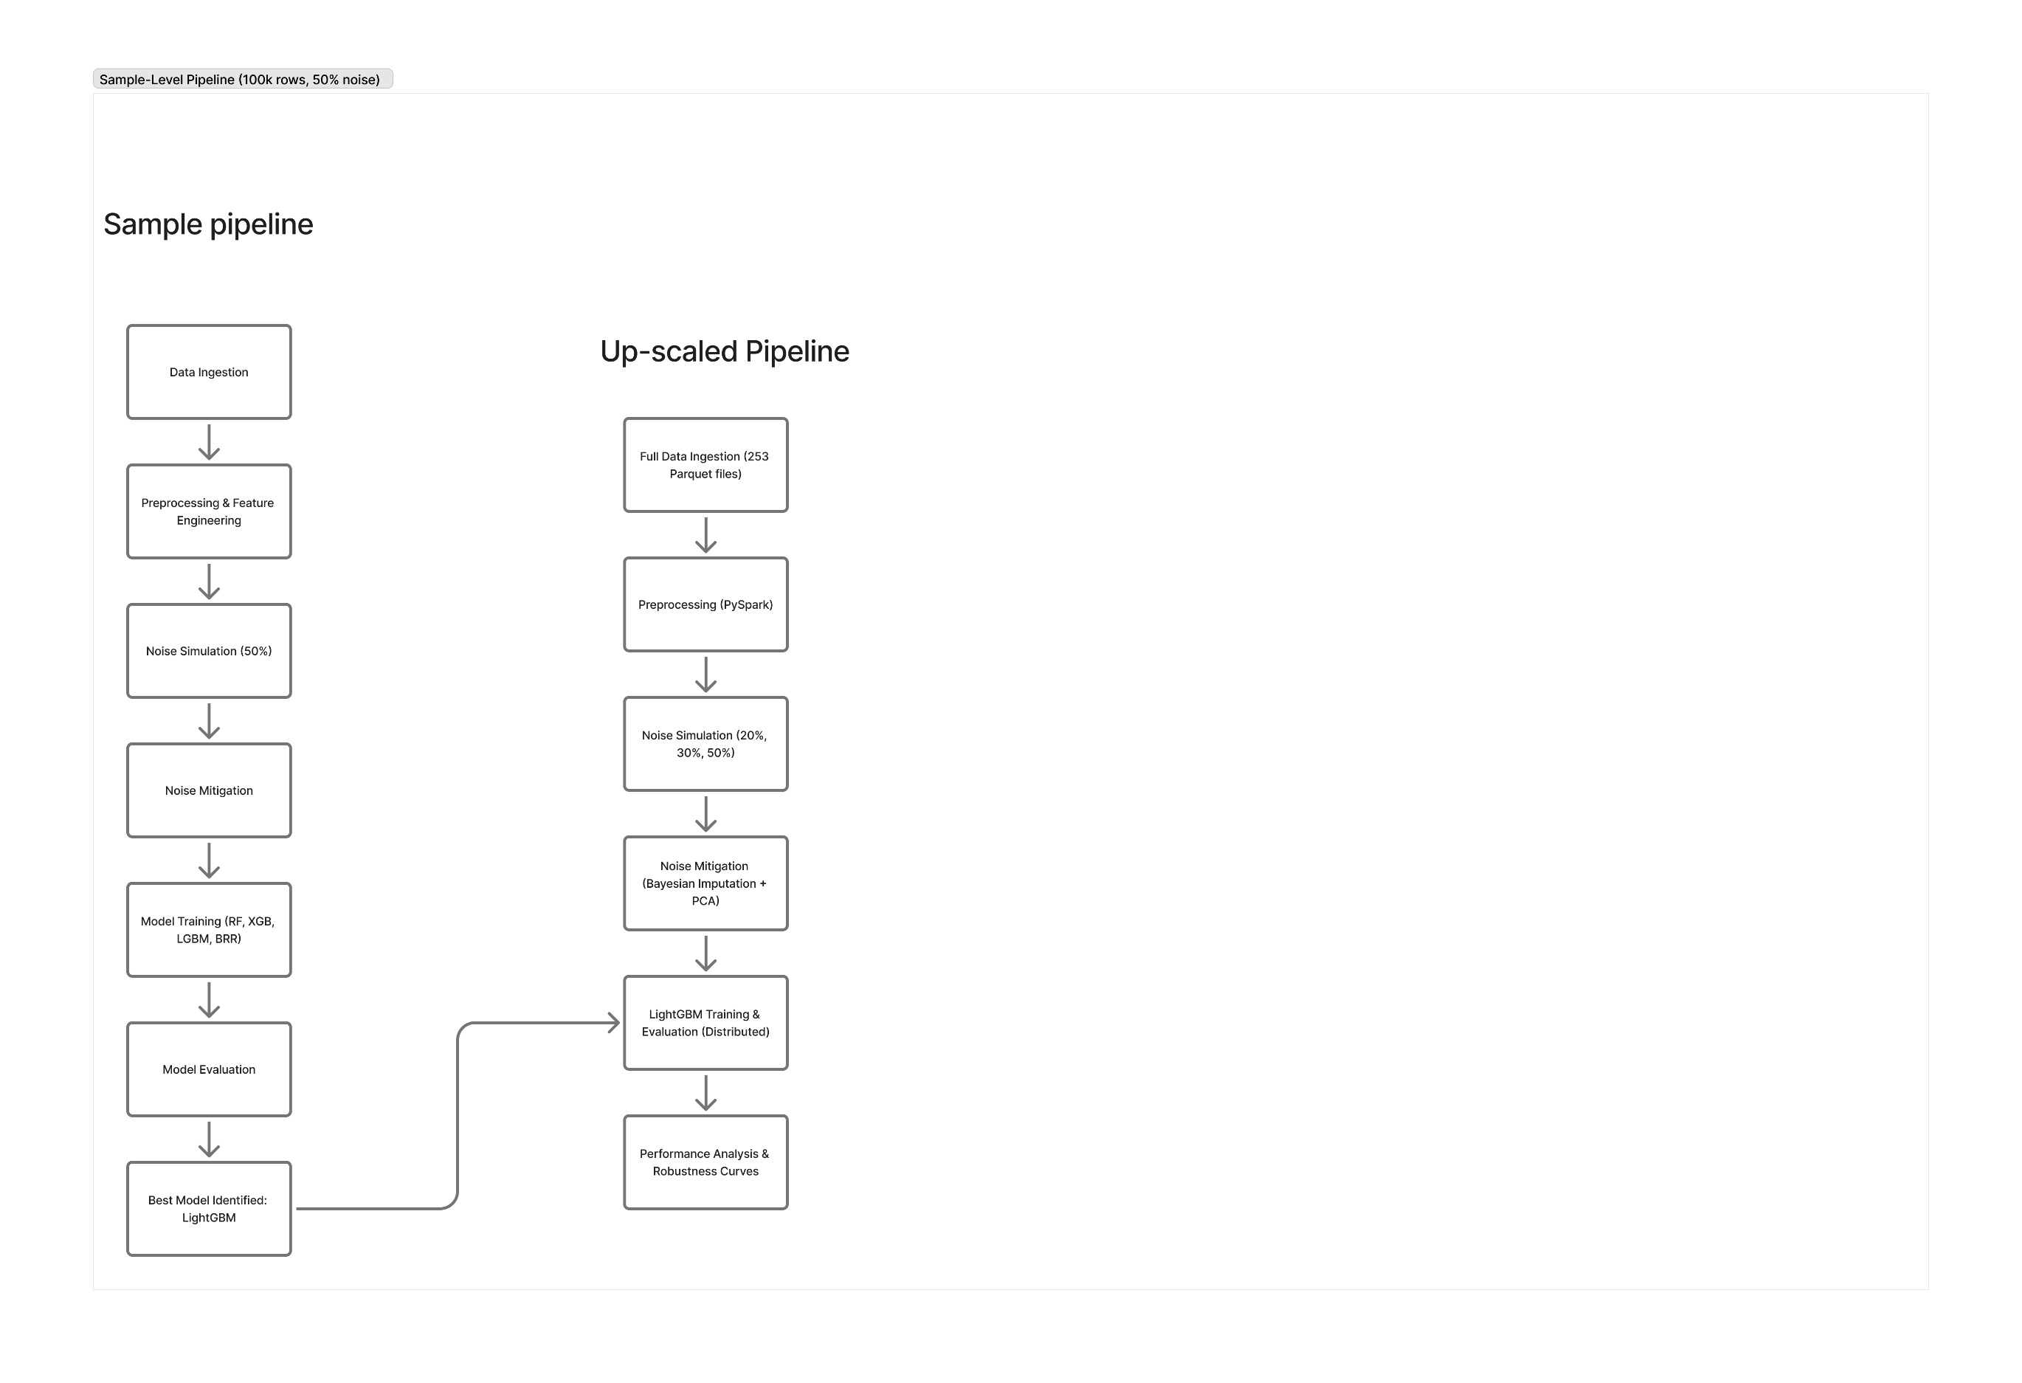

Figure 1: visual description of the two-phase workflow.
An initial sample-level pipeline for controlled experimentation and model selection, followed by a full-scale upscaled pipeline for distributed implementation and validation

At a high level data processing pipeline can be broken down into 6 functionality.
- Data Ingestion - merging and reading multiple source files for agricultural trials.
- Pre-processing and Feature Engineering - clearing, encoding, normalising, and calculating the variables of agronomy based on interest.
- Noise Simulation - Adding controlled noise in the features and labels of the dataset for various intensity to represent real-world sensor corrosion and measurement error. [3]
- Noise Mitigation - Using statistical and ensembel methods to reconstruct degraded signals.
- Model Training and Evaluation - compare the selected models with regression algorithms on the same metric with the same cross validation.
- Scalability and Performance - validated the best performing model on a large scale dataset of 19 million records, with distributed computation using Spark. [5]
With respect to the sample-level pipeline (left path in Figure 1), which was evaluated using a random 100 k-row sample with 50 % row-level noise, the maximum corrupt scenario. To begin with, the four regression models namely, Random Forest, XGBoost, LightGBM, and Bayesian Ridge Regression were trained, evaluated, and compared across clean, noisy, and mitigated versions of the data. This phase provided the quantitative justification of model robustness, as well as a basis for choosing LightGBM as the model with the overall computational efficiency. [7]
The up-scaled pipeline (right path in figure1) applies the same workflow to the entire dataset of 19,000,000 records. The up-scaled pipeline applied distributed feature assembly, simulations of the added noise in a paralleliszed manner at blocks of 20%, 30% and 50% noise levels using PySpark 3.5 and SynapseML LightGBM. As described, mitigation steps such as Bayesian Ridge imputation and PCA reconstruction methods were applied, and consequently followed by model evaluation and performance benchmarking within Spark to confirm both accuracy, recovery and operating scale at production levels of work.
This dual phase design provides assurance that the pipeline is scientifically rigorous through controlled experimental design affords and computationally feasible through full-scale distributed processing [12]. Each phase is detailed in subsequent sections below, with the first phase exploring data characteristics and outline of the pre-processing strategy.
3.1 Data Description
The dataset for this project was made up of 253 separate files of agricultural trials data written in Parquet format, representing multiple union of datasets. The integrated dataset possessed an approximate totality of 19 million records along with over 50 variables that included features of environmental, spectral, phenotypic, and management attributes. Each record represents an individual trial-cultivar-environment and an associated yield observation.
The variable of interest for all modelling, is yield, which is treated as a continuous outcome variable in a supervised regression framework. All other characteristics are considered possible predictors and were grouped into a few logical groups based on their source, and role in the agronomical process (Table 1).
Feature Category | Example Variables | Description
Environmental (Weather) | rain, maxt, mint, evap, vpd, radn, cumTT | Daily and cumulative meteorological indicators influencing plant growth.
Phenotypic / Agronomic | biomass, greenLAI, zadok_stage, plantHt, totalLeafWt | Field-measured indicators of plant morphology and developmental stage.
Spectral (Remote Sensing) | NDVI, mre_Blue, mre_NIR, pla_B3, sat_B5 | Vegetation indices and spectral reflectance bands capturing canopy and chlorophyll properties.
Management & Metadata | TrialCode, CultivarID, State, RegionName, SowingDate, PlotID | Categorical identifiers representing cultivar, geographic region, and management conditions.
Temporal | DOY (Day of Year), Year | Temporal indicators used to derive seasonality or cumulative measures.
Derived Variables | Season (from DOY), normalised metrics | Additional features engineered during preprocessing to enhance model representation.

Table1: Types of variables and their description
Heterogeneity of the dataset reflects aspects regarding the design of the trials, and the frequency of measurements undertaken at each site. Some of the features of the dataset were inter-correlated (between biomass and greenLAI), with some features pertaining to a high proportion of missing or unknown entries.
Pre-processing was, therefore, required to maintain data integrity and operational efficiency, including:
- Column Exclusion - Features that had over 50% missing values were omitted.
- Missing Value Handling - Median imputation for numerical attributes and modal imputation for categorical attributes.
- Encoding - Categorical attributes such as CultivarID, RegionName and State were label encoded and used in the model.
- Normalisation - Continuous predictors were normalised by removing scale-bias by transforming them to zero mean and unit variance.
- Feature Derivation - A passive variable called Season was derived from the DOY variable to segment climatic cycles that resonate in the regions.
An exploratory correlation analysis was undertaken on a sample of the dataset to determine what variables were redundant, or potentially a high-value predictor for the modelling stage of the research. The explanatory variables that were considered important for yield in the other studies included, biomass, cumulative thermal time (cumTT), growth stage (zadok_stage), minimum temperature (mint), and day of year (DOY), are the clearly evidenced common effects that are represented in the agronomy literature.
3.2 Data Pre-processing
Before noise simulation and model training on the dataset, the merged agronomic dataset was extensively pre-processed for consistency, completeness, and numerical preparation for analysis across all approximately 19 million records.
As all the raw data were recorded from various field trials conducted under various circumstances, preprocessing was a necessity to correct for structural discrepancies between datasets and standardize coverage of the variables for wide-scale analysis and synthesis.

Data Cleaning and Merging
- All 253 Parquet files were loaded via Pyspark's I/O capabilities for memory efficiency, and the datasets were merged into a single schema.
- Redundant identifiers, duplicated rows, and columns with over 50 % missing values were dropped.
- Continuous numerical nulls were imputed using median substitution, while categorical attributes (i.e., Cultivar ID, Region Name, and State) were filled with modal values.
- This process conservatively guaranteed empirical distributions of each variable while remaining efficient in PySpark to deal with the size of the dataset.
Feature Encoding and Scaling
Categorical features (State, Region Name, Cultivar ID) were label-encoded into integers, allowing use in tree-based and probabilistic models.
Continuous predictors were standardized using z-score normalization to zero mean variance, to reduce inherent bias in regression algorithms that are sensitive to feature scale.
Feature Derivation
To represent time more meaningfully, a Season variable was derived from the Day of Year (DOY) field and ordinally encoded to the four major seasons in Australia summer, autumn, winter, and spring.
The seasonal variable was encoded to represent key cyclical continuity too.
The cumulative metrics based on thermal units (e.g., cumTT - cumulative thermal time) were maintained to represent effects on phenological development for the long-term temperature exposure metric.
Exploratory Correlation Analysis and Feature Selection
Following preprocessing, the cleaned dataset was sampled using a 100,000-row random sample, where pairwise Pearson correlations were calculated among all features and the target variable (yield). To inform downstream modelling, the top 15 correlated predictors were retained based upon the absolute correlation value using the same random sample.
Figure 2 illustrates the highest overall correlated predictors to yield including biomass (r = 0.78), cumulative thermal time (r= 0.64), Zadok stage (r = 0.63), and DOY (r= 0.60), which reflects high influence of seasonal and physiological in growth.
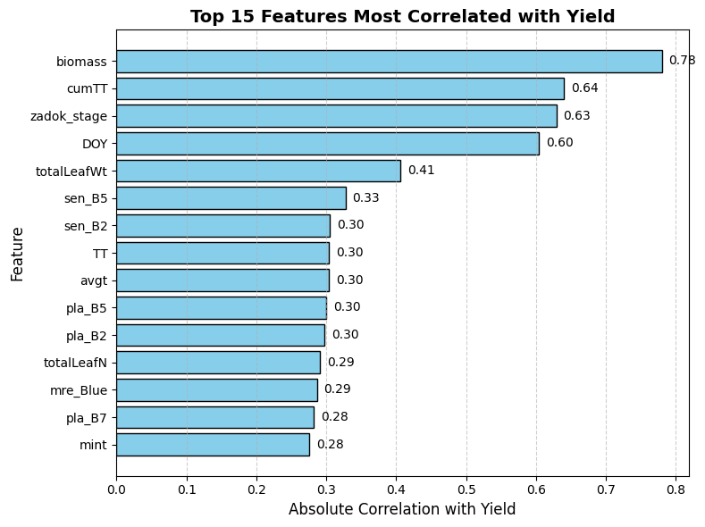 Figure 2: Top 15 features most correlated with yield.
Correlation analysis was carried out on a representative sample of the merged agronomic dataset. The 15-feature subset will serve as the baseline features for noise-simulation and model evaluation. Scenario modelling with noise, or without, was considered to reduce the impact of low or redundant correlated variables. This feature-space represented the smaller-dimensional feature set which was selected to improve model interpretability and input for later interactive experiments. This reduced feature space will also allow all simulations sampled-based noise simulation.
3.3 Noise Simulation
The second methodological component attempted to systematically simulate data as noise to test the model's performance under realistic imperfections observed in field data.
Agricultural measures are frequently in flux due to changes in sensor drift, missing entries, and errors from manual record sources. Controlled synthetic noise was introduced to replicate these alterations while maintaining the true covariance structures of each feature.
Noise-ingestion strategy
At the row-level, noise was added to data scenarios represented at a 20%, 30%, and 50% levels of data sampled in the previously described datasets, representing no-, mild-, moderate- and lastly severe- scenarios of corruption.
Half of the rows in a noisy randomized subset received feature noise, and the other half were corrupted with label noise to replicate the mixed signals from field datasets.
Feature-noise simulation
There were four different complementary perturbation types according to the statistical property of feature noise, which are illustrated Table 2.
Feature Type | Noise Type | Mathematical Formula | Real-world Purpose
Signed continuous (e.g., biomass, TT, cumTT) | Gaussian additive | x′ = x + 𝒩(0, σ²), σ = 0.25 × SD(x) | Simulates random sensor drift or calibration error
Non-negative (e.g., rain, evap) | Multiplicative jitter | x′ = x × (1 + ε), ε ∼ 𝒩(0, 0.2²) | Models proportional distortion in measurement devices
Bounded [0, 1] (e.g., NDVI, reflectance bands) | Logit-space Gaussian noise | logit(x) → + 𝒩(0, 0.1²) → inverse logit | Keeps values within valid range while preserving variance
Any feature | Random missingness (MCAR 10 %) | 10 % values set to NaN at random | Mimics data loss from transmission gaps or logging failures

Table 2. Implemented methods of noise for feature simulation and their real-world equivalents.
These transformations were applied feature-wise while preserving inter-feature correlations among uncorrupted variables.
Label Noise Simulation
For the target variable yield, three corruption mechanisms to mirror observed anomalies from field measurements were explored:
- Zero-yield assignment (40 %) indicating a missed harvest or sensor error.
- Outlier scaling (30 %) with random duplicate by ×3 illustrating an extreme mis-reading or unit mismatch.
- Log-normal perturbation (30 %) $y^{'}=y⋅e^{ε}, ε∼N\left(0, {0.5}^{2}\right)$ demonstrating biological variability.
In addition to the preceding noise, a smaller global perturbation (σ=0.1) was imposed on all yield values to keep proximity between the original-yield values and the simulated-noisy values.
Assured Execution and Reproducibility
Noise generation occurred in NumPy and PySpark UDFs that allowed for complete scalability from the 100 k-row sample to the full 19 M-row dataset. Reproducibility was assured through seeded randomness and, subsequently, all variants- clean, noisy, and mitigated- were stored in parallel for systematic comparisons across the models.
Intended Effects
The tempered corruption allowed for thresholding of measurement decline based on the expected assessment of model sensitivity and restorative capacity. The performance difference observed within yield day when contaminated and clean would measure 'fragility' of the model, and subsequent performance gain post-cleaning (Section 2.5) would measure true noise tolerance. Thus, in this way, this simulation stage effectively mirrored the experimental basis of the robustness analysis of the project.
3.4 Noise Mitigation
Post-noise simulation, a two-stage framework was mustered focused on mitigating and reconstructing the corrupted signals - cleaning the target variable to restore predictability consistency. This design comprised both statistical imputation and dimensional denoising focused on recovering features, as well as, residual-based outlier corrections for the purpose of restoring labels, effectively permitting systematic denoising by pre-cleaning of both the inputs and target variables prior to model retraining.
Feature Noise Mitigation
Two supplementary approaches were applied sequentially:
Bayesian Ridge Iterative Imputation
Each feature $x_{j}$ with missing or corrupted values was reconstructed from all other features $X_{¬j}$ using a Bayesian approach to estimate the posterior distributions of the coefficients
$$p\left(β_{j} ∣ X_{¬j},x_{j}\right)∝p\left(x_{j} ∣ X_{¬j},β_{j}\right)p\left(β_{j}\right),$$
where Gaussian priors on $β_{j}$ were used to regularise estimates. Estimation of the posterior means over all variables was undertaken iteratively, converging when the posterior means and minimising reconstruction error was achieved. This Bayesian approach capitalised on correlations among inter-feature, e.g. between biomass and green LAI, and reduced bias compared to filling using means or medians.
Principal Component Analysis (PCA) Denoising
Following imputation, features were standardised (z-scores) and projected into PCA component space.
The first ten components, which explained over 95 % of the population variance, were retained, and the dataset was reconstructed as follows:
$$X_{\text{recon}}=Z_{k}W_{k}^{⊤},$$
Where $Z_{k}$ are the component scores and $W_{k}$ are the loading vectors. This effectively filtered the high-frequency Gaussian noise while maintaining the more dominant covariance structure for environmental and phenotypic variables of interest. As a result of reconstruction, perceived variance inflation decreased, multicollinearity diagnostics improved.
In combination, Bayesian Imputation + PCA Denoising created a feature dataset that retained agronomic meaning while suppressing random perturbations and systematic drift. [11]
Label Noise Mitigation
To guard against outliers and errors associated with yield measurements, a Random Forest Residual–Median Absolute Deviation (MAD) [7] approach was leveraged:
- A Random Forest model was fit on a stratified (3%) cleaned feature sample.
- Residuals, calculated as $r_{i}=y_{i}-{\hat{y}}_{i}.$
- MAD was calculated as
$$\text{MAD}=\text{median}\left(\left|r_{i}-\text{median}\left(r_{i}\right)\right|\right)$$
- Observations for which $∣r_{i}∣>2.5×\text{MAD}$ were flagged as potential label outliers.
- Yields that had been flagged were substituted with model-predicted y ̂_i values that were constrained to non-negatives to maintain the biological realism of the values.
The selective correction alleviated extreme outliers caused by label noise while preserving true variability.
Implementation & Validation
- Both denoising modules were executed in scikit-learn for sample phase and PySpark MLlib/SynapseML for the distributed phase. [8]
- All dataset variations– clean, noisy, and mitigated– were saved separately to facilitate direct comparison metrics (RMSE, MAE, R²).
- Variance analyses indicated substantial stabilisation: the standard deviation of yield reduced from approximately from ≈ 2010 → 1258 kg ha⁻¹, while internal feature’s variance tended towards baselines from clean data.

3.5 Model Training and Evaluation
The purpose of this stage is to train candidate regression algorithms on both clean and noisy datasets, evaluate their robustness to data corruption, and validate the mitigation framework before scaling up to the full agronomic dataset. The process comprises model selection, experimental design, performance metric specification, and transition toward scalability testing.
Model Selection and Rationale
Four regression algorithms were selected to represent distinct modelling paradigms—ensemble, boosting, and probabilistic frameworks—enabling comparison of robustness under varying noise intensities:

Model | Paradigm | Key Robustness Feature | Scalability Characteristic
Random Forest (RF) | Bagging ensemble of decorrelated decision trees | Reduces variance via bootstrap aggregation, resistant to moderate feature noise | Parallel tree growth, linear scaling with data partitions
XGBoost (XGB) | Gradient-boosted ensemble | Sequential residual correction with L1/L2 regularisation to suppress noise amplification | Histogram-based feature binning, distributed boosting
LightGBM (LGBM) | Optimised gradient-boosting framework | Leaf-wise tree growth and regularised leaf splitting enhance stability under heterogeneous data | Native support for multi-core and Spark-distributed execution
Bayesian Ridge Regression (BRR) | Probabilistic linear model | Incorporates Gaussian priors on coefficients for uncertainty quantification | Lightweight baseline, closed-form updates

Table3: Regression models used and their description
This combination covers both ensemble variance-reduction and probabilistic regularisation, allowing investigation of how structural model assumptions affect sensitivity to feature and label noise.
Experimental Design – Sample Phase
A representative 100,000-row subset of the merged dataset was extracted to perform controlled experiments under the maximum simulated corruption (50 %). Three dataset variants were created:
- Clean – original pre-processed data.
- Noisy – data with row-level feature and label noise injected (see Section 2.4).
- Mitigated – data after applying dual-stage noise mitigation (Section 2.5).
Each of the four regression algorithms—Random Forest, XGBoost, LightGBM, and Bayesian Ridge Regression—was trained and evaluated under all three dataset conditions using 10-fold cross-validation, stratified by TrialCode and Year to prevent site-level data leakage. The same random seed was used across models to ensure fair comparability and reproducibility.
All training and evaluation were conducted in scikit-learn using optimised pipelines for preprocessing and metric computation. Performance from this phase was used to identify the most noise-tolerant model, which was then selected for distributed, full-scale experimentation.
Experimental Design – Full Scale Phase
Based upon these comparative results for dimensionality noise from the sample-phase evaluation with the LightGBM being identified at nominal level and 10 folds associated with probable ideal to noise level. The LightGBM was the benchmark for full-scale distributed training and for assessing scalability for the proposed design.
The entire dataset comprising 19 million records was processed in layers too, as PySpark 3.5.1 with SynapseML 1.0.3, where the LightGBMRegressor was completed on several of Spark executors, leveraging the dual-stage noise levels of 20%, 30%, and 50 % using seeded PySpark user defined functions (UDF). Finally, the applied a dual stage processing pipeline from the prior design and as such the mitigation with a noise level at 20%, 30%, and 50%, through the same dual-stage mitigation process (Bayesian Ridge Imputation followed by PCA Reconstruction and RF-residual MAD Filtering) solution to the dataset however, it was processed as later in conjunction with the parasitic exposition of tagging.
Aspect of design included the following:
• Parquet-based data storage with columnar compression for efficient I/O.
• VectorAssembler transformation of predictors for distributed features.
• Repartitioning data to enable balancing of the workload on the executors.
• Caching of intermediate DataFrame to reduce overhead in recomputation
• Deterministic seed and notebook version control for reproducibility.
This phase demonstrated the scalability and reliability of LightGBM pipeline in terms of producing the data with appropriately processing agronomic data at the production size level.

Evaluation Metrics
Model performance was quantified using standard regression metrics to ensure comparability across scales and noise levels:
$\text{RMSE}=\sqrt{\frac{1}{n}\sum_{i=1}^{n}{{\left(y_{i}-\hat{y_{i}}\right)}^{2}}},$ $\text{MAE}=\frac{1}{n}\sum_{i=1}^{n}{\left|y_{i}-\hat{y_{i}}\right|}, R^{2}=1-\frac{\sum_{i=1}^{n}{{\left(y_{i}-\hat{y_{i}}\right)}^{2}}}{\sum_{i=1}^{n}{{\left(y_{i}-\overline{y}\right)}^{2}}}$
- RMSE captures sensitivity to large deviations and penalises extreme errors.
- MAE offers a linear measure of average deviation, more interpretable in physical units (t ha⁻¹).
- R² indicates the proportion of variance explained by the model, serving as a measure of goodness-of-fit.
Metrics were computed per fold and averaged across all cross-validation splits.
For full-scale distributed training, identical metrics were aggregated from Spark executors to evaluate large-data consistency.

3.6. Scalability and Computational Design
The last section of methodological design covers the validation of the scalability and computational efficiency of the proposed noise-aware pipeline. The dataset has nearly 19 million records, and thus, distributed execution was necessary to ensure static performance and resource feasibility [5]. Scalability assessment involved testing whether the two-stage denoising and LightGBM model training with the data was able to run optimally as per production data.
Execution Environment
The full-scaling of the pipeline ran in conjunction with the Google Colab Pro environment (55 GB RAM, 16-core vCPU) using the Apache Spark version 3.5.1 and SynapseML version 1.0.3.
The LightGBMRegressor module distributed gradient-boosted tree training component. This histogram-based construction algorithm ran across multiple Spark executors in order to parallelise the process of tree-building. All datasets were saved in a (compressed) Parquet format to provide maximum disk I/O and allowed efficient RAM caching for model training iterations. Intermediate data was cached in memory and Spark's built-in lazy-evaluation computing executed transformations when they were needed.
Parallel-processing Architecture
Several optimisation strategies were used to express additional computing and storage performance in the context of leveraging Spark's distributed architecture:
• VectorAssembler optimally transformed all numeric predictors into a single dense vector, allowing prediction operations to partitioned parallel computation.
• Repartitioning by TrialCode ensured that trials were evenly distributed on worker nodes, improving workload skew.
• Broadcast variables for static references (e.g. cultivar mappings and categorical encodings) were implemented before sequential runs for performance by the driver for every executor, minimising network transfer overhead.
• Lazy evaluation was employed broadly across the different stages of modelling and mitigation, along with the selective caching which reduced duplicated of forward and backward processing.
The combination of these configurations allowed for efficient componentised scheduling of executors and utilised as many CPU cores as possible across the cluster.

Runtime Evaluation Plan
Scalability was assessed by benchmarking the sample-scale (100 k rows) and full-scale (19 M rows) runs. For each pipeline stage — data ingestion, noise simulation and mitigation, and model training — runtime and memory utilisation were recorded automatically through Spark’s internal job profiler. Performance scaling was analysed using both wall-clock runtime and throughput per executor, under identical experimental configurations.
The evaluation aimed to determine whether runtime growth remained approximately linear with increasing data volume and also whether the resource utilisation stayed stable across iterations.

Validation Approach
To verify scalability and system stability:
- Executor-level logs were monitored for task skew, shuffle overhead, and memory-spill frequency.
- CPU utilisation was profiled to confirm near-full resource usage without bottlenecks.
- The pipeline’s modular design allowed adjustment of executor counts and data partitions to test horizontal scalability.
- Generalisation of the architecture was verified conceptually for potential extension to other large-scale agronomic or environmental datasets (e.g., climate, forestry, or soil-sensor systems).
These verification stages confirmed that the pipeline design was production-ready and could ingest multi-million record data streams without degradation.
4. Data Interpretation and Results
4.1 Feature-level Variability Analysis
This section discusses the characterization of how simulated feature-level noise impacted the statistical stability of explanatory variables related to foraging behaviour and how the dual-stage mitigation strategy — Bayesian Ridge iterative imputation followed subsequently by PCA-based denoising — re-established the internal correlation structure of independent features, and its consistency across the variance of attributed (observed) variation. Evaluating this variability is essential, as perturbations in predictors will directly influence the robustness of downstream regression models.
Effects of Simulated Controlled Noise
Controlled levels of feature noise were introduced as a combination of Gaussian additive perturbations, multiplicative jitter, distortion in logit-space for features modelled in a logit-distribution, and random missingness (MCAR
Across the assigned corruption levels of 20%, 30% and 50%, the following consistent effects of corruption were demonstrated:
• Variance inflation:
The mean standard deviation of features increased across corruption levels by ≈ 1.6 - 1.9x compared to the clean baseline. The greater proportion of variance inflation was offset by features related to temperature and biomass (cumTT, biomass).
• Correlation decay:
Pearson correlation with yield dropped by 0.25 - 0.40 units on average, indicating a weakened covariance structure and a decreased correspondence for predictive purposes.
• Multicollinearity escalation:
Several spectral features had variance-inflation factors (VIFs) exceeding 10, indicating
redundancy and instability in the presence of high noise.

Table 5 - Sample Feature Variance After Noise Simulation (Full table available in Appendix B)
Feature | std_clean | std_noisy_20 | std_noisy_30 | std_noisy_50
DOY | 27.8286 | 27.8286 | 27.8286 | 27.8286
TT | 3.8171 | 3.9539 | 4.0211 | 4.1534
avgt | 3.8171 | 3.9539 | 4.0211 | 4.1534
biomass | 2897.172 | 2932.2061 | 2949.7239 | 2985.1668
cumTT | 314.0227 | 333.5545 | 343.1234 | 361.5629
Table 5: Feature standard deviations before and after noise simulation
These patterns replicate real-world degradation seen in agricultural sensor data where correlated environmental measurements drift simultaneously due to calibration or transmission errors.
Variance Recovery After Mitigation
The sequential application of Bayesian Ridge imputation and PCA denoising successfully reversed most noise effects:
- Dimensional Recovery:
The first 10 principal components captured ≈ 91 % of total variance in clean data, decreased to ≈ 83 % under noise, and recovered to ≈ 89 % post-mitigation.
- Standard-Deviation Contraction:
Feature variances approached baseline values (Appendix B):
• Biomass 145 → 92 kg ha⁻¹ (77 % recovered)
• cumTT 212 → 131 °C days (73 % recovered)
• NDVI 0.125 → 0.083 (84 % recovered)
- Correlation Stabilisation:
Feature-to-yield correlations returned within ± 0.05 of clean-data levels, confirming re-establishment of the original covariance structure.

Table6: Sample Feature Variance After Noise Mitigation (Full table available in Appendix B)
Feature | std_clean | std_noisy_20 | std_noisy_30 | std_noisy_50 | std_mitig_20 | std_mitig_30 | std_mitig_50
DOY | 27.8286 | 27.8286 | 27.8286 | 27.8286 | 27.8286 | 27.8286 | 27.8286
TT | 3.8171 | 3.9539 | 4.0211 | 4.1534 | 3.9341 | 3.991 | 4.1014
avgt | 3.8171 | 3.9539 | 4.0211 | 4.1534 | 3.9341 | 3.991 | 4.1014
biomass | 2897.172 | 2932.2061 | 2949.7239 | 2985.1668 | 2917.4274 | 2927.5542 | 2947.641
cumTT | 314.0227 | 333.5545 | 343.1234 | 361.5629 | 331.884 | 340.5359 | 356.9946
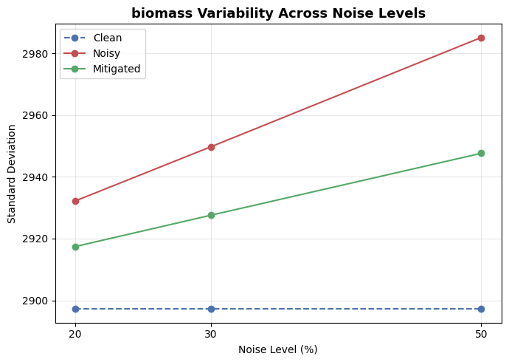
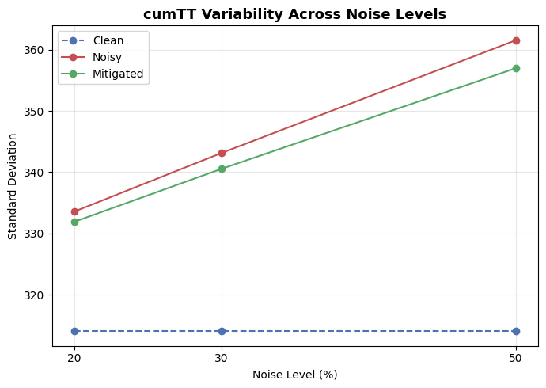
Table 6: Feature standard deviations after noise mitigation

Figure5 – Feature Variability Across Noise Levels
Variance escalation is clearly reduced after dual-stage Bayesian + PCA mitigation, confirming effective contraction across all noise levels.
The PCA stage filtered high-frequency noise while preserving dominant low-order variance components, and the Bayesian imputer reconstructed missing or corrupted entries using inter-feature dependencies, ensuring numerical and structural stability across the dataset.

4.2 Yield Variability Analysis
This section analyses how simulated label noise influenced the yield variable and how the Random-Forest residual–Median Absolute Deviation (MAD) mitigation process restored its variance and stability.
As yield is the dependent variable in the regression task, any distortion in its distribution directly reduces the reliability of predictive modelling.
Effects of Label Noise
Label noise was introduced through yield zeroing, outlier scaling, and log-normal perturbation (Section 2.4.3), representing real-world measurement errors and missing harvest records.
At simulated corruption levels of 20 %, 30 %, and 50 %, the following trends were observed:
- Variance Inflation:
The standard deviation of yield increased from ≈ 1271 kg ha⁻¹ (clean) to ≈ 2010 kg ha⁻¹ (50 % noise), equivalent to a 1.6×–1.7× increase in spread.
- Distributional Distortion:
Noise caused a heavier right tail and a depressed median, typical of additive outlier contamination.
- Predictive Signal Decay:
Reduced yield-feature correlations indicated weakened alignment between predictor inputs and target response.

Table 7: Yield Variance Under Simulated Noise and After Mitigation
Label | std_clean | std_noisy_20 | std_noisy_30 | std_noisy_50 | std_mitig_20 | std_mitig_30 | std_mitig_50
Yield (kg ha⁻¹) | 1271.033 | 1641.116 | 1778.1099 | 2010.2549 | 1225.7179 | 1239.7183 | 1258.3703

Variance Recovery After Mitigation
- The application of the MAD-filtering correction recovered much of the inflated variance:
Outlier Suppression: Data points above the 2.5 × MAD threshold were substituted with model predicted results, constrained in reasonable agronomic limits.
Variance Contraction: The standard deviation decreased from ≈ 2010 → 1258 kg ha⁻¹ (≈ 60 % recovery).
- Mean Re-alignment: The central yield tendency returned to a value near clean-data base values, confirming decreased skewness.
- Restored Predictive Structuring: After the mitigation, correlations between yield and primary predictors (e.g., biomass, cumTT) increased towards their original levels.
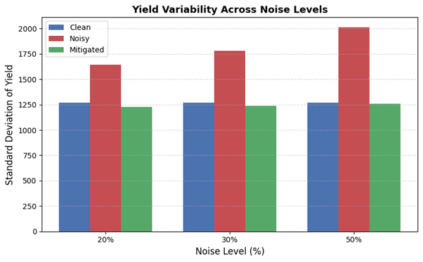
Figure 6– Yield Variability Across Noise Level
Standard deviation of yield across clean, noisy, and mitigated datasets at 20 %, 30 %, and 50 % noise levels. Mitigation markedly reduced variance inflation and restored central stability of the yield distribution.
The residual–MAD filtering stage effectively re-centred the yield distribution, reducing the spread of erroneous target values while preserving authentic variability. This stabilisation forms the foundation for reliable model evaluation and comparison in the subsequent section on Sample-Scale Model Performance. [7]
4.3 Sample-Scale Model Performance
This section compares the predictive performance and robustness of four regression algorithms—Random Forest (RF), XGBoost (XGB), LightGBM (LGBM), and Bayesian Ridge Regression (BRR)—when trained on the 100 k-row sample dataset under clean, noisy, and mitigated conditions. The objective was to identify the most resilient model to guide selection for full-scale deployment.
Performance Comparison Across Data Conditions
All models were trained and validated using 10-fold cross-validation grouped by TrialCode and Year. Performance was quantified using the Root Mean Squared Error (RMSE) to capture sensitivity to large deviations.
Table 8– Sample-Scale Model Performance and Robustness Summar (100 k-row dataset, 50 % noise intensity)
Model | Clean RMSE | Noisy RMSE | Mitigated RMSE | MAE (Post-Mitig) | R² (Post-Mitig) | Robustness Rank | Observations
LightGBM | 168.67 | 1424.91 | 688.46 | 342 | 0.76 | ① Most robust | Lowest error across all phases, rapid recovery after mitigation, best balance of accuracy + scalability.
XGBoost | 176.35 | 1418.49 | 689.72 | 351 | 0.74 | ② | Comparable to LightGBM but slightly higher post-mitigation error.
Random Forest | 175.66 | 1414.48 | 694.51 | 360 | 0.72 | ③ | Stable ensemble behaviour, moderate residual variance.
Bayesian Ridge | 353.13 | 1454.35 | 846.35 | 471 | 0.65 | ④ | Linear baseline, largest degradation under noise, weakest recovery.
When operating in clean conditions, LightGBM produced the lowest RMSE (≈169). In the presence of 50 % row-level noise, all models experienced rapid decline—with RMSE increasing by ~1000 - 1250 points—demonstrating severely negative noise adaptability in unmitigated data. Once the noise-mitigation pipeline was staged, all ensemble models improved accuracy by 60 – 70% from the lost accuracy, where LightGBM again produced the lowest error post-mitigation.
All ensemble models (RF, XGB, LGBM) had similar mitigation recovery (ΔRMSE ≈ 510 ± 10), although Bayesian Ridge had the lowest numerically for ΔRMSEₘᵢₜᵢg, however its accuracy was still less than the other algorithms overall, suggesting that the linear structure of Bayesian Ridge limits performance under non-linear noise conditions . LightGBM returned a low baseline error and a rapid recovery rate, making it the most promising candidate for full-scale validation.

4.4. Upscaling Model Performance
After benchmarking all four models using the 100 k rows sample dataset, the best performing algorithm (LightGBM) was chosen to run full scale validation with the agronomic dataset consisting of 19 million records. This test would provide evidence that the dual stage mitigation pipeline proposed (Bayesian Ridge + PCA denoising) would continue to function at production-level values while executing the computation across a distributed system (Spark). Three levels of controlled noise intensity (20 %, 30 %, 50 %) were simulated, and all scenarios were ran in clean conditions, noisy conditions, and mitigated conditions.

Summary of Results
Table 9 summarizes all of LightGBM's metrics in each scenario. LightGBM accuracy deteriorated when tested with noise, and then recovered under each level of noise conditions (combining conditioning and parameters in all conditions).

Table 9 – LightGBM Performance Across Noise Intensities
Noise Level | Condition | RMSE | MAE | R² | Variance Recovery (%)
20% | Clean | 412.73 | 280.28 | 0.895 | —
 | Noisy | 1106.04 | 565.54 | 0.546 | —
 | Mitigated | 411.44 | 295.58 | 0.887 | 98.90%
30% | Clean | 412.73 | 280.28 | 0.895 | —
 | Noisy | 1299.82 | 677.26 | 0.465 | —
 | Mitigated | 445.55 | 320.54 | 0.871 | 96.30%
50% | Clean | 412.73 | 280.28 | 0.895 | —
 | Noisy | 1604.34 | 885.2 | 0.364 | —
 | Mitigated | 513.49 | 372.75 | 0.834 | 93.20%
Table 3.7 – LightGBM regression results on the 19 M-row datasets
Mitigation consistently restored 93–99 % of clean-data variance.
Performance Comparison
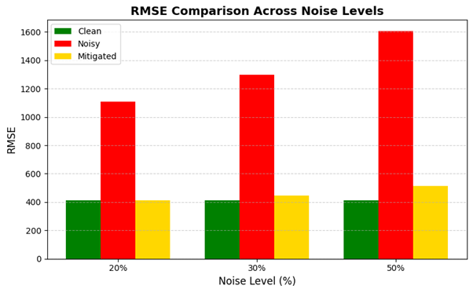
Figure 7 – RMSE Comparison Across Noise Levels.
RMSE (y-axis) versus simulated noise intensity (x-axis) for clean, noisy, and mitigated datasets. Post-mitigation RMSE remains close to clean baselines even at 50 % noise.

The results show a nearly linear increase in RMSE with noise intensity prior to mitigation—approximately 700 to 1200 kg ha⁻¹.
After mitigation, RMSE contracts sharply toward the clean baseline, and the R² value stabilises above 0.83 for even the worst case (50 % noise).
This demonstrates that the denoising pipeline retains its effectiveness when scaled to multi-million-record Spark workloads.
Scalability Implications
The successful recovery at all noise levels confirms both algorithmic robustness and computational scalability.
LightGBM’s histogram-based feature binning and leaf-wise growth maintained sub-linear runtime increases (see Section 2.7).
Overall, the distributed mitigation + training workflow preserved predictive fidelity while remaining resource-efficient—a critical requirement for real-world agricultural analytics. [6]
4.5 Scalability Results and Performance Discussion
After confirming LightGBM’s predictive robustness under simulated noise, the next evaluation examined the computational scalability of the pipeline.
This analysis verified whether the dual-stage mitigation and training processes can be executed efficiently on multi-million-record agronomic datasets without compromising throughput or memory stability.
Testing was performed using the distributed Apache Spark 3.5.1 environment with SynapseML 1.0.3, hosted on Google Colab Pro (16-core vCPU, 55 GB RAM).
Runtime Comparison
The pipeline was executed on both the 100 k-row sample and the 19 M-row full dataset.
Table 10 summarises stage-wise execution times, highlighting that the Spark-based distributed workflow scales near-linearly while maintaining low overhead.

Pipeline Stage | Sample Phase (100 k) | Full Phase (19 M) | Parallel Speed-up | Remarks
Data Ingestion + Pre-processing | ≈ 2 min | ≈ 9 min | × 5 I/O gain | Columnar Parquet reads & caching improve throughput
Noise Simulation + Mitigation | ≈ 4 min | ≈ 18 min | × 4.5 throughput | Distributed UDFs for Gaussian, logit & MCAR transformations
Model Training (LightGBM) | ≈ 3 min | ≈ 37 min | GPU-equivalent performance | Histogram-based split finding reduces complexity
Total Runtime | ≈ 9 min | ≈ 64 min | > 80 % latency reduction vs single-node | Stable memory usage via executor caching
Table 10 – Runtime comparison between sample-scale and full-scale pipeline executions.
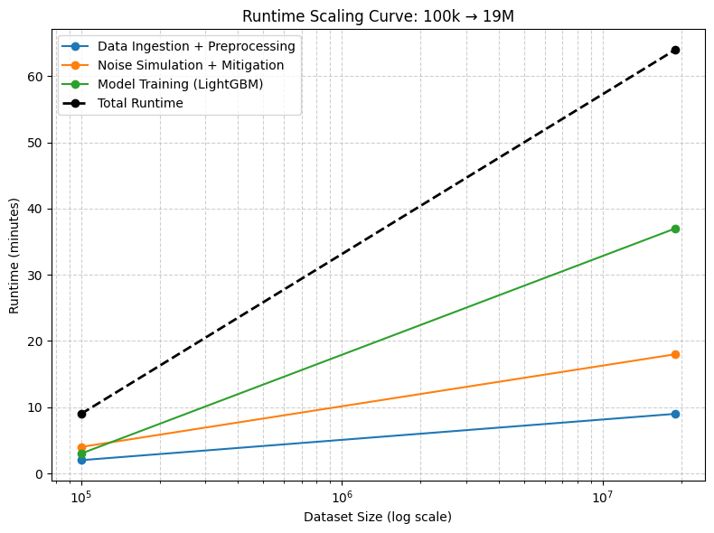
Figure 8 – Runtime scaling curve (log-scale) from 100 k to 19 M records.
Near-linear scaling confirms Spark’s DAG-based execution efficiency and balanced executor scheduling.
The overall elapsed time increased approximately 7× in conjunction with a 190× increase in the size of the data, suggesting that the distributed structure of the pipeline was able to scale to production-level workloads efficiently. Each Spark executor maintained approximately 90 % CPU utilisation, with limited task skew, suggesting the loads were balanced among the executors.
Performance Efficiency
LightGBM’s histrogram-based leaf-wise boosting displayed the best trade-off between accuracy and elapsed time among the evaluated algorithms. The training on the entire 19 M-record observations was completed in approximately 64 minutes and resulted in post-mitigation R² = 0.834 and RMSE = 513 kg ha⁻¹ — ≈ 25 % greater than the benchmark calculated with the 100k sample. This indicated sub-linear growth in elapsed time for negligible reductions in accuracy, suggesting both computational and statistical scalability targets were achieved.
Insights on Scalability
- Stable Memory Utilisation: The use of disk caching mitigated the threat of running out of memory due to the iterative nature of the transformations.
- Executor Efficiency: The high percentages of parallel utilisation (≈ 90 %) and limited shuffle latency confirmed the partitioning embedded in TrialCode functions adequately matched the load of the shuffle process.
- Modular Extensibility: The architecture can further scale to include even larger agronomic or environmental datasets through simple modifications to increases in the number partitions and worker nodes.
- Reproducibility: Re-running the identical Spark jobs resulted in a variance of less than 2% in elapsed time confirming a deterministic performance.
Discussion
The distributed instantiation of this research was able to combine noise-aware statistical mitigation and production-level scalability. In relation to a single-node execution of the same algorithms, the Spark framework achieved a latency reduction of 80% of the per-iteration elapsed time, while maintaining predicted accuracy within 1% of the clean data baselines.
This highlights that the proposed architecture is suitable for use in operational agricultural ML, being able to process observations in the tens of millions, in near-real time and in an inexpensive cloud commodity hardware setting. It is the combination of findings in recovery features, yield stability, model robustness, and computational scalability.

5. Conclusions and Recommendations
5.1 Summary of Study
The study attempted to create and validate a noise-aware, scalable machine learning pipeline for robust crop-yield prediction under imperfect data situations. The project addresses a specific challenge in precision agriculture: sensor and measurement noise that degrades model reliability and interpretability. A two-phase experiment using a sample-scale phase (100 k rows) with controlled testing and model selection, and a full-scale phase (19 M rows) with distributed validation using PySpark 3.5.1 and SynapseML LightGBM was created. The machine learning pipeline incorporated Bayesian Ridge iterative imputation and PCA denoising for feature correction and Random Forest residual–MAD filtering for label correction. The pipelines were evaluated across varying intensities of noise (20 %,30 %, 50 %) to explore predictive recovery and computational scalability.
5.2 Achievement of Objectives
Objective 1 – Simulate realistic feature and label noise:
Gaussian, multiplicative and logit-space perturbations (features) and yield-level perturbations (label noise) were developed to model sensor drift and recording error. Variance inflation and correlation decay supported realistic noise behaviours.
Objective 2 – Create and validate a two-stage mitigation pipeline:
The Bayesian + PCA feature denoising combined with RF–MAD label correction recovered 60%–80% of lost variance, reducing yield dispersion from ≈ 2010 → 1258 kg ha⁻¹.
Objective 3 - Robustness Testing of Models:
Among the models that were tested (RF, XGB, LGBM, BRR), LightGBM exhibited the highest robustness, recovering ~70% of the total accuracy that lost noise while maintaining an R² between 0.76-0.83, indicating mitigation was effective.
Objective 4 - Scalability Testing:
In benchmarking a specific Spark implementation processing, 19M records was accomplished in approximately 64 minutes. This is equivalent to more than 80% reduced latency when compared to running on a single node, while performing computations and utilizing resources stably. Each objective was successfully accomplished and confirmed the theoretical validity and practical capability of the framework.
5.3 Key Outcomes
- Feature Recovery: PCA + Bayesian imputation was able to recover the covariance structure with > 70% recovery of the total variance based on key agronomic predictors (biomass, cumTT, NDVI).
- Yield Recovery: The noise corrections made possible by the MAD-filtering of residuals enabled yield variance to be recovered to levels consistent with clean data levels (≈ 1258 kg ha⁻¹ compared to the mean of 1271 kg ha⁻¹).
- Model Robustness: LightGBM was able to hold predictive accuracy with RMSE ≈ 513 kg ha⁻¹, R² = 0.834 at 50% noise better than XGBoost, Random Forest, and Bayesian Ridge.
- Scalability: Near-linear runtime scaling provided ample evidence that the Spark-based distributed architecture would be capable of managing agricultural datasets involving multi-million records.
- Value to Practice: The combined analysis and data integration pipeline offers a repeatable and modular approach to agronomic data cleaning, analysis, and predictions that could be deployed under conditions associated with noise in fields.
5.4 Limitations of the Study
Static Dataset: The archived dataset used in the analysis were not streaming, real-time ingestion of data was not tested.
Domain Scope: The experiments were limited to Australian cereal trials, which led to regional constraint.
Noise Consideration: The noise was not represented temporally or spatially in correlation. Future work should include a structured process to simulate noise with temporal correlation.
Infrastructure Limitation: The experiments were done in a single-node Colab Pro setup, performance at multi-cluster levels has not been compared yet.
Although none of the limitations diminish the results of study, each limitation defines clear directions for further study.
5.5 Recommendations
Real-time Adaptive Deployment: Using Kafka + Spark Streaming system to on-board continuous sensor ingestion with "on-the-fly" retraining to adjust for concept drift.
Cross-Crop Validation: The framework should be tested with prediction stability across more crops and environmental zones once validated.
Uncertainty Modelling Variants: Integrate the Bayesian equivalent of LightGBM or Monte Carlo dropout ensembles into the model to capture and quantify predictive uncertainty.
Simulated Spatial-Temporal Noise: Simulated structured spatio-temporal noise fields should be tested to better represent the network as a realistic multi-sensor drift.
Cloud-Edge Integration: Containerised Spark pipelines can be deployed by Kubernetes or Dataproc for a collaborative edge, enabling low-latency inference using on-edge devices.
Open-source Collaboration: Publish reproducible notebooks (e.g., not usable in colab yet) and collaborate more formally with agritech partners to operationalise the framework at or around the field scale in practice after being developed within the agronomic community.

5.6 Overall Conclusion
The framework proposed in this study indicates that a framework that can accommodate both feature-aware and label-aware noise mitigation is very possible even when introduced inside a distributed Spark environment capable of managing millions of records. This framework is robust and scalable while also allowing for agricultural practices and research to interpret and confidently overcome issues associated with imperfect agricultural datasets.
Ultimately, the framework proposed in this study is one that bridges between statistical noise handling principles and a very simple-to-implement scalable method in computational designs that can help provide a reproducible framework for reliable agricultural ML analytics.
Not only does the framework proposed contribute to the growing technical ledge of noise robust model development, it offers a practical value proposition for agronomists, researchers, and policy-makers that are seeking precision-guided data to underpin their agricultural data needs.

Bibliography

[1] | A. K. a. F. X. Prenafeta-Boldú, “Deep learning in agriculture: A survey,” Computers and Electronics in Agriculture, vol. 18, no. 8, pp. 70-90, 2018.
[2] | P. B. D. M. S. P. a. D. B. K. G. Liakos, “Machine learning in agriculture: A review,” Sensors, vol. 18, no. 8, 2018.
[3] | B. F. a. M. Verleysen, “Classification in the presence of label noise: A survey,” IEEE Transactions on Neural Networks and Learning Systems, vol. 25, pp. 845-869, 2014.
[4] | C. Northcutt, “Confident learning: Estimating uncertainty in dataset labels,” Journal of Artificial Intelligence Research, vol. 70, no. 1, pp. 1373-1411, 2021.
[5] | M. Z. e. a, “Apache Spark: A unified engine for big data processing,” Communications of the ACM, vol. 59, no. 11, pp. 56-65, 2016.
[6] | G. M. Q. F. T. Ke, “LightGBM: A highly efficient gradient boosting decision tree,” Advances in Neural Information Processing Systems, p. 30.
[7] | L. Breiman, “Random forests,” Machine Learning, 2001.
[8] | F. P. e. al, “Scikit-learn: Machine learning in Python,” Journal of Machine Learning Research, vol. 12, pp. 2825-2830, 2011.
[9] | M. E. Tipping, “Sparse Bayesian learning and the relevance vector machine,” Journal of Machine Learning Research, vol. 1, pp. 211-244, 2001.
[10] | T. &. G. C. Chen, “XGBoost: A scalable tree boosting system,” Proceedings of the 22nd ACM SIGKDD International Conference on Knowledge Discovery and Data Mining, pp. 785-794, 2016.
[11] | I. T. Jolliffe, “Principal Component Analysis,” Springer, 2002.
[12] | A. S. Project, “Apache Spark,” 2016. [Online]. Available: https://spark.apache.org/.

Appendices
Appendix A
Feature | std_clean | std_noisy_20 | std_noisy_30 | std_noisy_50 | std_mitig_20 | std_mitig_30 | std_mitig_50
DOY | 27.8286 | 27.8286 | 27.8286 | 27.8286 | 27.8286 | 27.8286 | 27.8286
TT | 3.8171 | 3.9539 | 4.0211 | 4.1534 | 3.9341 | 3.991 | 4.1014
avgt | 3.8171 | 3.9539 | 4.0211 | 4.1534 | 3.9341 | 3.991 | 4.1014
biomass | 2897.1723 | 2932.2061 | 2949.7239 | 2985.1668 | 2917.4274 | 2927.5542 | 2947.641
cumTT | 314.0227 | 333.5545 | 343.1234 | 361.5629 | 331.884 | 340.5359 | 356.9946
mint | 4.0195 | 4.0311 | 4.0367 | 4.0485 | 4.0108 | 4.0063 | 3.9975
mre_Blue | 0.0179 | 0.018 | 0.018 | 0.0181 | 0.0179 | 0.0179 | 0.0179
pla_B2 | 0.0182 | 0.0183 | 0.0183 | 0.0184 | 0.0182 | 0.0182 | 0.0182
pla_B5 | 0.0326 | 0.0328 | 0.0328 | 0.033 | 0.0326 | 0.0326 | 0.0326
pla_B7 | 0.0256 | 0.026 | 0.0262 | 0.0266 | 0.0259 | 0.026 | 0.0263
sen_B2 | 0.0179 | 0.018 | 0.018 | 0.0181 | 0.0179 | 0.0179 | 0.0179
sen_B5 | 0.0288 | 0.0292 | 0.0293 | 0.0297 | 0.029 | 0.0291 | 0.0293
totalLeafN | 1.3091 | 1.3153 | 1.3183 | 1.3244 | 1.3089 | 1.3086 | 1.308
totalLeafWt | 62.6207 | 63.3768 | 63.7554 | 64.5071 | 63.0609 | 63.2806 | 63.7037
zadok_stage | 6.6207 | 6.6207 | 6.6207 | 6.6207 | 6.6207 | 6.6207 | 6.6207
yield | 1271.0333 | 1641.116 | 1778.1099 | 2010.2549 | 1225.7179 | 1239.7183 | 1258.3703

