A CRM System for Laptop Rental Management

# Project Overview

The Laptop Rentals CRM project is designed to facilitate the delivery of laptops for rental purposes. By using the capabilities of customer relationship management (CRM), the application aims to enhance customer satisfaction, optimize operational workﬂows, and increase overall system eﬃciency. Furthermore, this CRM system will streamline communication through targeted email outreach to potential customers.

# Objectives

## Business Goals:

* + Automate the processes involved in booking rentals and tracking inventory.
  + Enhance customer communication with email notiﬁcations for status updates.
  + Maintain accurate and accessible records for both rented and available laptops.
  + Deliver reports and dashboards to offer insights on rental performance.
  + Integrate an effective billing process tailored to rental services.

## Speciﬁc Outcomes:

* + Maintain visibility over each individual rental, customer details, and associated billing.
  + Use Apex triggers for automated communications.
  + Provide real-time updates on inventory using roll-up summary ﬁelds.
  + Generate custom reports and dashboards for comprehensive business insights.

# Key Salesforce Features and Concepts Used

## Created Objects:

* + **Total Laptops:** Tracks the total inventory.
  + **Consumer:** Stores customer details such as name and email.
  + **Laptop Bookings:** Manages the rental orders.
  + **Billing Process:** Tracks payments for rented laptops.

## Custom Tabs:

Each created object, like Consumer and Laptop Bookings, is accessible through dedicated tabs.

## Custom Lightning App:

All CRM components are brought together within a single, cohesive Lightning app for user- friendly access.

## Validation Rules:

A phone number validation ensures only correctly formatted numbers are accepted in the Consumer object.

## Proﬁles & Roles:

* + **Owner Proﬁle:** Responsible for overseeing all operations.
  + **Agent Proﬁle:** Focused on handling bookings and customer relations.
  + **Role Hierarchy:** Ensures data access is controlled, allowing managers and agents to access pertinent customer and booking data.

## Flows:

Salesforce Flows manage automated processes, particularly for popular models like Dell, HP, Acer, and Mac laptops.

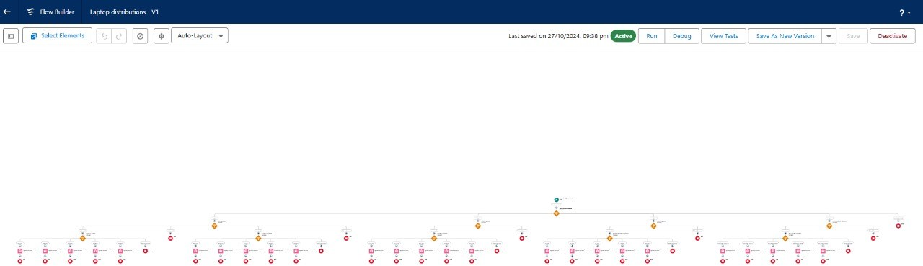

# Solution Design Overview

## Creation and Setup of Objects:

* + **Create Total Laptops Object:**Stores the total inventory of available laptops.
  + **Create Consumer Object:**Manages customer details such as name, email, and phone.
  + **Create Laptop Bookings Object:**Tracks individual laptop rental orders linked to both **Consumer** and **Total Laptops**.
  + **Create Billing Process Object:**Manages billing information, including rental charges.

## Fields and Relationships:

* + **Consumer Object:** Fields include name, email, and a phone ﬁeld with validation.

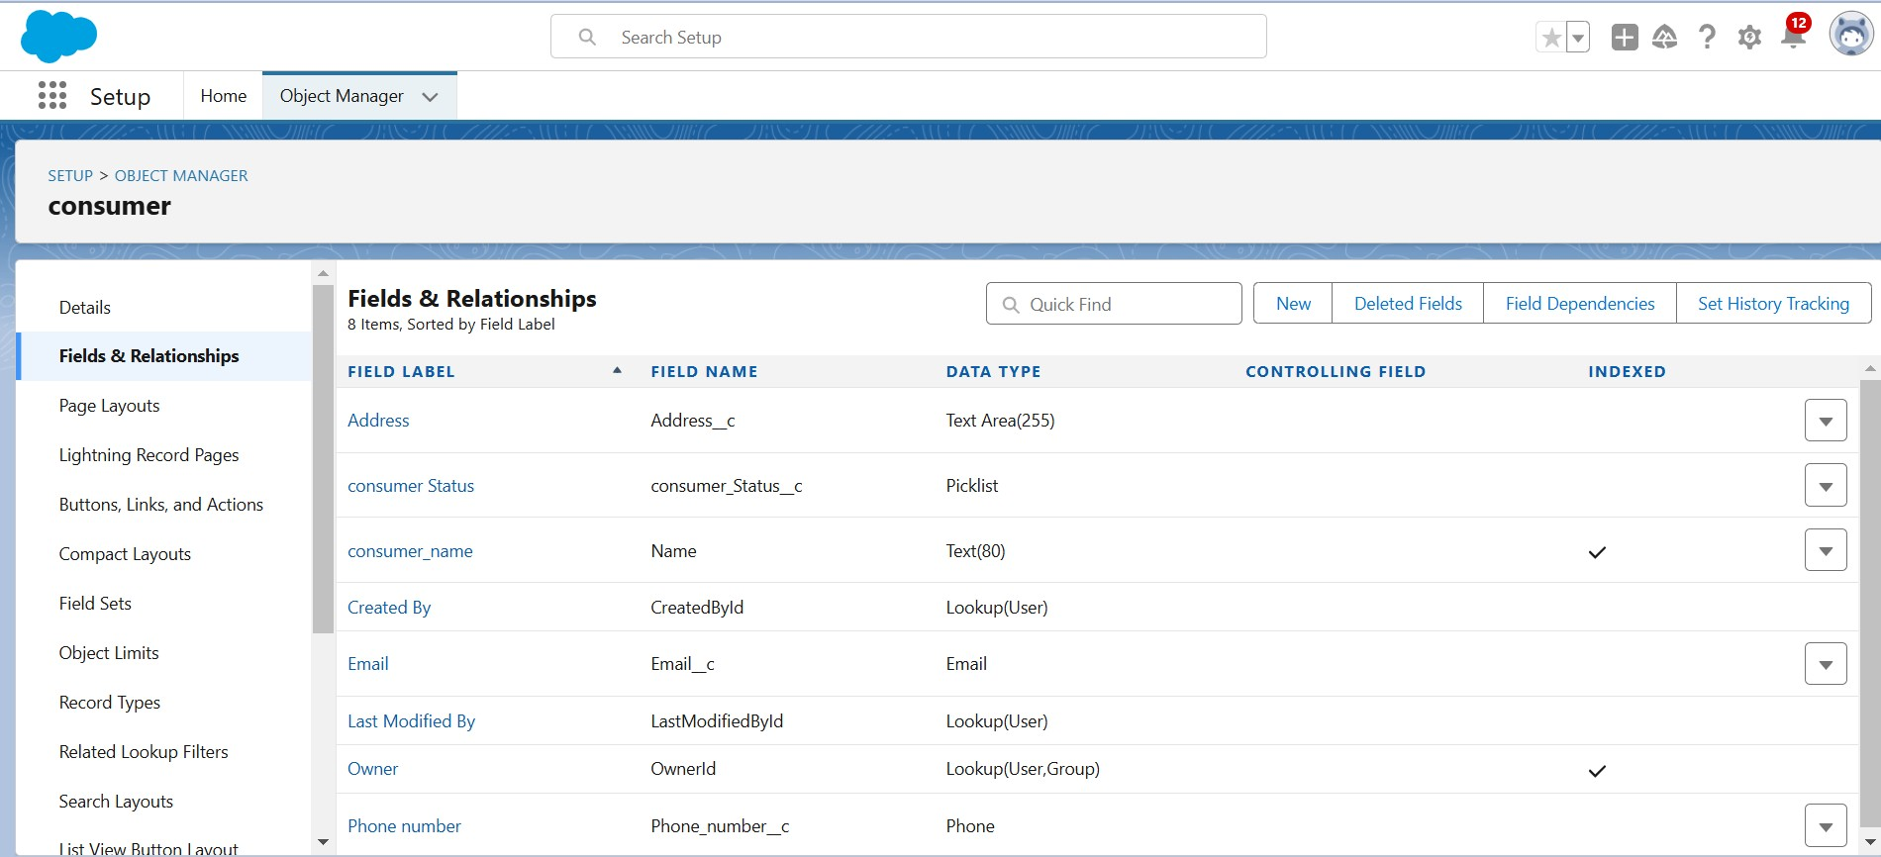

* + **Laptop Booking Object:** Fields include rental amount, laptop type, and a lookup ﬁeld to link to Customer records

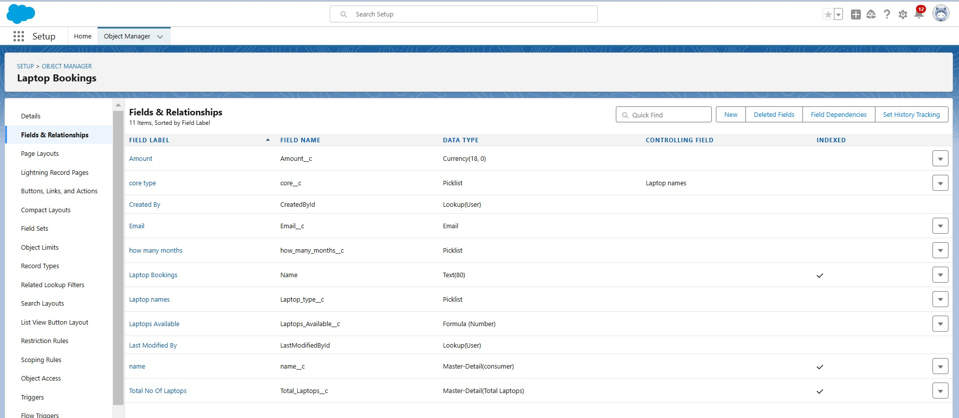

* + **Billing Records Object:** Fields track billing amounts, payment status, and due dates.

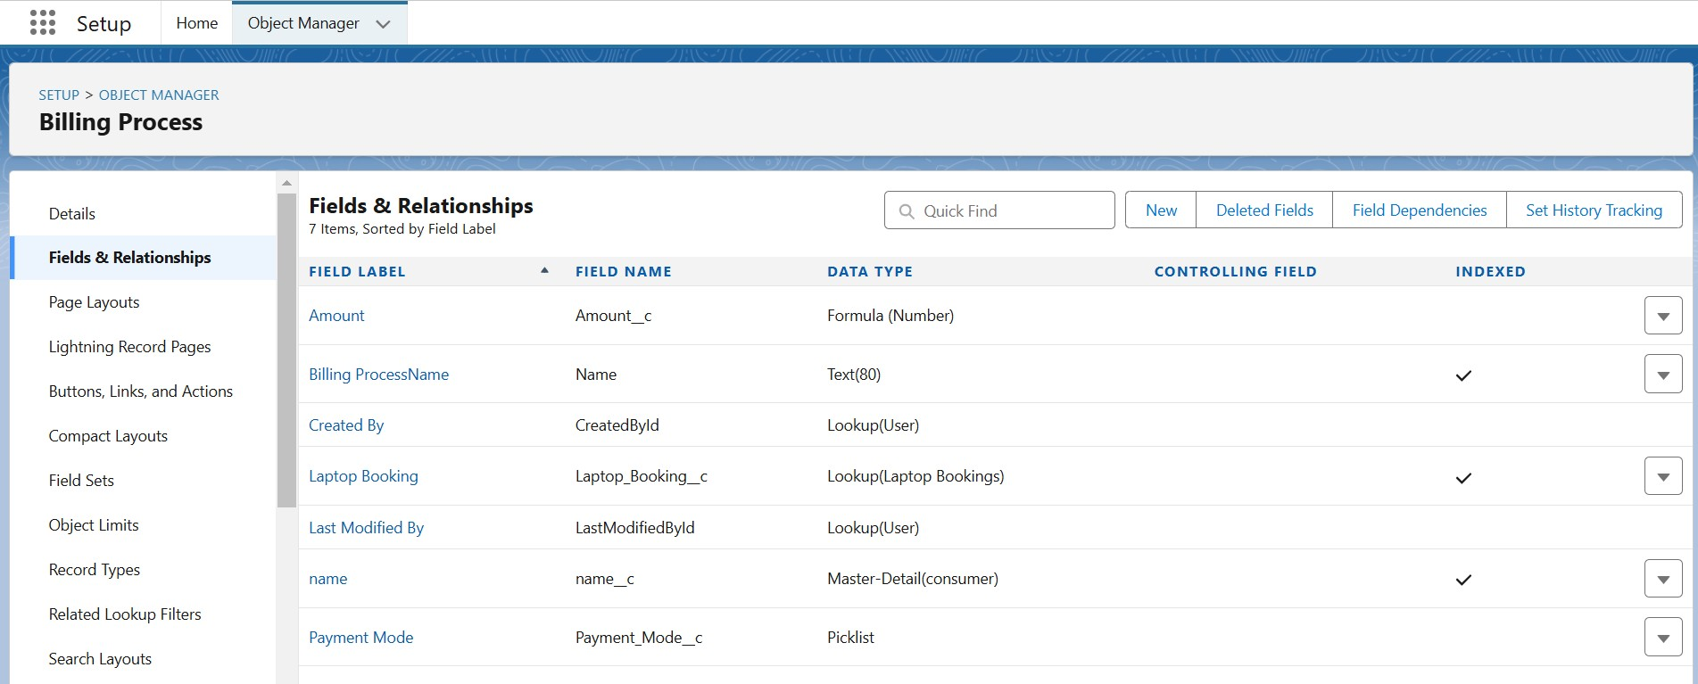

* + **Relationships:** Lookup and master-detail ﬁelds interconnect the Rental Orders, Customer, and Inventory objects.

## Validation Rules:

* + **Phone Number Validation:** Ensures only numbers are entered in the Consumer object phone ﬁeld.

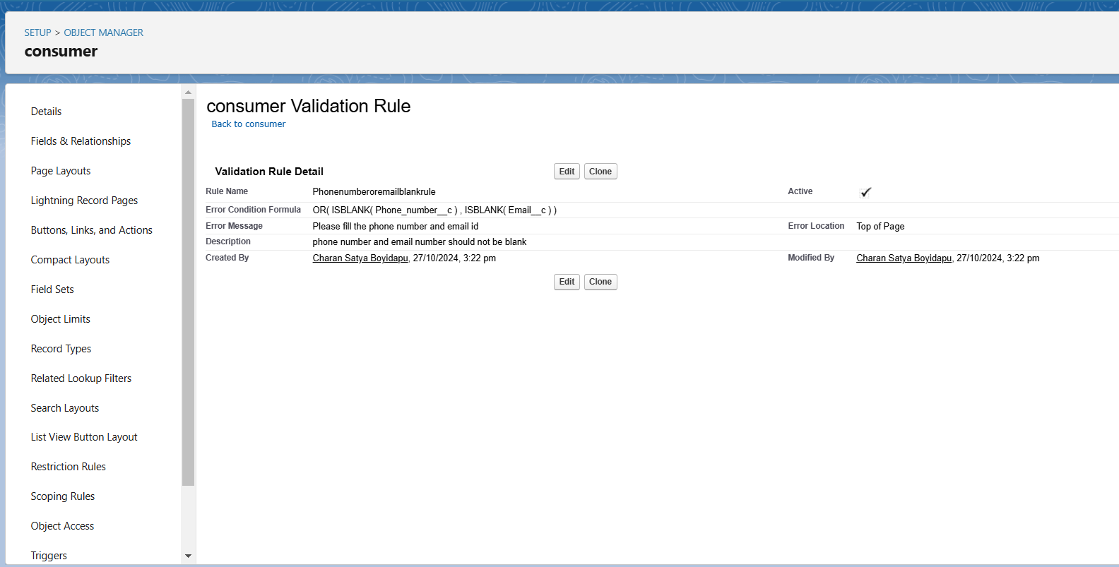

## Apex Implementation

* + **Email Notiﬁcation Trigger:** Sends an email to customers once a booking is created or updated.

**Trigger Code:**

trigger LaptopBooking on Laptop_Bookings c (After insert,after update) {

if(trigger.isAfter && ( trigger.isInsert || trigger.isupdate))

{

LaptopBookingHandler.sendEmailNotiﬁcation(trigger.new);

}

}

**Handler Class Code:**

public class LaptopBookingHandler {

public static void sendEmailNotiﬁcation (List<Laptop_Bookings c> lapList){ for(Laptop_Bookings c lap:lapList)

{

Messaging.SingleEmailMessage email = new Messaging.SingleEmailMessage(); email.setToAddresses( new List<String>{lap.Email c}); email.setSubject('Welcome to our company');

string body = 'Dear ' +lap.Name +', \n';

body += 'Welcome to Laptop Rentals! You have been seen as a valuable customer to us.\n Please continue your journey with us, while we try to provide you with good quality resources. \n Laptop Amount = ' + lap.Amount c + ' \n core type = '+lap.core c +' \n Laptop type = '+lap.Laptop_type c;

email.setPlainTextBody(body);

Messaging.sendEmail(new List<Messaging.SingleEmailMessage>{email});

}

}

}

## Reports and Dashboards Create a Report:

* + **Report Type:** “Consumers with Laptop Bookings and Total Laptops.”
  + **Fields:** Consumer Name, Booking Amount, Laptop Type, and Core Type.
  + **Sharing Report:** Share the report with the **Owner Proﬁle** to provide visibility into booking trends.

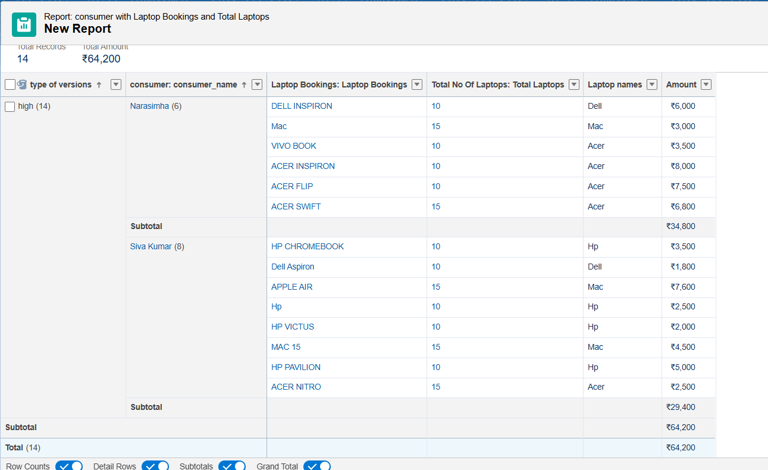

## Create Dashboard:

* + **Dashboard Folder:** Organized for easy access.
  + **Dashboard Components:** Widgets for tracking bookings, available laptops, and billing summaries.

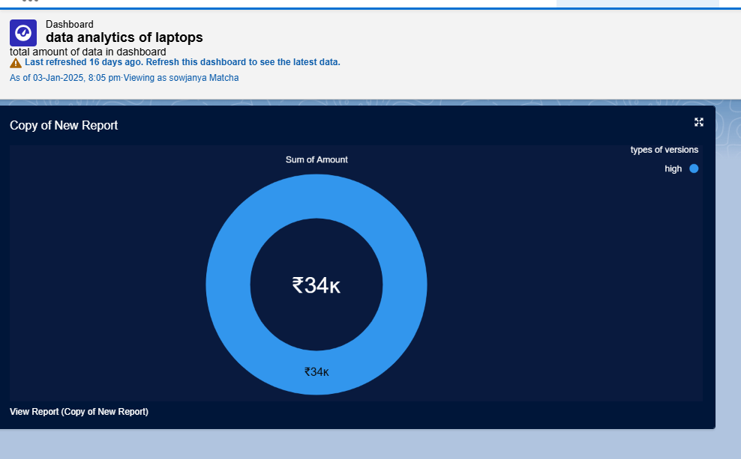

# Testing and Validation

## Testing Approach:

* + **Unit Testing:** Veriﬁes email trigger functionality.
  + **Functional Testing:** Checks data relationships across objects.
  + **User Acceptance Testing:** Ensures the application meets user expectations.

## Sample Test Cases:

* + **Test Case 1:** Validate that an email notiﬁcation is sent when a booking is created.
  + **Test Case 2:** Conﬁrm that roll-up summary ﬁelds reﬂect the correct count of available laptops.
  + **Test Case 3:** Ensure only available laptops are shown as options during booking.

# Key Scenarios Addressed by Salesforce

* + **Automated Booking and Order Management:** Simpliﬁes the booking process and captures customer interactions.
  + **Real-Time Inventory Tracking:** Provides visibility into rented and available laptops.
  + **Automated Customer Communication:** Apex triggers support seamless communication.
  + **Data-Driven Reporting:** Custom reports offer insights into rental activities and trends.
  + **Billing Management:** Monitors and updates payment statuses per rental.

# Conclusion

## Summary of Achievements:

* + **Streamlined Operations:** Optimized laptop rental management.
  + **Automated Communication:** Enhanced customer interaction through email notiﬁcations.
  + **Up-to-Date Inventory Tracking:** Ensured accurate data for informed decisions.
  + **Detailed Reporting:** Developed custom reports and dashboards for trend analysis. This Salesforce-powered CRM for laptop rentals has optimized processes, improved customer interactions, and delivered critical insights into rental performance, making it an adaptable, scalable solution for rental management.