**WEEK – 6**

**React**

**1)Hands on 1**

Create a new React Application with the name “myfirstreact”, Run the application to print “welcome to the first session of React” as heading of that page.

**Code:**

import './App.css';

function App() {

  return (

    <h1> Welcome the first session of React </h1>

  );

}

export default App;

**Output:**

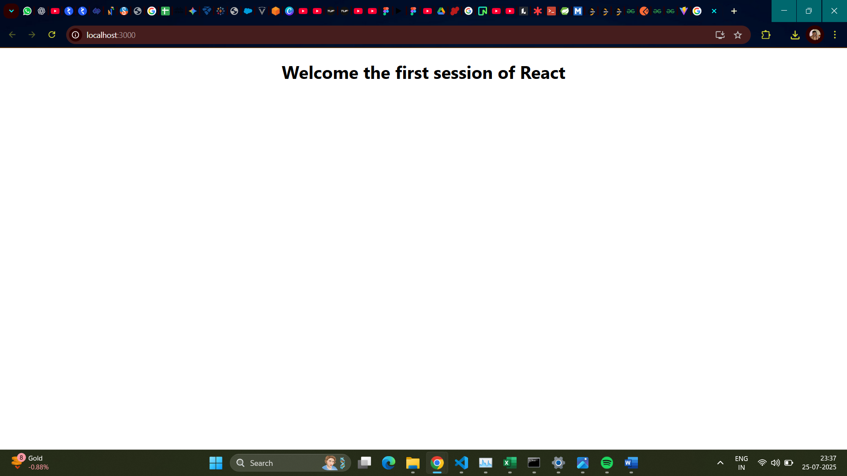

**2)Hands on 2**

Create a react app for Student Management Portal named StudentApp and create a component named Home which will display the Message “Welcome to the Home page of Student Management Portal”. Create another component named About and display the Message “Welcome to the About page of the Student Management Portal”. Create a third component named Contact and display the Message “Welcome to the Contact page of the Student Management Portal”. Call all the three components.

**Code:**

App.js

import './App.css';

import {Home} from './Components/Home';

import {About} from './Components/About';

import {Contact} from './Components/Contact';

function App() {

  return (

    <div *className*="container">

      <*Home*/>

      <*About*/>

      <*Contact*/>

    </div>

  );

}

export default App;

Home.js

import React, {Component} from 'react';

class Home extends Component{

    render(){

        return(

            <div>

                <h3> Welcome to the Home Page of Student Management Portal </h3>

            </div>

        );

    };

};

export { Home };

Contact.js

import React, {Component} from 'react';

class Contact extends Component{

    render(){

        return(

            <div>

                <h3> Welcome to the Contact Page of Student Management Portal </h3>

            </div>

        );

    };

};

export { Contact };

About.js

import React, {Component} from 'react';

class About extends Component{

    render(){

        return(

            <div>

                <h3> Welcome to the About Page of Student Management Portal </h3>

            </div>

        );

    };

};

export { About };

**Output:**

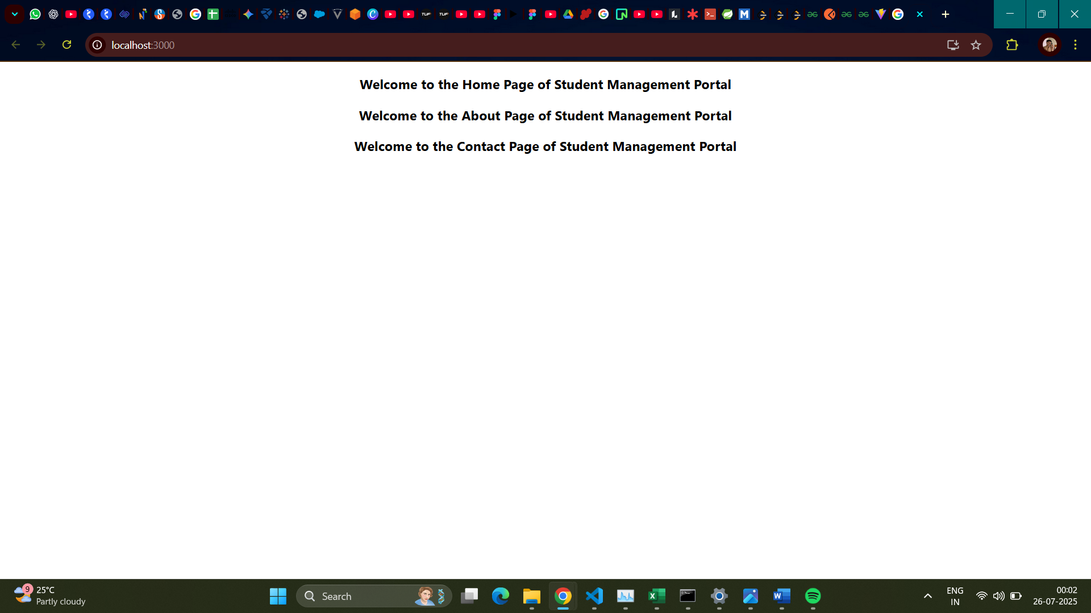

**3)Hands on 3**

Create a react app for Student Management Portal named scorecalculatorapp and create a function component named “CalculateScore” which will accept Name, School, Total and goal in order to calculate the average score of a student and display the same.

**Code:**

App.js

import React from 'react';

import { CalculateScore } from './Components/CalculateScore';

function App() {

  return (

    <div *className*="App">

      <*CalculateScore* *Name*={"Steeve"} *School*={"DNV Public School"} *total*={284} *goal*={300} />

    </div>

  );

};

export default App;

CalculateScore.js

import React from 'react';

import '../StyleSheets/mystyle.css';

const percentToDecimal = (*decimal*) => {

    return (*decimal*.toFixed(2) * 100) + '%';

};

const calcScore = (*total*, *goal*) => {

    if (*goal* === 0) return "N/A";

    return percentToDecimal(*total* / *goal*);

};

export const CalculateScore = ({ *Name*, *School*, *total*, *goal* }) => (

    <div *className*="formatstyle">

        <h1 *style*={{ color: "brown" }}>Student Details:</h1>

        <div *className*="Name">

            <b><span>Name:</span></b>

            <span> {*Name*}</span>

        </div>

        <div *className*="School">

            <b><span>School:</span></b>

            <span> {*School*}</span>

        </div>

        <div *className*="Total">

            <b><span>Total:</span></b>

            <span> {*total*}</span>

            <span>Marks</span>

        </div>

        <div *className*="Score">

            <b><span>Score:</span></b>

            <span>

                {calcScore(*total*, *goal*)}

            </span>

        </div>

    </div>

);

mystyle.css

*.Name* {

    font-weight: 300;

    color: blue;

}

*.School* {

    color: crimson;

}

*.Total* {

    color: darkmagenta;

}

*.formatstyle* {

    text-align: center;

    font-size: large;

}

*.Score* {

    color: forestgreen;

}

**Output:**

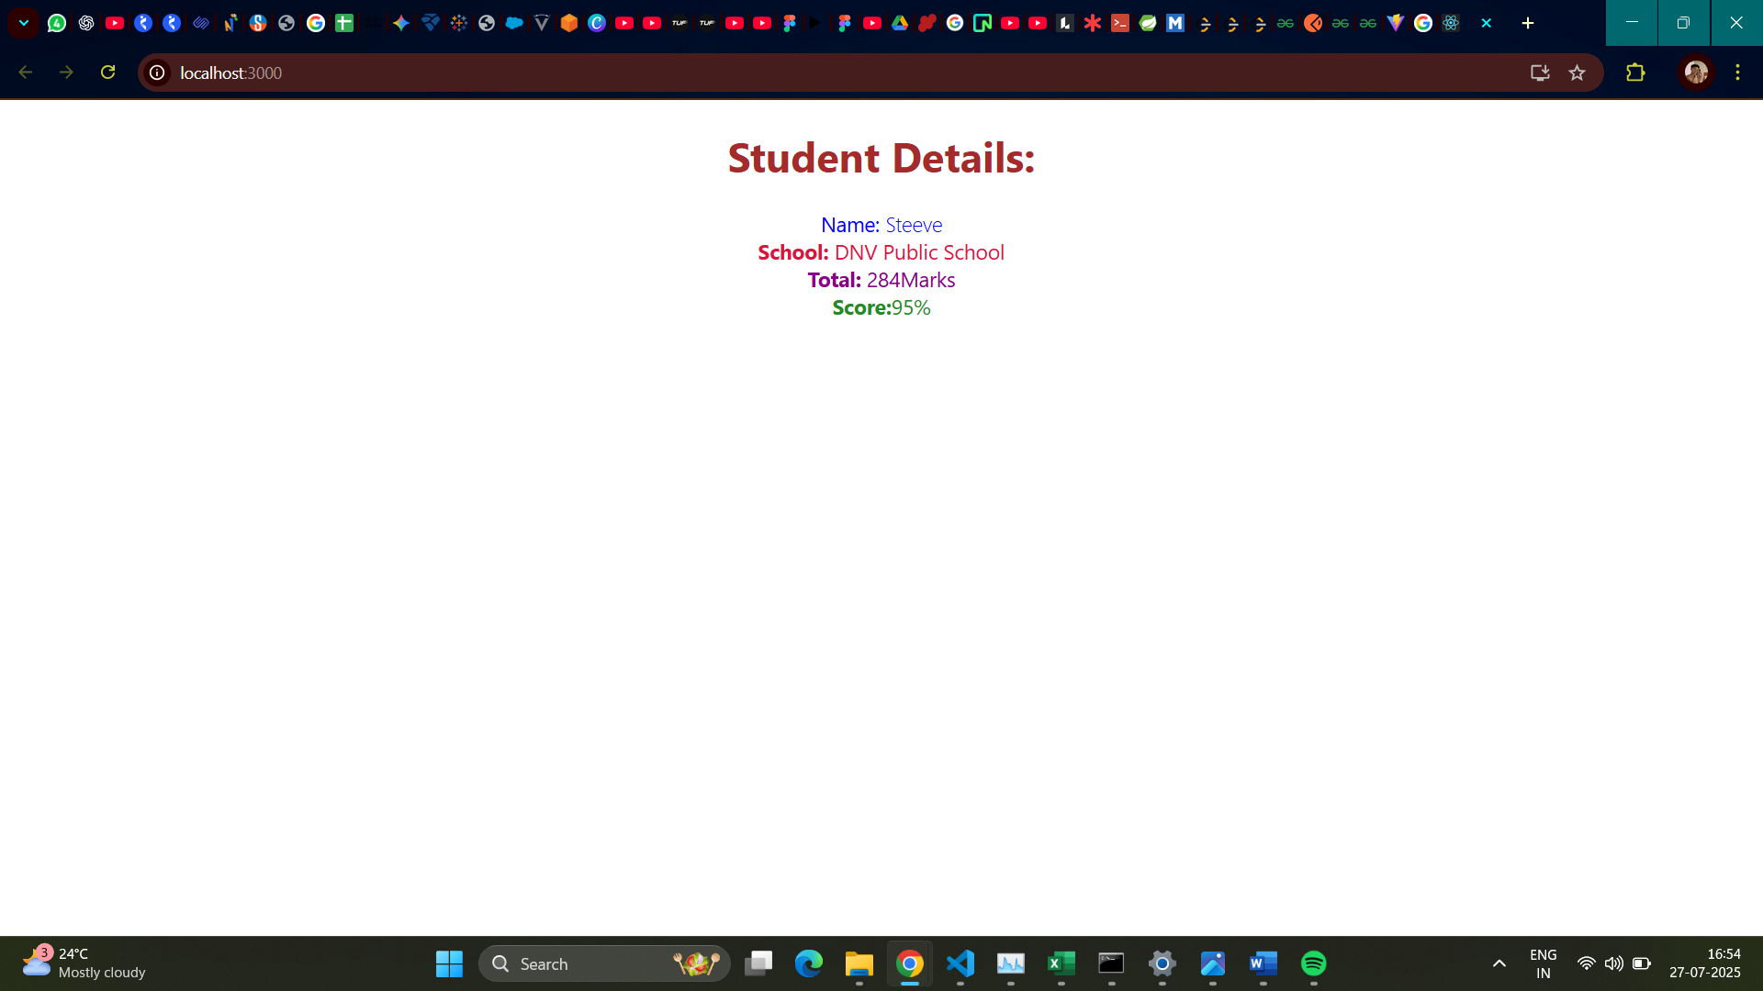

**4)Hands on 4**

Create a new react application using *create-react-app* tool with the name as “blogapp”.

**Code:**

App.js

import React from 'react';

import Posts from './Posts';

function App() {

  return (

    <div *className*="App">

      <*Posts* />

    </div>

  );

}

export default App;

Post.js

class Post {

    constructor(*id*, *title*, *body*) {

*this*.id = *id*;

*this*.title = *title*;

*this*.body = *body*;

    }

}

export default Post;

Posts.js

import React from 'react';

class Posts extends *React*.Component {

    constructor(*props*) {

*super*(*props*);

*this*.state = {

            posts: [],

            hasError: false,

            error: null,

            errorInfo: null,

        };

    }

    loadPosts = async () => {

        try {

            const response = await fetch('https://jsonplaceholder.typicode.com/posts');

            if (!response.ok) {

                throw **new** *Error*(`HTTP error! status: ${response.status}`);

            }

            const data = await response.json();

*this*.setState({ posts: data });

        } catch (error) {

            console.error("Failed to fetch posts:", error);

*this*.setState({ hasError: true, error: error });

        }

    };

    componentDidMount() {

*this*.loadPosts();

    }

    componentDidCatch(*error*, *errorInfo*) {

        console.error("Caught an error:", *error*, *errorInfo*);

*this*.setState({

            hasError: true,

            error: *error*,

            errorInfo: *errorInfo*,

        });

        alert("An error occurred in the component! Check console for details.");

    }

    render() {

        if (*this*.state.hasError) {

            return (

                <div *style*={{ color: 'red', textAlign: 'center', padding: '20px' }}>

                <h2>Something went wrong.</h2>

                <p>{*this*.state.error && *this*.state.error.toString()}</p>

                </div>

            );

        }

        if (*this*.state.posts.length === 0) {

          return <div *style*={{ textAlign: 'center', padding: '20px' }}>Loading posts...</div>;

        }

        return (

            <div *style*={{ padding: '20px', maxWidth: '800px', margin: '0 auto' }}>

                <h1 *style*={{ textAlign: 'center', marginBottom: '30px', color: '#333' }}>Blog Posts</h1>

                {*this*.state.posts.map((*post*) => (

                    <div *key*={*post*.id} *style*={{ border: '1px solid #eee', borderRadius: '8px', padding: '15px', marginBottom: '20px', backgroundColor: '#fff', boxShadow: '0 2px 5px rgba(0,0,0,0.05)' }}>

                        <h2 *style*={{ color: '#0056b3', fontSize: '1.5rem', marginBottom: '10px' }}>{*post*.title}</h2>

                        <p *style*={{ color: '#555', lineHeight: '1.6' }}>{*post*.body}</p>

                    </div>

                ))}

            </div>

        );

    }

}

export default Posts;

**Output:**

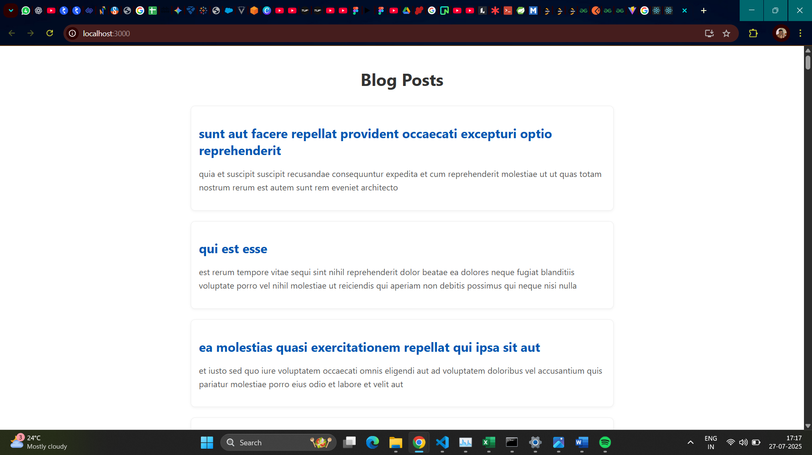

**5)Hands on 5**

My Academy team at Cognizant want to create a dashboard containing the details of ongoing and completed cohorts. A react application is created which displays the detail of the cohorts using react component. You are assigned the task of styling these react components.

**Code:**

CohortDetails.module.css

*.box* {

    width: 300px;

    display: inline-block;

    margin: 10px;

    padding-top: 10px;

    padding-bottom: 10px;

    padding-left: 20px;

    padding-right: 20px;

    border: 1px solid black;

    border-radius: 10px;

    box-sizing: border-box;

}

dt {

    font-weight: 500;

}

CohortDetails.js

import React from 'react';

import styles from './CohortDetails.module.css';

function CohortDetails(*props*) {

    const headingStyle = {

        color: *props*.cohort.currentStatus === 'Ongoing' ? 'green' : 'blue'

    };

    return (

        <div *className*={styles.box}>

            <h3 *style*={headingStyle}>

                {*props*.cohort.cohortCode} -

                <span>{*props*.cohort.technology}</span>

            </h3>

            <dl>

                <dt>Started On</dt>

                <dd>{*props*.cohort.startDate}</dd>

                <dt>Current Status</dt>

                <dd>{*props*.cohort.currentStatus}</dd>

                <dt>Coach</dt>

                <dd>{*props*.cohort.coachName}</dd>

                <dt>Trainer</dt>

                <dd>{*props*.cohort.trainerName}</dd>

            </dl>

        </div>

    );

}

export default CohortDetails;

**Output:**

