# Lab: Intro to jQuery

## Text from a List

NOTE: Don’t forget to comment the code and explain what it’s doing. You can comment in HTML like this:

<!--Comment -->

A HTML page holding a **list** of items and an [Extract Text] button is given. Implement the extractText function which will be called when the button's onClick event is fired.

### HTML and JavaScript Code

You are given the following **HTML** code:

|  |
| --- |
| text.html |
| <!DOCTYPE **html**> <**html lang="en"**> <**head**>  <**meta charset="UTF-8"**>  <**title**>Text from List</**title**>  <**script src="https://ajax.googleapis.com/ajax/libs/jquery/3.5.1/jquery.min.js" script**>  <**script src="extractText.js"**></**script**> </**head**> <**body**>  <**ul id="items"**>  <**li**>first item</**li**>  <**li**>second item</**li**>  <**li**>third item</**li**>  </**ul**>  <**button onclick="***extractText*()**"**> Extract Text</**button**>  <**div id="result"**></**div**> </**body**> </**html**> |
|  |

It comes together with the following **JavaScript** code:

|  |
| --- |
| extract-text.js |
| **function** *extractText*() {  *//* ***TODO*** } |

### Screenshot

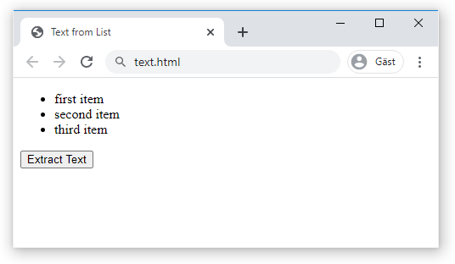 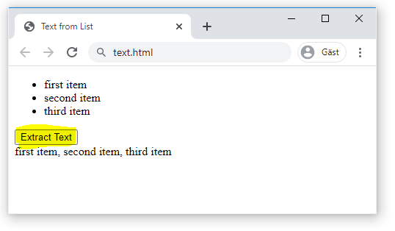

## Search in a List

An HTML page holds a **list** of towns, a **search** box and a [Search] button. Implement the search function to **bold** the items from the list which include the text from the **search** box. Also print the amount of items the current search **matches** in the format **"<matches> matches found."**

### HTML and JavaScript Code

You are given the following **HTML** code:

|  |
| --- |
| list.html |
| <!DOCTYPE **html**> <**html lang="en"**> <**head**>  <**meta charset="UTF-8"**>  <**title**>Search in List</**title**>  <**script src="https://ajax.googleapis.com/ajax/libs/jquery/3.5.1/jquery.min.js" script**>  <**script src="search.js"**></**script**> </**head**> <**body**> <**ul id="towns"**>  <**li**>Stockholm</**li**>  <**li**>Malmö</**li**>  <**li**>Göteborg</**li**>  <**li**>Malung</**li**> </**ul**> <**input type="text" id="searchText"** /> <**button onclick="***search*()**"**>Search</**button**> <**div id="result"**></**div**> </**body**> </**html**> |

It comes together with the following **JavaScript** code:

|  |
| --- |
| search.js |
| **function** *search*() {  *//* ***TODO*** } |

### Screenshots

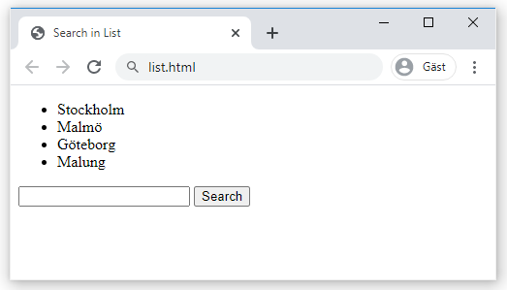 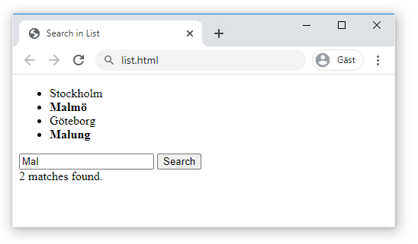

## Table Countries

You are given and HTML table holding **countries** and their **capitals**. You need to implement a [Create] link to create a new country and for each existing country implement [Up], [Down] and [Delete] links to manipulate its position in the table.

### HTML and JavaScript Code

You are given the following **HTML** code:

|  |
| --- |
| countries.html |
| <!DOCTYPE **html**> <**html lang="en"**> <**head**>  <**meta charset="UTF-8"**>  <**title**>Countries Table</**title**>  <**style**>  **td**, **th** { **background**: **#DDD**; **padding**: 5**px** 10**px** }  **input**[**type**=**'text'**] { **width**: 60**px** }  </**style**>  <**script src="https://ajax.googleapis.com/ajax/libs/jquery/3.5.1/jquery.min.js"**></**script**>  <**script src="initialize-table.js"**></**script**> </**head**> <**body**> <**table id="countriesTable"**>  <**tr**>  <**th**>Country</**th**>  <**th**>Capital</**th**>  <**th**>Action</**th**>  </**tr**>  <**tr**>  <**td**><**input type="text" id="newCountryText"** /></**td**>  <**td**><**input type="text" id="newCapitalText"** /></**td**>  <**td**><**a href="#" id="createLink"**>[Create]</**a**></**td**>  </**tr**> </**table**> <**script**>$(() => *initializeTable*())</**script**> </**body**> </**html**> |

It comes together with the following **JavaScript** code:

|  |
| --- |
| initialize-table.js |
| **function** *initializeTable*() {  *//* ***TODO*** } |

### Screenshots

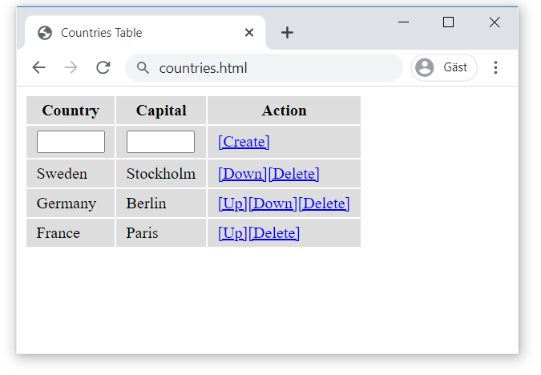

## Buttons Link

You are given HTML holding some buttons. Implement the attachEvents function which should attach click events on the buttons. When a button is **clicked** it should **remove** the class="selected" attribute from the button that currently holds it and **add it to its own attributes**.

### HTML, CSS and JavaScript Code

You are given the following **HTML** code:

|  |
| --- |
| buttons.html |
| <!DOCTYPE **html**> <**html lang="en"**> <**head**>  <**meta charset="UTF-8"**>  <**title**>Title</**title**>  <**link rel="stylesheet" href="link-buttons.css"** />  <**script src="https://ajax.googleapis.com/ajax/libs/jquery/3.5.1/jquery.min.js"**></**script**>  <**script src="link-buttons.js"**></**script**> </**head**> <**body onload="**attachEvents()**"**>  <**a class="button"**>Stockholm</**a**>  <**a class="button"**>Malmö</**a**>  <**a class="button"**>Göteborg</**a**> </**body**> </**html**> |

It comes with this **CSS**:

|  |
| --- |
| link-buttons.css |
| **a**.**button** {  **border**: 1**px solid #CCC**;  **background**: **#EEE**;  **padding**: 5**px** 10**px**;  **border-radius**: 5**px**;  **color**: **#333**;  **text-decoration**: **none**;  **display**: **inline-block**;  **margin**: 5**px**; }  **a**.**button**.**selected** {  **color**: **#111**;  **font-weight**: **bold**;  **border**: 1**px solid #AAA**;  **background**: **#BBB**; }  **a**.**button**.**selected**::**before** {  **content**: **"\2713\20\20"**; }  **a**:**hover** {  **cursor**: **pointer**; } |

and the following **JavaScript** code:

|  |
| --- |
| link-buttons.js |
| **function** *attachEvents*() {  *//* ***TODO*** } |

### Screenshots

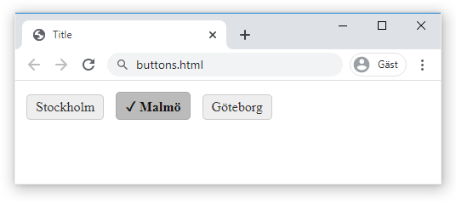

### Hints

* Use the attachEventListener function.

## Selectable Cities

Create an HTML page listing **Cities**, a city should be selectable. Clicking on a town should **select/deselect** it, a selected city should have the data-selected attribute added to it and its background color should be changed to #DDD. Also create a button [Show Cities] that prints the text **"Selected cities: "** followed by all selected towns joined with a **", "**.

### HTML and JavaScript Code

You are given the following **HTML** code:

|  |
| --- |
| towns.html |
| <!DOCTYPE **html**> <**html lang="en"**> <**head**>  <**meta charset="UTF-8"**>  <**title**>Selectable Cities</**title**>  <**style**>  **li** {  **display**: **inline-block**;  **cursor**: **pointer**;  **padding**: 10**px**;  }  **ul** { **padding**:0; }  </**style**>  <**script src="https://ajax.googleapis.com/ajax/libs/jquery/3.5.1/jquery.min.js"**></**script**>  <**script src="select-towns.js"**></**script**> </**head**> <**body**> <**h2**>Cities</**h2**> <**ul id="items"**>  <**li**>Stockholm</**li**>  <**li**>Göteborg</**li**>  <**li**>Malmö</**li**>  <**li**>Uppsala</**li**>  <**li**>Umeå</**li**> </**ul**> <**button id="showTownsButton"**>Show Cities</**button**>  <**div** **id="selectedTowns"**></**div**> <**script**>$(*attachEvents*())</**script**> </**body**> </**html**> |

It comes together with the following **JavaScript** code:

|  |
| --- |
| select-towns.js |
| **function** *attachEvents*() {  *//* ***TODO*** } |

### Screenshots

### 