Company/Client Name | Madras Cricket Club
Project Name | Message Broadcasting
Release Date
Release Notes | Broadcasting message with image/file to selected group through whatsapp/email
IP | http://3.109.198.190:3000/

Screen :
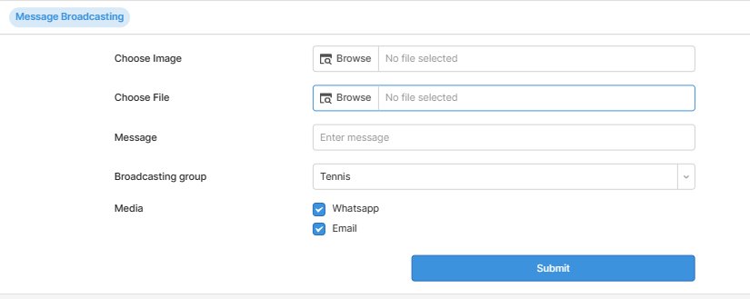

- Choose Image and File
- Enter broadcasting message
- Choose Broadcasting group from list(All,Tennis…etc)
- You can also select the media whatsapp and email
- When click on submit button details are saved in database and the message broadcasting is started for selected group and media.

