To meet the requirements of the task

1. LANDSAT -8 OLI Level 1 data during 15 Jan 2023-30 Jan 2023 has been taken over the study area as shown in Fig1.

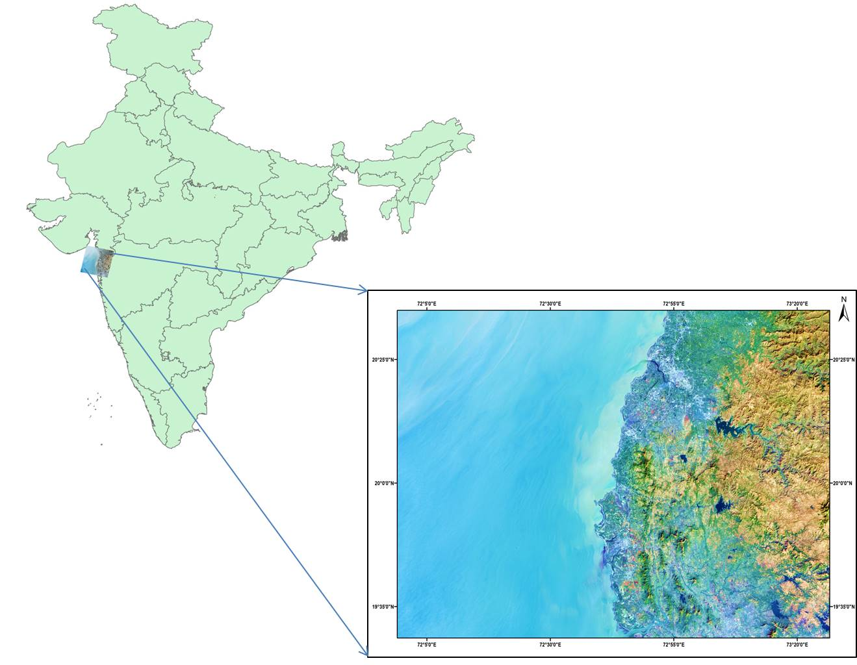

Fig1: Study Area: Maharashtra Coast

1. Atmospheric correction for the LANDSAT-8 Level 1 data was performed based on the literature review using Digital Image Processing software. The process involves converting DN values of each band to reflectance value and then which is obtained by using the equation below

ρ′λ=MpQcal+Ap

ρ′λ=ρ′λcos/(θSZ)=ρ′λsin/(θSE)

where

*Mp* = band-specific multiplicative from metadata;

*Ap* = additive rescaling factors from metadata;

*Qcal* = quantized and calibrated standard product pixel values;

*θSE* = sun elevation angle;

*θSZ* = solar zenith angle computed by (90° − θSE);

1. To identify the most suited Index for mapping seaweed ,Processed LANDSAT-8 OLI data bands were then used for calculating the Floating Algae Index (FAI), Normalized Difference Vegetation Index (NDVI) and Seaweed Enhancing Index (SEI).The analysis was performed using python where different libraries (rasterio, matplotlib, numpy) were utilised. Based on the results, the performance of SEI found better when compared with NDVI and FAI.

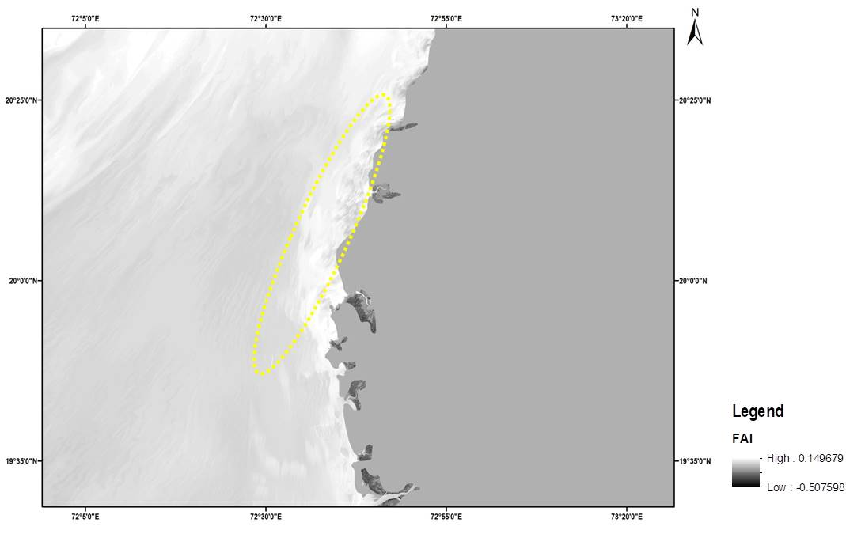

Fig 2: Floating Algae Index ranging from -0.507 to 0.149

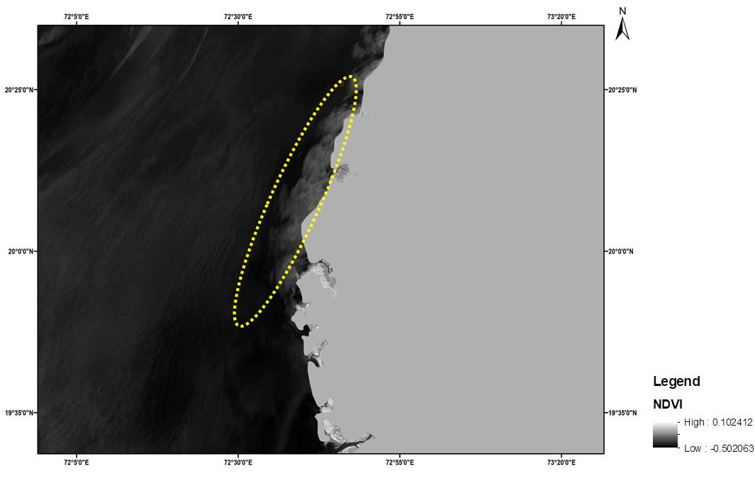

Fig 3: NDVI ranging from -0.502 to 0.102

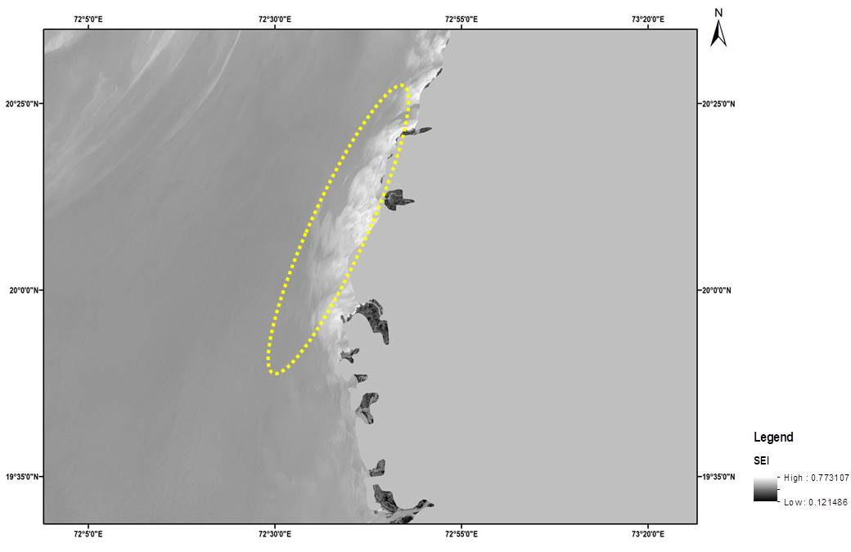

Fig 4: SEI ranging from 0.12 to 0.773