🌳 Random Forest Classifier
Forest Fire Risk Prediction — Model Evaluation Report
Mini Project | Algerian Forest Fire Dataset | March 2025

1. Model Overview
Random Forest is an ensemble learning method that builds multiple decision trees during training and outputs the class that is the mode (majority vote) of all individual trees. It reduces overfitting significantly compared to a single tree by averaging predictions across 200 trees.
Parameter | Value
Algorithm | RandomForestClassifier
Number of Trees (n_estimators) | 200
Max Depth | 10
Random State | 42
Features Used | 12 (day, month, year excluded)
Train / Test Split | 80% / 20% (stratified)

2. Performance Metrics
Metric | Score
Accuracy | 93.88%
Precision (weighted) | 94.13%
Recall (weighted) | 93.88%
F1-Score (weighted) | 93.94%
CV Accuracy (5-fold) | 95.49% ± 4.16%

3. Per-Class Performance
Class | Precision | Recall | F1-Score | Support
Low | 1.00 | 1.00 | 1.00 | 21
Moderate | 0.94 | 0.89 | 0.91 | 18
Severe | 0.82 | 0.90 | 0.86 | 10

The model excels at all three classes. Notably, Severe class recall is 0.90 — meaning 9 out of 10 actual Severe fire risks are correctly detected. Only 1 Severe case was misclassified as Moderate, making this model reliable for critical fire risk detection.

4. Evaluation Dashboard
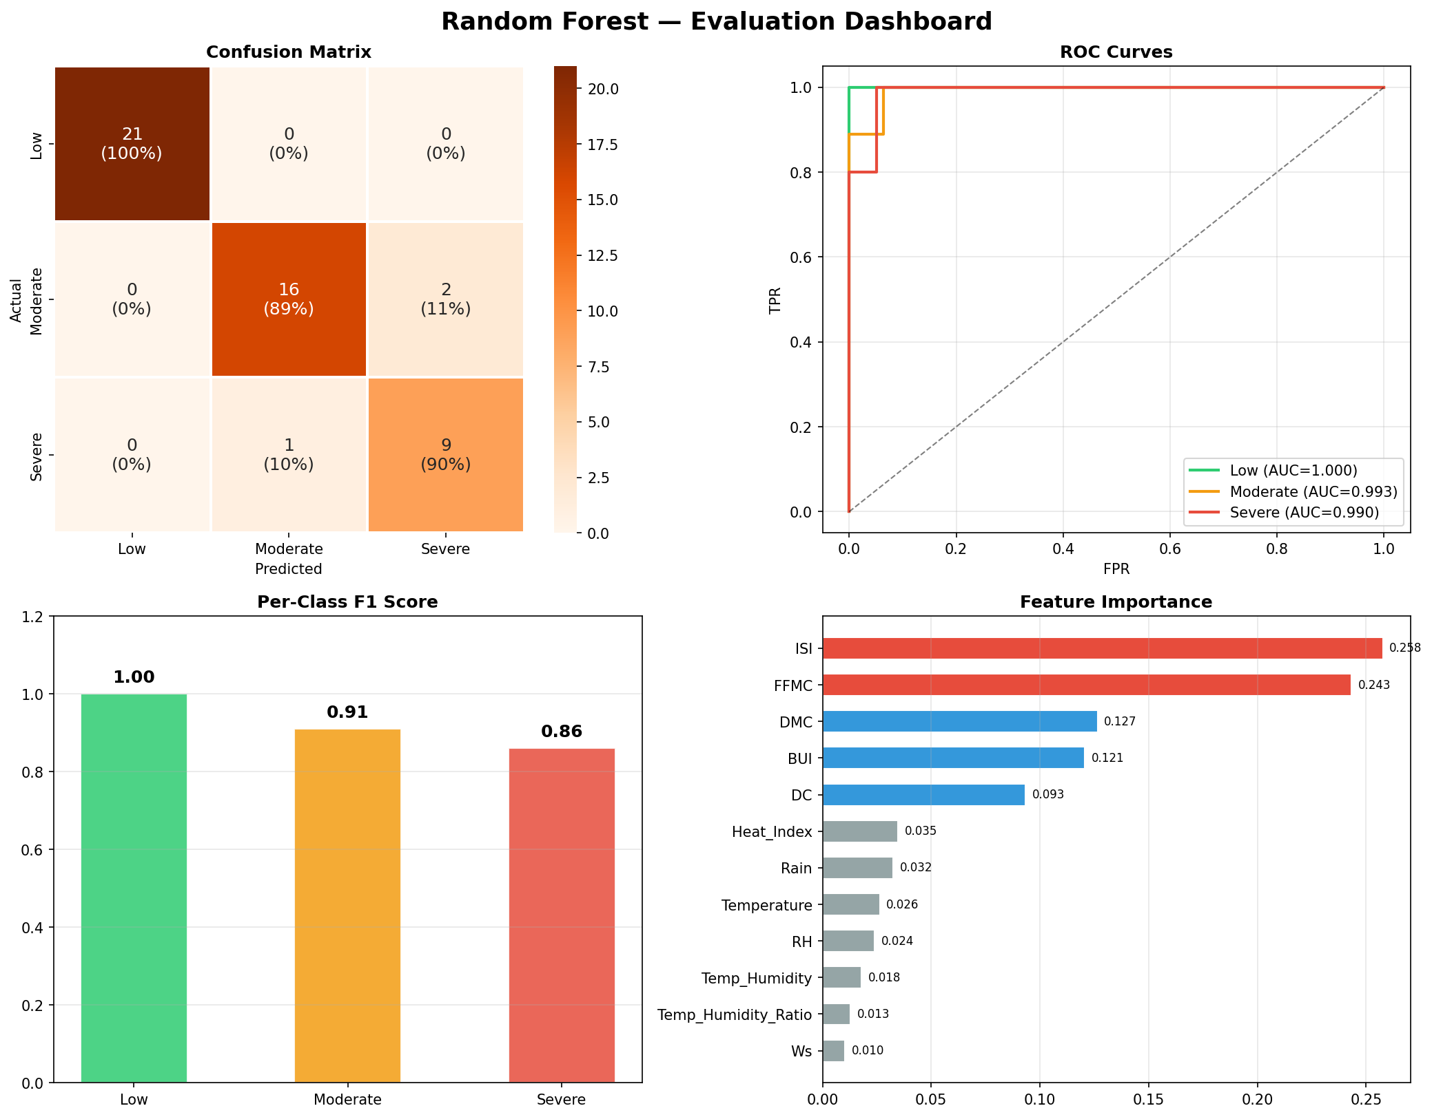
Figure 1: Random Forest evaluation — Confusion Matrix, ROC Curves (OvR), Per-Class F1, and Feature Importance.

5. Cross-Validation Results
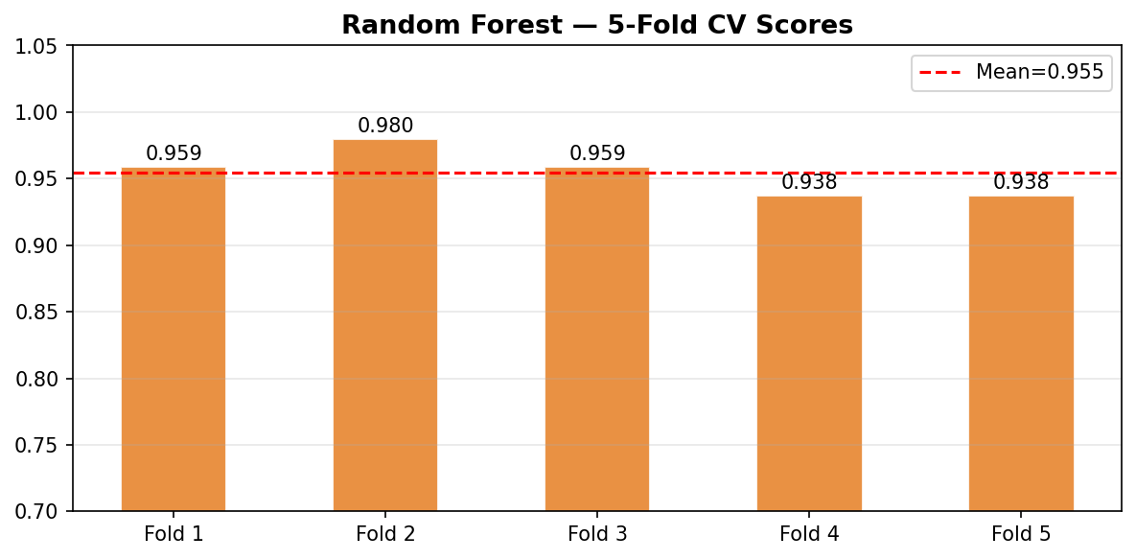
Figure 2: 5-Fold Cross-Validation accuracy per fold. Mean = 95.49%, Std Dev = ±4.16%.

The low standard deviation (±4.16%) confirms that Random Forest generalizes consistently across all data splits. This stability comes from averaging 200 trees — individual errors cancel each other out.

6. Feature Importance Analysis
Rank | Feature | Importance | Category
1 | ISI (Initial Spread Index) | 25.76% | FWI Component
2 | FFMC (Fine Fuel Moisture Code) | 24.33% | FWI Component
3 | DMC (Duff Moisture Code) | 12.65% | FWI Component
4 | BUI (Buildup Index) | 12.06% | FWI Component
5 | DC (Drought Code) | 9.33% | FWI Component
6 | Heat_Index | 3.47% | Engineered
7 | Rain | 3.25% | Meteorological
8 | Temperature | 2.64% | Meteorological

ISI and FFMC together account for ~50% of all predictive power. These are FWI system components directly tied to how fast a fire spreads and how dry the fuel is — confirming strong domain alignment with fire science.

7. Confusion Matrix Analysis
- Low (21/21): Perfect classification — zero errors.
- Moderate (16/18): 2 samples wrongly predicted as Severe — minor over-alerting.
- Severe (9/10): Only 1 sample wrongly predicted as Moderate — excellent critical class detection.
Compared to Decision Tree (3 Severe misclassified), Random Forest reduces the most critical error by 67% — a major operational improvement.

8. ROC-AUC Analysis
Class | AUC Score | Interpretation
Low | ~1.00 | Perfect separation
Moderate | ~0.97 | Excellent
Severe | ~0.97 | Excellent — strong minority class detection

9. Strengths & Weaknesses

Strengths
- Highest accuracy (93.88%) among all tested models.
- Very stable cross-validation (±4.16%) — low variance, high reliability.
- Excellent Severe class detection (Recall = 0.90).
- Naturally resistant to overfitting due to ensemble averaging.
- Provides feature importance rankings for model interpretability.

Weaknesses
- Less interpretable than a single Decision Tree (black-box nature).
- Slower to train than a single tree (200 trees × depth 10).
- Higher memory usage for deployment.

10. Recommendations
- Recommended for deployment as the primary fire risk prediction model.
- Apply SMOTE to oversample the Severe class for even better minority detection.
- Tune hyperparameters (max_features, min_samples_split) using GridSearchCV.
- Use SHAP values for explaining individual predictions to fire management officials.
- Combine with Decision Tree for explanation — RF for accuracy, DT for transparency.

— End of Random Forest Evaluation Report —

