**select a.account_number, c.CUSTOMER_NUMBER, c.FIRSTNAME, c.lastname, a.account_opening_date**

**from customer_master c join account_master a**

**on a.CUSTOMER_NUMBER = c.CUSTOMER_NUMBER**

**order by a.account_number;**

**select count(customer_number) Cust_Count**

**from customer_master**

**where CUSTOMER_CITY = 'Delhi';**

**select c.CUSTOMER_NUMBER, c.FIRSTNAME, c.lastname, a.account_number**

**from customer_master c join account_master a**

**on a.CUSTOMER_NUMBER = c.CUSTOMER_NUMBER**

**where DAY(a.account_opening_date) > 15**

**order by c.CUSTOMER_NUMBER, a.account_number;**

**SELECT COUNT(cm.CUSTOMER_NUMBER) AS Count_Customer**

**FROM customer_master cm**

**LEFT JOIN account_master am**

**ON cm.CUSTOMER_NUMBER = am.customer_number**

**WHERE am.account_number IS NULL;**

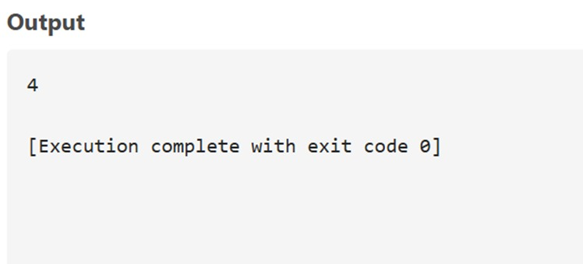

**SELECT**

**t.transaction_type,**

**COUNT(*) AS Trans_Count**

**FROM**

**transaction_details t**

**JOIN**

**account_master a ON t.account_number = a.account_number**

**WHERE**

**a.customer_number LIKE '%001'**

**GROUP BY**

**t.transaction_type**

**ORDER BY**

**t.transaction_type ASC;**

