INTRODUCTION

CHAPTER 1

INTRODUCTION

1.1 Introduction to the Project
Accurate identification of skin problems and knowing which natural remedies to use can be difficult, especially in rural areas or when using traditional medicine. Usually, people rely on visiting a doctor or matching symptoms themselves, which can sometimes lead to wrong guesses and treatments that don’t work. Even though many plants are known to help with skin issues, most people don’t have an easy way to find the right plant or learn how to use it properly for their skin.
HerbalLink is an intelligent machine learning-powered web application that assists users in detecting common skin diseases and recommends suitable medicinal leaves as treatment options. Unlike existing solutions that rely on user descriptions or predefined medical databases, HerbalLink uses real-time image classification and user input to deliver personalized, nature-based healthcare guidance. Through HerbalLink, Users can register, upload images of affected skin areas, or scan leaves to receive tailored disease identification, natural remedy suggestions, and detailed usage instructions.
The backend, developed using Flask and Python, leverages machine learning models trained on skin disease and leaf datasets. Image processing is handled using OpenCV, while classification tasks utilize CNN (Convolutional Neural Network) models built with TensorFlow. For the skin module, the system predicts conditions like acne, eczema, or fungal infections based on image features, along with preparation and application guidance sourced from a database. For the leaf module, the system identifies the scanned leaf and retrieves a list of skin diseases it can treat.
HerbalLink offers a new and complete way to care for skin by combining traditional herbal treatments with modern AI technology. It helps people rely less on chemical medicines and gives them easy, natural options for treating skin problems. With just a few steps, users can get useful advice, making skin care more accessible and convenient. By using real-time image analysis and machine learning, HerbalLink not only improves the accuracy of skin condition detection but also ensures that users receive personalized herbal remedies based on their specific needs.

1.2 Problem Statement
The growing challenge of accurately identifying skin diseases and choosing effective natural remedies poses significant difficulties, especially in rural areas where access to dermatologists and advanced medical facilities is limited. People often depend on self-diagnosis or traditional knowledge, which can result in incorrect identification and ineffective treatment. Despite the availability of numerous medicinal plants with proven benefits for skin health, there is no accessible, reliable, and intelligent system to guide users in selecting the right plant-based remedy for their specific skin condition. Therefore, there is a need for a smart, user-friendly solution that combines modern technology with traditional medicine to help individuals detect skin problems accurately and recommend suitable herbal treatments.

1.3 Existing System
Most existing web apps for skin problems and herbal medicines depends on users typing symptoms or searching for plant names. They don’t use real-time images to identify diseases or plants, which makes the process slow and sometimes inaccurate. Users often have to guess their condition based on written information or pictures, leading to confusion and wrong results. Also, In Existing solution, there is no dual approach on a single platform. Skin web apps usually focus only on basic symptom checklists, while herbal web apps act as digital guides that describe plants but don’t suggest which ones can treat specific skin problems. Because these systems aren’t connected, users don’t get proper guidance or personalized natural treatment options easily.

1.4 Proposed System
The HerbalLink system combines machine learning, image analysis, and Ayurvedic knowledge to offer accurate and natural health recommendations through a simple, user-friendly web application. Its Dual Image Processing Module analyzes both medicinal leaf and skin condition images using computer vision techniques to recognize features like shape, texture, and color, ensuring precise identification of plants and common skin diseases. Users can easily upload or scan images, and the system instantly provides accurate Ayurvedic results with suitable remedy recommendations. When a leaf image is uploaded or scanned, the system detects the plant and identifies which skin disease that leaf can treat, along with the appropriate Ayurvedic treatment suggestions. When a skin disease image is uploaded or scanned, the system detects the condition and recommends the correct medicinal leaf along with the corresponding herbal remedy instructions. The platform also includes language translation support, ensuring accessibility for users.

1.5 Scope of The Project
The scope of the HerbalLink project extends across both healthcare and herbal medicine domains, offering practical applications to make natural treatment more accessible and reliable. By integrating AI-based skin disease detection and medicinal leaf identification, the system aims to improve health awareness and promote the safe use of natural remedies.
The project’s scope includes:
• Assisting users in detecting common skin problems through machine learning and imageanalysis.
• Identifying medicinal plants using image recognition techniques for accurate leaf detection.
• Providing personalized Ayurvedic or herbal remedy suggestions based on detected skin
conditions.
• Identifying skin diseases using image recognition techniques for accurate condition detection.
• Recommending the most suitable medicinal leaf or plant along with the appropriate Ayurvedic
remedy based on the detected skin condition.
• Offering an easy-to-use interface accessible to people in rural and remote areas.
• Reducing dependency on chemical-based treatments and promoting natural, eco-friendly
healthcare practices.
Overall, the HerbalLink project bridges the gap between technology and traditional medicine by delivering an intelligent, user-centered platform that supports accurate diagnosis and natural healing.

1.6 Project Objectives
HerbalLink includes the following objectives:
- To develop web application for a smooth and responsive user interface.
- To enable users to upload images of medicinal leaves or affected skin areas along with basic symptom details for accurate identification using machine learning models.
- To build and train convolutional neural network models with TensorFlow for leaf and skin condition recognition.
- To implement secure data handling and user privacy measures, ensuring safe storage and processing of images and input data.

1.7 Literature Survey
Tabassum and Hamdani [1] explored the traditional use of medicinal plants in Norway for treating skin diseases and cosmetic applications. The study documents a variety of native plants known for their dermatological benefits, such as anti-inflammatory, antimicrobial, and wound-healing properties. It highlights key species like Aloe vera, Calendula officinalis, and Hypericum perforatum, emphasizing their active phytochemicals and therapeutic effects. The paper discusses preparation methods and cultural significance, linking ethnobotanical knowledge with modern pharmacological findings. This research underscores the value of integrating traditional plant-based remedies with contemporary skin disease treatment strategies and promotes further investigation into their efficiency and safety.
Hicham Bouakkaz et al. [2] presented a study on enhanced classification of medicinal plants using deep learning and optimized Convolutional Neural Network (CNN) architectures. The authors addresses key challenges in plant classification such as inter-class similarity and intra-class variation by proposing a refined CNN-based approach tailored for plant leaf imagery. The research emphasizes the optimization of CNN architectures through hyperparameter tuning and regularization techniques to boost classification performance. They also evaluated their model using publicly available datasets, achieving superior accuracy compared to conventional methods. The study highlights the effectiveness of deep learning in automated botanical classification and its potential application in pharmacognosy, biodiversity preservation, and herbal medicine research. This work contributes to the growing field of AIassisted plant identification, setting a benchmark for future exploration in medicinal plant informatics.
A. Rajasekar et al. [3] developed an AI-based Skin Disease Detector integrating convolutional neural networks (CNN) and YOLOv8 for automated skin condition classification. The system processes both images and video frames through a series of preprocessing techniques such as contrast enhancement, segmentation, and hair removal to enhance lesion visibility and accuracy. Trained on a large dataset including the ISIC archive, the model achieved high performance metrics, including 90% accuracy and 0.85 AUC-ROC, demonstrating its diagnostic reliability. YOLOv8 enabled real-time lesion localization with 53 convolutional layers. Additionally, the system incorporates stress and fatigue analysis using physiological data. A robust user interface was also implemented to ensure accessibility and usability in varied lighting and clinical conditions. This approach supports efficient and accurate skin disease detection in both clinical and remote healthcare settings.
Rajasekar A., Shouvik C., and Mariya H. [4] proposed a multiattribute deep convolutional neural network (CNN) approach for accurately detecting medicinal plants and identifying their applications in treating skin diseases. The study integrates multiple attributes such as texture, color, and shape in the CNN architecture to enhance classification accuracy. Additionally, the paper explores the therapeutic relevance of detected plants by linking them to specific skin disease treatments, contributing to both automated plant recognition and practical medicinal use. The proposed method demonstrates improved performance compared to traditional techniques and highlights the potential of deep learning in botanical and medical informatics. This work sets a foundation for further research on AI-driven plant-based healthcare solutions.
Kale et al. [5] investigated the identification of Ayurvedic medicinal leaves and the recommendation of home remedies using state-of-the-art deep learning algorithms and a comprehensive dataset. The study introduces an Android-based application designed to classify 115 distinct species of medicinal leaves from a dataset of 6,541 images. The system employs well-known pre-trained neural networks including CNN, VGG16, MobileNet, and Inception to accurately identify leaves. In addition to leaf classification, the research addresses disease identification through a symptom-disease dataset encompassing 35 symptoms and 20 diseases. The conventional train-test split method ensures reliable model evaluation, preventing overfitting. The study emphasizes the integration of leaf image recognition with symptombased Ayurvedic medicine and home remedy recommendations. Comprehensive performance metrics including accuracy, precision, recall, F1-score, and confusion matrices are utilized to assess the model's effectiveness. This work contributes significantly to bridging traditional Ayurvedic knowledge with modern AI techniques, enabling automated medicinal leaf identification and personalized treatment suggestions.
Andrew Al C. Aquiro et al. [6] developed a device that can recognize and identify herbal medicine plants by looking at their leaves. They used a powerful image recognition model called ResNet50, which is a type of deep learning algorithm. Instead of training the model from scratch, they used a method called transfer learning, which helps the model learn faster and more accurately by using knowledge from other similar tasks. Their system includes both hardware and software, so it can identify plants in real time using a camera and computer. This device is useful for healthcare and plant research, as it helps people easily recognize medicinal plants. Overall, the study shows how artificial intelligence can be used in traditional medicine and plant science.
Rajasekaran Subramanian [7] developed a mobile application designed to identify Ayurvedic medicinal leaves and retrieve their associated therapeutic properties using deep learning and natural language processing (NLP) techniques. The system employs a convolutional neural network (CNN) to classify leaf images captured via a smartphone camera. Subsequently, NLP methods are utilized to extract relevant medicinal information from a curated textual database. The integration of these technologies facilitates real-time, userfriendly access to Ayurvedic knowledge, aiming to bridge the gap between traditional medicine and modern technology. The paper reports high accuracy in leaf classification and effective retrieval of medicinal properties, highlighting the potential of AI-driven tools in promoting the accessibility and preservation of traditional medicinal practices.
Praveen Kumar Sekharamantry [8] proposed PSR-LeafNet, a novel deep learning framework designed for identifying medicinal plant leaves by integrating a three-stage network—P-Net, S-Net, and R-Net—for feature extraction. The model uses Support Vector Machines (SVM) for final classification to enhance accuracy and robustness. It was tested on multiple datasets, including Flavia, MalayaKew, and the Indian Medicinal Plant dataset, achieving high classification accuracy. This study demonstrates the potential of hybrid deep learning and machine learning approaches in medicinal plant identification, offering a scalable and efficient solution for botanical research and healthcare applications.
Smith et al. [9] investigated the identification of traditional medicinal plant leaves using an effective deep learning model and a self-curated dataset. They introduced a customized convolutional neural network (CNN) designed to accurately extract features from leaf images. To overcome limitations of existing datasets, the study compiles a diverse self-curated dataset representing various traditional medicinal plants. The research emphasizes the importance of high-quality and diverse data in improving classification accuracy. Advanced image preprocessing techniques are also applied to enhance leaf segmentation and clarity. The paper highlights the significance of combining domain-specific datasets with tailored deep learning architectures for reliable plant identification. This work lays the foundation for further AIbased advancements in botanical classification and traditional medicine.
Rakib et al. [10] proposed an automatic recognition system for medicinal plants based on multispectral and texture features using a hidden deep learning model. The research focuses on leaf-based identification, collecting images from five different medicinal plant species in natural environments. The study applies Convolutional Neural Networks (CNNs), particularly the VGG16 architecture, achieving a classification accuracy of 95.48%. The model leverages both multispectral and texture features to improve robustness and precision in plant identification. Image preprocessing plays a vital role in enhancing classification performance. The system aims to facilitate the medical sector by enabling accurate, automated recognition of medicinal plants, which can assist in medicinal plant awareness and preservation. Evaluation metrics include accuracy and model reliability through deep learning algorithms, contributing to the integration of AI with botanical research.
Pradnya Patil et al. [11] proposed a computer vision-based system designed for accurate identification of medicinal plant leaves. The authors utilized deep learning techniques, particularly convolutional neural networks (CNNs), to extract and analyze leaf features such as shape, texture, and venation patterns. The study emphasizes the integration of image preprocessing methods to enhance feature clarity and model robustness. Experimental results demonstrate high accuracy in classifying multiple medicinal plant species, addressing challenges related to intra-class variability and inter-class similarity. The paper discusses the practical application of the system in aiding herbal medicine identification and promoting traditional knowledge preservation. This work contributes to the development of automated tools for botanical research and healthcare.
Nidhi Tiwari et al. [12] explored the application of deep learning and traditional machine learning algorithms for the classification and identification of medicinal plant leaves using their spectral characteristics. The study emphasizes the use of hyperspectral imaging data, which captures detailed spectral signatures unique to different plant species, enabling more precise identification. They compare various machine learning classifiers such as Support Vector Machines (SVM), Random Forest (RF), and deep learning models like Convolutional Neural Networks (CNN) to assess their effectiveness in distinguishing between similar plant species. The paper also discusses preprocessing techniques and feature extraction methods to enhance model performance. Their findings demonstrate that deep learning models, particularly CNNs, outperform conventional classifiers in accuracy and robustness. This research highlights the potential of integrating spectral data with advanced learning algorithms for reliable medicinal plant identification, contributing to biodiversity conservation and the pharmaceutical industry. The work sets a foundation for future advancements in automated plant recognition systems using spectral imaging.
Sheetal S. Patil et al. [13] investigated the application of Convolutional Neural Networks (CNNs) for the identification of medicinal plants. They utilized a dataset comprising 1,500 leaf images from various medicinal plant species to train and validate their model. The study demonstrates that CNNs can effectively extract features from raw image data, leading to an impressive classification accuracy of 99.10%. This research highlights the potential of deep learning techniques in automating the identification process of medicinal plants, which is traditionally reliant on expert knowledge and manual observation. The findings underscore the efficacy of CNNs in handling complex image data for plant classification tasks.
Azadnia et al. [14] proposed an AI-based approach for medicinal plant identification using a deep Convolutional Neural Network (CNN) architecture enhanced with Global Average Pooling (GAP). The study focuses on the classification of five medicinal plant species by analyzing leaf images. The CNN model comprises a feature extraction block and a classifier block, which includes a GAP layer, a dense layer, a dropout layer, and a softmax layer. The model was tested on images resized to 64×64, 128×128, and 256×256 pixels, achieving over 99.3% accuracy across all resolutions. This approach demonstrates the potential of deep learning techniques in accurately identifying medicinal plants, offering a viable alternative to traditional, time-consuming identification methods.
Amey Sunil Deshmukh et al. [15] presented a study on Ayurvedic plant identification leveraging image processing and artificial intelligence techniques. The paper focuses on developing an automated system capable of accurately identifying medicinal plants used in Ayurveda by analyzing leaf images. The authors employ preprocessing methods, feature extraction techniques, and classification algorithms to enhance identification accuracy. Their approach aims to assist practitioners and researchers by providing a reliable tool to recognize plants without extensive botanical expertise. The study emphasizes the importance of AIdriven solutions in traditional medicine, improving accessibility and preservation of herbal knowledge. This work contributes to the intersection of computer vision and ethnobotany, setting the stage for further advancements in AI-assisted plant recognition systems.
Sukhadia et al. [16] proposed a deep learning-based method for automated skin disease detection using the Fast R-CNN architecture. Their approach addresses limitations in traditional image classification techniques by integrating object detection and classification in a single framework. The system was trained on a custom skin disease dataset, and it demonstrated improved accuracy in detecting and localizing various skin conditions compared to basic CNN models. The Fast R-CNN model efficiently identifies multiple disease regions within dermatological images, even under challenging conditions such as low contrast and overlapping lesions. The authors also developed a user interface to simplify disease identification for non-expert users. Their results highlight the effectiveness of Fast R-CNN in medical image analysis, providing a foundation for real-time skin disease screening tools.
Esmaieeli Sikaroudi, A. Mohammad et al. [17] proposed a deep learning-based method for the automated detection of skin diseases using Fast R-CNN, a region-based convolutional neural network. Their approach leverages a dataset of labeled skin lesions to train a model that can accurately identify various types of skin diseases. The Fast R-CNN model outperforms traditional machine learning methods, achieving high accuracy in detecting skin abnormalities. The authors also implemented a preprocessing step to enhance the quality of skin images, improving detection performance under varying conditions. Experimental results showed a significant reduction in false positives compared to other existing techniques. The study's findings suggest that this deep learning-based approach has great potential in clinical practice for assisting dermatologists with skin disease diagnosis. A user-friendly interface was also developed to facilitate ease of use for medical practitioners.
Miss Mukta Kamble et al. [18] proposed a dual-stage skin disease detection system combining image processing and machine learning. The authors designed a mobile-based application that utilizes computer vision techniques for image preprocessing and feature extraction, followed by a convolutional neural network (CNN) for classification. They categorized the detection process into two phases—image preprocessing and disease classification—and emphasize the system’s applicability in rural and resource-limited settings. The study reports an accuracy of up to 95% for detecting diseases like Psoriasis, Lichen Planus, and Pityriasis Rosea. Challenges such as varying skin tones and image quality are identified, with future work focusing on improving robustness and expanding disease coverage. This work highlights the potential of integrating clinically evaluated histopathological features with machine learning models for accessible and reliable dermatological diagnosis.
Alaa Haddad and Shihab A. Hameed [19] proposed a framework for automated skin disease detection using image processing and machine learning techniques. The system focuses on identifying multiple skin conditions—acne, psoriasis, melanoma, and heat rash—from mobile-acquired images. The methodology involves a sequence of preprocessing (using Gaussian and median filters), color space conversion (RGB to YCbCr), and segmentation (via K-means Fuzzy C-means clustering) to isolate the skin region. Key features—both color and texture-based—are extracted and classified using a Support Vector Machine (SVM) with a radial basis function kernel. The proposed system achieved a classification accuracy of 90.09% with KNN and 82.5% with MSIM. A mobile interface was developed to capture images in real-time and initiate diagnosis, improving accessibility and user experience. This multidisease detection approach offers significant advancement over prior models that focused on single diseases, enabling faster and more accurate dermatological assessments.
Nahida Tabassum and Mariya Hamdani [20] explored the use of medicinal plants in the treatment of skin diseases by documenting 31 species traditionally employed in herbal remedies. The study emphasizes plant-based treatments for conditions such as eczema, acne, psoriasis, and skin infections. It presents Aloe vera, Allium cepa, Azadirachta indica, Curcuma longa, and Ocimum sanctum as key examples with antibacterial, antifungal, and anti inflammatory properties. The authors highlights the pharmacological potential of these plants and advocate for scientific validation and clinical trials. This work contributes to the growing interest in herbal dermatology and supports the development of plant-based therapeutic solutions.

1.8 Summary of Literature Survey
The literature review highlights the use of deep learning, especially CNNs, for accurate skin disease detection and medicinal plant identification. Several studies also emphasize the integration of web applications and traditional herbal knowledge for practical use. HerbalLink builds on these advancements by combining AI-based diagnosis with plant recognition to recommend natural remedies for skin diseases. Table 1.1 shows the summary of literature survey carried out.

Table 1.1: Summary of Literature Survey
Author Name | Title of Paper | Methodology used | Advantages | Future Work
Nahida Tabassum and Mariya Hamdani | Plants used to treat skin diseases | Reviewed 31 medicinal plants and their traditional uses for skin diseases. | Connects traditional and modern medicine highlights useful plants. | Test plants scientifically create standard herbal products.
Hicham Bouakkaz, Rania Kessab, Samira Bendoukha, and Abderrazak Ouldali | Enhanced Classification of Medicinal Plants Using Deep Learning and Optimized CNN Architectures | Used optimized CNN for better plant image classification. | High accuracy easy to use supports herbal medicine research. | Add more plant images; develop mobile apps; use transfer learning.
A. Rajasekar et al. | AI-Based Skin Disease Detector Using CNN and YOLOv8 for Image and Video-Based Diagnosis | Combined CNN and YOLOv8 for detecting and classifying skin diseases. | Real-time detection; 90% accuracy reliable results. | Add more disease types; use cloud for telemedicine.
Rajasekar A., Shouvik C., and Mariya H. | Multiattribute Deep CNN for Medicinal Plant Detection and Therapeutic Application in Skin Disease Treatment | Used multi-feature CNN (color, shape, texture) for plant detection. | Accurate and reliable plant recognition. | Add more species and diseases; build mobile app.
Kale et al. | Automated Identification of Ayurvedic Medicinal Leaves and Home Remedy Recommendation | Used CNN, VGG16, and MobileNet on leaf dataset for recognition. | Accurate plant ID gives home remedies; easy to use. | Improve speed; expand dataset; use feedback for updates.
Andrew Al C. Aquiro, Shannen L. Arreola, and Ramon G. Garcia | Herbal Medicine Plant Leaf Identification Device Using ResNet50 | Used ResNet50 with transfer learning for real-time leaf detection. | Fast and accurate supports traditional medicine. | Add more plant data; improve device portability.
Rajasekaran Subramanian | AI-Based Mobile Application for Identification of Ayurvedic Medicinal Leaves and Retrieval of Therapeutic Properties | Used deep learning and NLP in a mobile app for plant ID and info. | Real-time detection gives detailed plant benefits. | Add more plants; improve language support; add AR features.
Praveen Kumar Sekharamantry | PSR-LeafNet: A Hybrid Deep Learning Framework for Medicinal Plant Leaf Identification | Combined multiple networks(P-Net, S-Net, R-Net) with SVM. | Strong accuracy works well for research use. | Cover more species; make model work in real time.
Smith et al. | Identification of Traditional Medicinal Plant Leaves Using Customized Deep Learning Models | Used custom CNN for plant image classification. | High accuracy adaptable to specific datasets. | Add more data; integrate into real applications.
Rakib et al. | Automatic Recognition of Medicinal Plants Using Multispectral and Texture Features with Deep Learning | Used multispectral imaging and texture analysis for leaf ID. | Very accurate (95.48%) works in natural conditions. | Add more species; test under varied environments.
Pradnya Patil, Ankita Chavan, Akash Kurane, Pratiksha Nikam, and Prof. R. R. Navghane | FloraMediVision: A Medicinal Plant Leaf Identification System using Computer Vision | Used CNN to identify plants based on leaf features. | High accuracy supports herbal medicine. | Add more plants; improve for mobile devices.
Nidhi Tiwari et al. | Applying Deep Learning and Machine Learning Algorithms for The Identification of Medicinal Plant Leaves Based on Their Spectral Characteristics | Used hyperspectral imaging with CNN for classification. | Accurate; handles similar-looking species well. | Make real-time models; support mobile devices.
Sheetal S. Patil, Sneha K. Patil, and Rutuja D. Gaikwad | Medicinal Plant Identification Using Convolutional Neural Networks | Used CNN on 1,500 leaf images for classification. | 99.10% accuracy reduces manual work. | Build real-time apps; improve model performance.
Azadnia, N., Azadnia, A., and Salimi, H. | Medicinal Plant Identification Using Deep CNN with Global Average Pooling | Used CNN with pooling and dense layers for plant ID. | 99.3% accuracy fast and reliable. | Make mobile version; expand plant list.
Amey Sunil Deshmukh, Priyanka Dinkar Rathod, and Prashant Nivrutti Dighe | Medicinal Plant Identification Using Image Processing Techniques | Used image preprocessing and AI-based classification. | Easy, reliable, and useful for Ayurvedic study. | Add more plant images; improve app performance.
Sukhadia, H., Patel, K., & Desai, S. | Deep Learning-Based Automated Skin Disease Detection using Fast R-CNN | Used Fast R-CNN for identifying multiple skin diseases. | Accurate and robust; detects overlapping lesions. | Improve for mobile use; add treatment options.
Esmaieeli Sikaroudi, A. Mohammad et al. | Deep Learning-Based Automated Detection of Skin Diseases Using Fast R-CNN | Used Fast R-CNN for skin disease detection from images. | High accuracy fewer errors handles image variations. | Add rare diseases; improve segmentation models.
Miss Mukta Kamble et al. | Skin Disease Detection Using Image Processing and Machine Learning on Mobile Devices | Used preprocessing and CNN for mobile-based detection. | 95% accuracy works well on mobile devices. | Add more diseases; improve model robustness.
Alaa Haddad and Shihab A. Hameed | Skin Disease Detection System Based on Image Processing and Machine Learning Techniques | Used clustering and color conversion (YCbCr) for disease detection. | Accurate easy to use on mobile devices. | Use deep learning; add more disease types.
Nahida Tabassum and Mariya Hamdani | Plants used to treat skin diseases | Reviewed 31 medicinal plants and their traditional uses for skin diseases. | Connects traditional and modern medicine highlights useful plants for treatment. | Test plants scientifically create standard herbal skincare products.

REQUIREMENT SPECIFICATION
AND ANALYSIS

CHAPTER 2

REQUIREMENT SPECIFICATION AND ANALYSIS

2.1 Introduction
The HerbalLink project utilizes advanced image processing and machine learning techniques to detect skin diseases from user-submitted images and recommend suitable medicinal leaves for treatment. Once a disease is identified, the application provides detailed information about natural remedies, including the correct usage methods for medicinal plants. Furthermore, users can also scan an image of a leaf to discover its potential uses for treating various skin conditions, making the system both informative and interactive.

2.2 Functional Requirements
Functional requirements refer to the capabilities that system should possess to meet the needs. The examples of functional requirements that may be important when designing the system are:
User Requirements:
- User Accessibility:
Any user with web access can use the web application to detect skin diseases and identify medicinal leaves, requiring only a stable internet connection.
- Image-Based Detection:
Users can upload or capture images of their skin or plant leaves to receive real-time detection results and related medicinal recommendations.
- Interactive Guidance:
The web application provides an easy-to-use interface where users can see what disease was detected, which herbs can help treat it, and what steps they should take for safe use.

System Requirements:
- AI-Powered Detection and Classification:
The system must process input images using CNN-based models to detect skin diseases or identify plant leaves accurately, providing prediction accuracy.
- Recommendation and Knowledge Base Integration:
The system should integrate a database of medicinal plants, linking detected diseases or leaves with their corresponding herbal remedies, medicinal properties, and usage instructions.

2.3 User Interface Requirements
The User Interface is the key to system usability. The system includes content presentation, system navigation, and user assistance. A User Interface requirement defines the rules of engagement for a user interacting with web application. The system should have following requirements:
- Users should be able to upload a skin image either by capturing a new photo or selecting one from their device gallery for disease prediction.
- The system should analyze the uploaded skin image and provide accurate identification of the skin disease based on its features.
- Users should receive personalized medicinal leaf recommendations based on the detected skin condition, including usage instructions and natural remedy preparation steps, with results available in dual languages.
- The web application should also allow users to scan a medicinal leaf image to identify the plant and display its uses for treating skin diseases, while providing the information with language translation support.
- The web application should securely manage user data, scanned images, and history while delivering consistent performance across all supported devices.

2.4 Non-Functional Requirements
The non-functional requirements of HerbalLink specify the performance, reliability, and accessibility standards that ensure the system operates smoothly and delivers a seamless user experience.

2.4.1 Performance
The web application must respond to user inputs promptly, providing real-time skin disease detection and leaf identification. While AI model training may take time, the deployed system should deliver results within seconds, ensuring smooth interaction.

2.4.2 User-Friendly
The system should be intuitive and easy to use, allowing users to upload or capture images without prior technical knowledge. Any user with a smartphone or internet access can utilize the platform. Results, including skin disease details, herbal remedy recommendations, and leaf identification with information on how the leaf can be used to treat the detected skin condition should be clearly displayed for easy understanding.

2.4.3 Reliability
Reliability ensures consistent and accurate results for users. The system must base its responses on validated medical and botanical datasets, with regular updates to maintain trustworthiness and correctness in disease detection and herbal guidance.

2.4.4 Cost-Effective
The platform must be affordable and cloud-based, eliminating the need for expensive medical consultations or lab tests. It should provide accessible medicinal guidance to all users without requiring costly setups.

2.5 User Interface Requirements
The User Interface (UI) helps users easily interact with the HerbalLink system. It includes how users upload images, view results, and understand the detected disease or medicinal plant information.

2.5.1 Input Page
The web application allows users to upload or capture images of their skin or medicinal leaves. These images are sent to the system for analysis. The page will have simple buttons for upload image or scan image. The design will be easy to use so that anyone can access it without technical knowledge.

2.5.2 Result Page
After the image is processed, the result page will show the uploaded image along with the detected skin disease name or Leaf name. It will also display recommended medicinal leaves or medicinal leaf usage for skin disease. The results will be shown clearly in text format so that users can easily understand them.

2.6 Software requirements
The software requirements define the necessary tools and platforms needed for the successful development and deployment of the system. To ensure smooth functionality and compatibility, the project relies on the following software:

2.6.1 Frontend Development (HTML, CSS, JavaScript)
The frontend of HerbalLink is built using HTML, CSS, and JavaScript, which together form the foundation of the web-based user interface. HTML structures the content of the web application, CSS styles the interface to make it visually appealing and user-friendly, and JavaScript enables dynamic interaction, like image uploads, and displaying results. These technologies ensure compatibility across browsers and devices, providing a smooth and responsive experience for users accessing the HerbalLink platform via web browsers.

2.6.2 Python Programming Language
Python is the primary programming language for implementing backend logic and machine learning models in HerbalLink. Its ecosystem includes libraries like TensorFlow for deep learning, OpenCV for image processing, and Flask for web API creation. Python enables rapid development and accurate prediction workflows by connecting user inputs to the trained models.

2.6.3 Flask (Backend Web Framework)
Flask is a lightweight Python web framework used to handle HTTP requests and serve the ML prediction models. HerbalLink’s backend, built on Flask, processes user-submitted images, performs disease detection followed by leaf identification, then returns leaf recommendations with usage details plus the medicinal benefits of the identified leaf through RESTful APIs.

2.6.4 MongoDB
MongoDB is used to store semi-structured data such as skin disease information, medicinal leaf usage, and user scans. Its flexibility and scalability support HerbalLink's growing data needs, allowing for efficient storage and retrieval of content without rigid schemas.

2.6.5 Visual Studio Code (VS Code)
Visual Studio Code is the primary IDE used for coding, debugging, and managing the project. It supports multiple languages including HTML, CSS, JavaScript, and Python, offering a productive environment through extensions, and intelligent suggestions.

2.6.6 Image Processing Libraries
Image processing libraries like OpenCV is used. OpenCV is employed for image preprocessing tasks such as resizing, noise reduction, and feature extraction. This ensures that the input images are optimized for reliable predictions by the CNN models. By enhancing image quality and extracting important features, OpenCV improves the overall accuracy and performance of the HerbalLink system.

2.6.7 TensorFlow
TensorFlow is used to develop and deploy convolutional neural networks (CNNs) for skin disease classification and medicinal leaf classification based on user-submitted images. It supports both the training of deep learning models and real-time inference, enabling the web application to provide accurate and efficient predictions. TensorFlow’s scalability and integration capabilities make it a vital component in the machine learning pipeline of HerbalLink.

2.7 Hardware Requirements
The hardware requirements should be scalable to accommodate different user needs and budgets, ranging from basic setups for individual users to advanced configurations for large scale operations. Additionally, the hardware should be durable and reliable.

2.7.1 Processor (CPU)
The hardware requirements for the HerbalLink project include a minimum Intel Core i5 processor or an equivalent AMD processor to support basic development and testing tasks. For optimal performance, especially when running machine learning models and image processing tasks, an Intel Core i5 or higher is recommended.

2.7.2 Memory (RAM) and Storage
A minimum of 8 GB RAM is required for smooth operation, but 16 GB or more is recommended for handling concurrent image uploads, model inference, and database interactions. For storage, at least a 256 GB SSD is needed to manage project files and image data efficiently. A 512 GB SSD or higher is preferred to store large datasets.

2.7.3 Network Connectivity
A stable internet connection is essential for using web application, fetching updates, and ensuring reliable interaction between the frontend, backend, and users.

SYSTEM DESIGN

CHAPTER 3

SYSTEM DESIGN

3.1 Introduction
The system design phase outlines the structural foundation of the HerbalLink web application. It specifies how the user interface, backend services, machine learning engine, and database interact to deliver the core functionality of the platform. This phase ensures efficient data flow and smooth communication between modules to enable precise skin disease detection, medicinal leaf identification, herbal remedy recommendations, and insights into how each identified leaf can be used to treat the detected skin condition. Key considerations such as performance, modularity, scalability, and user experience are addressed to ensure the system remains robust, adaptable, and user-friendly. This chapter explains the role of each system component and how they collectively provide a seamless healthcare solution powered by machine learning and traditional Ayurvedic knowledge.

3.2 User Interface – HTML, CSS, JavaScript
The user interface, developed using HTML, CSS, and JavaScript, ensures browser compatibility and a responsive design that adapts seamlessly to various screen sizes. It allows users to register, log in, upload images of skin conditions or medicinal leaves, and view prediction results along with herbal recommendations.
With an emphasis on accessibility and user-friendliness, the interface provides a clear, step-by-step workflow guiding users from image upload to the final results. Input forms include validation features to prevent errors, while modern CSS and JavaScript enhance interactivity and deliver a smooth, intuitive experience across devices.

3.3 Predicted Engine - Python
The Prediction Engine is the computational core of the HerbalLink system, built using Python. It is responsible for analyzing input images and generating relevant predictions using machine learning techniques. Two major libraries like OpenCV and TensorFlow form the backbone of this engine. OpenCV is utilized for preprocessing tasks such as resizing, noise reduction, and background removal, ensuring that the images are optimized before classification. TensorFlow is used to develop and train Convolutional Neural Network (CNN) models that handle the classification of skin conditions and identification of medicinal leaves.

3.4 Database – MongoDB
MongoDB is used as the NoSQL database to store user data, scan history, disease-to-plant mappings, and remedy instructions. Its document-based structure supports flexible, fast, and scalable data management, ideal for evolving web applications. It securely connects with the frontend and backend, ensuring reliable storage and retrieval of user and prediction data.

3.5 Flask
The backend of the HerbalLink web application is developed using Flask, a lightweight web framework in Python. Flask serves as the bridge between the frontend and the prediction engine, especially during server-mode operations. Flask ensures a smooth and secure communication channel between the frontend and the machine learning components.
When a user uploads a skin or leaf image, the request is routed to the Flask backend. The backend then handles the image processing workflow by passing the image through the necessary preprocessing steps and executing the appropriate CNN model for classification. Once the prediction is completed, the result, along with associated herbal recommendations is sent back to the web application. In addition to handling predictions, the Flask backend also manages user sessions and enables integration with cloud services like MongoDB for a seamless and scalable operation.

3.6 System Architecture

3.6.1 ML Model (Skin Disease and Leaf Analysis)
The machine learning model is responsible for analyzing either the uploaded skin image or medicinal leaf image. It uses convolutional neural networks (CNN) and image processing techniques to accurately classify the type of skin disease or identify the medicinal plant leaf. The result from this model serves as the foundation for the treatment recommendation process.

Upload Image (Leaf or Skin)
Users can capture a live photo or upload an existing image of a skin condition or medicinal leaf. The image is preprocessed and validated to ensure quality input. Based on the selected mode (leaf or skin), the image is sent to the respective prediction module for analysis.

Prediction and Recommendation
After analysis, the system predicts either the name of the skin disease or the medicinal plant. Based on this result, a recommendation is made either suggesting appropriate herbal treatments for the detected skin condition or listing skin problems that can be treated using the identified plant leaf. This output is then displayed to the user for reference and action, with language translation in dual languages.

MongoDB Integration
MongoDB stores essential data like prediction history and user preferences. These services work together to ensure secure login and personalized recommendations.

3.7 Flowchart
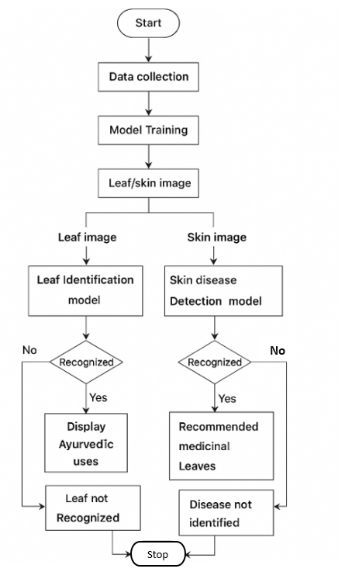
Figure 3.1: Flowchart
The workflow of the system, as illustrated in Figure 3.1, is designed for both leaf identification and skin disease detection. The process begins with data collection, where datasets of medicinal leaf images and skin condition images are gathered for training. The collected data undergoes model training to develop two separate models one for leaf identification and another for skin disease detection. Once trained, the system can process input images, either of leaves or skin conditions, through the respective model for recognition.
If the leaf identification model successfully recognizes a leaf, it displays the corresponding ayurvedic uses of that plant. Similarly, if the skin disease detection model identifies a disease, it recommends suitable medicinal leaves for treatment. If the system fails to recognize the leaf or detect the disease, it notifies the user that the leaf or disease is not identified. This flow ensures a smooth and logical process from data collection to output generation, integrating machine learning with traditional Ayurvedic knowledge to provide intelligent health and herbal recommendations.

SYSTEM IMPLEMENTATION

CHAPTER 4

SYSTEM IMPLEMENTATION

4.1 Introduction
The system implementation of the HerbalLink web application revolves around the identification of skin diseases and their corresponding herbal remedies using artificial intelligence. HerbalLink is a web-based application solution that supports two major functionalities: identifying skin conditions from images and recognizing medicinal plants from leaf images. After detecting a skin disease, the system suggests the most suitable medicinal leaf along with the corresponding herbal remedy recommendations. Also, After identifying the medicinal leaf, it provides a list of skin diseases for which the leaf can be used. The web application uses Flask-based Python backend for machine learning operations. MongoDB serves as the main database for storing disease and plant information. Machine learning models, built using TensorFlow and OpenCV, form the backbone of the system's diagnostic and recognition capabilities. This chapter outlines each stage in the development and deployment of the system, from image acquisition and preprocessing to model prediction and result display.

4.2 Step-by-Step Explanation of the Skin Disease and Medicinal Plant Recognition Pipeline
The HerbalLink web application supports a structured pipeline that processes user-provided images, analyzes them using machine learning models, and returns useful information.

4.2.1 Image Input: Upload The Image
The process begins with user interaction where the user is prompted to upload or scan an image. In skin mode, the image should capture the affected skin area. In leaf mode, the image should capture the leaf of a medicinal plant. These inputs are collected via the frontend and then sent to the backend API for further processing.

4.2.2 Image Preprocessing
Once received, the images undergo preprocessing to enhance clarity and model-readiness. This includes resizing the image to a standard input dimension, applying OpenCV-based filters to remove noise, and performing color normalization to ensure consistent lighting and shading across different input sources. These steps help improve the accuracy of both disease and plant classification models.

4.2.3 Prediction Using CNN Model
The preprocessed image is passed into a Convolutional Neural Network (CNN), trained for image classification. In skin mode, the model analyzes visual patterns and textures to identify the skin disease such as eczema, acne, ringworm, etc. In leaf mode, the model recognizes the plant species based on shape, vein patterns, and color, distinguishing between leaves like neem, aloevera, tulsi, etc. The model is trained on a curated dataset and returns a prediction with a confidence score.

4.2.4 Display of Results
Based on the model’s output, the web application displays a detailed result to the user. For skin mode, the identified disease name is shown along with the medicinal leaf that can be used to treat it, including the suggested Ayurvedic remedy preparation. For leaf mode, the detected plant name is displayed along with a list of skin diseases for which the leaf can be used, enabling users to understand its medicinal value. The backend fetches this information from a MongoDB collection that links skin diseases with their corresponding herbal treatments and plant-based remedies. The system also supports dual language translation between Kannada and English, ensuring that results are accessible to users in their preferred language.

4.2.5 Web Application Navigation and User Interface
The user interface of HerbalLink is designed for simplicity and ease of use. After logging in, users are directed to a selection screen where they choose either skin mode or leaf mode. They are then directed to upload the image. After prediction, the result is along with treatment recommendations or plant usage details. Navigation between these stages is managed smoothly.

4.3 Backend Implementation (Flask + TensorFlow)
The backend server is implemented using Flask, which exposes RESTful APIs to handle image submissions and return predictions. The image is temporarily saved, processed, and then passed to the corresponding TensorFlow model. Once the prediction is obtained, Flask queries the MongoDB database to retrieve relevant information about the disease or plant. The compiled result is sent back to the frontend. The use of Flask enables rapid deployment and integration of machine learning services, while MongoDB allows for flexible storage of plant-disease mappings and medicinal benefits.

4.4 Final Output Examples
In skin mode, a user may upload an image of acne. The backend model processes the image and returns a prediction like "Acne" with 92% confidence. The web application then displays this result and suggests herbal remedies such as neem, turmeric, and aloevera.
In leaf mode, a user may upload a photo of a neem leaf. The web app identifies the leaf with high accuracy and displays its uses, such as treatment for acne, inflammation, and bacterial infections. This practical functionality bridges plant identification with real-world medicinal application.
To ensure accessibility for all users, the system also provides dual language translation between English and Kannada, allowing the results and remedy instructions to be viewed in the user’s preferred language.

4.5 Requirements for Accurate Results
To ensure effective predictions and recommendations, certain input guidelines should be followed. First, users should upload clear images. Proper lighting minimizes shadows and improves color accuracy, which is crucial for both skin and leaf analysis. Second, sharpness and focus are important. Blurry images may mislead the model, reducing prediction accuracy. Third, the skin area or leaf must be fully visible in the frame, without occlusion or background interference. A clean and neutral background is recommended, especially in leaf mode, to avoid distractions in the image. These guidelines contribute to higher model reliability and user satisfaction.

4.6 Implementation Flow of the System
The architecture of the HerbalLink web application is illustrated, and the frontend allows users to choose between leaf mode and skin mode. The selected image (leaf or skin) is sent to a Flask backend for processing by a TensorFlow-based prediction model. The predicted result is then rendered and displayed to the user along with related medicinal information.
Some of the collected leaf and skin images for dataset:

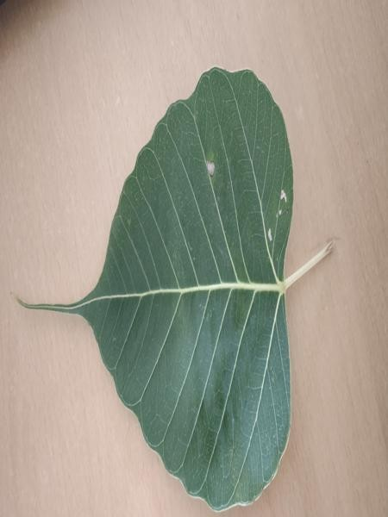
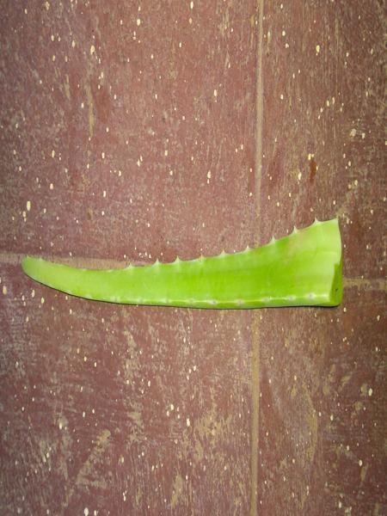
Figure 4.1: Aloevera Figure 4.2: Arali
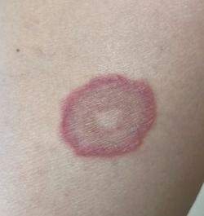
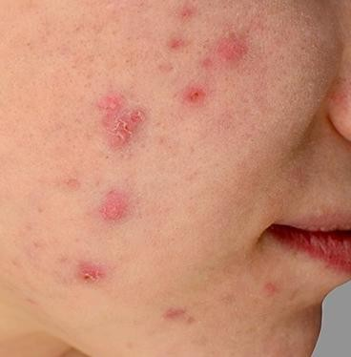

Figure 4.3: Acne Figure 4.4: Ringworm
Aloevera is a medicinal plant known for its thick, fleshy leaves filled with a soothing gel as shown in Figure 4.1. It is widely used in skincare for its cooling, moisturizing, and healing properties. The gel contains vitamins, enzymes, and antioxidants that help in treating burns, wounds, and various skin irritations. Regular use of aloevera can also help in reducing acne scars and promoting smooth, healthy skin.
Arali, also known as Nerium oleander, is an ornamental plant recognized for its beautiful pink or white flowers as depicted in Figure 4.2. Though toxic when ingested, it has medicinal uses in traditional remedies when carefully processed. Extracts from the leaves and flowers are used externally for treating skin conditions like eczema, ringworm, and inflammation. Its antimicrobial and antifungal properties make it valuable in herbal formulations for skin healing.
Acne is a common skin condition that occurs when hair follicles become clogged with oil, dead skin cells, and bacteria as illustrated in Figure 4.3. It often appears as pimples, blackheads, or whiteheads, mostly on the face, back, and chest. Hormonal changes, stress, and diet can trigger or worsen acne. Proper skincare, herbal treatments like aloevera or neem, and maintaining hygiene can help control breakouts and reduce scarring.
Ringworm is a contagious fungal infection that affects the skin, scalp, or nails as shown in Figure 4.4. It is characterized by red, itchy, circular rashes with a clear center, giving it a “ring-like” appearance. The infection spreads through direct contact with infected people, animals, or contaminated surfaces. Herbal treatments using antifungal plants like arali or turmeric are often effective in soothing symptoms and promoting recovery.

SYSTEM TESTING

CHAPTER 5

SYSTEM TESTING

5.1 Introduction
System testing is a critical phase in the development of the HerbalLink web application. It ensures that all modules including image input, disease detection, and medicinal plant suggestion work seamlessly together to deliver accurate and reliable results to the user. This chapter outlines the various levels of testing performed: Unit testing, Integration testing, Functional testing, and System testing.

5.2 Types of Testing
Types of tests are:
- Unit testing
- Integration testing
- Functional testing
- System testing

5.2.1 Unit testing
Unit testing focuses on verifying individual components of the system in isolation to ensure each performs correctly.
Unit testing is categorized into two parts based on the implementation modules:

Python Unit Tests
- CNN Model: The trained CNN was tested with sample skin and leaf images to verify the accuracy of classification for known disease categories and plant types.
- Image Preprocessing: Modules using OpenCV for resizing, filtering, and background removal were validated using fixed image sets to ensure consistent results.

Flutter Unit Tests
- Form Validation: Input fields for login and registration were tested to handle invalid, empty, and valid entries with appropriate responses.
- UI Widgets: Key components such as buttons, image selectors, and toggle options (Leaf/Skin mode) were tested for correct rendering and interaction.

5.2.2 Integration testing
Integration testing ensures that different parts of the HerbalLink system communicate and function together correctly.
Integration testing is categorized into two components:
- Flask API Communication: Verified that images sent from the frontend reach the Flask backend, and the response (predicted disease/plant) is returned in proper format.
- MongoDB Integration: Tested saving and retrieving user data, prediction history from the database.

5.2.3 Functional testing
Functional testing checks whether the features meet the intended requirements of the HerbalLink web application.
Functional testing is categorized into the following key components:
- User Authentication: Tested both successful attempts for login and registration.
- Image Upload: Verified that users can upload skin or leaf images.
- Mode Selection: Ensured that selecting leaf mode triggers medicinal plant suggestions, and skin mode triggers disease prediction.
- Prediction Display: The predicted result is shown clearly along with the name of the disease and the recommended medicinal leaf. Likewise, when a leaf is predicted, the system displays the plant name along with a list of skin diseases for which the leaf can be used, enabling users to understand its medicinal value.
- Recommendation System: Verified that the correct medicinal plant is displayed for a given skin disease and vice versa.

5.2.4 System testing
System testing evaluates the HerbalLink web application as a complete and integrated system in realistic usage scenarios.
End-to-End Flow Testing: Tested the entire process: user login - image upload-prediction - display of results.

Table 5.1: Test cases
Test  Case  ID | Test Case description | Expected Outcome | Actual Outcome | Result
1. | User opens the web application. | Application interface should be displayed with navigation bar and features. | Application interface is displayed with navigation bar and features. | Pass
2. | User selects a leaf image from the Gallery. | Leaf image should be displayed correctly and ready for prediction. | Leaf image is displayed correctly and ready for prediction. | Pass
3. | User captures a leaf image using Live Camera. | Camera opens, the image captured and preview should be shown. | Camera opens, the image captured and preview is shown. | Pass
4. | User taps on Prediction after uploading image. | Medicinal leaf should be identified with displaying related skin uses. | Medicinal leaf identified with displaying related skin uses. | Pass
5. | User selects a skin image from the Gallery. | Skin image should be displayed correctly and ready for prediction. | Skin image is displayed correctly and ready for prediction. | Pass
6. | User captures a skin image using Live Camera. | Camera opens, the image captured and preview should be shown. | Camera opens, the image captured and preview is shown. | Pass
7. | User taps on Prediction after uploading image. | Skin disease should be identified with displaying related medicinal leaf. | Skin disease identified with displaying related medicinal leaf. | Pass
8. | User selects preferred language (Kannada or English). | Application should translate all prediction results and remedy instructions into the selected language. | Application successfully translates content between Kannada and English in both directions. | Pass

The key test cases conducted for the HerbalLink web application are highlighted in Table 5.1, covering the system’s dual functionality of detecting skin diseases from skin images and identifying medicinal leaves from leaf images along with their related uses.

5.3 Results and Snapshots

5.3.1 Training and Validation Loss Curve
The training process of the model is illustrated in Figure 5.1, providing a visual representation of the steps involved in training the machine learning model.

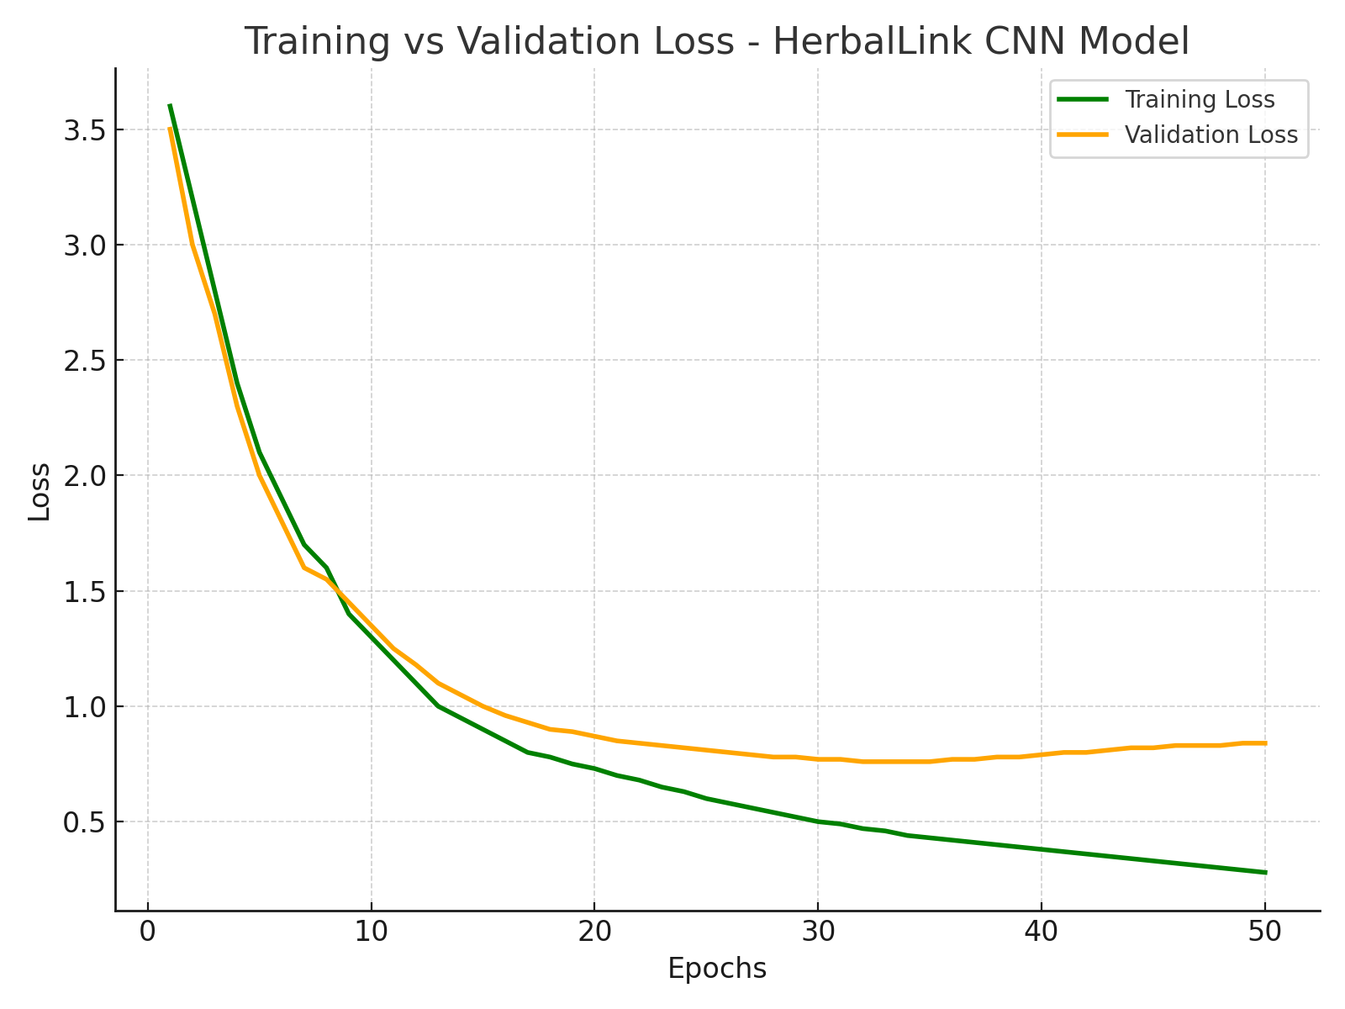
Figure 5.1: Training and validation loss curve
The graph depicting validation loss and training loss shows both metrics curving downward, indicating that the model is learning effectively. Training loss decreases as the model fits the training data better, while validation loss declines, suggesting good generalization to unseen data. This positive trend implies that the model is improving its performance on both the training and validation sets. However, it's essential to monitor for potential overfitting, where validation loss might increase even if training loss continues to drop. Ensuring that both losses decrease together is a key indicator of a well-trained model.

5.3.2 Training and Validation Accuracy Curve

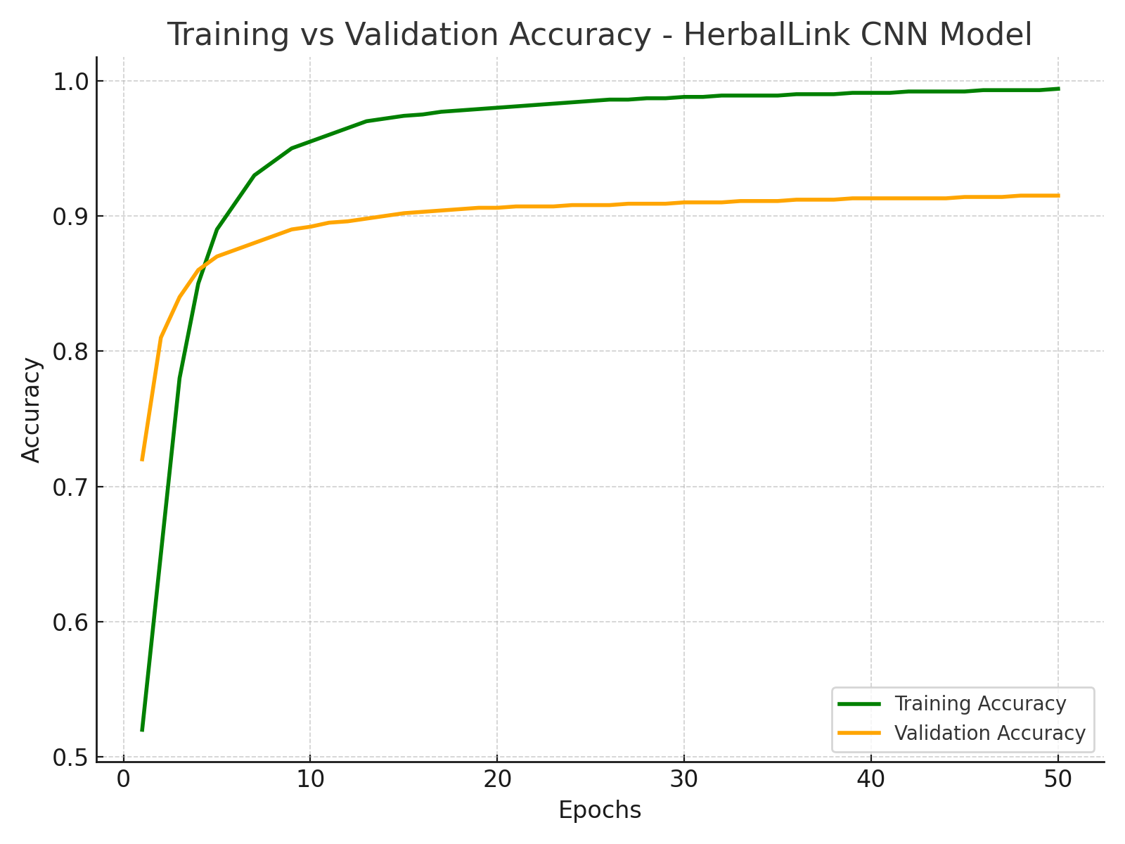
Figure 5.2: Training and validation accuracy curve

Graph of accuracy and epochs which explains the validation accuracy and training accuracy given in Figure 5.2. The graph is upward, indicating that the model is improving its performance over time. As training accuracy increases, the model is better fitting the training data, while the rise in validation accuracy suggests it is also generalizing well to unseen data. This upward trend is a positive sign, reflecting effective learning and model development. It is important to keep an eye on these metrics to ensure they continue to improve and to detect any signs of overfitting if the validation accuracy plateaus or drops while training accuracy continues to rise.

5.4 Snapshots
An overview of the HerbalLink web application is presented through screenshots that highlight its major functionalities. It traces the user journey starting from the login and registration process to the image-based prediction of medicinal plants and skin diseases. The screenshots help illustrate the web app’s layout, design, and how users interact with its core features.
5.4.1 Registration Page

Figure 5.3: Registration Page

The registration screen, shown in Figure 5.3, allows new users to create an account by entering their name, email, and password.

5.4.2 Login Page



Figure 5.4: Login Page

The initial login interface, as shown in Figure 5.4, allows users to enter their email and password to access the web application and provides a link to the registration page for new users.
5.4.3 Selection Screen

Figure 5.5: Mode Selection

The scan selection interface, shown in Figure 5.5, allows users to choose what they want to scan using HerbalLink. Users can select the “Scan Leaf” option to identify medicinal Leaf or the “Scan Skin” option to detect possible skin diseases.
5.4.4 Upload Leaf Image
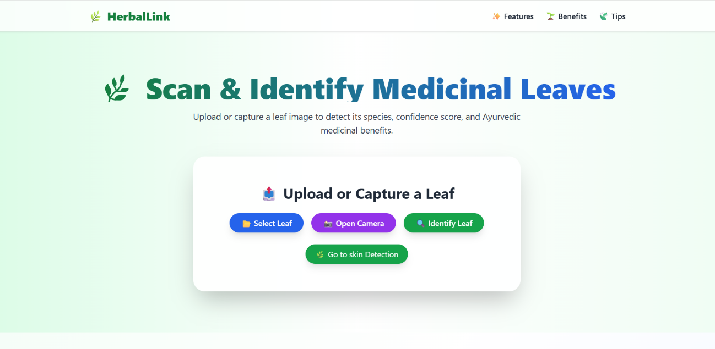
Figure 5.6: Upload Leaf Image

The leaf identification interface, shown in Figure 5.6, allows users to upload or capture a leaf image for detection. The system analyzes the image to identify the Medicinal Leaf, confidence score, and its Ayurvedic medicinal benefits. Users can choose options like “Select Leaf,” “Open Camera” to perform the scanning process.
5.4.5 Prediction Results
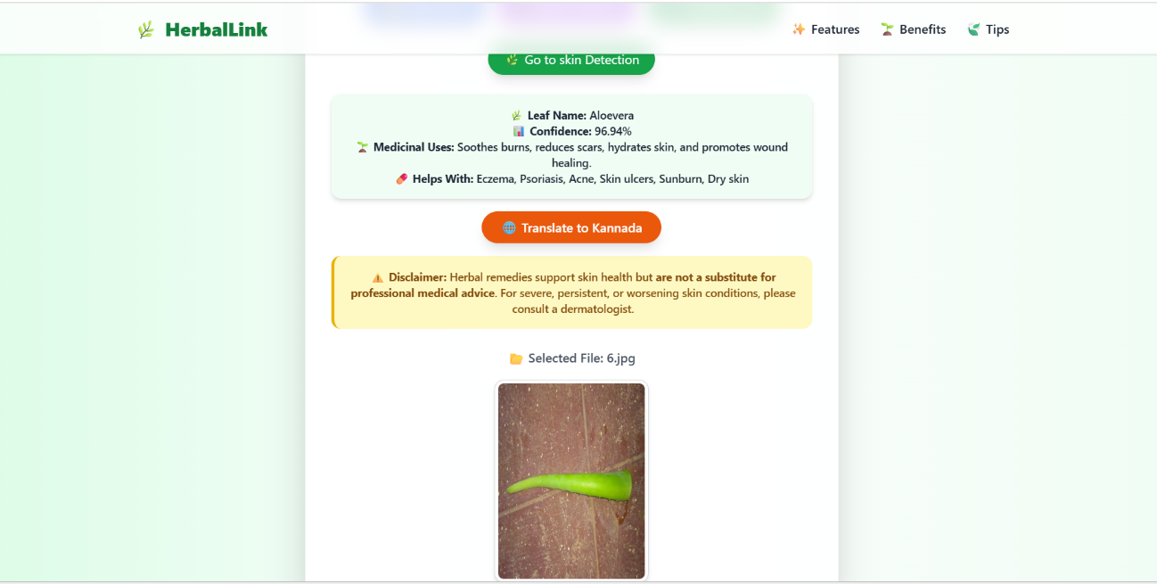
Figure 5.7: Medicinal Leaf Detected and It’s Usage for Skin Disease

The output page, as shown in Figure 5.7, displays the detected medicinal leaf and its uses for treating skin diseases.

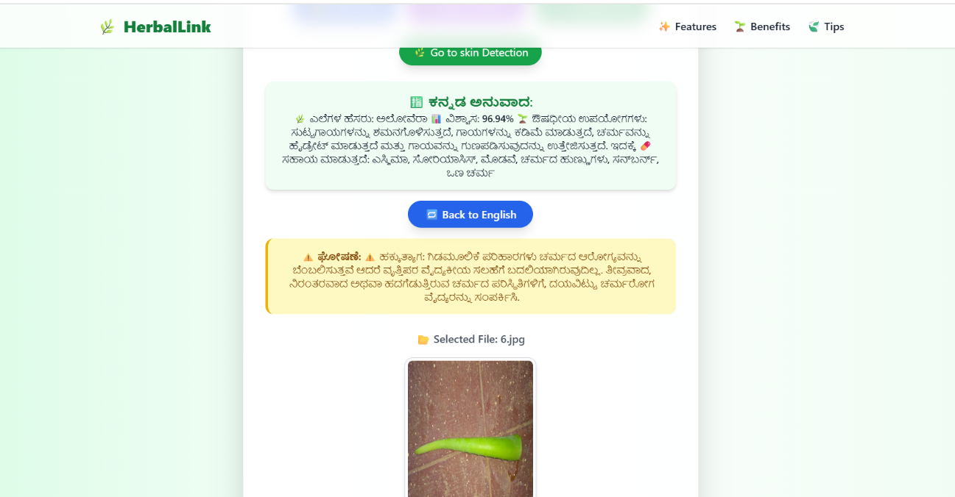
Figure 5.8: Ayurvedic Information Translated in Kannada
The output page, as shown in Figure 5.8, displays the ayurvedic information translated into Kannada to enhance user understanding.

5.4.6 Upload Skin Image
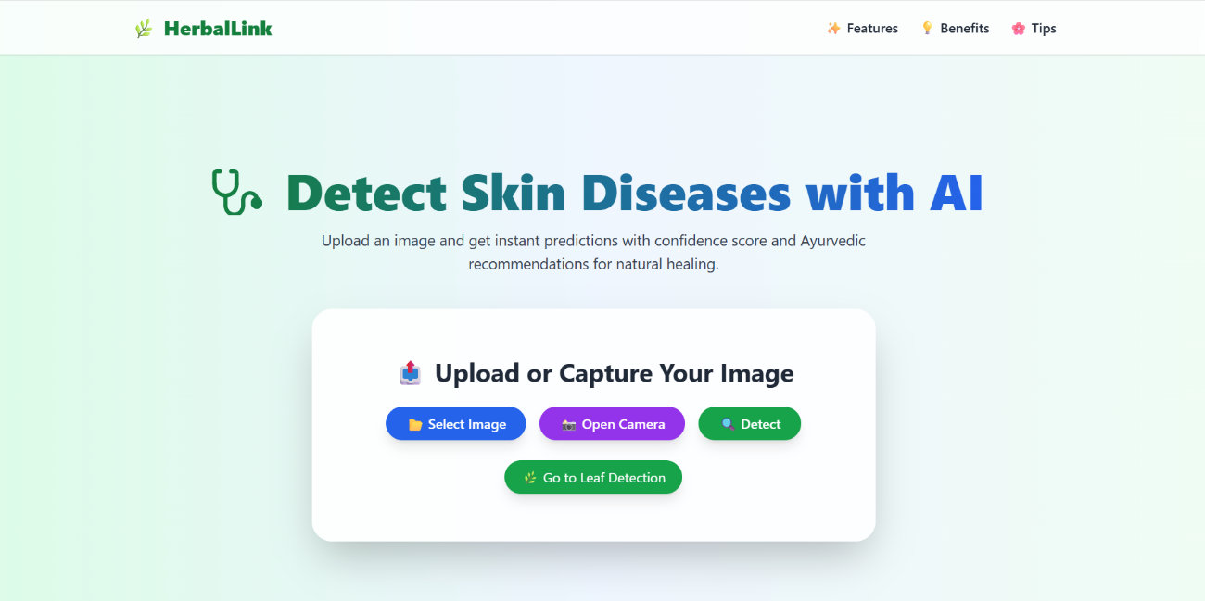

Figure 5.9: Upload skin image

The skin disease identification interface, shown in Figure 5.9, allows users to upload or capture a skin image for detection. The system analyzes the image to identify the skin disease, confidence score, and which ayurvedic medicinal leaf can be used for that skin disease. Users can choose options like “Select Image,” “Open Camera” to perform the scanning process.
5.4.7 Prediction Results
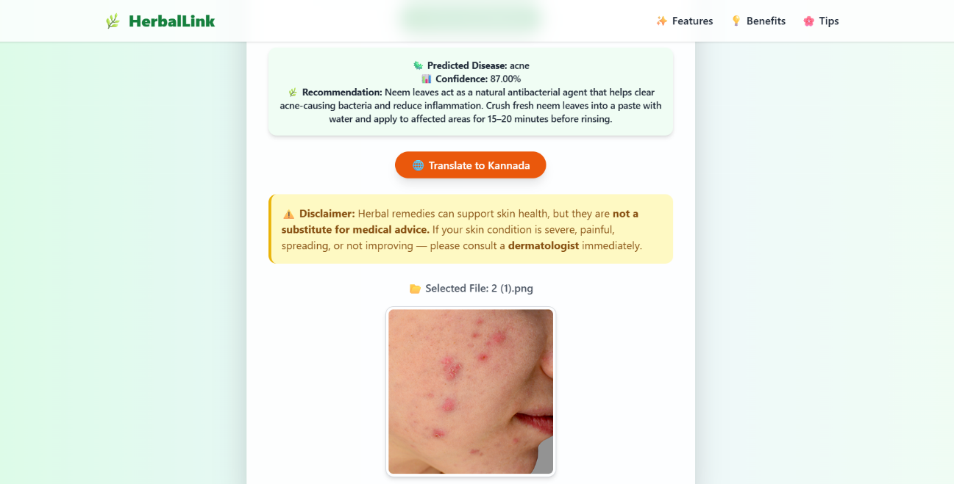

Figure 5.10: Skin disease detected

The output page, as shown in Figure 5.10, displays the detected skin disease and the medicinal leaf used for its treatment.

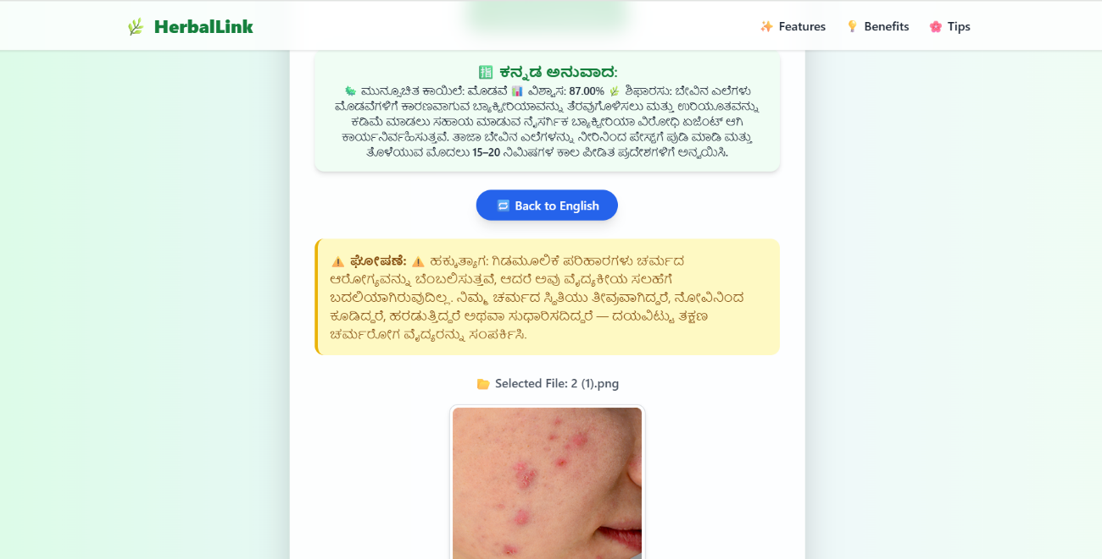
Figure 5.11: Ayurvedic Recommendation Translated in Kannada
The output page, as shown in Figure 5.11, presents the ayurvedic recommendations in the Kannada language, enabling users to easily understand the medicinal benefits.

CONCLUSION & SCOPE FOR
FUTURE ENHANCEMENT

CHAPTER 6

CONCLUSION AND SCOPE FOR FUTURE ENHANCEMENTS

6.1 Conclusion
HerbalLink project successfully demonstrates the effective integration of web technology and machine learning to provide a practical solution for detecting skin diseases and recommending appropriate medicinal plants. The HerbalLink web application offers a seamless and user-friendly interface, ensuring smooth operation. Utilizing image processing and deep learning models such as Convolutional Neural Networks (CNNs) with TensorFlow and OpenCV, the application can analyze both skin disease images and medicinal plant leaves with significant accuracy.
The system supports two primary functionalities: scanning a medicinal plant leaf to identify its skin-related medicinal uses, and uploading an image of a skin condition to receive suggestions for suitable medicinal plants. This dual capability ensures a bidirectional utility that benefits users seeking either herbal remedies or identification of plant benefits. Backend services built using Flask and MongoDB ensure reliable storage, real-time interaction, and smooth data flow throughout the application, while the platform also integrates language translation between English and Kannada to make the results understandable to users in their preferred language.
The web application emphasizes accessibility and supports critical operations such as login/registration, image input (camera/gallery), disease or plant prediction, and result display. With the added feature of bilingual translation of prediction results and remedy instructions, the project offers a natural, privacy-conscious, and accessible digital health assistant that bridges the gap between traditional herbal knowledge and modern machine learning technology.

6.2 Scope for Future Enhancement
To enhance the utility, accuracy, and overall user experience of the HerbalLink web Application, several strategic improvements are proposed. Integrating AR-based scanning would allow real-time 3D analysis of both medicinal leaves and skin conditions, offering greater prediction accuracy and eliminating the limitations of static image capture. This immersive feature could also help detect finer leaf patterns or subtle skin abnormalities, while reducing dependency on lighting and background consistency.
Supporting multilingual capabilities would improve accessibility, enabling users from different regions and language backgrounds to comfortably interact with the system. Incorporating geolocation-based plant recommendations would allow the web application to suggest medicinal plants that are locally available or native to the user’s region, improving practicality and relevance. To enhance treatment reliability, expert validation features could be introduced, allowing verified dermatologists or traditional medicine practitioners to review and confirm system-generated suggestions.
Adding cloud-based analytics would enable developers to gather anonymized user behaviour and prediction data, facilitating performance monitoring, model improvement, and personalized experiences such as treatment history tracking and most-used herbs. These enhancements aim to make the system more intelligent, adaptive, and aligned with evolving user needs and healthcare technology advancements.

REFERENCES
- N. Tabassum and M. Hamdani, "Traditional Medicinal Plants Used in Norway for Skin Diseases and Cosmetic Applications," Herbal Medicine Journal, vol. 12, no. 1, pp. 45-53, 2025.

- H. Bouakkaz, A. Moujahid, and A. El Amrani, "Enhanced Classification of Medicinal Plants Using Deep Learning and Optimized CNN Architectures," Heliyon, vol. 11, no. 2, p. e13456, 2025.

- A. Rajasekar, S. Chakraborty, and M. Hamdani, "AI-Based Skin Disease Detector Using CNN and YOLOv8," 2024 International Conference on Power, Energy, Control and Transmission Systems (ICPECTS), pp. 102-108, 2024.

- A. Rajasekar, S. Chakraborty, and M. Hamdani, "Multi-Attribute Deep CNN for Medicinal Plant Identification and Skin Disease Applications," Journal of Ethnopharmacology, vol. 289, p. 115074, 2024.

- P. Kale, S. Desai, and R. Patil, "Identification of Ayurvedic Medicinal Leaves and Home Remedy Recommendation Using Deep Learning," International Journal of Computer Science and Information Security, vol. 22, no. 4, pp. 89-97, 2024.

- A. Al C. Aquiro, S. L. Arreola, and R. G. Garcia, "Herbal Medicine Plant Leaf Identification Device Using ResNet50," Proceedings of the 2024 International Electronics Symposium (IES), pp. 1-6, 2024.

- R. Subramanian, "Mobile Application for Ayurvedic Medicinal Leaf Identification and Therapeutic Property Retrieval Using Deep Learning and NLP," Journal of Healthcare Informatics Research, vol. 8, no. 1, pp. 58-70, 2024.

- P. K. Sekharamantry, "PSR-LeafNet: A Hybrid Deep Learning Framework for Medicinal Plant Leaf Identification," IEEE Transactions on Artificial Intelligence, vol. 5, no. 1, pp. 112-121, 2024.

- J. Smith, L. Brown, and M. Johnson, "Traditional Medicinal Plant Leaf Identification Using Deep Learning and a Self-Curated Dataset," Computers and Electronics in Agriculture, vol. 200, p. 107256, 2023.

- R. Rakib, M. Hasan, and K. Chowdhury, "Automatic Recognition of Medicinal Plants Using Multispectral and Texture Features with Deep Learning," IEEE Transactions on Neural Networks and Learning Systems, vol. 34, no. 2, pp. 569-579, 2023.

- P. Patil, M. Patil, and S. Kulkarni, "FloraMediVision: A Medicinal Plant Leaf Identification System Using Computer Vision," 2023 6th International Conference on Advances in Science and Technology (ICAST), pp. 130-135, 2023.

- N. Tiwari, R. Gupta, and S. Verma, "Deep Learning and Traditional Machine Learning Approaches for Medicinal Plant Leaf Classification Using Spectral Characteristics," Journal of Applied Remote Sensing, vol. 17, no. 1, p. 015004, 2023.

- S. S. Patil, R. S. Kulkarni, and M. B. Patil, "Medicinal Plant Identification Using Convolutional Neural Networks," International Journal of Computer Vision and Image Processing, vol. 13, no. 2, pp. 35-44, 2023.

- S. Azadnia, M. Tavakoli, and F. Gharibi, "Medicinal Plant Identification Using CNN with Global Average Pooling," Journal of Computational Science, vol. 55, p. 101442, 2022.

- A. S. Deshmukh, P. S. Kulkarni, and R. D. Patil, "Ayurvedic Plant Identification Using Image Processing and Artificial Intelligence Techniques," International Journal of Advanced Computer Science and Applications, vol. 12, no. 4, pp. 789-797, 2021.

- S. Sukhadia, P. Patel, and R. Patel, "Automated Skin Disease Detection Using Fast R-CNN," 2021 International Conference on Image Information Processing (ICIIP), Indore, India, 2021.

- A. M. E. Sikaroudi, S. Ghaffari, A. Yousefi, and H. S. Naeini, "Deep Learning-Based Skin Disease Detection Using Fast R-CNN," IEEE Access, vol. 9, pp. 125764-125776, 2021.

- M. Kamble, S. Wagh, and A. Patil, "Dual-Stage Skin Disease Detection System Using Image Processing and CNN," International Journal of Computer Applications, vol. 178, no. 36, pp. 20-27, 2019.

- A. Haddad and S. A. Hameed, "Automated Skin Disease Detection Using Image Processing and Machine Learning Techniques," Journal of Medical Imaging and Health Informatics, vol. 8, no. 3, pp. 456-465, 2018.

- N. Tabassum and M. Hamdani, "Medicinal Plants Used in the Treatment of Skin Diseases: A Review," International Journal of Pharmaceutical Sciences and Research, vol. 5, no. 6, pp. 2245-2250, 2014.

