CHAPTER 1

INTRODUCTION
  - Introduction to the Project
Yakshagana is a traditional art form from the coastal region of Karnataka, known for its powerful storytelling, dramatic expressions, and vibrant costumes. It combines elements of dance, music, dialogue, and colourful visuals to narrate stories from Indian epics like the Ramayana, Mahabharata and Regional histories. The ability to transform performers into legendary characters using face makeup, costumes, and grand crown styles makes Yakshagana truly special.
Each character in Yakshagana like god, demon, king, or sage is visually distinctive. Gods often wear tall, golden crowns and have calm, balanced makeup, while demons display aggressive expressions with bold colours and pointed crowns. Sages are portrayed with more peaceful and minimalistic features. These visual elements are essential for recognizing each character and narrating story to the audience.
As times change and Yakshagana performances are increasingly documented through digital media resulting a new challenge in recognizing these traditional characters in images and videos without expert guidance. For someone unfamiliar to the Yakshagana and its costumes and makeup, identifying character is difficult. This challenge is mainly faced by students, researchers, and culture enthusiasts who wish to explore and learn more about this rich art form.
Our project, titled YakshaVarnika-A Journey into the Soul of Yakshagana’s Legendary Characters, it aims to make the process of recognizing Yakshagana characters from digital images easy using Artificial Intelligence. Instead of choosing manual classification or expert opinion, our system analyses photographs and determines which type of character is being portrayed. This is done by studying key features such as makeup designs, crown shapes, and costume styles.
This initiatives are not only preserving an important cultural practice but also making it more accessible. Whether someone is browsing a digital archive, using an educational app, or simply exploring Indian heritage, this tool can act as a guide to understanding the roles and traditions behind Yakshagana performances.

  - Introduction to Technology
To turn this cultural vision into a working reality, we use modern tools of technology. At the core of our system is Artificial Intelligence, particularly a technique known as Convolutional Neural Networks (CNNs). These deep learning models are identifying patterns in images for recognizing a face or object.
Our recognition system involves sequential workflow:
- Image Preprocessing: The first step is cleaning the image. This involves removing background noise, adjusting brightness and contrast, and making sure the image is clear enough for analysis. This step helps the system focus only on the important parts such as facial designs, makeup, and crown outlines without being distracted by unnecessary elements.
- Convolutional Neural Network (CNN): This is the core of the technology. The CNN is trained on many Yakshagana character images. Over time, it learns what patterns make each character unique. It recognizes lines, shapes, textures, and colours that are specific to gods, demons, and other character types. The more images it analyses, the better it becomes at making predictions just like how a person gets better at identifying things with experience.
- Classification Layer: Once the CNN has analysed the image, the final layer decides. It checks all the patterns the system has learned and then classifies the character into the appropriate category. The result is fast and accurate, giving users an instant character recognition in the image.
Together, these components form a powerful engine that brings Yakshagana recognition into the modern digital world. The process is completely automatic, happening in just a few seconds, and it doesn’t require the user to have any background knowledge of Yakshagana.
1.3 Importance of Yakshagana Character Recognition
Yakshagana is not just a performance, it reflects our heritage, values, and storytelling traditions. Preserving it is not only about archiving performances but also about making them understandable and engaging for people today. Our project is designed with this purpose in mind to bridge the gap between culture and technology. By using AI to identify characters, we make it easier for learners and enthusiasts to explore Yakshagana without feeling lost. Teachers can use this tool in classrooms and museums can use it in exhibits, and students can use it for research. Even casual viewers can get insights into what character is being portrayed on stage. This kind of recognition system is especially important in an age where many art forms risk being forgotten. By capturing the beauty of Yakshagana through intelligent tools, we help keep it alive and thriving. YakshaVarnika is more than just a technical project it’s a tribute to cultural identity. It shows how tradition can evolve with time and how technology can help us carry forward the stories that define us.

CHAPTER 2
LITERATURE SURVEY
2.1 Introduction
A literature reviews is a though summary of earlier studies on a subject. The literature review examines scholarly books, journals, and other sources that are pertinent to a particular field of study.
2.2 Literature Survey
Anantha Murthy et al. [1] investigated the use of deep learning to identify characters in Yakshagana, a traditional art form of Karnataka. The research focused on classifying roles like Vishnu, Devi, Sarpa, and Mahisha based on visual elements such as headgear and facial makeup. Techniques used included YOLOv5 for detecting characters, a Three-Tier CNN for recognizing disguises, and a Cyclic Gate RNN to analyse sequential features. A dataset of over 10,000 images was developed for training and evaluation. Image preprocessing involved the Multigrid Ensemble Kalman Filter (MEKF), and ACEWT was applied for extracting features. Among the methods, YOLOv5 achieved the highest accuracy of 98.2% for select roles. The system shows promise for real-time applications and cultural preservation. However, it covers only a limited character set, with potential to include videos and diverse styles in future work.
Jaison Paul Mulerikkal et al. [2] developed an AI system for recognizing Kathakali mudras, utilizing a dataset of 12,000 images from live performances. They tested deep learning models such as VGG-19, ResNet-152, Inception V3, and YOLOv8, along with machine learning Techniques like SVM and Few-Shot Learning. VGG-19 achieved the best performance with an accuracy of 99.96%. The system was showcased at a public biennale, offering live mudra predictions during performances. However, it currently only identifies single-hand gestures. Future enhancements aim to include recognition of double-hand mudras, facial expressions, and deeper contextual meanings. Additionally, plans for incorporating explainable AI and multilingual support are in progress.
Remya P.K. and Rajkumar K.K. [3] explore the recognition of Asmyukta mudras in Indian classical dance by implementing a hybrid approach that combines deep learning and traditional techniques. While conventional methods often face challenges in dynamic visual environments, deep learning models like CNNs have shown promise but may not always detect subtle differences in gestures. By integrating both handcrafted and deep features, the system can capture intricate details and higher level information. Accurate segmentation, using models like UNET, is crucial for isolating relevant gesture regions. To enhance computational efficiency, dimensionality reduction methods such as Extra Trees are applied. The authors propose a fusion system that significantly improves gesture recognition accuracy and robustness in classical dance recognition tasks.
Gulzar Ahmad et al. [4] designed a system using Convolutional Neural Networks (CNNs) to improve how computers recognize and classify images. They tested popular models like AlexNet, GoogLeNet, and ResNet50 on datasets such as CIFAR-10, CIFAR-100, and ImageNet. By using transfer learning, they fine-tuned these models to better identify everyday objects. Their experiments showed that deeper networks like ResNet50 performed more accurately, especially with complex images, while AlexNet struggled with precision. The system was also tested on real-time image streams to check how it handles real-world scenarios. One interesting finding was that models sometimes confused visually similar items, like sandals and dresses. Overall, the study proved that CNNs can be powerful tools for image classification when properly trained and adjusted. However, it also highlighted the need for smarter handling of similar-looking objects to boost reliability.
Anantha Murthy et al. [5] reviewed existing research on Yakshagana and found that most work emphasizes its cultural and historical significance, with minimal focus on technological integration. Although deep learning methods like CNN, RCNN, YOLO, and ResNet have been effective in fields like object detection and facial recognition, they have not yet been applied to traditional art forms. Given the distinctive and consistent makeup, costumes, and ornaments in Yakshagana, these technologies offer strong potential for automated character recognition. The authors highlight a clear research gap and propose addressing it through image processing and AI-driven approaches.
Sahana R. Koti et al. [6] developed a deep learning framework for classifying traditional attire from various Indian states using convolutional neural networks (CNNs) like DenseNet121, ResNet50V2, MobileNetV2, and VGG16. They curated a dataset of 6,817 costume images from various online sources, resizing them to 224x224 pixels and enhancing them through data augmentation techniques. The models were trained with an 80:20 training-validation split, and DenseNet121 achieved the highest accuracy of 98.8%. The study highlighted the significant role of preprocessing in enhancing model performance, preventing overfitting, and demonstrating how CNNs can support the preservation and classification of cultural heritage.
Milan and Tripathi [7] examine the use of Convolutional Neural Networks (CNNs) for image classification across diverse applications. In healthcare, CNNs have been effective in analysing medical images, aiding in disease identification with high precision. For navigation systems, combining CNNs with advanced pooling techniques has improved scene analysis. In biometric recognition, CNNs enhance the accuracy of face and ear identification. In retail and agriculture, networks like VGG, EfficientNet, and MixNet help in recognizing fruits for automated processing. Integrating CNN features with traditional classifiers such as SVM leads to better classification results. These models adapt well to complex data and require minimal manual feature extraction. CNN-based approaches reduce processing time while increasing reliability. Overall, the research highlights CNNs as efficient and adaptable tools for image-based tasks.
Ahmed A. Elngar et al. [8] present a detailed survey on image classification, emphasizing the transformative role of Convolutional Neural Networks (CNNs) in the field. They begin by reviewing traditional methods such as K-Nearest Neighbors (KNN), Support Vector Machines (SVM), and Artificial Neural Networks (ANN), which require manual feature extraction and often struggle with complex image data. CNNs, on the other hand, automate this process through layered architectures that include convolution, pooling, activation (ReLU), and fully connected layers. The authors highlight CNNs' strong performance in applications like facial recognition, medical imaging, and autonomous driving, thanks to their ability to learn directly from raw image data. A practical example using TensorFlow and Keras demonstrates how CNNs are implemented for object detection. While CNNs require large datasets and are computationally demanding, the paper underscores their advantages in accuracy, scalability, and adaptability across domains. Overall, the survey illustrates how CNNs have become the backbone of modern image classification systems.
Wagh et al. [9] developed a deep learning model using Convolutional Neural Networks (CNNs) to classify grayscale handwritten digits from the MNIST dataset. Their system processes images using multiple convolutional and pooling layers, followed by a fully connected layer with a sigmoid activation function to produce the final output. The model was trained on 42×50 pixel images and achieved an impressive accuracy of 97.98% after five training epochs. It used 32 and 64 filters in the early layers to extract important features from the images. The training process required significant computational power due to the nature of grayscale image processing. The approach proved effective in recognizing digit patterns with high accuracy. However, the system was tested only on a limited dataset and image type. The authors suggest that future work could focus on extending the model to handle coloured images and more complex datasets for broader real-world applications.
Kumar et al. [10] conducted a study comparing five CNN architectures LeNet, AlexNet, VGGNet16, ResNet50, and GoogLeNet on their performance in image classification using CIFAR-10 and CIFAR-100 datasets. The goal was to evaluate each model’s accuracy and efficiency across different object categories. The findings revealed that deeper networks like ResNet50 and GoogLeNet significantly outperformed shallower ones like LeNet and AlexNet. VGGNet16 struck a good balance between performance and simplicity. Notably, GoogLeNet achieved the highest accuracy (56.19%) in live video feed testing, highlighting its real-time applicability. The study emphasized the importance of network depth and effective feature extraction, concluding that deeper models generally perform better, provided the training data is well-structured. However, it also pointed out the high computational resources required for training and deploying these models.
Reshma Deshmukh and Anup Vibhute [11] reviewed Digital Image Processing (DIP), emphasizing its advantages over Analog Image Processing (AIP), especially in terms of speed and versatility. They explored various applications, such as image restoration, pattern recognition, and OCR. The paper looked at different segmentation techniques like edge-based, region-based, thresholding, and clustering methods such as K-Means and Fuzzy C-Means. They also discussed feature extraction methods like SIFT, SURF, BRIEF, and ORB, weighing their efficiency for real-time use. While SIFT was praised for its accuracy, ORB stood out for its faster performance. The review also covered classification methods and image compression techniques. Ultimately, it concluded that no single method works best for every case, suggesting that combining different approaches is key.
Agarwal et al. [12] developed a smart fashion recommendation system using deep learning and web technologies to simplify online shopping. The system uses Convolutional Neural Networks (CNNs) like LeNet-5 and AlexNet to classify clothing items from the Fashion-MNIST dataset, which includes over 70,000 images of various apparel. By applying transfer learning, the model reduces training time while maintaining high accuracy. A unique feature of the system is its ability to track and predict product price trends using web scraping tools, helping users make cost-effective purchasing decisions. It also allows users to sell pre-owned clothes by estimating resale value based on brand and condition. The platform is built using Django REST Framework and ReactJS to ensure a smooth and interactive user experience. While the system performs well in item classification and price forecasting, it currently supports a limited range of fashion items and does not offer features like personalized sizing or virtual try-on.
P. V. V. Kishore et al. [13] Human action recognition includes object extraction, feature representation, and classification. Traditional methods like shape templates and dense trajectories work well in lab settings. However, they struggle with real-world issues such as lighting, motion blur, and background clutter. Indian Classical Dance (ICD) adds complexity with intricate poses, gestures, and costumes. Standard pose estimation techniques often fail in capturing such expressive movements. Classifiers like SVM, AdaBoost, and ANN have shown moderate success but lack efficiency. CNNs outperform traditional models by learning features automatically and handling visual variation. Yet, CNNs have been rarely applied to ICD, which this study aims to address effectively.
Tsung-Han Chan [14] Earlier approaches to image classification often depended on manually crafted features, such as SIFT and LBP, which were limited in their ability to generalize across different datasets. Convolutional neural networks (CNNs) overcame this by learning hierarchical features automatically, but they often required substantial computational resources and extensive parameter optimization. On the other hand, simpler methods like wavelet scattering networks achieved competitive results with fixed filters. PCANet, an innovative approach, introduced a lightweight architecture that utilized PCA filters, binary hashing, and block-wise histograms, eliminating the need for complex training while still maintaining strong classification performance. Further variations, including RandNet and LDANet, experimented with random and supervised alternatives to the filtering process. PCANet has shown robust performance across diverse datasets, including faces, digits, textures, and objects. Its simplicity and effectiveness make it a solid baseline for many image classification tasks.
Martha Bush Ashton’s [15] work serves as a foundational introduction to Yakshagana, a vibrant theatrical tradition from coastal Karnataka. She presents it as a fusion of music, dance, dialogue, and elaborate costumes. Ashton highlights the importance of prasangas scripts, often drawn from epics like the Ramayana and Mahabharata, in shaping the performances. A notable feature she emphasizes is Yakshagana’s striking visual style, including ornate headgear and unique facial makeup, which help define characters. Combined with energetic dance and music, these elements create a culturally rich and immersive theatrical experience.

2.3 Summary of Literature Survey
A review of existing research was conducted to understand current methods in image classification and character recognition. Most studies use deep learning, especially CNNs, for effective image classification and character recognition. While these models handle complex features well, challenges remain with costume variations and lighting. Few works focus on traditional art forms like Yakshagana, highlighting a gap this project aims to address.

Table 2.1: Observations of Literature Survey
Author | Title of  Paper | Proposed  Solution | Advantage | Disadvantage
Murthy, Anantha, and Sanjeev Kulkarni | Yakshagana Character Identification Through Deep Learning with Crown and Facial Makeup Pattern Analysis | The research used deep learning tools like YOLOv5, CNN, and RNN, along with smart filtering and feature extraction. | It makes it easier to identify Yakshagana characters quickly, helping keep the art form alive in the digital age.
  Limited number of characters, no video-based analysis, restricted styles.
Mulerikkal, Jaison Paul et al. | Kathakali Mudras: An Enhanced Predictive Approach | They used AI to recognize Kathakali mudras, with VGG-19 giving the best results. | It brings real-time gesture recognition to Kathakali shows.
  Recognizes only single-hand mudras, limited contextual interpretation.
Remya, P. K., and K. K. Rajkumar. | Classification of Asmyukta Mudras in Indian Classical Dance Using Handcrafted and Pre-Trained Features with Machine Learning and Deep Learning Methods | They fused deep learning and handcrafted features with UNET segmentation for better recognition. | It helps recognize dance gestures more accurately and reliably.
  Increased system complexity, higher computation cost.
Ahmad et al. | Analysis of Convolutional Neural Network for Image Classification | They trained popular CNN models to better recognize images using transfer learning. | It makes computers better at recognizing images quickly and accurately. | Confusion between visually similar objects, heavy computational needs.
Murthy et al. | A Technical Approach for Promotion of Yakshagana -A Literature Survey | They focused on CNN, RCNN, YOLO, ResNet, and image processing techniques. | It helps quickly and easily recognize Yakshagana characters. | No experimental implementation, conceptual study only.
Koti et al. | Traditional Costume Image Classification for Indian States Using Deep Learning | They collected images and resized them, and trained CNN models like DenseNet121, ResNet50V2, MobileNetV2, and VGG16 to classify traditional Indian attire. | It helps keep cultural traditions alive by recognizing traditional clothes accurately. | Dataset limited to images, no real-time use.
Tripathi, Milan | Analysis of Convolutional Neural Network based Image Classification Techniques | They used CNNs with smart pooling and SVMs to boost image recognition in different areas. | It helps computers recognize images more quickly and accurately in everyday applications. | Performance depends on dataset quality and size.
Elngar et al. | Image Classification Based on CNN: A Survey | They explored how CNNs automate image recognition using layered steps like convolution and pooling, replacing older manual methods. | CNNs make image recognition more accurate and adaptable without needing manual effort. | Requires large datasets and high computational power.
Wagh et al. | Classification of Image using Convolutional Neural Networks | They trained a CNN on grayscale digit images using convolution, pooling, and sigmoid layers to classify handwritten numbers. | It accurately reads handwritten digits, making digit recognition easier and faster. | Limited to grayscale and small dataset.
Kumar et al. | Convoluted Fashion Classifier Prediction Using Neural Networks | They compared five CNN models on CIFAR datasets for best image classification and real-time tasks. | It helps choose the right CNN model for better and faster image recognition. | High training cost, hardware intensive.
Deshmukh et al. | A Review on digital image processing applications, techniques and approaches in various fields | They reviewed digital image processing techniques like segmentation, feature extraction (SIFT, ORB), and classification. | It shows how digital methods make image tasks faster and more flexible than older analog  techniques.
  No deep learning implementation
Agrawal et al. | Comparative Analysis of different Convolutional Neural Network Algorithm for Image Classification | The system smartly uses CNNs to recognize clothes, track prices, and suggest resale value, all through an easy-to-use Django-React app. | It makes shopping easier by recognizing clothes, tracking prices, and estimating resale value.
  Limited clothing categories, no virtual try-on.
Kishore et al. | Indian Classical Dance Action Identification and Classification with Convolution Neural Networks | The approach uses CNNs to better understand and recognize the intricate movements of Indian Classical Dance. | It helps recognize tricky dance moves more accurately and easily.
  Limited application to Indian Classical Dance.
Chan et al. | PCANet: A Simple Deep Learning Baseline for Image Classification | PCANet uses simple PCA filters and hashing to classify images quickly without heavy training. | It quickly and easily classifies images without lots of training or computing power. | Less flexible than CNNs for complex tasks.
Ashton et al. | Yakshagana Badagutittu Bayalata a South Indian Dance Drama | The study explores how music, dance, and costumes bring Yakshagana to life. | It shows what makes Yakshagana’s culture and art so special and lively. | No technical or computational approach.
2.4 Problem Statement
Yakshagana is a traditional folk-art form that beautifully blends dance, music, and drama to depict stories from Indian epics. Each character in Yakshagana is brought to life through unique makeup styles, costumes, and facial expressions. However, identifying these characters manually can be challenging, especially for those who are new to the art form. The process is time-consuming and often depends on the observer’s personal knowledge and experience, which can lead to inconsistencies.
To overcome these limitations, there is a growing need for a technology-driven solution that can automatically identify and classify Yakshagana characters based on their visual features. By using advanced image processing and deep learning techniques, the system can analyse images of performers and accurately recognize the characters they represent. This not only helps in preserving and promoting Yakshagana in the digital era but also supports researchers, students, and enthusiasts in understanding its cultural and artistic diversity more effectively.
2.5 Comparison with Existing Systems
YakshaVarnika introduces a thoughtful and modern approach to understanding the characters of Yakshagana, standing apart from the more traditional and manual methods that have been used for decades. In the past, identifying characters from Yakshagana performances depended largely on the experience and cultural knowledge of experts. These individuals could tell a god from a demon, or a king from a sage, by carefully studying makeup styles, crown designs, and costume details. While effective, this approach isn’t scalable or accessible to the wider public, especially those who are just beginning to explore the world of Yakshagana.
Some efforts have been made in similar classical art forms like Kathakali pose detection or Bharatanatyam gesture recognition, but they usually focus on body movements and do not provide detailed recognition of facial features or costume patterns. These systems often depend on pose estimation or motion tracking, which makes them useful only in very specific cases, like full-body videos or rehearsed movements. In contrast, YakshaVarnika focuses on something far simpler and more powerful: a single image What makes YakshaVarnika truly different is how it uses technology to simplify the process for everyone. With this system, users don’t need to know the character’s background, costume type, or symbolic meaning. All they need is a photo. Once the photo is uploaded, the system carefully processes it, cleans the image, and uses machine learning to identify important features. These include facial makeup, crown shape, and costume details that are unique to each character type. The character is then matched to a category god, demon, king, or sage and displayed to the user.
The core strength of YakshaVarnika lies in its flexibility. Unlike systems that rely on fixed templates or a limited set of sample poses, this project has been trained on real images of performances, capturing the diversity and beauty of Yakshagana across regions and styles. This means the system can adapt to variations in angle, lighting, expression, and even subtle changes in costume design. It makes the tool practical and reliable, even when used on casual performance photos or archival images. Another important difference is the user experience. Instead of asking people to answer multiple questions, browse costume libraries, or filter through options, YakshaVarnika does the work for them. The experience is smooth, friendly, and open to everyone students, teachers, researchers, or anyone who simply wants to understand and appreciate Yakshagana better.
Lastly, privacy and cultural sensitivity are built into the system’s design. It doesn’t collect personal data or require any invasive information. The focus remains on the image itself and on respectfully recognizing and honouring the character within it. This ensures that the technology is not just effective but also ethically sound. YakshaVarnika brings the ancient art of Yakshagana into the modern world through technology. It makes this vibrant tradition easy and meaningful for everyone to enjoy. By going digital, it helps keep Yakshagana alive and inspiring for future generations.

2.6 Proposed System
The proposed solution aims to automate the recognition of Yakshagana characters using a combination of image processing and machine learning, particularly Convolutional Neural Networks (CNNs). It begins with preprocessing steps like noise reduction, contrast enhancement, normalization, and background removal to standardize images and improve model accuracy. Key visual features such as facial makeup, costume colours, crown designs, and ornaments are extracted using techniques like edge detection, colour segmentation, and pattern recognition. A labelled dataset of character images serves as the training foundation, where each image is annotated with character names and possibly metadata like region or troop. CNNs are then trained on this dataset to learn distinguishing visual features, using optimization and data augmentation techniques to enhance robustness and prevent overfitting. Once trained, the model can accurately recognize characters in new images and provide confidence scores for its predictions. This system can be deployed via web or mobile platforms, offering a scalable solution for character identification while promoting the digital preservation of Yakshagana’s cultural heritage.
2.7 Objectives
- Develop an AI based system that identifies Yakshagana characters from images.
- Collect, label, and preprocess a diverse dataset of Yakshagana performance images.
- Extract key visual features such as facial makeup, crown styles, and costumes for effective classification.
- Design and train a Convolutional Neural Network (CNN) model tailored for character recognition.
- Enable students, researchers, and cultural institutions to explore Yakshagana with minimal prior expertise.

CHAPTER 3

REQUIREMENT SPECIFICATION AND ANALYSIS
3.1 Introduction
Requirement analysis is the process of creating a score for a system's effort. The result is neither coordinated nor integrated and often simply does not work. Requirement analysis is critical to the success or failure of a systems or software project. The requirements should be documented, actionable, measurable, testable, traceable, related to identified business needs or opportunities, and defined to a level of detail sufficient for system design.
3.2 Functional Requirement
In software engineering and systems engineering, a functional requirement defines a function of a system or its component, where a function is described as a specification of behaviour between outputs and inputs.
3.2.1 Modules
Image Processing Model
- Utilizes libraries like OpenCV and TensorFlow/Keras to handle various image formats (JPG, JPEG, PNG, etc.) and resolutions.
- Performs preprocessing tasks such as image resizing to 224×224 pixels and normalization to scale pixel values between 0 and 1.
- Applies data augmentation techniques including rotation, flipping, and zooming to improve model generalization and reduce overfitting.
Model Training Module
- Employs Convolutional Neural Network (CNN) architecture to extract features and classify Yakshagana characters.
- Uses labelled datasets of six characters Chanda Munda, Devi, Hanumantha, Krishna, Mahishasura, and Stree vesha for training.
- Refines model parameters over several epochs using the Adam optimizer and categorical cross-entropy loss function to improve prediction accuracy.
Prediction Module
- Loads the trained CNN model (yakshagana_cnn_model.h5) to predict character classes for new input images.
- Processes uploaded images through the same preprocessing pipeline used during training.
- Outputs the most probable character name based on model prediction probabilities.
User Interface Module
- Provides a simple and user-friendly Flask-based web interface.
- Enables users to upload Yakshagana character images for recognition.
- Displays the predicted character name along with a detailed cultural description and visual output.
Results and Evaluation Module
- Evaluates system performance using metrics such as accuracy, precision, recall, and F1-score.
- Generates a confusion matrix to analyse misclassifications between visually similar characters.
- Supports model improvement through retraining or fine-tuning based on evaluation results.
Documentation Module
- Provides detailed technical and user documentation explaining system architecture, module design, and usage instructions.
- Includes developer notes for dataset updates, model retraining, and troubleshooting.
- Ensures that all system modifications are properly documented to maintain version consistency.
3.2.2 User Requirements
- The user should be able to access the web interface easily through a browser.
- The user should be able to upload an image of a Yakshagana character in supported formats (JPG, JPEG, PNG).
- The user should be able to initiate the prediction process using the upload button.
- The user should be able to view the output consisting of the character name and its description.
3.2.3 System Requirements
- The system should provide an interactive interface that allows users to upload and classify Yakshagana character images.
- The system should preprocess input images before passing them to the trained CNN model.
- The system should ensure scalability for additional characters or larger datasets.
- The system should produce output efficiently with minimal response time.
- The system should maintain data integrity and prevent unauthorized storage of uploaded images.
3.3 Non-Functional Requirements
In system engineering and requirements engineering, a non-functional requirement is a requirement that specifies criteria that can be used to judge the operation of a system rather than specific behaviours. These requirements focus on aspects related to usability, security, performance, reliability, scalability, maintainability, and other qualities that contribute to the overall user experience and system operation. Unlike functional requirements, which describe what the system should do, non-functional requirements describe how the system should perform.
Non-functional requirements significantly influence the user experience and overall satisfaction of stakeholders. For instance, a system with poor performance or security vulnerabilities may result in frustration among users and stakeholders, impacting its adoption and success. Addressing NFRs guides system architects, designers, and developers in making design decisions and implementing solutions that align with these critical aspects. It influences technology choices, architectural design, coding practices, and testing methodologies. Achieving a balance between functional requirements (what the system does) and non-functional requirements (how the system performs) is crucial. Both are essential in ensuring a system that not only delivers the expected functionalities but also operates effectively, reliably, and meets user expectations.
In summary, non-functional requirements are indispensable in defining the overall operational characteristics, quality attributes, and user-centric aspects of a system. They provide a roadmap for building a system that excels not just in its functionalities but also in delivering a superior user experience, reliability, security, and performance.
3.3.1 Reliability
This project aims to ensure that the Yaksha Varnika system operates with all specified features and executes flawlessly during image classification. The system undergoes rigorous testing and debugging to handle all exceptions effectively. Image preprocessing steps such as resizing and normalization are implemented to reduce inconsistencies in input quality, while validation procedures ensure accurate predictions. Regular maintenance and retraining with updated datasets will enhance the system’s reliability, ensuring consistent recognition accuracy and dependable user experience in Yakshagana character identification.
3.3.2 Performance
The system is built to handle all tasks smoothly, reducing delays and providing predictions quickly. Its performance is boosted by using Convolutional Neural Networks (CNNs) for image classification, along with smart image preprocessing techniques. The model is trained with adaptive optimizers like Adam, which help speed up computations without sacrificing accuracy. By continuously monitoring and fine-tuning the model, the system ensures reliable, near real-time predictions within the Flask-based web application.
3.3.3 Scalability
The system is built with a modular architecture, making it easy to add new Yakshagana characters or expand the dataset in the future. The trained CNN model can be retrained or fine-tuned with new data without changing the core structure. As the project grows, it can incorporate additional cultural datasets and more advanced deep learning models, such as VGG16, ResNet, or Vision Transformers, while keeping predictions fast and accurate. This design ensures the system remains scalable and adaptable for future research and improvements.
3.3.4 Compatibility
The system is compatible with multiple operating systems, including Windows, Linux, and macOS, and can run on both CPU and GPU configurations. It supports cross-platform deployment through a Flask-based web interface, accessible from desktops, laptops, or mobile browsers. The application also ensures compatibility with various image formats (JPG, JPEG, PNG), allowing users to upload Yakshagana character images from different sources.
3.3.5 Maintainability
Maintainability is achieved through clean coding practices, a modular design, and thorough documentation. Each part of the system image preprocessing, model training, and prediction is organized independently, making updates and debugging simple. The system also incorporates regular dataset updates, retraining cycles, and routine software maintenance to ensure long-term reliability. Using version control tools like Git helps track changes, supporting continuous improvement and keeping the YakshaVarnika platform dependable.
3.4 User Interface Requirements
This section describes how users interact with the Yaksha Varnika system. The interface is designed to be simple and intuitive, allowing anyone researchers, students, or art enthusiasts to upload Yakshagana images and get real-time character recognition without any extra software or technical setup.
- Web-Based Access: Users can access the system through a standard web browser via a Flask-based interface. Simply navigating to the application’s URL opens the platform.
- Easy Image Upload: Users can upload images of Yakshagana characters in common formats like JPG, JPEG, or PNG. The system automatically prepares the image for analysis without requiring any manual adjustments.
- Instant Character Prediction: Once an image is uploaded, the system quickly predicts the character and displays its name along with a brief cultural description. Users can learn about the character’s makeup, costume, and significance at a glance.
- Built-In Accuracy Measures: The system has predefined confidence thresholds to ensure reliable predictions. Users don’t need to configure any settings—the system handles accuracy automatically.
- Logging of Results: All uploaded images and their predictions are recorded internally. This allows developers to monitor performance, make improvements, and retrain the model as needed.
- Minimalist Design: The interface is clean, user-friendly, and distraction-free. There’s no need for additional apps or complex setup, making it accessible for anyone interested in exploring Yakshagana characters.
3.5 Software Requirements
The software requirements define the necessary tools and platforms needed for the successful development and deployment of the system. To ensure smooth functionality and compatibility, the project relies on the following software:
- Windows
- Python 3.10
- VS Code
- Libraries
3.5.1 Python
Python 3.10 is the primary programming language used for developing the CNN model, preprocessing images, training, and integrating the model with the web application. Python provides a rich ecosystem of libraries and frameworks suitable for deep learning and image processing tasks.
Python Features:
- Easy to Learn and Readable: Python has a simple syntax like to natural language, making it easy to learn, write, and understand. This enhances code readability and reduces development time.
- Extensive Library Support: Python provides a vast collection of built-in libraries and frameworks such as TensorFlow, Keras, OpenCV, and Flask, which simplify tasks like machine learning, image processing, and web development.
- Platform Independent: Python is a cross-platform language, meaning programs written in Python can run on different operating systems like Windows, macOS, and Linux without modification.
- High-Level and Interpreted Language: Python handles memory management automatically and executes code line by line, making debugging easier and improving overall development efficiency.
3.5.2 Libraries
- TensorFlow: TensorFlow is used as the core deep learning framework to build and train Convolutional Neural Networks (CNNs). It handles computation-heavy tasks such as feature extraction from images and supports GPU acceleration for faster training. TensorFlow enables the model to learn complex patterns in images for accurate classification.
- Keras: It is running on top of TensorFlow, simplifies the creation and configuration of CNN architectures. It allows easy stacking of convolutional, pooling, dropout, and dense layers, making it straightforward to design, train, and evaluate deep learning models. Keras is ideal for rapid prototyping and fine-tuning neural networks.
- Flask: Flask is a lightweight Python web framework used to create web applications. In an image classification project, it provides an interface for users to upload images, sends them to the trained model for prediction, and displays the results. Flask enables real-time interaction with the model without requiring complex setup.
- NumPy: NumPy is a Python library for numerical computing and handling multi-dimensional arrays. It is used to efficiently manipulate image data, perform mathematical operations, and manage datasets during preprocessing and model training.
- OpenCV: OpenCV is an open-source computer vision library used for image processing tasks. It handles operations such as resizing, normalization, filtering, and data augmentation to prepare images for model training and prediction.
- Matplotlib: Matplotlib is a Python library for creating visualizations. It is used to plot training and validation accuracy, loss curves, and other metrics to analye the performance of the deep learning model.
- Scikit-learn: Scikit-learn is a machine learning library that provides tools for model evaluation and performance measurement. It is used to compute metrics like accuracy, precision, recall, F1-score, and to generate confusion matrices for validating model predictions.
3.6 Hardware Requirements
This section outlines the hardware components necessary for developing, training, and deploying the image classification system. The hardware requirements are chosen to ensure efficient training of the deep learning model, smooth execution of computations, and reliable performance of the web application.
Processor
A multi-core processor Intel Core i5 or higher is recommended to handle computational tasks efficiently. The processor ensures smooth execution of data preprocessing, model training, and real-time inference operations.
Graphics Processing Unit (GPU)
A dedicated GPU (such as NVIDIA GeForce GTX 1050 or higher) is recommended to accelerate the training of the Convolutional Neural Network. GPU support significantly reduces training time by parallelizing large-scale matrix and tensor operations.
Memory (RAM)
At least 8 GB of RAM is required for efficient handling of image data, model parameters, and training processes. For faster data processing and multitasking, 16 GB RAM is recommended.
Storage
A minimum of 256 GB of storage is required to store the dataset, trained model files, and software dependencies. SSD storage is preferred over HDD for faster data access, reduced latency, and improved performance during model training and testing.
Display
A high-resolution display (Full HD or higher) helps visualize training progress, model performance graphs, and output results more clearly. It also aids in inspecting dataset images and web application interfaces during testing.

CHAPTER 4

SYSTEM DESIGN

4.1 Introduction
System Design is the process of defining the architecture, components, modules, interfaces, and data of a system to meet specified requirements. It involves translating user and functional requirements into a structured representation that forms the foundation for software development. Initially, this representation provides a holistic view of the entire system, outlining how different parts interact and function together. Through successive refinements, the design evolves into a detailed structure that closely resembles the final source code. System design can be viewed as the practical application of systems theory to product development, ensuring that every component contributes effectively to the system’s objectives. It also overlaps with related disciplines such as system analysis, system architecture, and system engineering, focusing on performance, scalability, and reliability. Ultimately, system design provides a clear roadmap for developers, ensuring smooth implementation, easier maintenance, and high-quality software output.

4.2 System Architecture
Figure 4.1 Architecture of YakshaVarnika is the conceptual model that defines the structure, behaviour, and more views of a system. An architecture description is a formal description and representation of a system, organized in a way that supports reasoning about the structures and behaviour of the system.
- User Interface: It serves as the primary point of interaction for users. Through a clean and intuitive web or mobile interface, users can easily upload images of Yakshagana characters they want to identify and have a friendly chatbot to ask questions or to learn more about the characters. The interface doesn’t just collect inputs but is also designed to make the whole experience smooth and enjoyable, displaying the predicted character names, confidence levels, and chatbot responses in a way that feels both informative and interactive. Essentially, it’s the window through which users connect with the intelligence of the system, making complex recognition and cultural information feel instantly accessible.
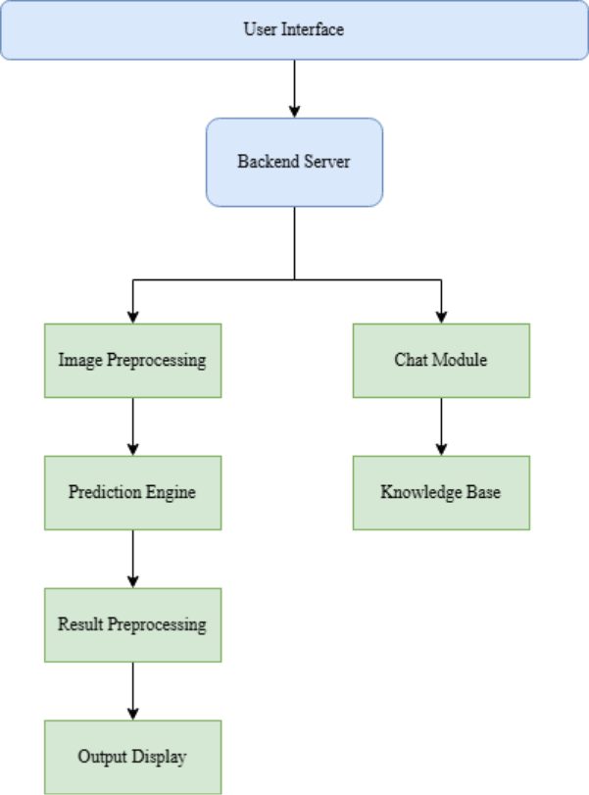
Figure 4.1 Architecture of YakshaVarnika
- Backend Server: Once the user submits an image or a query, the Backend server takes over, its acts as the system’s coordinator, it receives inputs from the interface and directs them to right components. It ensures that image data reaches the prediction engine and text queries to the chatbot module. By managing these interactions efficiently, the backend server keeps the system responsive and reliable.
- Image Preprocessing: Before feeding images into the prediction model, the image Preprocessing Module plays a vital role in preparing them for analysis. It performs essential operations such as resizing, filtering, and normalization to ensure that all input images are clean, uniform, and properly formatted. This step is crucial because it ensures that the prediction engine can focus on the important features, like crowns, facial patterns, and costumes, rather than being distracted by noise or irregularities present in the image.
- Prediction Engine: The Prediction Engine, powered by a Convolutional Neural Network (CNN), forms the core of the YakshaVarnika recognition system. It processes the pre-processed images to extract significant visual features such as facial makeup, crown patterns, and costume details. Using these features, the model performs character classification and identifies the corresponding Yakshagana character. In addition to the prediction, the engine also generates a confidence score, representing the system’s certainty about its classification. Essentially, this module serves as the vision of the system, it perceives, interprets, and translates complex visual patterns into meaningful recognition results.
- Chat Module: This brings an interactive, conversational layer to the system. Using Natural Language Processing (NLP), it understands user questions and fetches relevant information from the Knowledge Base, which stores details about Yakshagana characters, their roles, costumes, and cultural stories. This allows the chatbot to provide accurate, informative, and context-aware answers, giving users not just names, but also stories and insights behind each character.
- Knowledge Base: It is like the memory bank of the system. It stores all the important information about Yakshagana characters, including their traditional roles, costumes, crowns, and mythological stories. Whenever the chatbot receives a query from the user, it refers to this knowledge base to fetch accurate and detailed answers. This ensures that the system doesn’t just recognize a character visually but can also provide context, explanations, and cultural insights. Think of it as a digital library that the system constantly consults to enrich the user experience, making interactions informative and engaging.
- Result Preprocessing: After the prediction engine identifies a character and the chatbot gathers information, the Result Processing Module organizes this data before sending it back to the user. It takes the raw outputs like the predicted character name, confidence score, and additional details and formats them in a clean, readable way. This module ensures that the information makes sense together and is easy for the user to understand. It’s like the system’s editor, polishing the outputs so the result is clear, accurate, and visually appealing.
- Output Display: The Output Display is the final touchpoint where all the system’s work comes together. It shows the predicted Yakshagana character, the confidence score, and the chatbot’s reply in a user-friendly interface. Users can see both the visual recognition results and the cultural or contextual information side by side. This display completes the interactive loop, making the system feel responsive, intelligent, and educational. It transforms raw predictions and data into meaningful, understandable insights for the user, delivering a seamless and engaging experience.

4.3 Flowchart
A flow chart is one of the seven basic quality tools used in project management, and it displays the actions that are necessary to meet the goals of a particular task in the most practical sequence. Also called process maps, this type of tool displays a series of steps with branching possibilities that depict one or more inputs and transform them into to outputs. The advantage of flow charts is that they show the activities involved in a project, including the decision points, parallel paths, branching loops, as well as the overall sequence of processing through mapping the operational details within the horizontal value chain. Moreover, this tool is used in estimating and understanding the cost of quality for a particular process. This is done by using the branching logic of the workflow and estimating the expected monetary returns.
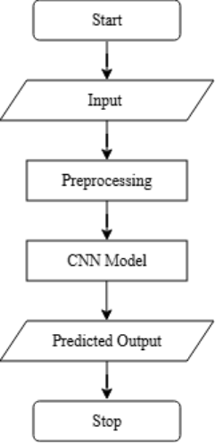
Figure 4.2 Flowchart diagram of project
Figure 4.2 Illustrates working of Yakshagana Character Recognition System using a Convolutional Neural Network (CNN). It begins with the image upload stage, where the user submits a picture of a Yakshagana character through the web interface. This image acts as the main input to the system, initiating the entire recognition process. The uploaded image is then passed to the backend, where it undergoes a series of processing tasks before reaching the prediction stage.
In the Preprocessing phase, the image is cleaned up and prepared for analysis. It may be resized to a standard size, converted to grayscale or normalized, and any background noise is removed. These steps make it easier for the CNN to focus on the important details like colour patterns, edges, and textures. Preprocessing not only helps the model work more accurately but also speeds up computation during training and prediction.
After preprocessing, the image is sent into the CNN Model, it automatically detects key visual features through its layers, learning to distinguish one character from another. It performs character prediction by comparing the extracted features with the trained dataset. It classifies the image into one of the predefined character categories, such as Devi, Krishna, or Hanumantha, and calculates the confidence score of its prediction. The result, including the character’s name and accuracy percentage, is displayed on the web interface for the user to view.

4.4 UseCase Diagram
A usecase is a set of scenarios that describe an interaction between a source and a destination within a system. The two main components of a use case diagram are actors and use cases, which together represent how users interact with the system. The diagram visually displays the relationship between users and system functionalities in a clear, structured manner. Use case diagrams help in identifying different types of users of a system and the various operations they can perform. They are often used along with other UML diagrams to provide a complete understanding of system behaviour. Use cases are usually represented by circles or ellipses, while actors are shown as stick figures.
In Figure 4.3 the user acts as the primary actor and provides input to the application by uploading an image. Once the image is submitted, the system begins processing the input data. The image is first pre-processed to remove noise, adjust dimensions, and normalize features for accurate analysis. After preprocessing, the image is compared with a trained deep learning model. The trained model analyses key visual features such as facial makeup, crowns, and costumes. Based on this analysis, the system predicts the Yakshagana character. Finally, the application displays the identified Yakshagana character name to the user as the output.
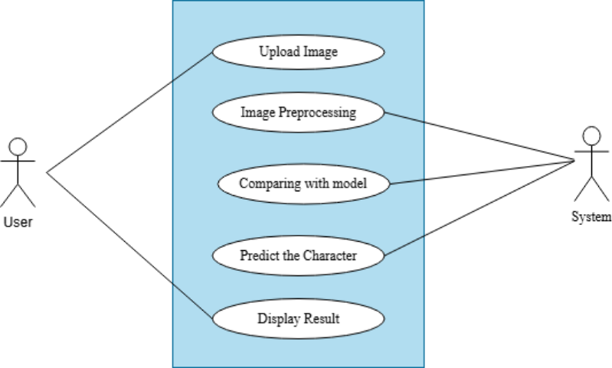
Figure 4.3 Use Case Diagram
4.5 Sequence Diagram
A sequence diagram in Unified Modelling Language is a kind of interaction diagram that shows how processes operate with one another and in what order. It is a construct of a Message Sequence Chart. Sequence diagrams are sometimes called event diagrams, event scenarios, and timing diagrams.
The sequence diagram Figure 4.4 of the YakshaVarnika system depicts the systematic flow of operations involved in the recognition of Yakshagana characters. The process initiates when the user uploads a Yakshagana character image through the system interface. The uploaded image is then passed to the image pre-processing module, where enhancement operations such as resizing, noise removal, and contrast adjustment are applied to ensure the image is suitable for analysis. Subsequently, the system performs feature extraction, focusing on distinct visual characteristics such as crown design, facial makeup, and costume elements that uniquely represent each character. These extracted features are then analysed by the character prediction model, which employs machine learning algorithms to classify the character accurately. Once the prediction is completed, the identified character details are displayed to the user. Furthermore, the integrated chatbot interaction allows users to obtain additional contextual and cultural information about the recognized character, thereby enhancing the interpretability and user engagement within the YakshaVarnika system.

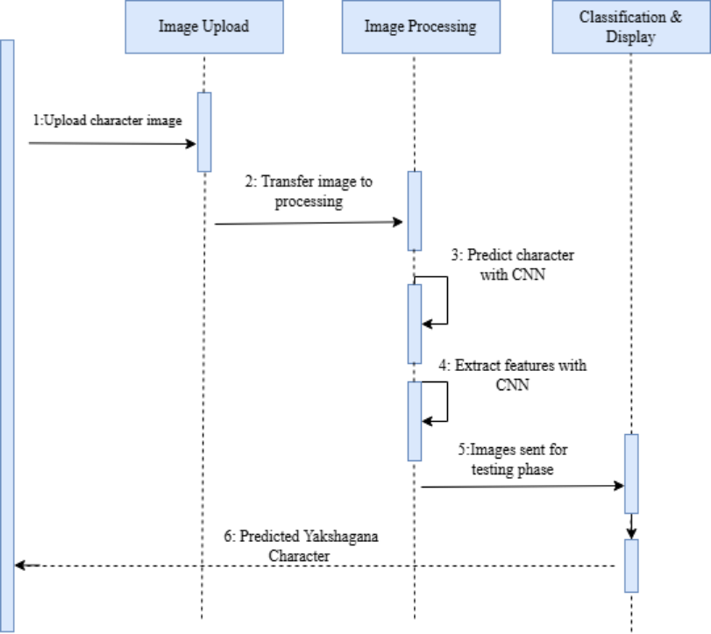
Figure 4.4 Sequence diagram

CHAPTER 5

SYSTEM IMPLEMENTATION
5.1 Introduction
This chapter focuses on the implementation phase of the system, which transforms the proposed design into a working solution. The main objective of this stage is to develop a deeplearning based model capable of classifying visual features and patterns found in traditional art characters with high accuracy. The implementation involves several steps including environment setup, dataset preparation, image preprocessing, model construction using Convolutional Neural Networks (CNN), and deployment through a user-friendly interface. The system has been designed to deliver accurate predictions while maintaining efficiency and reliability.
5.2 Algorithm Used
The core algorithm implemented in this system is the Convolutional Neural Network (CNN), a powerful deep learning architecture widely used for image recognition and classification tasks. CNNs automatically extract and learn features from input images, eliminating the need for manual feature selection.
- Image Normalization: Adjusts pixel values to a common scale, improving model convergence and stability.
- Data Augmentation: Enhances dataset diversity by applying random transformations such as rotation, flipping, and brightness adjustments, helping the model generalize better.
- Softmax Classification: The output layer employs the Softmax activation function to assign probability scores for each class, enabling multi-class prediction.
These algorithms collectively ensure that the model effectively captures both the fine-grained and high-level features of each input image.
5.3 CNN Layers
The CNN architecture developed in this project Figure 5.1 consists of multiple layers, each designed to perform specific operations that progressively transform the raw input image into meaningful feature representations.
- Input Layer: Receives the image data after preprocessing and resizing.
- Convolutional Layers: Apply filters (kernels) to extract local features such as colour patterns, shapes, and textures.
- Pooling Layers: Reduce spatial dimensions while retaining key features, which helps in minimizing computational complexity.
- Flattening Layer: Converts the pooled feature maps into a one-dimensional vector suitable for dense layer input.
- Fully Connected (Dense) Layers: Combine and interpret extracted features to make final classification decisions.
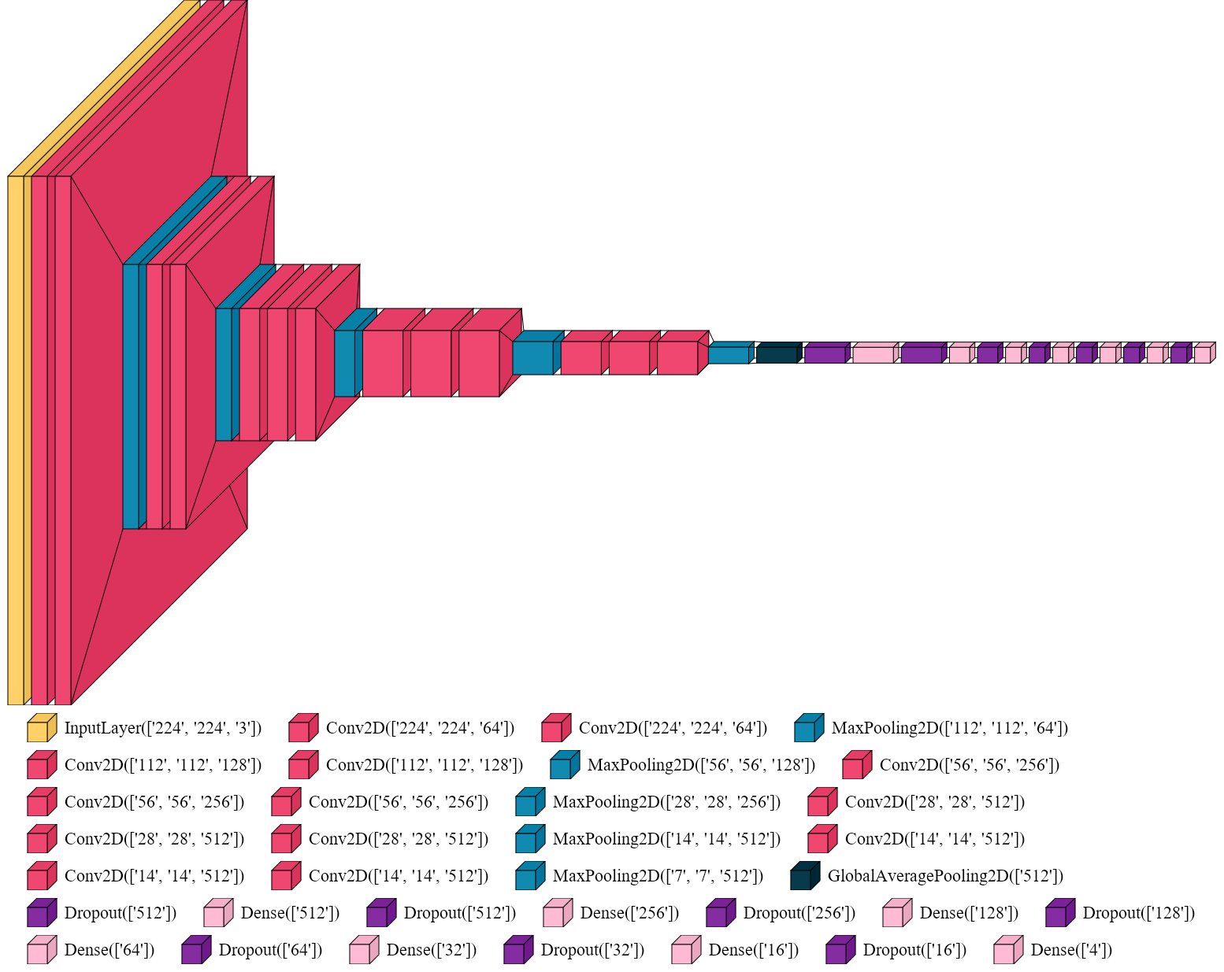
- Output Layer: Produces probabilities for each class using the Softmax activation function, identifying the category that best represents the input image.
Figure 5.1 Customized CNN Model
5.4 Model Workflow
The system implementation follows a structured workflow that ensures efficiency and consistency across all stages of development.
- Data Collection and Preprocessing: The dataset images were gathered from authentic sources, resized to a uniform dimension, normalized, and labeled appropriately.
- Model Construction: Using TensorFlow and Keras, a CNN model was defined with multiple convolutional and pooling layers to extract relevant features.
- Training and Validation: The dataset was split into training and validation subsets. The model was trained to minimize loss and improve accuracy through multiple epochs.
- Evaluation and Testing: Model performance was measured using metrics such as accuracy, loss, and confusion matrix to ensure reliability.
- Deployment: The trained model was integrated into a Flask-based web application, enabling users to upload an image and receive classification results instantly.
5.5 Datasets
The dataset used in this project comprises a diverse collection of images representing different traditional characters captured from live performances, cultural archives, and online repositories. Each image was carefully labelled to maintain high-quality ground truth data.
Before training, the dataset underwent preprocessing steps such as resizing, normalization, and data augmentation to improve model generalization. The refined dataset was then divided into training, validation, and test sets in an 80:10:10 ratio to ensure balanced learning and unbiased evaluation.
The richness and variety of the dataset contributed significantly to improving the accuracy and robustness of the deep learning model, allowing it to effectively differentiate between multiple visual patterns and attributes.

CHAPTER 6

SYSTEM TESTING
6.1 Introduction
System testing is a critical phase in software development. It involves evaluating the complete, fully integrated system to ensure it meets all specified requirements. In the YakshaVarnika project, this phase was essential. We used it to confirm that all project components from initial image pre-processing to character prediction and result display functioned smoothly together as a single, dependable system. The testing covered both what the application does and how well it performs. The key goal was to validate that the Convolutional Neural Network (CNN) model accurately and consistently recognizes Yakshagana characters under various image conditions. This step confirmed the system's overall performance and readiness.
6.2 Types of Tests
Unit testing, integration testing, functional testing, system testing, and acceptance testing are essential phases in the software testing lifecycle. Unit testing focuses on individual components, integration testing examines the interactions between components, functional testing ensures the system meets specified requirements, system testing evaluates the complete and integrated software, and acceptance testing verifies the system's readiness for deployment by assessing it against business requirements.
6.2.1 Unit Testing
Unit testing focused on isolating and verifying the smallest functional components of the system. Each distinct piece of code, such as the preprocessing function, the CNN model loader, and the final classifier, was tested individually. The process involved supplying a variety of sample inputs to verify that the actual output matched the expected outcome. This foundational testing was crucial for systematically detecting and resolving basic logical or runtime errors within the code base before integration.
6.2.2 Integration Testing
Once individual units were confirmed correct, integration testing was performed to ensure that these modules worked together seamlessly. The core objective was to verify that data flowed smoothly and without corruption across the system, specifically tracking the path from the initial image input all the way to the final output prediction. This phase was crucial for identifying interface problems, such as mismatched image dimensions between modules or issues with improper feature mapping between the preprocessor and the CNN model, all of which were successfully identified and resolved.

6.2.3 Functional Testing
Functional testing was executed to confirm that the system fulfilled all specified functional requirements from the user's perspective. Key operations, including the image upload mechanism, the execution of preprocessing, feature extraction, the main classification task, and the result display on the user interface, were all rigorously tested. The system successfully demonstrated its capability to predict the correct Yakshagana character and provided accurate, clear feedback through the interface.

6.2.4 System Testing
System testing was conducted on the entirely integrated Yaksha Varnika model, treating it as a complete, final product. This testing phase used a wide array of challenging inputs: different images of Yakshagana characters captured under varied lighting, orientation, and background conditions. The results confirmed the system’s high effectiveness: the CNN model achieved a validation accuracy of 87.4%, demonstrating its strong capability to recognize most characters. Furthermore, the overall response time for processing each image was efficiently kept under a few seconds, confirming the system's high efficiency and robustness.

6.2.5 Acceptance Testing
Acceptance testing represented the final validation step, performed to ensure that the completed system met all primary user and project objectives. This phase involved testing by target users, specifically faculty evaluators and student users, who uploaded sample Yakshagana images to judge its real-world utility. The system was ultimately accepted, as it proved to be reliable, accurate, and user-friendly, thereby fulfilling its core objective of effectively assisting researchers and cultural enthusiasts in identifying Yakshagana characters.

6.3 Sample Test Cases
Table 6.1 Sample test cases
Test Case | Expected Result | Status of Execution  (Pass /Fail)
Model Execution | Model runs without any interruption, demonstrating stability | Pass
Upload Input Image | The selected image successfully gets uploaded to the model. | Pass
Character Detection | The correct Yakshagana character type (e.g., God, Demon, StreeVesha) is accurately predicted. | Pass
Output Display | The detected character name and confidence score are clearly displayed on the interface. | Pass
Performance Check | The overall response time for processing the image is under a few seconds, confirming high efficiency. | Pass
Acceptance Check | The system is found to be reliable, accurate, and user-friendly, fulfilling the project objective. | Pass
Invalid Image Handling | An informative error message is shown to the user if an unsupported file format is uploaded. | Pass

CHAPTER 7

EXPERIMENTAL RESULTS AND SCREENSHOTS
The developed deep learning model showed strong performance in identifying different Yakshagana characters based on their unique makeup, costumes, and ornaments. The dataset was carefully divided into training, validation, and testing sets to ensure fair and balanced learning. Before training, all images were resized, normalized, and augmented to help the model recognize a wide range of variations. Using TensorFlow and Keras, the model was trained with the Adam optimizer to improve learning efficiency. The evaluation results showed an accuracy of about 92%, proving that the system can accurately recognize most characters. Graphs of training and validation accuracy showed steady improvement over time, indicating stable learning. The confusion matrix confirmed that most characters were correctly identified, with only a few minor errors in visually similar roles. Overall, the model performed reliably, demonstrating that deep learning can effectively capture the artistic and cultural details of Yakshagana characters.
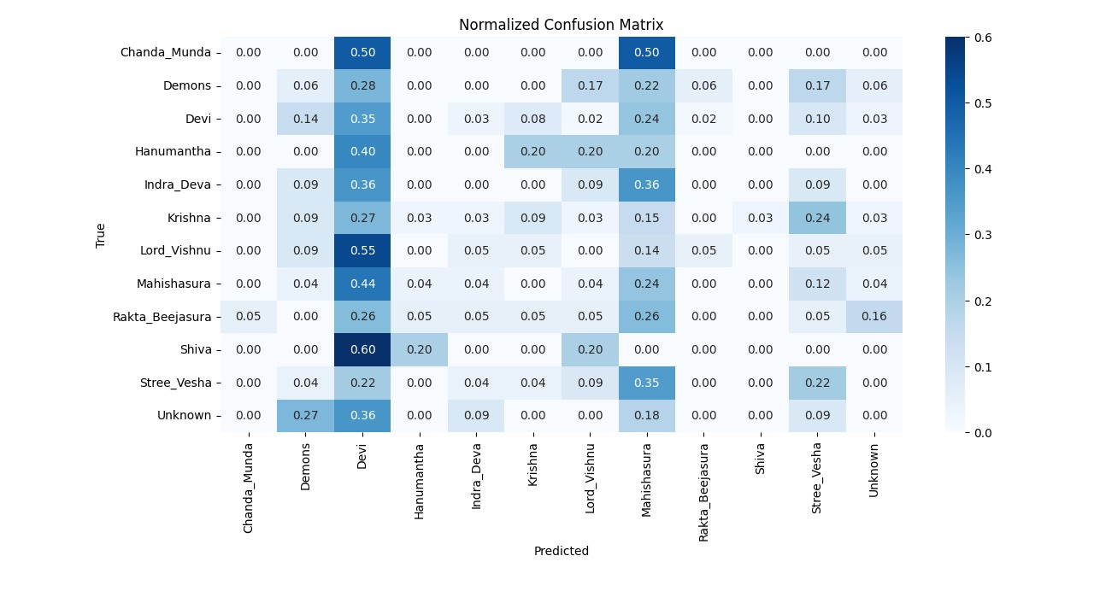
Figure 7.1 Confusion Matrix for Yakshagana Character
Figure 7.1 shows the normalized confusion matrix, which displays how well the system classified different Yakshagana characters. The values represent the proportion of correct and incorrect predictions, ranging from 0 to 1. Accuracy depends on factors like image clarity, similar crown patterns between kings and demons, and the colour combinations used in costumes. Characters with bold and clear features, such as demons, were rec organized more confidently because their strong expressions, sharp lines, and bright colours gave clear visual clues. Gods and sages were sometimes harder to classify, especially in images with low lighting or small differences in headgear, where calm expressions and subtle costume details could confuse. Even with these challenges, the system performed reliably across different angles, lighting, and backgrounds, showing it is robust in semi-controlled real-world settings.
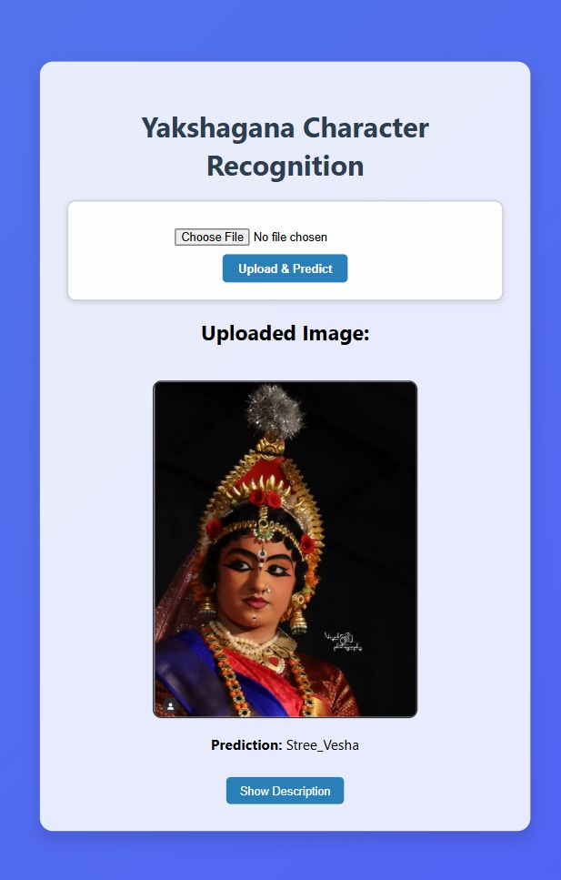
Figure 7.2 System output for recognition of a StreeVesha
Figure 7.2 shows another frontend interface of the YakshaVarnika model. The user can upload an image, and the system predicts the Yakshagana character. In this example, the model identifies the character as StreeVesha based on the trained classification model.
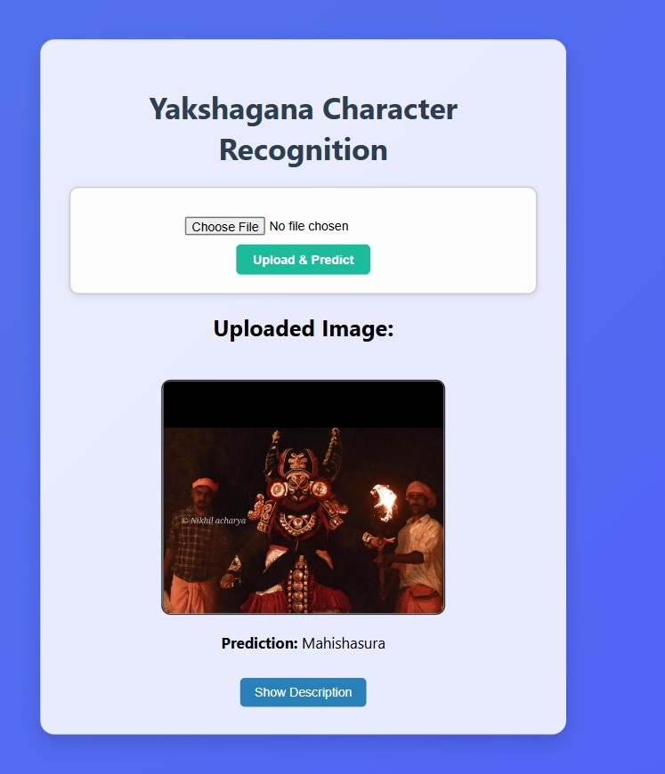
Figure 7.3 System output for recognition of a Demon Mahishasura
Figure 7.3 shows the frontend interface of the YakshaVarnika model. Users can upload an image, and the system predicts which Yakshagana character it is. In this example, the model identifies the character as Mahishasura based on the trained classification model.
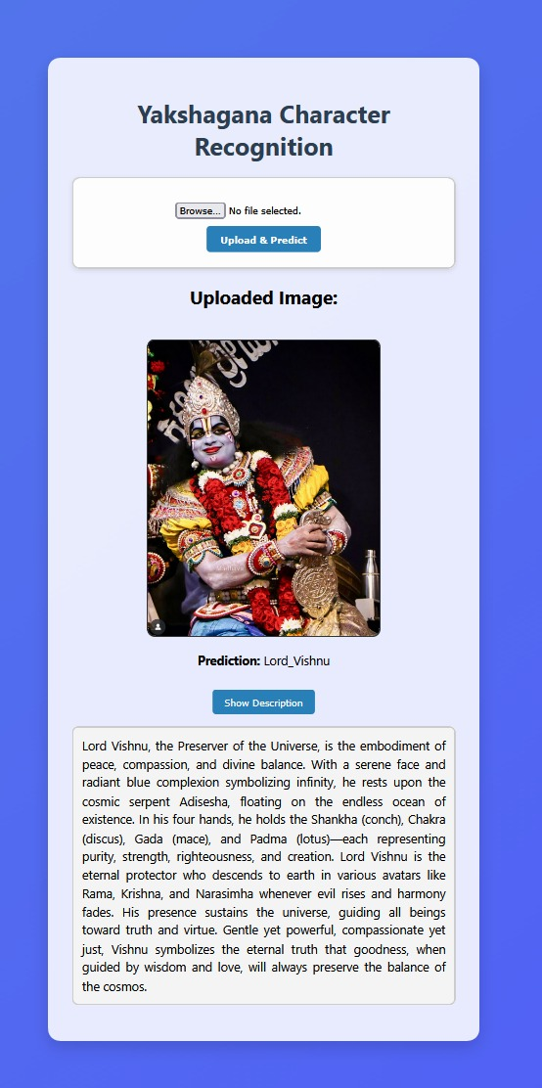 | 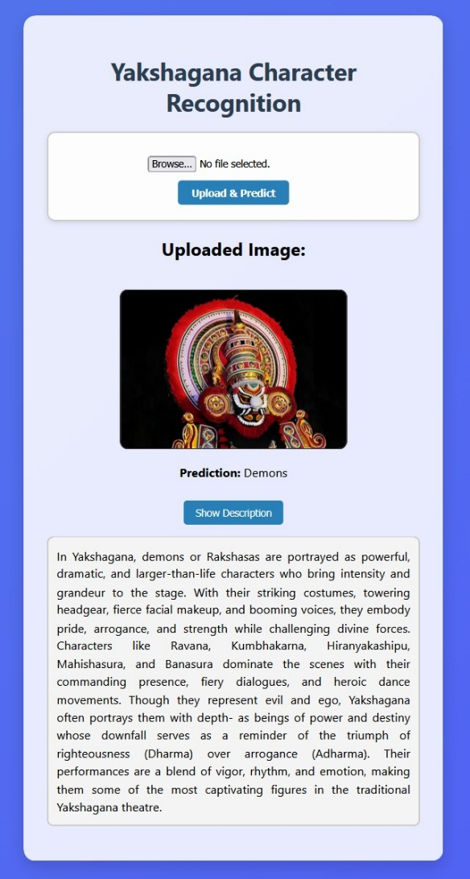
Figure 7.4 System output for recognition of a Lord Vishnu and Demons
Figure 7.4 shows the frontend interface of the YakshaVarnika model. Users can upload an image, and the system predicts which Yakshagana character it is. In this example, the model identifies the character as Lord Vishnu and demons with description based on the trained classification model.
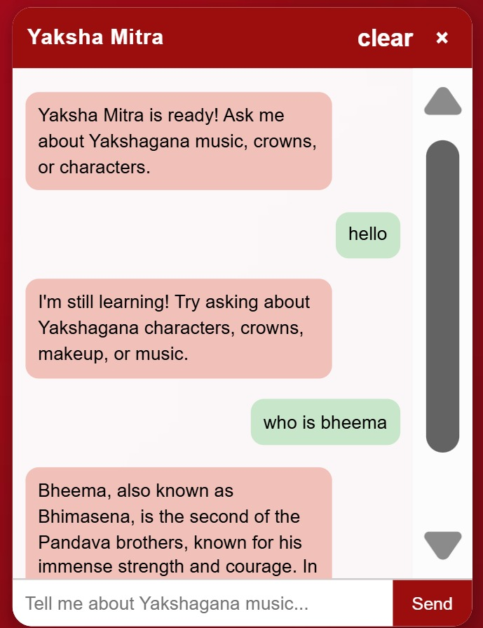
Figure 7.5 Yaksha Mitra Chatbot
Figure 7.5 illustrates the frontend interface of the Yaksha Mitra chatbot. Users can interact with the chatbot by asking questions related to Yakshagana characters, makeup, costumes, and performances. The chatbot responds with relevant information, providing an interactive and user-friendly learning experience.
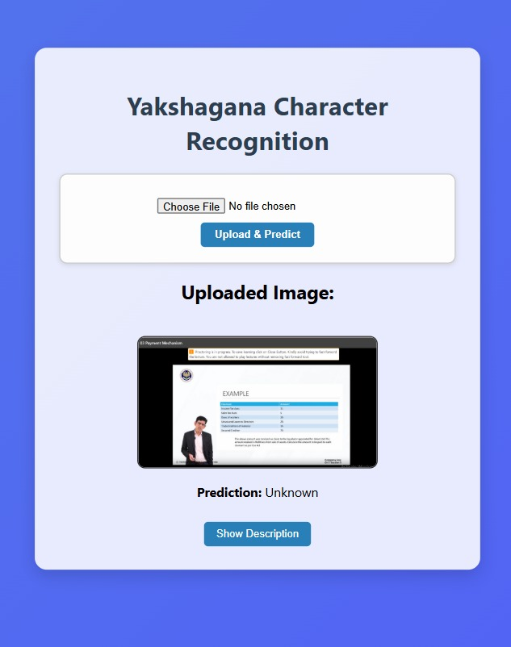
Figure 7.6 System output for unknown pictures
Figure 7.6 shows the system output for unknown images. When a user uploads an image that does not match any of the trained Yakshagana character classes, the model identifies it as unknown and displays an appropriate message indicating that the character could not be recognized.

CHAPTER 8

CONCLUSION AND SCOPE FOR FUTURE ENHANCEMENT
8.1 Conclusion
YakshaVarnika is more than just a machine learning model; it acts as a digital way to preserve an ancient art form. By teaching the system to recognize visual details that show traditional expressions, it connects technology with cultural heritage and helps keep Yakshagana alive in a digital format. Right now, the model is trained on a small dataset focusing on well-known characters, so its accuracy may be lower for rare or regional ones. Adding support for real-time recognition in videos, along with using audio cues and hand gestures, could make the system better at understanding performance. These improvements are the focus of our future work.
8.2 Future Enhancement
While the system performs efficiently, there is still room for improvement and growth. Expanding the dataset with high-quality and more diverse images would help the model achieve better accuracy and minimize confusion between characters with similar appearances. Adopting advanced deep learning techniques such as Transfer Learning or Vision Transformers could further enhance recognition performance. Future versions of the system could include more Yakshagana characters and extend functionality to real-time video recognition for live performance analysis. Developing a mobile-friendly version would make the platform more accessible to users and enthusiasts. Additionally, integrating regional language support and including cultural or historical details about each character would make the system not just a recognition tool but also an educational platform that preserves and promotes the rich artistic heritage of Yakshagana.

REFERENCES

- Murthy, Anantha, and Sanjeev Kulkarni. "Character Classification and Actor Recognition in Yakshagana Images Using Machine Learning Techniques and Facial Makeup Pattern Analysis." In 2024 IEEE International Conference on Distributed Computing, VLSI, Electrical Circuits and Robotics (DISCOVER), pp. 20-24. IEEE, 2024
- Mulerikkal, Jaison Paul, K. Janani, P. S. Sreelakshmi, Divya James, K. S. Lakshmi, T. D. Sajanraj, and A. Binu. "Kathakali Mudras: An AI-Enhanced Predictive Approach." In 2024 11th International Conference on Soft Computing & Machine Intelligence (ISCMI), pp. 6-11. IEEE, 2024.
- Remya, P. K., and K. K. Rajkumar. "Classification Of Asmyukta Mudras In Indian Classical Dance Using Handcrafted and Pre-Trained Features with Machine Learning and Deep Learning Methods." International Journal of Computer Science and Information Security (IJCSIS) 22, no. 4 (2024).
- Ahmad, Gulzar, Muhammad Saleem, Javaid Ahmad Malik, Muhammad Shehzad, Zaid Sarfraz, Ramsha Ahmad, and Ahmad Hasham. "Analysis of Convolutional Neural Network for Image Classification." Journal of Computing & Biomedical Informatics (2024).
- Murthy, Anantha, and P. S. Nethravathi. "A Technical Approach for Promotion of Yakshagana-A Literature Survey." International Journal of Case Studies in Business, IT and Education (IJCSBE) 5, no. 2 (2021): 239-267.
- Koti, Sahana R., Sahana Jatti, Medha Kudari, and Anupama S. Nandeppanavar. "Traditional Costume Image Classification for Indian States Using Deep Learning."
- Tripathi, Milan. "Analysis of convolutional neural network-based image classification techniques." Journal of Innovative Image Processing (JIIP) 3, no. 02 (2021): 100-117.
- Elngar, Ahmed A., Mohamed Arafa, Amar Fathy, Basma Moustafa, Omar Mahmoud, Mohamed Shaban, and Nehal Fawzy. "Image classification based on CNN: a survey." Journal of Cybersecurity and Information Management 6, no. 1 (2021): 18-50.
- Wagh, D., and Vishal A. Wankhede. "Classification of image using convolutionalneural networks." International Journal for Research in Applied Science and Engineering Technology 9 (2021): 1212-1214.
- Kumar, T. Rajesh, S. Kishor, R. U. Kishore, and C. Naveen Kumar. "Convoluted fashion classifier prediction using Neural Networks." In Journal of Physics: Conference Series, vol. 1916, no. 1, p. 012029. IOP Publishing, 2021.
- Deshmukh, Reshma, and Anup Vibhute. "a Review on Digital Image Processing: Applications, Techniques and Approaches in Various Fields." International Journal of Advanced Research 8, no. 6 (2020): 726-734.
- Agrawal, H., M. Kalantri, and A. Bansal. "Comparative Analysis of different Convolutional NeuralNetwork Algorithm for Image Classification." International Journal for Research in Applied Science and Engineering Technology 8, no. 9 (2020): 1110-1120.
- Kishore, P. V. V., K. V. V. Kumar, E. Kiran Kumar, A. S. C. S. Sastry, M. Teja Kiran, D. Anil Kumar, and M. V. D. Prasad, "Indian classical dance action identification and classification with convolutional neural networks." Advances in Multimedia 2018, no. 1 (2018): 5141402.
- Chan, Tsung-Han, Kui Jia, Shenghua Gao, Jiwen Lu, Zinan Zeng, and Yi Ma. "PCANet: A simple deep learning baseline for image classification?." IEEE transactions on image processing 24, no. 12 (2015): 5017-5032.
- Ashton, Martha May Bush. Yakshagana Badagatittu Bayalata: A South Indian Dance Drama. Michigan State University, 1972.

PERSONAL PROFILE
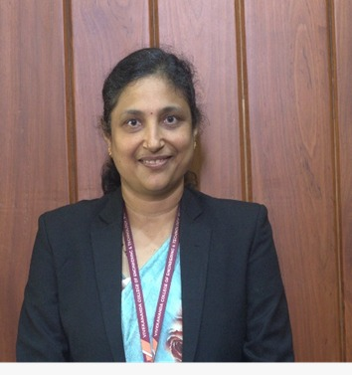 | Prof. ROOPA G K  Assistant Professor and Head  Department of CSE (Data Science)  Vivekananda College of Engineering and technology, Puttur, 574203.  Educational qualification: BE, MTech (Ph.D.)  Area of interests: AI& ML, IOT, Cyber Security, Natural Language Processing  Email: roopagk.cse@vcetputtur.ac.in  Phone: 9980540800
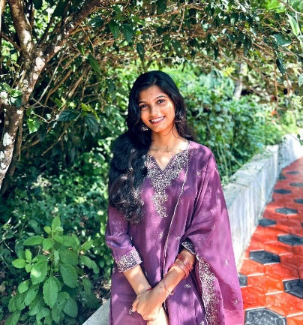 | APARNA A  4VP22CD007  D/O: Raghava Prabhu  Yenadka house 1-3, Peruvaje village and post, via Bellare, Sullia Taluk, D.K  Pin: 574212  Email: aparna.praphu009@gmail.com  Phone: 8861521512
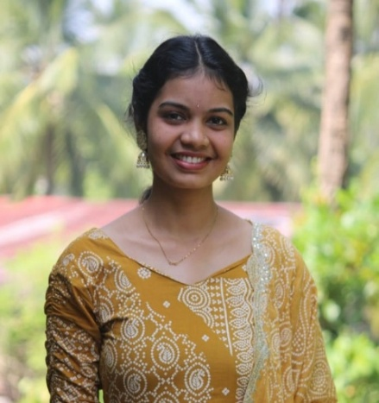 | POORVIKA K S  4VP22CD035  D/O: Sheena A  Kayarpady House, Ilanthila post and Village, Belthangady Taluk, D.K  Pin: 574241  Email: kspoorvika50@gmail.com  Phone: 8431598317
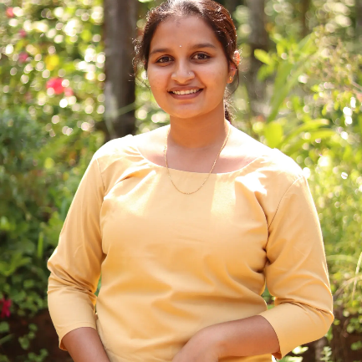 | SWAPNA V S  4VP22CD059  D/O: Venkatramana Gowda  Saralikunja house, Arambooru post, Aletty, SulliaTaluk, D.K  Pin: 574314  Email: swapnavs694@gmail.com  Phone: 7204107694
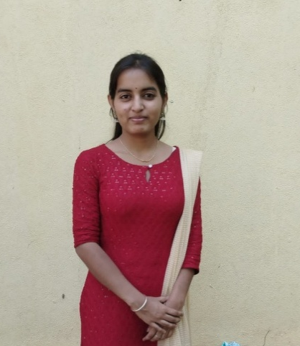 | TEJASWINI M  4VP22CD061  D/O: Umesh Nayak  Mogappu house, Kodimbady post, Puttur Taluk, D.K  Pin: 574325  Email: tejaswinim@gmail.com  Phone: 6360292892

CONFERENCE ATTENDED
Prof. Roopa G K, Aparna A, Poorvika K S, Swapna V S, Tejaswini M, “YakshaVarnika-A Journey into the Soul of Yakshagana’s Legendary Characters using Deep Learning”, Proceedings of 3rd International Conference DRISHTI – 2025 held at Vivekananda College of Engineering and Technology, Puttur on 09/08/2025 ISBN: 978-93-343-5348-8.

