Encrypted Cloud Storage with Searchable Symmetric Encryption
Vijayakumar P, Professor, SENSE
Shravan Adash M, 23BEC1149
Preetish RK, 23BEC1470
Prajinesh P, 23BEC1113
HOW TO USE: every grey line is a note, not report text. Write each section as normal paragraphs in your own words, then delete the grey notes. Headings, equations, figures, captions and references can stay.
Abstract (write one paragraph, ~150–200 words)
– problem: encrypting files before upload stops the server from doing keyword search
– approach: Searchable Symmetric Encryption (SSE); two processes — trusted client (port 5000) holds keys, untrusted cloud (port 5001) stores ciphertext
– crypto used: Argon2id + HKDF-SHA256 key derivation; AES-256-GCM for files and filenames; HMAC-SHA256 encrypted index based on Cash et al. Π_{bas}
– extra features: AND multi-keyword search, delete, password change with re-encryption
– evaluation: benchmark suite (crypto cost, index build, search, rebuild, storage); leakage shown from captured client–cloud traffic
Keywords: Searchable symmetric encryption (SSE); encrypted cloud storage; encrypted inverted index; AES-256-GCM; HMAC-SHA256; Argon2id; leakage analysis
I. INTRODUCTION
– cloud storage widely used; owner loses control of the server → confidentiality risk
– AES before upload protects data but server can no longer search it → user must download + decrypt everything
– SSE idea: encrypted index + search token from keyword and secret key; server finds matches without seeing keyword/plaintext
– practical challenges: index construction, token generation, efficiency, updates, search/access-pattern leakage
– what your project does differently: full running system with real process boundary, measured performance, leakage demonstrated from traffic
– end with paper organisation: Sec. II related work, III proposed system, IV results, V conclusion
II. RELATED WORK
– follow the template: each paragraph covers two papers → what they did → one limitation relative to your project
– [1] Hu et al. SEAC — dynamic SSE + update/search permission control for e-health; multi-client, heavier than your single-owner scope
– [2] Xu et al. — forward-secure, multi-user, verifiable DSSE, zero-trust (malicious server); uses OPRF + hash state; complex
– [3] Yang et al. — DSSE with access control for both search and update in multi-user cloud; access control = your future work
– [4] 2025 TIFS paper — forward/backward private conjunctive DSSE, 3-D chain, lower communication; you do AND by client-side intersection (simpler, leaks more)
– [5] Ren et al. — conjunctive query (cuckoo filter) + non-interactive real deletion; your delete = rebuild index without the doc, then delete
– [6] Zhang et al. — Bloom filter + B+-tree dynamic SSE; focuses on index structure, not end-to-end latency
– [7] Wang et al. — decentralised multi-client Boolean search, no key escrow, Enron dataset
– [8] Wu et al. MMKFB — multi-client multi-keyword threshold queries, forward/backward privacy, additive homomorphism
– [9] Wu et al. — verifiable SE hiding search + access pattern; those are exactly the leakages your system keeps (future work)
– [10] Khan et al. BloomSec — per-file Bloom filters, less communication; index representation affects storage (link to your storage result)
– [11] Xue et al. — multi-keyword ranked SE, hidden attributes, incentives, P2P; outside your scope
– [12] Mohammed et al. — review of ~80 SSE schemes; single-keyword static SSE is the baseline
– [13] Cash et al. — source of the Π_{bas} construction you implemented
– final gap paragraph: papers extend the scheme and measure crypto/index cost; less work on a full running system, where latency really goes, and leakage shown from real traffic

III. PROPOSED SSE-BASED ENCRYPTED CLOUD STORAGE SYSTEM
– overview paragraph: two processes, browser talks only to client, unlock → keys, upload → encrypt + index, search → token only, AND = client intersection

3.1 Key Derivation and Vault Unlock
– random 16-byte salt stored on cloud; Argon2id with t = 3, m = 64 MiB, p = 4 (RFC 9106 [14]) → 256-bit master key
– HKDF-SHA256 with labels vault:k_file:v1 / vault:k_index:v1 → two independent sub-keys
– verifier = AES-GCM of fixed text under K_index; wrong password → decryption fails → unlock rejected (HTTP 401)
– measured unlock ≈ 57 ms
 | MK = Argon2id(pw, salt; t = 3, m = 64 MiB, p = 4) | (1)
 | K_{file} = HKDF(MK, “vault:k_file:v1”), K_{index} = HKDF(MK, “vault:k_index:v1”) | (2)
 | V = AES-GCM(K_{index}, “vault-verifier:v1”) | (3)
– explain each symbol after the equations; then Step 1 (master key) and Step 2 (sub-keys + verification) like the template

3.2 Document Encryption Module
– AES-256-GCM = confidentiality + integrity; fresh random 96-bit nonce every time, no caller-supplied nonce
– 128-bit tag detects tampering; all decrypt failures give one generic error
– filename encrypted separately; random 128-bit document ID
– accepted inputs: .txt, .pdf (text layer), .zip of these
– ciphertext = plaintext + 28 bytes (12 nonce + 16 tag)
 | C = AES-GCM(K_{file}, N, M) = (N, CT, T) | (4)

3.3 Keyword Extraction and Encrypted Index Construction
– one tokenizer for indexing and searching: lowercase, alphanumeric tokens, drop <2 chars and stop words, dedupe
– per keyword: K1 makes labels, K2 encrypts document IDs (F = HMAC-SHA256)
– one (label, value) row per posting; label = 64 hex chars; index has no keywords/IDs in plaintext
– sorted order → reproducible labels; fresh nonces → rebuilt values look different
– static index: whole index rebuilt and replaced in one transaction after upload/delete/password change
 | K₁ = F(K_{index}, “1” ‖ w), K₂ = F(K_{index}, “2” ‖ w) | (5)
 | ℓ_{c} = F(K₁, c), v_{c} = AES-GCM(K₂, id_{c}), c = 0, 1, …, |DB(w)| − 1 | (6)

3.4 Search Token Generation and Encrypted Search
– client sends only K1 (the token); K2 never leaves the client
– cloud recomputes labels for counter 0, 1, 2 … and stops at first missing label; never decrypts
– cloud has its own HMAC code, imports nothing from client package
– AND query: one search per keyword, intersect on client, stop early if empty
– cost: cloud learns each keyword's result set + that they were asked together
 | R(w₁ ∧ w₂ ∧ … ∧ w_{q}) = R(w₁) ∩ R(w₂) ∩ … ∩ R(w_{q}) | (7)

3.5 Document Deletion and Password Rotation
– delete: rebuild index WITHOUT the document first, then delete ciphertext (why this order?)
– password change: verify current password independently; phase 1 decrypt + tokenise everything, write nothing, abort if any fails; phase 2 new salt + keys, re-encrypt every doc, rebuild index, write salt + verifier last
– limitation: phase 2 not atomic — connection loss can leave mixed state; documented, future fix = envelope encryption

3.6 Trust Boundary and Leakage Model
– cloud never gets: password, sub-keys, K2, plaintext content, filenames, keywords
– cloud does learn: number + sizes of documents, number of postings, search pattern (same keyword = same token), access pattern (matching rows + documents fetched), AND co-occurrence, full fetch during every rebuild
– each leakage item demonstrated by tests that capture real HTTP traffic
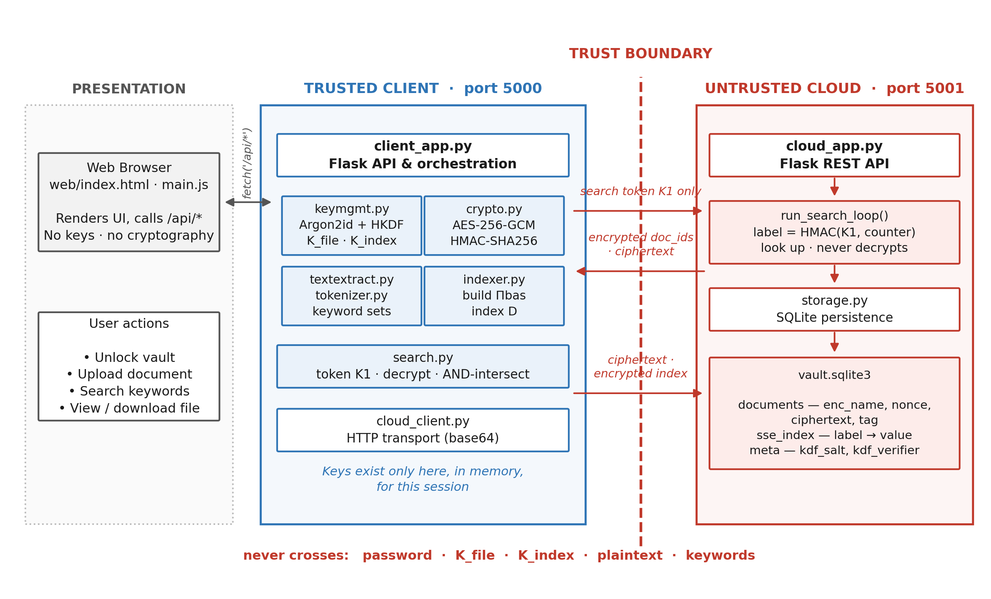
Fig. 1 Proposed SSE-based encrypted cloud storage system with a process-level trust boundary

3.7 SSE-Based Encrypted Storage and Search Algorithm
– short intro paragraph; refer to Fig. 2
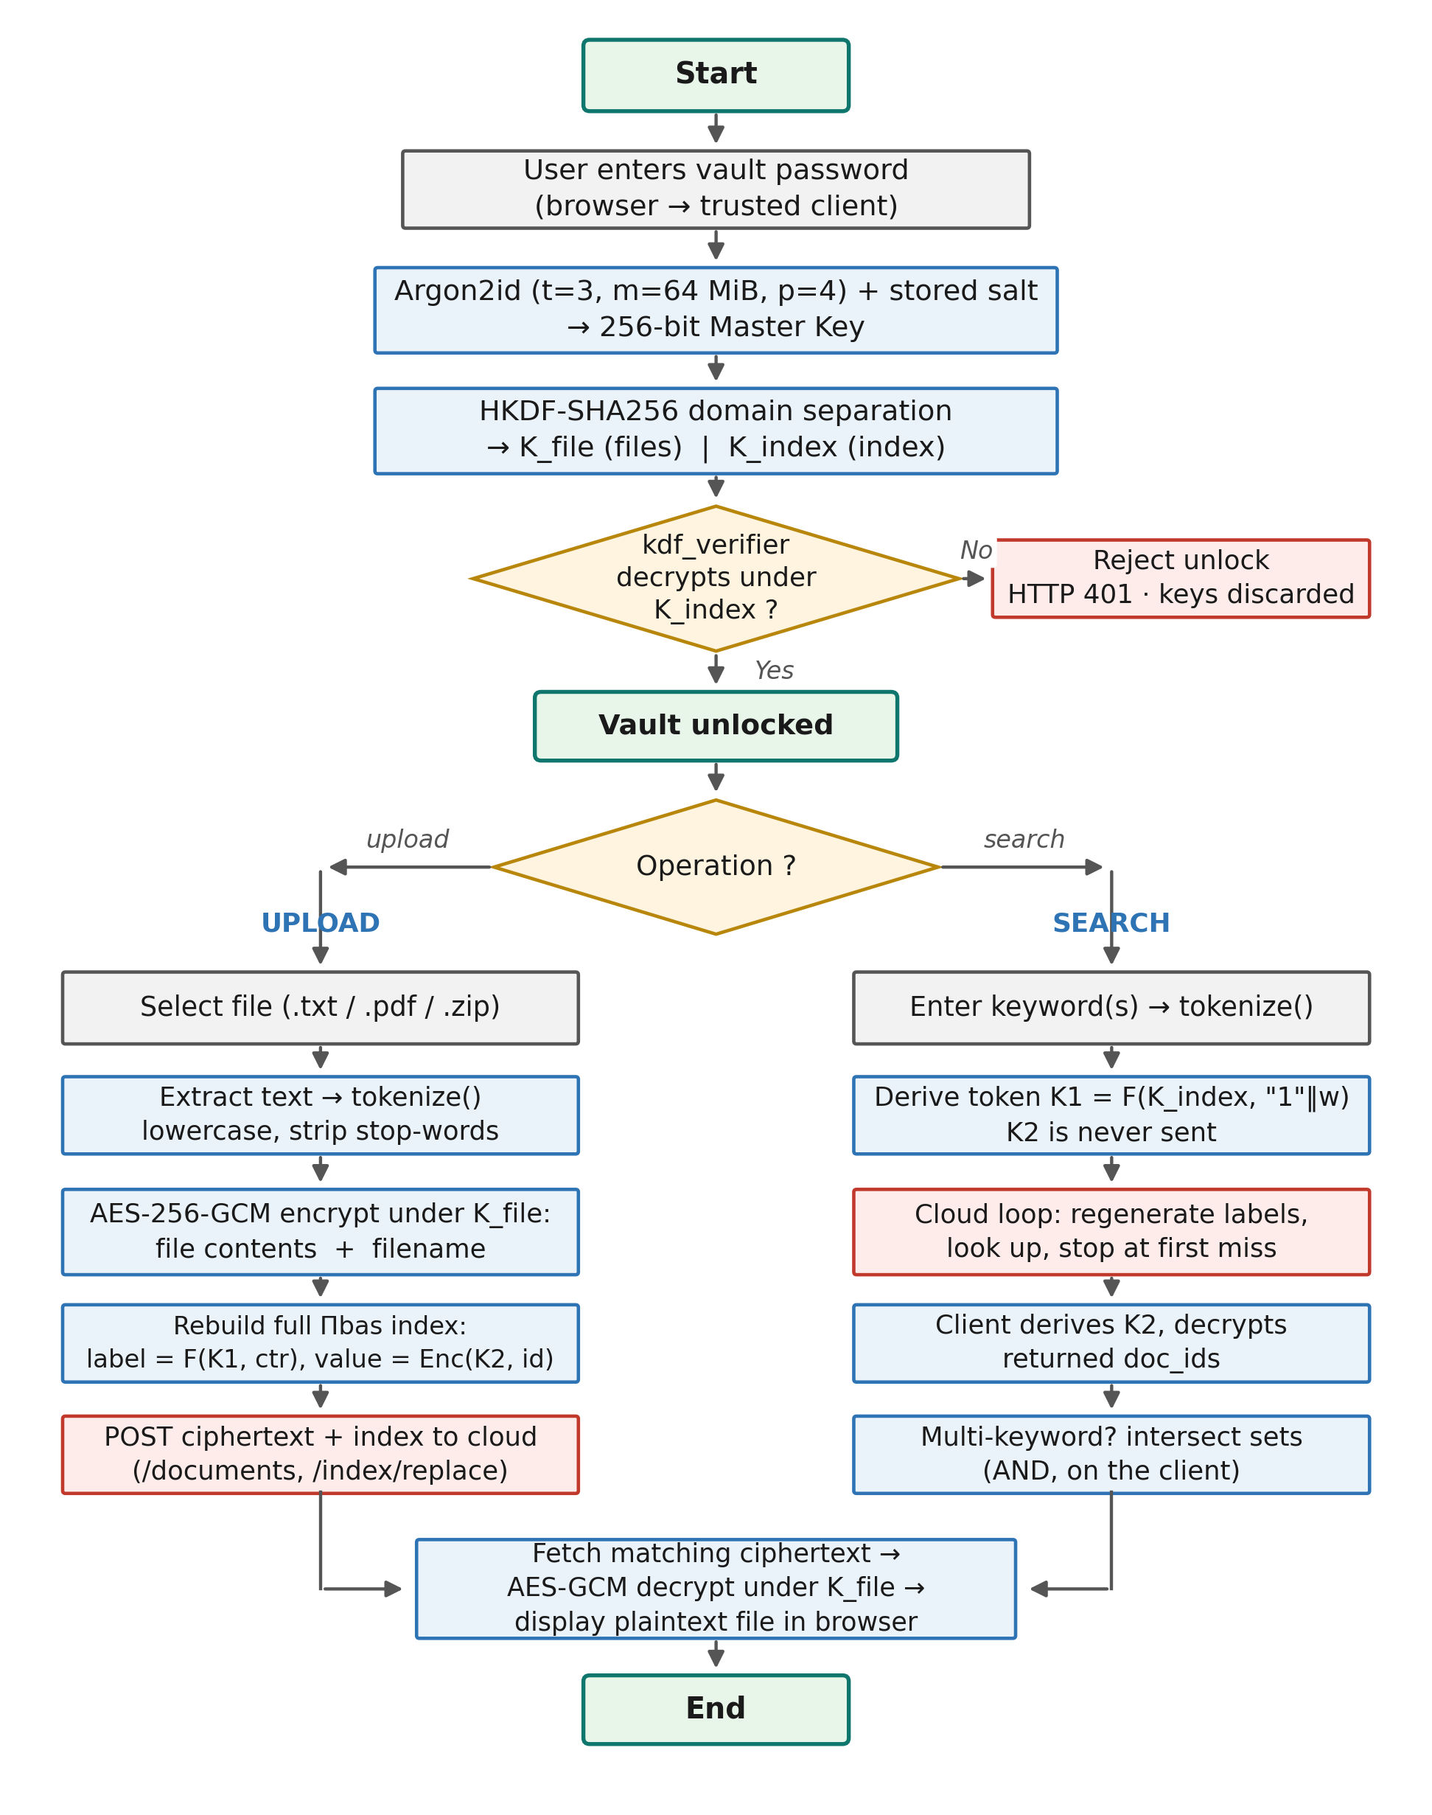
Fig. 2 Complete workflow of the implemented system
Input: Password pw, document set D = {D₁, D₂, …, D_{n}} and query keywords w₁, …, w_{q}
Output: Encrypted documents and encrypted index stored on the cloud, followed by the decrypted documents matching the query
Step 1 - Derive the keys
– eq. (1)–(3)
Step 2 - Extract and tokenise each document
– keyword set W(D_{i})
Step 3 - Encrypt the document and its filename
– random id, eq. (4)
Step 4 - Upload the encrypted document
– what is sent; what never leaves the client
Step 5 - Derive the keyword keys
– eq. (5)
Step 6 - Build the encrypted index
– eq. (6)
Step 7 - Replace the index on the cloud
– single transaction
Step 8 - Generate the search token
– T_{w} = K₁; K₂ stays on client
Step 9 - Run the cloud search loop
– eq. (8)
 | S(w) = { v_{c} : ℓ_{c} = F(T_{w}, c) ∈ I, c = 0, 1, 2, … } | (8)
Step 10 - Decrypt the matching identifiers
– eq. (9)
 | R(w) = { AES-GCM⁻¹(K₂, v) : v ∈ S(w) } | (9)
Step 11 - Combine multi-keyword results
– eq. (7)
Step 12 - Retrieve and decrypt the documents
– tag check, eq. (10)
 | M = AES-GCM⁻¹(K_{file}, N, CT, T) | (10)
IV. RESULT AND DISCUSSION
4.1: Simulation Tools
– Python 3.13, Flask 3.1.3, cryptography 50.0.1, argon2-cffi 25.1.0, pypdf, SQLite 3.50.4, pytest
– functional tests: 8 hand-written sample documents
– benchmarks: Windows 11 laptop, Intel 64-bit, 10 physical / 12 logical cores, 16 GB RAM
– benchmark corpus: deterministic synthetic text, Zipf-like word frequencies, ~40% stop words; 10-doc corpus is prefix of 200-doc corpus
– medians of 10–30 repetitions after warm-up
Correctness: Exact match between search results and the corpus ground truth, and successful decryption after retrieval
Search Latency: Cloud-side search time and client end-to-end search time
Processing Time: Key derivation, encryption, decryption, index construction and index rebuild time
Storage Overhead: Size of the encrypted database relative to the plaintext
Key Size: AES-256-GCM with 256-bit keys, HMAC-SHA256 with 256-bit labels, Argon2id with 64 MiB memory cost
4.2: Functional Results
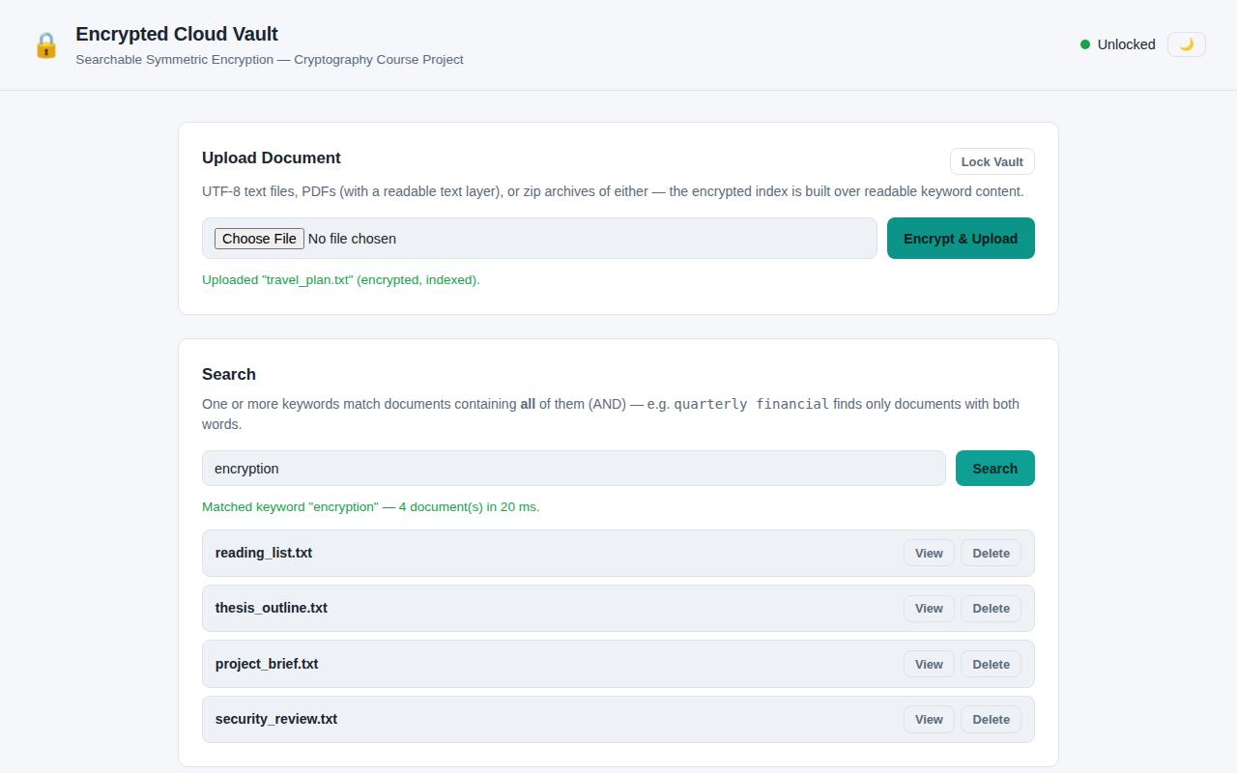
Fig. 3 Single-keyword encrypted search returning four matching documents
– “encryption” → 4 of 8 documents in 20 ms; index has 400 postings; matches tokenizer ground truth
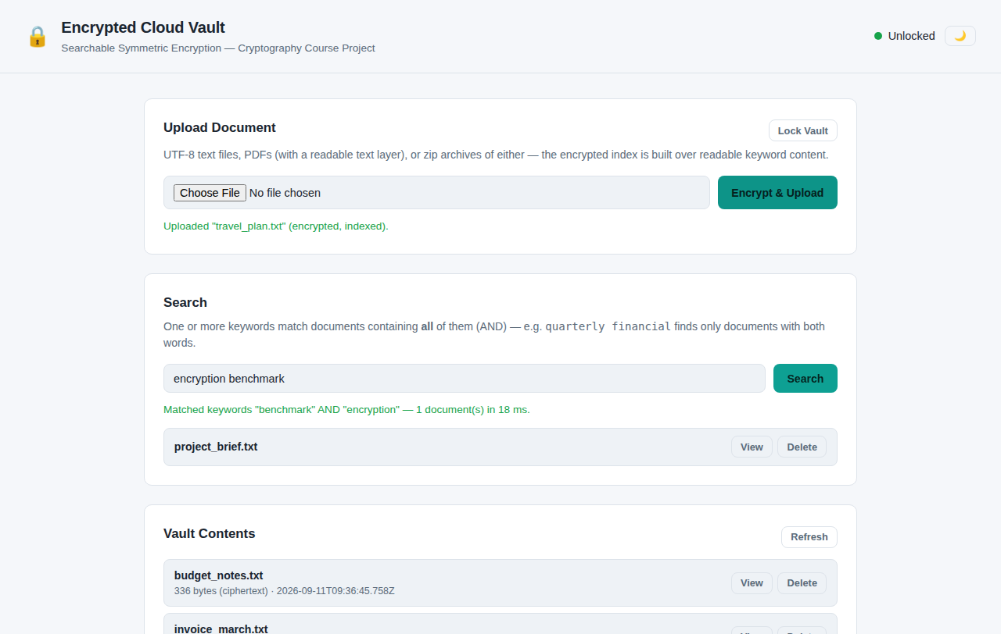
Fig. 4 Conjunctive (AND) search intersecting two keyword result sets on the client
– “encryption benchmark”: each word in 4 docs, intersection = 1 doc (project_brief.txt), 18 ms; traffic shows 2 separate single-token searches
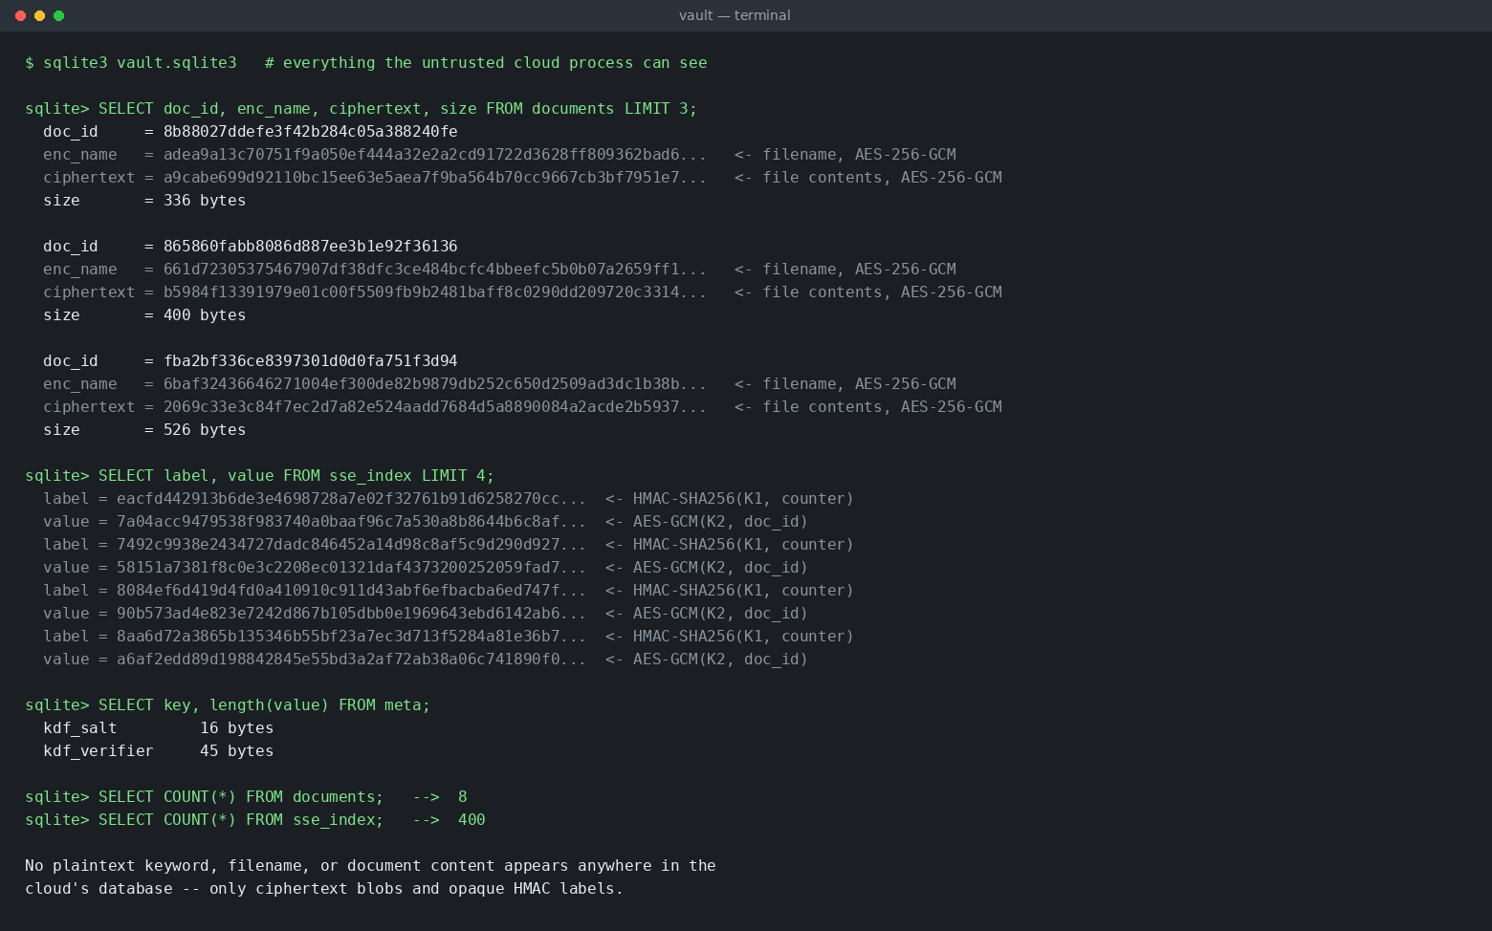
Fig. 5 Contents of the cloud database — only ciphertext and opaque HMAC labels are stored
– no plaintext filename/keyword/content in cloud DB; only ciphertext, labels, encrypted IDs, salt, verifier
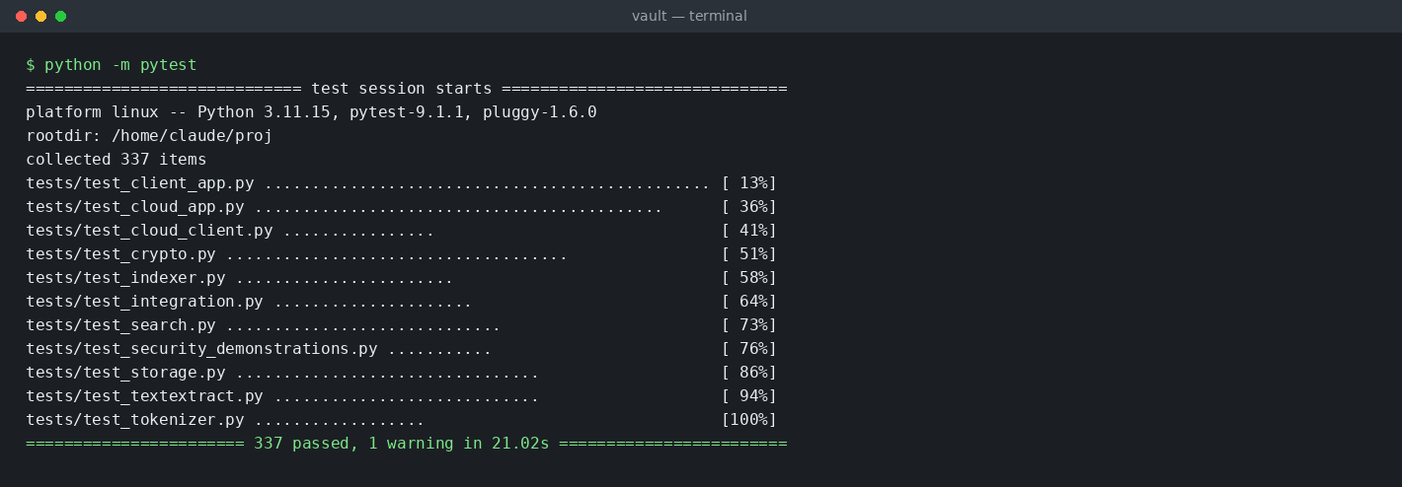
Fig. 6 Complete automated test suite passing (337 tests)
– 337 tests: crypto, tokenizer/index, search, both services, delete, password change, traffic-capture security tests
4.3: Performance Evaluation
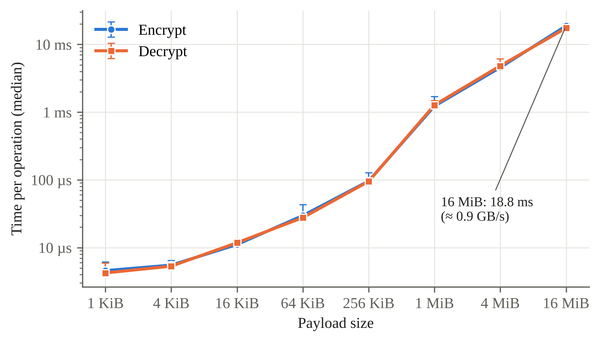
Fig. 7 AES-256-GCM encryption and decryption time versus payload size (median, min–max bars, n = 15)
– linear in size; 1 MiB → 1.23 ms; 16 MiB → 18.8 ms (≈ 0.9 GB/s); encrypt ≈ decrypt
– compare: Argon2id unlock 57 ms (slow on purpose); one HMAC ≈ 3.4 µs; full token ≈ 5 µs
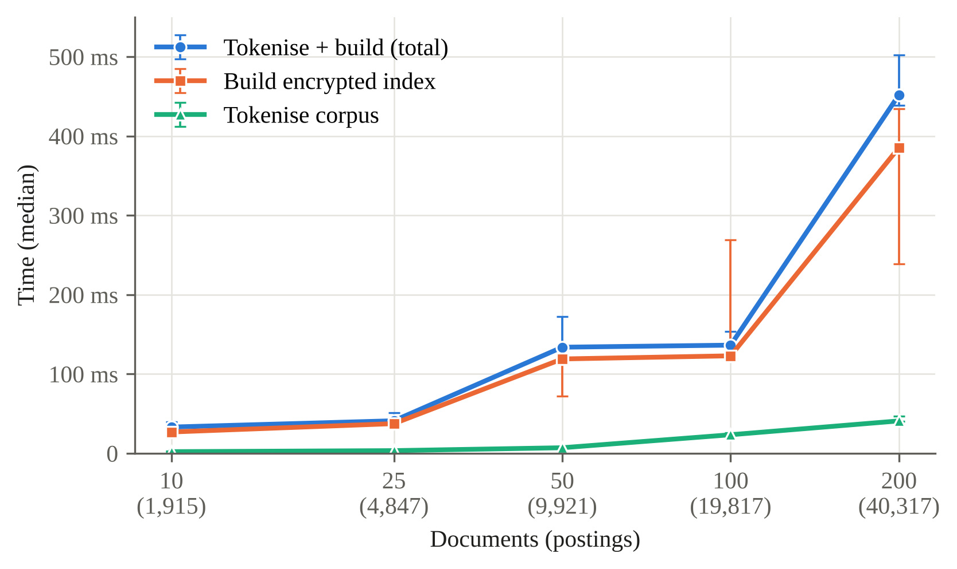
Fig. 8 Encrypted index construction time versus number of documents (median, min–max bars, n = 10)
– 10 docs (1,915 postings): 33 ms total; 200 docs (40,317 postings, 6,074 keywords): 452 ms total = 386 ms build + 41 ms tokenise
– ≈ 11 µs per posting at 200 docs; driven by postings, not document count; 50/100 points noisy
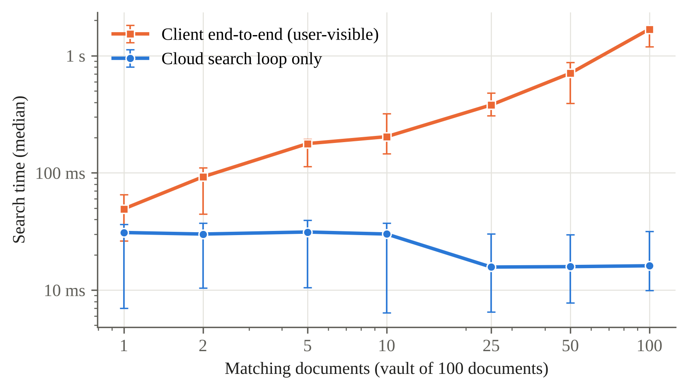
Fig. 9 Cloud-side search time and client end-to-end search latency versus number of matching documents
– vault = 100 docs; cloud loop flat 16–31 ms for 1–100 matches; end-to-end 49 ms → 1.68 s
– reason: one document request per result (to show filename) → batching would fix
– fixed 5 matches, vault 25 → 200 docs: cloud 15–17 ms, end-to-end 96–98 ms → independent of vault size
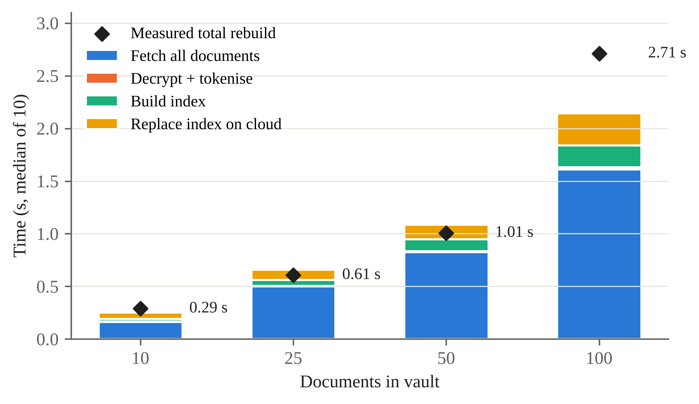
Fig. 10 Decomposition of the static index rebuild time performed after every upload
– rebuild: 0.29 s (10 docs) → 2.71 s (100 docs)
– at 100 docs: fetch all docs 1.61 s of 2.15 s step sum; decrypt+tokenise 22 ms; build 208 ms; replace 305 ms
– limitation: none of 3 runs reached 200 docs, so reported only to 100
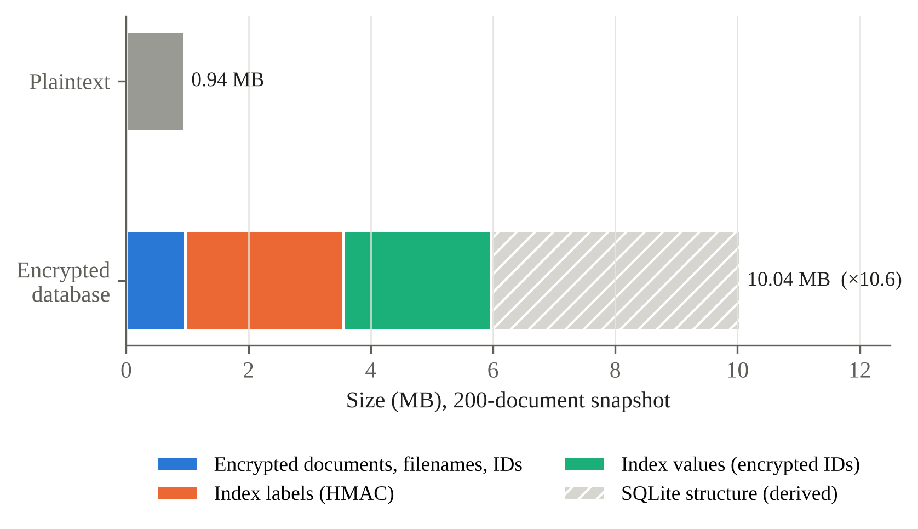
Fig. 11 Storage footprint of the encrypted database at 200 documents (single snapshot)
– plaintext 944,350 B vs database 10,039,296 B → ≈ 10.6×
– doc ciphertext only +28 B/doc; index ≈ 5.0 MB (40,317 postings × 124 B = 64 label + 60 value); ≈ 4.1 MB SQLite structure (derived)
– single snapshot, not a scaling result
V. CONCLUSION (not in the template — confirm with sir)
– what was built and verified (337 tests)
– main findings: crypto cheap; cloud search ~constant; user latency = per-result fetches; updates = full rebuild; storage ≈ 10×
– future work: batch fetch, dynamic SSE with forward/backward privacy, hide search/access pattern, atomic password change, multi-user
References
[1] Z. Hu, J. Wang, Z. Chen, Z. Ge, M. Bian, L. Chen, and Y. Zhou, “SEAC: Dynamic Searchable Symmetric Encryption with Lightweight Update-Search Permission Control,” Cybersecurity, vol. 8, article 75, 2025.
[2] S. Xu, X. Chen, Y. Guo, Y. Yang, S. Wang, S.-M. Yiu, and X. Cheng, “Forward-Secure Multi-User and Verifiable Dynamic Searchable Encryption Scheme within a Zero-Trust Environment,” Future Generation Computer Systems, vol. 166, p. 107701, 2025.
[3] L. Yang, Y. Yang, D. Niyato, Z. Li et al., “Dynamic Searchable Symmetric Encryption With Efficient and Complete Access Control for Multi-User Cloud Computing,” IEEE Transactions on Mobile Computing, 2025.
[4] “Forward and Backward Private Conjunctive Dynamic Searchable Symmetric Encryption With Refined Leakage Function and Low Communication,” IEEE Transactions on Information Forensics and Security, vol. 20, pp. 8224–8236, 2025.
[5] Z. Ren, P. He, R. Yu, L. Deng, Y. Tong, and S. Xu, “Dynamic Searchable Symmetric Encryption with Efficient Conjunctive Query and Non-Interactive Real Deletion,” Journal of Network and Computer Applications, vol. 245, article 104387, 2026.
[6] X. Zhang, H. Wang, J. Lu, T. Li et al., “A Bloom Filter-Based Dynamic Symmetric Searchable Encryption Scheme over Cloud Data,” Cybersecurity, vol. 9, article 47, 2026.
[7] X. Wang, J. Gong, K. Zhang, and H. Qian, “Decentralized Multi-Client Boolean Keyword Search for Encrypted Cloud Storage,” Computer Standards & Interfaces, vol. 97, article 104127, 2026.
[8] P. Wu, J. Shen, Z. Cao, and X. Dong, “MMKFB: Multi-Client and Multi-Keyword Searchable Symmetric Encryption with Forward and Backward Privacy,” Frontiers of Computer Science, vol. 19, no. 3, article 193804, 2025.
[9] A. Wu, D. Feng, M. Zhang, J. Chi, and Y. Zhang, “Efficient Verifiable Searchable Encryption with Search and Access Pattern Privacy,” Security and Safety, vol. 4, article 2024022, 2025.
[10] A. N. Khan, A. Naveed, A. Mehmood, D. Arora, A. ur R. Khan, and J. Ali, “BloomSec: Scalable and Privacy-Preserving Searchable Encryption for Cloud Environments,” PLOS ONE, vol. 20, no. 12, article e0336944, 2025.
[11] J. Xue, L. Zeng, W. Zhang, F. Li, X. Zhang, Y. Zhou, and L. Liu, “Incentive-Assisted Multi-Keyword Ranked Searchable Encryption with Hidden Attributes for Community Data Sharing,” Peer-to-Peer Networking and Applications, vol. 18, no. 3, article 153, 2025.
[12] H. M. Mohammed, M. H. Hashim, D. Kh. Altmemi, Z. A. Abduljabbar, Z. A. Hussien, V. O. Nyangaresi, A. A. Alyousif, and H. A. Neamah, “A Review: Searchable Symmetric Encryption Functionalities, Challenges and Solutions,” in Software Engineering: Emerging Trends and Practices in System Development, Lecture Notes in Networks and Systems, vol. 1562, Springer, Cham, pp. 47–65, 2026.
[13] D. Cash, J. Jaeger, S. Jarecki, C. Jutla, H. Krawczyk, M.-C. Roşu, and M. Steiner, “Dynamic Searchable Encryption in Very-Large Databases: Data Structures and Implementation,” in Proc. Network and Distributed System Security Symposium (NDSS), 2014.
[14] A. Biryukov, D. Dinu, D. Khovratovich, and S. Josefsson, “Argon2 Memory-Hard Function for Password Hashing and Proof-of-Work Applications,” RFC 9106, Internet Engineering Task Force, Sept. 2021.

