Automated News Classification System
Santhoshi Goli
Masters in Artificial Intelligence
University of North Texas, Denton, Texas
Santhoshigoli@my.unt.edu

Divyasri Velagapudi
Masters in Computer Science
University of North Texas, Denton, Texas
divyasrivelagapudi@my.unt.edu

Sowmya Shetti
Masters in Data Engineering
University of North Texas, Denton, Texas
sowmyashetti@my.unt.edu

Amani Peddolla
Masters in Data Engineering
University of North Texas, Denton, Texas
amanipeddolla@my.unt.edu

- Introduction
In the current world, a huge amount of news is available online, which makes it difficult for people looking for certain information. To find a way for this, it is important to develop a system that can categorize news precisely as per requirement.
The main goal of Automated News Classification System is to solve this issue by using Natural Language Processing (NLP) techniques to classify news into different categories in a self-conscious and precise manner. The system uses a dataset comprising news articles along with their respective categories as labels to train ML models to be able to identify the topics of required articles.
- Problem Statement
The main aim is to address the huge volume of news available online, which makes it difficult for everyone to browse and obtain essential information quickly. We want to address this issue by building a News Article Topic Classification system that uses Natural Language Processing to directly categorize news items into separate subjects, allowing consumers to obtain information more quickly and effectively.

- Significance

This is highly significant for information retrieval and user experience. Efficiently classifying news can improve information accessibility for readers, time saving and effort while looking for certain areas. Also,

Such a system can provide targeted content distribution, customized suggestions, and increased user interaction on news platforms.

- Objectives:

Main objective is to reliably categorize news items into preset topics/categories. Attain high classification accuracy and efficiency to make sure the practical use of system. Create a simple user interface for easy integration into platforms. Estimate the model's performance using testing and validation processes to ensure its usefulness across many news datasets.

- Features:

Transformer based models are used for this project. For example, TF-IDF. A totally working News Article
Topic Classification system with an API for integrating with news platforms. Milestones involve creating the initial model, optimizing for effectiveness, connecting with the user interface, and doing comprehensive testing and validation.

- A way to collect and analyze large volumes of annotated text data from many sources.
- Preprocessing involves filtering and processing unstructured text input to prepare it for machine learning models. The method will be useful to newspapers for categorizing and automatically tagging online news. Naive Bayes, Support Vector Machines, and Artificial Neural Networks have all been used to tackle the problem of classifying news. Furthermore, few methods have been employed to improve performance and accuracy, including stop word removal, feature reduction, and stemming.^{[1]}
- Efficiently extract informative features from preprocessed text data using techniques like Bag-of-Words, Word Embeddings, or other advanced approaches. Regular expressions were used to remove extraneous characters and cast them to the common register. The content was edited to remove URL links and non-alphabetic characters (except spaces).
- Tokenization is the process of breaking down text into units such as symbols, words, and sentences.^{[3]}
- Model selection is the process of picking the best model from a pool of candidates based on performance metrics. First, the news websites are crawled in order to gather e-news pages. Next, news websites are used to extract article contents.^{[2]}
- A range of online pages, such as shopping, blog, and advertisement pages, are included in the news websites. Because of this, sorting only e-news articles is a challenging task.^{[2]}
- Model training involves constructing and teaching machine learning models based on extracted characteristics and preprocessed text input.
- Model Deployment: Integrating trained models into APIs or web services to predict emotion labels based on text input.
- User Interface: A simple interface for end users to interact with the system.
- Scalability: The system must be able to handle large text data flow and several concurrent user requests. ^{[3]}
- Security: The system's security measures should secure sensitive user data and prevent unwanted access.

- Dataset
- This project uses a large dataset of news stories gathered from reliable news providers.
- The dataset contains a certain number of news covering a variety of themes.
- Each news includes metadata such as the publishing news and category.
- To guarantee diversity across themes, the dataset includes articles from a variety of reliable news sources.
- Before model training, the dataset will go through preprocessing activities such as text cleaning, tokenization, and stop-word removal to assure data quality and appropriateness for NLP analysis.

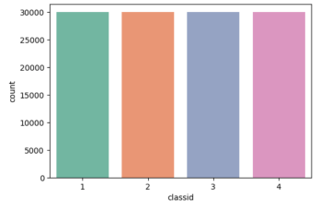
Where 1,2,3,4 stands for World, sports, business, Science & Tech news respectively.

Dataset link:
https://www.kaggle.com/datasets/amananandrai/ag-news-classification-dataset

- Methodology:

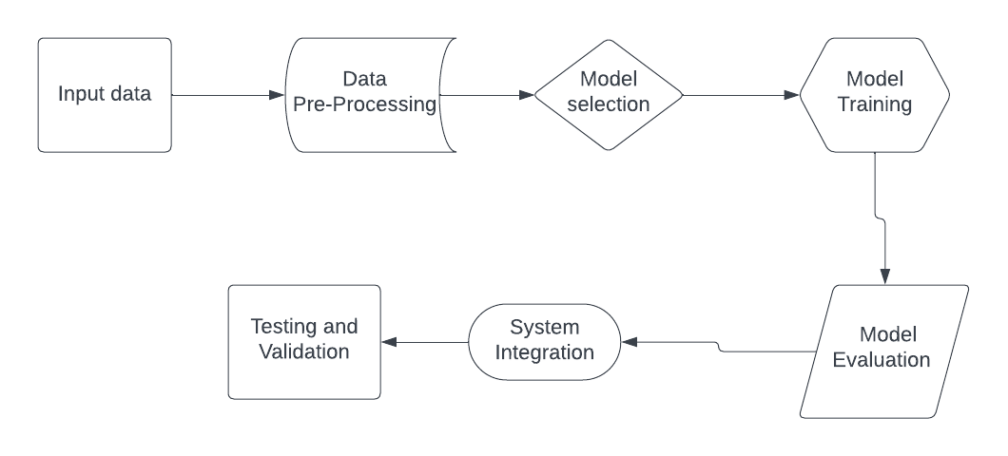

Workflow

Data Pre-processing: Tokenization, Lowercasing, Punctuation removal, removing digits, Stop words removal and Lemmatization.

Feature Extraction: For this process, TF-IDF Vectorizer is used to extract features from the preprocessed data. With the help of this trained TF-IDF, both training and testing data are transformed. All these features are then visualized.

Model Training and Evaluation:
Four different methods are used for this process. They are Multinomial Naive Bayes (NBM), Decision tree classifier, Gaussian Naïve Bayes and Stochastic gradient descent classifier.

Initially, Multinomial Naive Bayes model is fit on the training data. Then, prediction of the labels is done for data testing. In the end, the performance of the model is calculated using accuracy score and F1 score.

Similarly, all the 4 methods are trained and evaluated to get the best of all those.

- Implementation

Implementation of libraries:
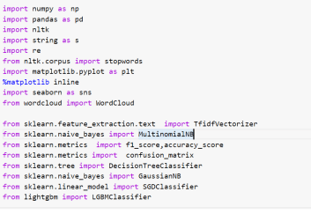
Here, NumPy, pandas and matplotlib are for data handling and visualization.
NLTK is for NLP tasks especially in data pre-processing. Even seaborn is for data representation. We use TF-IDF vectorizer for feature extraction.
Later using sklearn, necessary libraries are imported to evaluate required models.

Initially, data preprocessing is done. Later, Feature extraction is processed as follows:
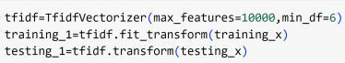

- Results

After the testing of 4 different models, following are the results in terms of F1 score, accuracy, and confusion matrix:

Multinomial Naïve Bayes:

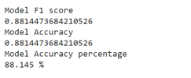

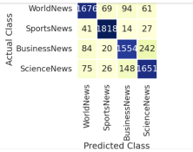

Decision Tree Classifier:

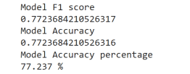

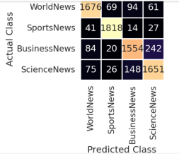
Gaussian Naïve bayes:

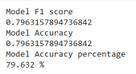

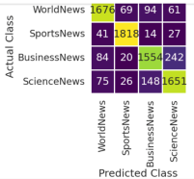

Stochastic gradient descent classifier:
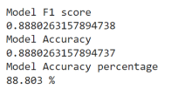
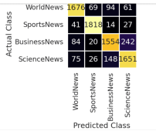
We can see that Multinomial Naïve Bayes and Stochastic gradient descent classifiers have given the best performance as per the considered data. Performance of any model is dependent on various factors. Out of which, data we consider is predominant.

- Project Management

Implementation Status report:

- Description:
The description includes an explanation of the project's aims, methodologies, and general workflow for the text categorization task. It also provides a quick summary of the data set and techniques used.

Task: Project Description
Person: Sowmya Shetti
Contribution: Description & documentation (100%)
Issues: NA

- Data Pre-processing:
This work includes preparing the text data, which includes tokenization, lowercase, punctuation, and digit removal, stop word removal, and lemmatization.

Task: Pre-processing the data
Person: Santhoshi Goli
Contribution: Text pre-processing (100%)
Issues: Encountered few issues while taking out stop words using NLTK. And also, in cases where there were emoticons used in the news.

- Feature Extraction:
Using the TfidfVectorizer, preprocessed text input is converted into TF-IDF feature vectors.

Task: Feature extraction
Person: Divyasri Velagapudi
Contribution: TD-IDF feature vectors creation (100%)
Issues: Faced difficulties in picking the suitable settings for the TfidfVectorizer, such as max_features and min_df.

- Model Training and Evaluation:
Model training and evaluation includes training several classifiers on TF-IDF features and assessing their performance against metrics such as F1-score, accuracy, and confusion matrix.

Task: Model training & evaluation
Person: Amani Peddolla
Contribution: Training classifiers and evaluating (100%)
Issues: Overfitting issue while performing Decision tree classifier.

- References:

- U. Suleymanov, S. Rustamov, M. Zulfugarov, O. Orujov, N. Musayev and A. Alizade, "Empirical Study of Online News Classification Using Machine Learning Approaches," 2018 IEEE 12th International Conference on Application of Information and Communication Technologies (AICT), Almaty, Kazakhstan, 2018, pp. 1-6, doi: 10.1109/ICAICT.2018.8747012.
- D. Dandeniya, "An Automatic e-news Article Content Extraction and Classification," 2018 18th International Conference on Advances in ICT for Emerging Regions (ICTer), Colombo, Sri Lanka, 2018, pp. 196-202, doi: 10.1109/ICTER.2018.8615480.
- E. A. Chelyshev and M. V. Raskatova, "Information System for Automatic News Text Classification," 2022 VI International Conference on Information Technologies in Engineering Education (Inforino), Moscow, Russian Federation, 2022, pp. 1-4, doi: 10.1109/Inforino53888.2022.9782937.
- Hermann, K. M., Kocisky, T., Grefenstette, E., Espeholt, L., Kay, W., Suleyman, M., & Blunsom, P. (2015).
Teaching machines to read and comprehend.
In Advances in Neural Information Processing Systems (pp. 1684-1692), https://cs.nyu.edu/~kcho/DMQA/ .

