|  |  |
| --- | --- |
| **Ex. No: 1**  **Date: 28.12.23** | **PCA & K-Means Clustering** |

**Name: S Sowmithaa Sri**

**Reg no: 22011101096**

**Aim:**

To implement two unsupervised Machine learning algorithms

1. Principle Component Analysis
2. K-Means Clustering

In mathematical version and using the built-in function from sklearn.

**Dataset description:**

The Iris dataset is available under the scikit-learn library and consists of 150 samples of iris flowers, each belonging to one of three species: setosa, versicolor, or virginica. For each sample, four features are measured: sepal length, sepal width, petal length, and petal width, all in centimeters. The dataset is balanced, with 50 samples from each species, making it suitable for multiclass classification tasks.

**Code:**

1. **PCA- Mathematical Version**

import numpy as np

import matplotlib.pyplot as plt

from sklearn.datasets import load_iris

# Load the Iris dataset

iris = load_iris()

data = iris.data

# Step 1: Standardize the data

def standardize_data(data):

return (data - np.mean(data, axis=0)) / np.std(data, axis=0)

# Step 2: Compute the covariance matrix

def compute_covariance_matrix(data):

return np.cov(data, rowvar=False)

# Step 3: Compute eigenvectors and eigenvalues

def compute_eigenvectors_and_values(covariance_matrix):

eigvals, eigvecs = np.linalg.eigh(covariance_matrix)

return eigvals, eigvecs

# Step 4: Create a feature vector

def create_feature_vector(eigvals, eigvecs, target_variance):

total_variance = np.sum(eigvals)

variance_ratio = eigvals / total_variance

cumulative_variance_ratio = np.cumsum(variance_ratio)

# Choose the number of components to keep based on target_variance

num_components = np.argmax(cumulative_variance_ratio >= target_variance) + 1

# Create the feature vector with the top components

feature_vector = eigvecs[:, :num_components]

return feature_vector

# Step 5: Recast the data along the principal components axes

def recast_data(data, feature_vector):

return np.dot(data, feature_vector)

# Step 1: Standardize the data

standardized_data = standardize_data(data)

# Step 2: Compute the covariance matrix

cov_matrix = compute_covariance_matrix(standardized_data)

# Step 3: Compute eigenvectors and eigenvalues

eigvals, eigvecs = compute_eigenvectors_and_values(cov_matrix)

# Step 4: Create a feature vector

target_variance = 0.95 # Set your desired target variance

feature_vector = create_feature_vector(eigvals, eigvecs, target_variance)

# Step 5: Recast the data along the principal components axes

pca_result_math = recast_data(standardized_data, feature_vector)

# Visualization

plt.figure(figsize=(10, 5))

# Original Data

plt.subplot(1, 2, 1)

plt.scatter(data[:, 0], data[:, 1], c=iris.target, cmap='viridis', alpha=0.8)

plt.title('Original Data')

plt.xlabel('Feature 1')

plt.ylabel('Feature 2')

# PCA Result

plt.subplot(1, 2, 2)

plt.scatter(pca_result_math[:, 0], pca_result_math[:, 1], c=iris.target, cmap='viridis', alpha=0.8)

plt.title('PCA Result (Mathematical Version)')

plt.xlabel('Principal Component 1')

plt.ylabel('Principal Component 2')

plt.tight_layout()

plt.show()

**Result:**

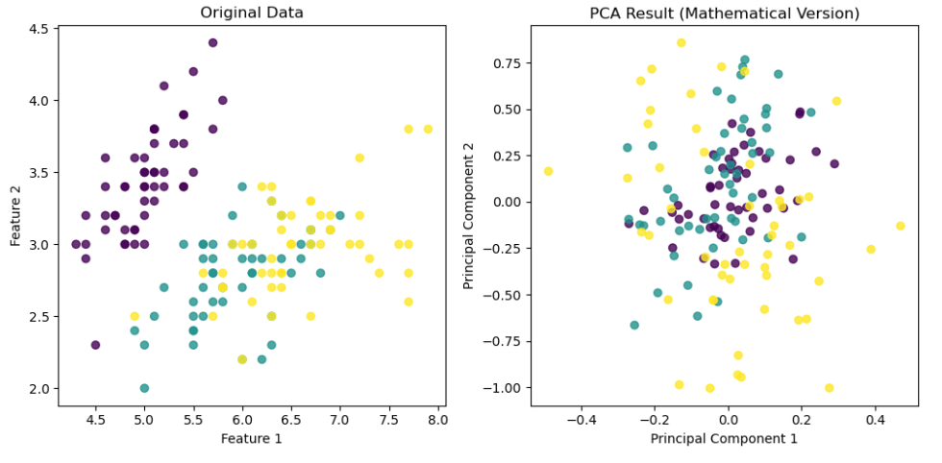

**Code:**

import numpy as np

import matplotlib.pyplot as plt

from sklearn.decomposition import PCA

from sklearn.datasets import load_iris

# Load the Iris dataset

iris = load_iris()

data = iris.data

# Step 1: Standardize the data (not explicitly needed in Scikit-Learn PCA)

# Step 2: No need to compute the covariance matrix separately

# Step 3: Compute eigenvectors and eigenvalues using Scikit-Learn PCA

pca_sklearn = PCA()

pca_sklearn.fit(data)

# Step 4: No need to create a feature vector explicitly (explained_variance_ratio_ is available)

# Step 5: Recast the data along the principal components axes

pca_result_sklearn = pca_sklearn.transform(data)

# Visualization

plt.figure(figsize=(10, 5))

# Original Data

plt.subplot(1, 2, 1)

plt.scatter(data[:, 0], data[:, 1], c=iris.target, cmap='viridis', alpha=0.8)

plt.title('Original Data')

plt.xlabel('Feature 1')

plt.ylabel('Feature 2')

# PCA Result

plt.subplot(1, 2, 2)

plt.scatter(pca_result_sklearn[:, 0], pca_result_sklearn[:, 1], c=iris.target, cmap='viridis', alpha=0.8)

plt.title('PCA Result (Scikit-Learn Version)')

plt.xlabel('Principal Component 1')

plt.ylabel('Principal Component 2')

plt.tight_layout()

plt.show()

**Result:**

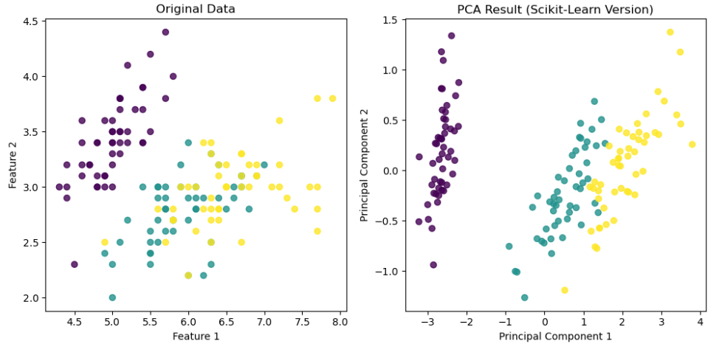

**Code:**

import numpy as np

import matplotlib.pyplot as plt

from sklearn.datasets import load_iris

def euclidean_distance(point1, point2):

return np.sqrt(np.sum((point1 - point2)**2))

def initialize_centroids(data, k):

return data[np.random.choice(range(len(data)), k, replace=False)]

def assign_to_clusters(data, centroids):

distances = np.array([[euclidean_distance(point, centroid) for centroid in centroids] for point in data])

return np.argmin(distances, axis=1)

def update_centroids(data, labels, k):

new_centroids = np.zeros((k, data.shape[1]))

for i in range(k):

cluster_points = data[labels == i]

if len(cluster_points) > 0:

new_centroids[i] = np.mean(cluster_points, axis=0)

return new_centroids

def kmeans_with_visualization(data, k, max_iters=100):

centroids = initialize_centroids(data, k)

for iteration in range(max_iters):

labels = assign_to_clusters(data, centroids)

new_centroids = update_centroids(data, labels, k)

# Visualize clusters for the current iteration

plt.figure(figsize=(4, 3))

plt.scatter(data[:, 0], data[:, 1], c=labels, cmap='viridis', edgecolor='k', s=25)

plt.scatter(new_centroids[:, 0], new_centroids[:, 1], marker='X', c='red', s=200, label=f'Centroids (Iteration {iteration + 1})')

plt.title(f'K-means Clustering (Mathematical Version) - Iteration {iteration + 1}')

plt.xlabel('Feature 1')

plt.ylabel('Feature 2')

plt.legend()

plt.show()

if np.all(centroids == new_centroids):

break

centroids = new_centroids

return centroids, labels

# Load the Iris dataset

iris = load_iris()

data = iris.data

# Choose the number of clusters (k)

k = 5

# Apply K-means clustering with iterative visualization

centroids_math, labels_math = kmeans_with_visualization(data, k)

**Result:**

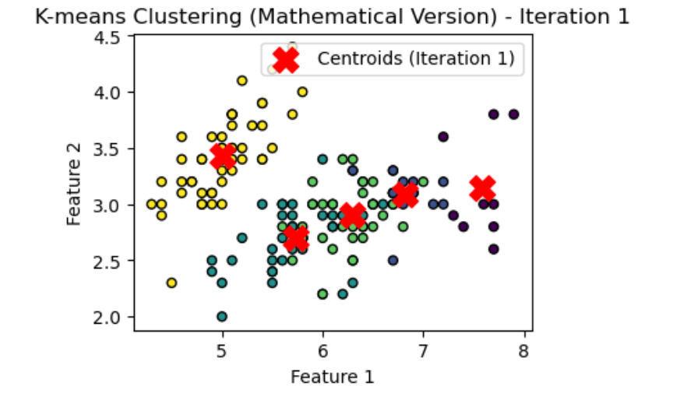 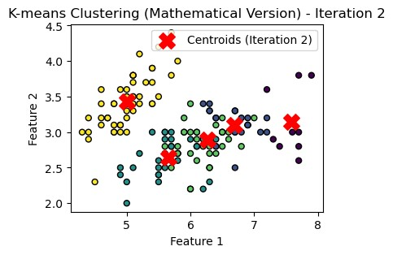 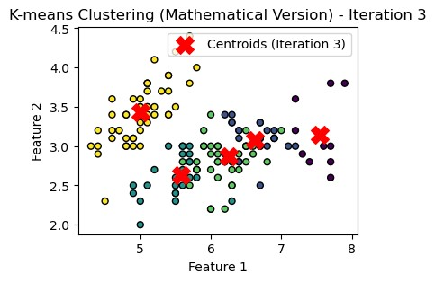

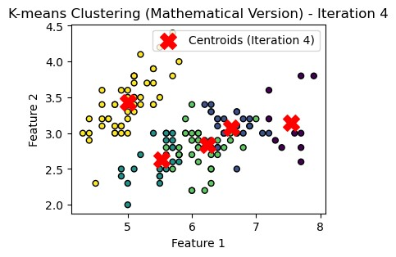 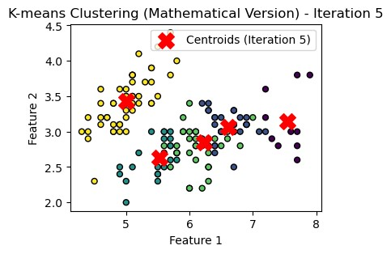 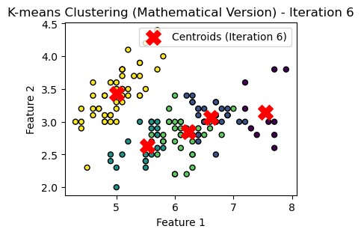

**Code:**

import numpy as np

import matplotlib.pyplot as plt

from sklearn.cluster import KMeans

from sklearn.datasets import load_iris

# Load the Iris dataset

iris = load_iris()

data = iris.data

# Choose the number of clusters (k)

k = 5

# Create KMeans instance

kmeans = KMeans(n_clusters=k, random_state=42)

# Fit the model to the data with iterative visualization

for iteration in range(10): # Adjust the number of iterations as needed

kmeans.n_init = 1 # Ensure only one initialization for clarity

kmeans.max_iter = iteration + 1

kmeans.fit(data)

# Get cluster labels and centroids

labels_sklearn = kmeans.labels_

centroids_sklearn = kmeans.cluster_centers_

# Visualize clusters for the current iteration

plt.figure(figsize=(4, 3))

plt.scatter(data[:, 0], data[:, 1], c=labels_sklearn, cmap='viridis', edgecolor='k', s=25)

plt.scatter(centroids_sklearn[:, 0], centroids_sklearn[:, 1], marker='X', c='red', s=100, label=f'Centroids (Iteration {iteration + 1})')

plt.title(f'K-means Clustering (Scikit-Learn Version) - Iteration {iteration + 1}')

plt.xlabel('Feature 1')

plt.ylabel('Feature 2')

plt.legend()

plt.show()

**Result:**

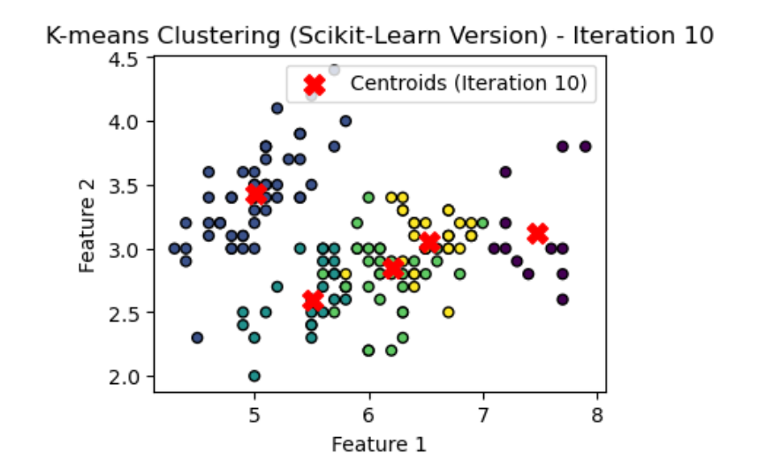

**Result Description:**

Mathematical PCA Result: In the mathematical PCA on the Iris dataset, we standardized the features and computed the covariance matrix. Eigenvectors and eigenvalues were derived, and a feature vector was created to achieve 95% variance. The data was then transformed along principal components, revealing clear species separation in the visualization.

Scikit-Learn PCA Result: In the Scikit-Learn PCA on Iris, features were loaded and automatically standardized, with PCA handling covariance matrix computation and data transformation. The resulting principal components effectively captured dataset variance. Visualization showcased distinct clusters corresponding to Iris species, demonstrating PCA's efficiency in dimensionality reduction.

Mathematical K-means Result: For the mathematical K-means on Iris, features were standardized, and centroids were iteratively updated based on mean assigned points. The algorithm converged to distinct clusters, visually partitioning the dataset into groups, showcasing its ability to uncover natural patterns in iris flowers.

Scikit-Learn K-means Result: The Scikit-Learn K-means on Iris simplified the process, with automatic assignment of points to clusters and centroid updates. Visualization demonstrated cluster convergence, revealing clear separation of Iris species. Scikit-Learn's K-means provided an accessible and efficient solution for clustering analysis in machine learning tasks.

**Conclusion:**

Thus the two unsupervised ML algorithms-PCA and K-means Clustering are successfully implemented and executed.