Exercise 1: Implementing the Singleton Pattern
Scenario:
You need to ensure that a logging utility class in your application has only one instance throughout the application lifecycle to ensure consistent logging.
Steps:
- Create a New Java Project:
  - Create a new Java project named SingletonPatternExample.
- Define a Singleton Class:
  - Create a class named Logger that has a private static instance of itself.
  - Ensure the constructor of Logger is private.
  - Provide a public static method to get the instance of the Logger class.
- Implement the Singleton Pattern:
  - Write code to ensure that the Logger class follows the Singleton design pattern.
- Test the Singleton Implementation:
  - Create a test class to verify that only one instance of Logger is created and used across the application.
SingletonTest.java

public class SingletonTest {
public static void main(String[] args) {
// Test 1: Get first instance
Logger logger1 = Logger.getInstance();
logger1.info("First logger instance created");

// Test 2: Get second instance
Logger logger2 = Logger.getInstance();
logger2.info("Second logger instance requested");

// Test 3: Compare instances
System.out.println("Are both instances the same? " + (logger1 == logger2));
System.out.println("Logger1 hashcode: " + logger1.hashCode());
System.out.println("Logger2 hashcode: " + logger2.hashCode());

// Test 4: Use logger in different parts
testInDifferentMethods();

// Test 5: Multiple operations
performMultipleOperations();
}

public static void testInDifferentMethods() {
Logger methodLogger = Logger.getInstance();
methodLogger.log("Testing from different method");
}

public static void performMultipleOperations() {
Logger opLogger = Logger.getInstance();
opLogger.info("Starting operations");
opLogger.log("Operation 1 completed");
opLogger.log("Operation 2 completed");
opLogger.error("Operation 3 failed");
opLogger.info("All operations finished");
}
}
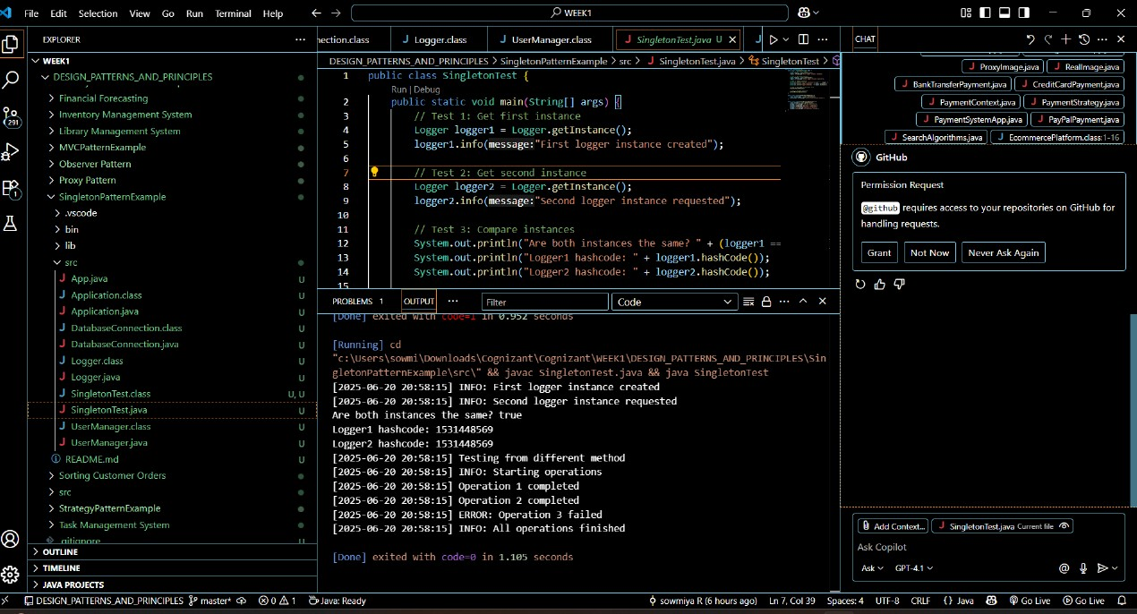

Exercise 2: Implementing the Factory Method Pattern
Scenario:
You are developing a document management system that needs to create different types of documents (e.g., Word, PDF, Excel). Use the Factory Method Pattern to achieve this.
Steps:
- Create a New Java Project:
  - Create a new Java project named FactoryMethodPatternExample.
- Define Document Classes:
  - Create interfaces or abstract classes for different document types such as WordDocument, PdfDocument, and ExcelDocument.
- Create Concrete Document Classes:
  - Implement concrete classes for each document type that implements or extends the above interfaces or abstract classes.
- Implement the Factory Method:
  - Create an abstract class DocumentFactory with a method createDocument().
  - Create concrete factory classes for each document type that extends DocumentFactory and implements the createDocument() method.
- Test the Factory Method Implementation:
  - Create a test class to demonstrate the creation of different document types using the factory method.
package FactoryMethodPatternExample;

// 1. Document interface - defines common behavior for all documents
interface Document {
void create();
void open();
void save();
void close();
String getDocumentType();
}

// 2. Concrete Document Classes
class WordDocument implements Document {
@Override
public void create() {
System.out.println("Creating a new Word document...");
}

@Override
public void open() {
System.out.println("Opening Word document with Microsoft Word...");
}

@Override
public void save() {
System.out.println("Saving Word document as .docx file...");
}

@Override
public void close() {
System.out.println("Closing Word document...");
}

@Override
public String getDocumentType() {
return "Word Document (.docx)";
}
}

class PdfDocument implements Document {
@Override
public void create() {
System.out.println("Creating a new PDF document...");
}

@Override
public void open() {
System.out.println("Opening PDF document with PDF reader...");
}

@Override
public void save() {
System.out.println("Saving PDF document as .pdf file...");
}

@Override
public void close() {
System.out.println("Closing PDF document...");
}

@Override
public String getDocumentType() {
return "PDF Document (.pdf)";
}
}

class ExcelDocument implements Document {
@Override
public void create() {
System.out.println("Creating a new Excel document...");
}

@Override
public void open() {
System.out.println("Opening Excel document with Microsoft Excel...");
}

@Override
public void save() {
System.out.println("Saving Excel document as .xlsx file...");
}

@Override
public void close() {
System.out.println("Closing Excel document...");
}

@Override
public String getDocumentType() {
return "Excel Document (.xlsx)";
}
}

// 3. Abstract Factory Class
abstract class DocumentFactory {
// Factory method - to be implemented by concrete factories
public abstract Document createDocument();

// Template method that uses the factory method
public Document processDocument() {
Document document = createDocument();
document.create();
return document;
}
}

// 4. Concrete Factory Classes
class WordDocumentFactory extends DocumentFactory {
@Override
public Document createDocument() {
return new WordDocument();
}
}

class PdfDocumentFactory extends DocumentFactory {
@Override
public Document createDocument() {
return new PdfDocument();
}
}

class ExcelDocumentFactory extends DocumentFactory {
@Override
public Document createDocument() {
return new ExcelDocument();
}
}

// 5. Document Type Enum for better type safety
enum DocumentType {
WORD, PDF, EXCEL
}

// 6. Factory Provider Class (Optional - for easier factory selection)
class DocumentFactoryProvider {
public static DocumentFactory getFactory(DocumentType type) {
switch (type) {
case WORD:
return new WordDocumentFactory();
case PDF:
return new PdfDocumentFactory();
case EXCEL:
return new ExcelDocumentFactory();
default:
throw new IllegalArgumentException("Unknown document type: " + type);
}
}
}

// 7. Test Class - Main Application
public class FactoryMethodPatternExample {
public static void main(String[] args) {
System.out.println("=== Factory Method Pattern Demo ===\n");

// Method 1: Using concrete factories directly
System.out.println("1. Creating documents using concrete factories:");
System.out.println("-".repeat(50));

// Create Word document
DocumentFactory wordFactory = new WordDocumentFactory();
Document wordDoc = wordFactory.processDocument();
System.out.println("Document type: " + wordDoc.getDocumentType());
wordDoc.open();
wordDoc.save();
wordDoc.close();

System.out.println();

// Create PDF document
DocumentFactory pdfFactory = new PdfDocumentFactory();
Document pdfDoc = pdfFactory.processDocument();
System.out.println("Document type: " + pdfDoc.getDocumentType());
pdfDoc.open();
pdfDoc.save();
pdfDoc.close();

System.out.println();

// Create Excel document
DocumentFactory excelFactory = new ExcelDocumentFactory();
Document excelDoc = excelFactory.processDocument();
System.out.println("Document type: " + excelDoc.getDocumentType());
excelDoc.open();
excelDoc.save();
excelDoc.close();

System.out.println("\n" + "=".repeat(60) + "\n");

// Method 2: Using factory provider for cleaner code
System.out.println("2. Creating documents using factory provider:");
System.out.println("-".repeat(50));

DocumentType[] types = {DocumentType.WORD, DocumentType.PDF, DocumentType.EXCEL};

for (DocumentType type : types) {
try {
DocumentFactory factory = DocumentFactoryProvider.getFactory(type);
Document document = factory.createDocument();

System.out.println("Processing " + document.getDocumentType() + ":");
document.create();
document.open();
document.save();
document.close();
System.out.println();

} catch (IllegalArgumentException e) {
System.err.println("Error: " + e.getMessage());
}
}

System.out.println("=".repeat(60));

// Method 3: Demonstrating polymorphism
System.out.println("\n3. Demonstrating polymorphic behavior:");
System.out.println("-".repeat(50));

DocumentFactory[] factories = {
new WordDocumentFactory(),
new PdfDocumentFactory(),
new ExcelDocumentFactory()
};

for (DocumentFactory factory : factories) {
Document doc = factory.createDocument();
System.out.println("Created: " + doc.getDocumentType());
}
}
}
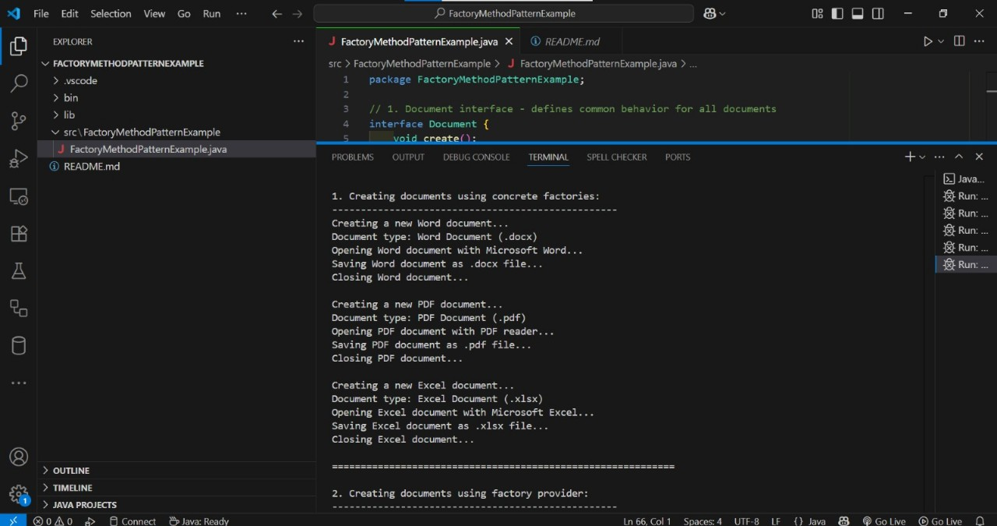

Exercise 3: Implementing the Builder Pattern
Scenario:
You are developing a system to create complex objects such as a Computer with multiple optional parts. Use the Builder Pattern to manage the construction process.
Steps:
- Create a New Java Project:
  - Create a new Java project named BuilderPatternExample.
- Define a Product Class:
  - Create a class Computer with attributes like CPU, RAM, Storage, etc.
- Implement the Builder Class:
  - Create a static nested Builder class inside Computer with methods to set each attribute.
  - Provide a build() method in the Builder class that returns an instance of Computer.
- Implement the Builder Pattern:
  - Ensure that the Computer class has a private constructor that takes the Builder as a parameter.
- Test the Builder Implementation:
  - Create a test class to demonstrate the creation of different configurations of Computer using the Builder pattern.

BuilderPatterExample.java
import java.util.ArrayList;
import java.util.List;

// 1. Product Class - Computer with multiple optional components
class Computer {
// Required parameters
private final String cpu;
private final String motherboard;

// Optional parameters
private final String ram;
private final String storage;
private final String graphicsCard;
private final String powerSupply;
private final String coolingSystem;
private final String caseType;
private final List<String> peripherals;
private final boolean isGamingPC;
private final boolean hasWiFi;
private final boolean hasBluetooth;
private final String operatingSystem;
private final int warrantyYears;

// Private constructor - only accessible through Builder
private Computer(Builder builder) {
// Required parameters
this.cpu = builder.cpu;
this.motherboard = builder.motherboard;

// Optional parameters
this.ram = builder.ram;
this.storage = builder.storage;
this.graphicsCard = builder.graphicsCard;
this.powerSupply = builder.powerSupply;
this.coolingSystem = builder.coolingSystem;
this.caseType = builder.caseType;
this.peripherals = new ArrayList<>(builder.peripherals);
this.isGamingPC = builder.isGamingPC;
this.hasWiFi = builder.hasWiFi;
this.hasBluetooth = builder.hasBluetooth;
this.operatingSystem = builder.operatingSystem;
this.warrantyYears = builder.warrantyYears;
}

// Getter methods
public String getCpu() { return cpu; }
public String getMotherboard() { return motherboard; }
public String getRam() { return ram; }
public String getStorage() { return storage; }
public String getGraphicsCard() { return graphicsCard; }
public String getPowerSupply() { return powerSupply; }
public String getCoolingSystem() { return coolingSystem; }
public String getCaseType() { return caseType; }
public List<String> getPeripherals() { return new ArrayList<>(peripherals); }
public boolean isGamingPC() { return isGamingPC; }
public boolean hasWiFi() { return hasWiFi; }
public boolean hasBluetooth() { return hasBluetooth; }
public String getOperatingSystem() { return operatingSystem; }
public int getWarrantyYears() { return warrantyYears; }

// 2. Static nested Builder class
public static class Builder {
// Required parameters
private String cpu;
private String motherboard;

// Optional parameters with default values
private String ram = "8GB DDR4";
private String storage = "256GB SSD";
private String graphicsCard = "Integrated";
private String powerSupply = "500W";
private String coolingSystem = "Stock Cooler";
private String caseType = "Mid Tower";
private List<String> peripherals = new ArrayList<>();
private boolean isGamingPC = false;
private boolean hasWiFi = true;
private boolean hasBluetooth = false;
private String operatingSystem = "Windows 11";
private int warrantyYears = 1;

// Constructor with required parameters
public Builder(String cpu, String motherboard) {
this.cpu = cpu;
this.motherboard = motherboard;
}

// Builder methods for optional parameters
public Builder ram(String ram) {
this.ram = ram;
return this;
}

public Builder storage(String storage) {
this.storage = storage;
return this;
}

public Builder graphicsCard(String graphicsCard) {
this.graphicsCard = graphicsCard;
return this;
}

public Builder powerSupply(String powerSupply) {
this.powerSupply = powerSupply;
return this;
}

public Builder coolingSystem(String coolingSystem) {
this.coolingSystem = coolingSystem;
return this;
}

public Builder caseType(String caseType) {
this.caseType = caseType;
return this;
}

public Builder addPeripheral(String peripheral) {
this.peripherals.add(peripheral);
return this;
}

public Builder peripherals(List<String> peripherals) {
this.peripherals = new ArrayList<>(peripherals);
return this;
}

public Builder isGamingPC(boolean isGamingPC) {
this.isGamingPC = isGamingPC;
return this;
}

public Builder hasWiFi(boolean hasWiFi) {
this.hasWiFi = hasWiFi;
return this;
}

public Builder hasBluetooth(boolean hasBluetooth) {
this.hasBluetooth = hasBluetooth;
return this;
}

public Builder operatingSystem(String operatingSystem) {
this.operatingSystem = operatingSystem;
return this;
}

public Builder warrantyYears(int warrantyYears) {
this.warrantyYears = warrantyYears;
return this;
}

// Build method that creates and returns Computer instance
public Computer build() {
// Optional: Add validation logic here
validateComputer();
return new Computer(this);
}

// Private validation method
private void validateComputer() {
if (cpu == null || cpu.trim().isEmpty()) {
throw new IllegalStateException("CPU is required");
}
if (motherboard == null || motherboard.trim().isEmpty()) {
throw new IllegalStateException("Motherboard is required");
}
if (warrantyYears < 0 || warrantyYears > 10) {
throw new IllegalStateException("Warranty years must be between 0 and 10");
}
}
}

// toString method for easy display
@Override
public String toString() {
StringBuilder sb = new StringBuilder();
sb.append("Computer Configuration:\n");
sb.append("├── CPU: ").append(cpu).append("\n");
sb.append("├── Motherboard: ").append(motherboard).append("\n");
sb.append("├── RAM: ").append(ram).append("\n");
sb.append("├── Storage: ").append(storage).append("\n");
sb.append("├── Graphics Card: ").append(graphicsCard).append("\n");
sb.append("├── Power Supply: ").append(powerSupply).append("\n");
sb.append("├── Cooling System: ").append(coolingSystem).append("\n");
sb.append("├── Case Type: ").append(caseType).append("\n");
sb.append("├── Operating System: ").append(operatingSystem).append("\n");
sb.append("├── Gaming PC: ").append(isGamingPC ? "Yes" : "No").append("\n");
sb.append("├── WiFi: ").append(hasWiFi ? "Yes" : "No").append("\n");
sb.append("├── Bluetooth: ").append(hasBluetooth ? "Yes" : "No").append("\n");
sb.append("├── Warranty: ").append(warrantyYears).append(" year(s)\n");
sb.append("└── Peripherals: ");
if (peripherals.isEmpty()) {
sb.append("None");
} else {
sb.append(String.join(", ", peripherals));
}
return sb.toString();
}
}

// 3. Pre-configured Computer Builder Classes (Optional Extension)
class GamingComputerBuilder {
public static Computer.Builder getGamingBuilder() {
return new Computer.Builder("Intel Core i7-13700K", "ASUS ROG Strix Z790")
.ram("32GB DDR5")
.storage("1TB NVMe SSD")
.graphicsCard("NVIDIA RTX 4070")
.powerSupply("750W 80+ Gold")
.coolingSystem("Liquid Cooling AIO")
.caseType("Full Tower RGB")
.isGamingPC(true)
.hasWiFi(true)
.hasBluetooth(true)
.warrantyYears(3);
}
}

class OfficeComputerBuilder {
public static Computer.Builder getOfficeBuilder() {
return new Computer.Builder("Intel Core i5-13400", "MSI Pro B760M")
.ram("16GB DDR4")
.storage("512GB SSD")
.powerSupply("450W 80+ Bronze")
.caseType("Mini ITX")
.hasWiFi(true)
.warrantyYears(2);
}
}

class BudgetComputerBuilder {
public static Computer.Builder getBudgetBuilder() {
return new Computer.Builder("AMD Ryzen 5 5600G", "ASRock B450M")
.ram("8GB DDR4")
.storage("256GB SSD")
.powerSupply("400W")
.caseType("Micro ATX")
.warrantyYears(1);
}
}

// 4. Test Class - Main Application
public class BuilderPatternExample {
public static void main(String[] args) {
System.out.println("=== Builder Pattern Demo - Computer Configuration ===\n");

// Example 1: Basic computer with minimal configuration
System.out.println("1. Basic Computer Configuration:");
System.out.println("-".repeat(60));
Computer basicComputer = new Computer.Builder("Intel Core i3-12100", "MSI H610M")
.build();
System.out.println(basicComputer);
System.out.println();

// Example 2: Gaming computer with extensive configuration
System.out.println("2. High-End Gaming Computer:");
System.out.println("-".repeat(60));
Computer gamingComputer = new Computer.Builder("AMD Ryzen 9 7900X", "ASUS ROG Crosshair X670E")
.ram("64GB DDR5-6000")
.storage("2TB NVMe SSD + 4TB HDD")
.graphicsCard("NVIDIA RTX 4090")
.powerSupply("1000W 80+ Platinum")
.coolingSystem("Custom Water Cooling Loop")
.caseType("Full Tower Tempered Glass")
.addPeripheral("Mechanical Gaming Keyboard")
.addPeripheral("Gaming Mouse")
.addPeripheral("4K Gaming Monitor")
.addPeripheral("Gaming Headset")
.isGamingPC(true)
.hasWiFi(true)
.hasBluetooth(true)
.operatingSystem("Windows 11 Pro")
.warrantyYears(5)
.build();
System.out.println(gamingComputer);
System.out.println();

// Example 3: Office computer using method chaining
System.out.println("3. Office Workstation:");
System.out.println("-".repeat(60));
Computer officeComputer = new Computer.Builder("Intel Core i7-13700", "Dell OptiPlex Motherboard")
.ram("32GB DDR4")
.storage("1TB SSD")
.graphicsCard("Intel UHD Graphics")
.powerSupply("500W")
.coolingSystem("Stock Intel Cooler")
.caseType("Small Form Factor")
.addPeripheral("Wireless Keyboard")
.addPeripheral("Wireless Mouse")
.addPeripheral("24-inch Monitor")
.hasWiFi(true)
.hasBluetooth(true)
.operatingSystem("Windows 11 Enterprise")
.warrantyYears(3)
.build();
System.out.println(officeComputer);
System.out.println();

// Example 4: Using pre-configured builders
System.out.println("4. Pre-configured Computer Types:");
System.out.println("-".repeat(60));

// Gaming PC with additional customization
Computer prebuiltGaming = GamingComputerBuilder.getGamingBuilder()
.addPeripheral("RGB Mechanical Keyboard")
.addPeripheral("Gaming Mouse Pad")
.build();
System.out.println("Gaming PC Configuration:");
System.out.println(prebuiltGaming);
System.out.println();

// Office PC
Computer officePC = OfficeComputerBuilder.getOfficeBuilder()
.addPeripheral("Wireless Keyboard & Mouse Set")
.build();
System.out.println("Office PC Configuration:");
System.out.println(officePC);
System.out.println();

// Budget PC
Computer budgetPC = BudgetComputerBuilder.getBudgetBuilder()
.build();
System.out.println("Budget PC Configuration:");
System.out.println(budgetPC);
System.out.println();

// Example 5: Demonstrating validation
System.out.println("5. Builder Validation Demo:");
System.out.println("-".repeat(60));
try {
// This will throw an exception due to invalid warranty years
Computer invalidComputer = new Computer.Builder("Intel i5", "Generic Motherboard")
.warrantyYears(15) // Invalid warranty period
.build();
} catch (IllegalStateException e) {
System.out.println("Validation Error: " + e.getMessage());
}

try {
// This will throw an exception due to empty CPU
Computer invalidComputer2 = new Computer.Builder("", "Generic Motherboard")
.build();
} catch (IllegalStateException e) {
System.out.println("Validation Error: " + e.getMessage());
}

System.out.println("\n" + "=".repeat(80));
System.out.println("Builder Pattern Benefits Demonstrated:");
System.out.println("• Flexible object construction with optional parameters");
System.out.println("• Method chaining for readable code");
System.out.println("• Immutable objects (thread-safe)");
System.out.println("• Built-in validation");
System.out.println("• Pre-configured builders for common configurations");
}
}
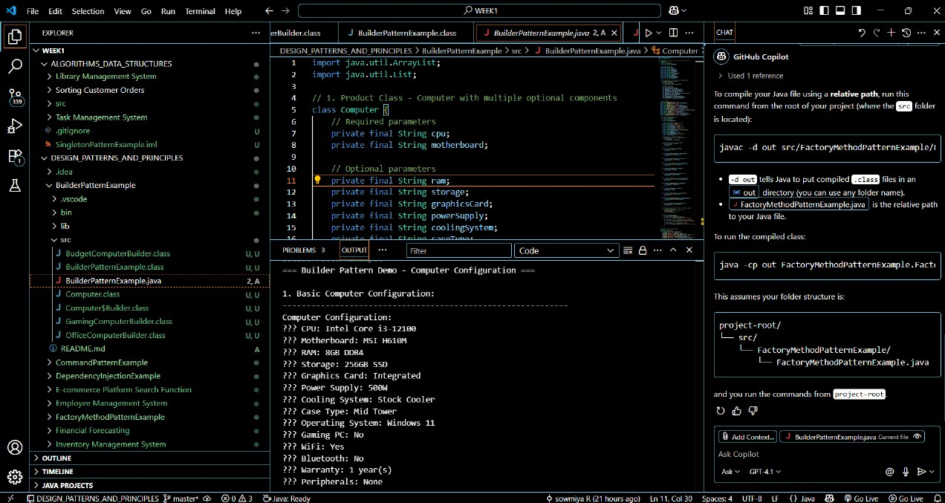

Exercise 6: Implementing the Proxy Pattern
Scenario:
You are developing an image viewer application that loads images from a remote server. Use the Proxy Pattern to add lazy initialization and caching.
Steps:
- Create a New Java Project:
  - Create a new Java project named ProxyPatternExample.
- Define Subject Interface:
  - Create an interface Image with a method display().
- Implement Real Subject Class:
  - Create a class RealImage that implements Image and loads an image from a remote server.
- Implement Proxy Class:
  - Create a class ProxyImage that implements Image and holds a reference to RealImage.
  - Implement lazy initialization and caching in ProxyImage.
- Test the Proxy Implementation:
  - Create a test class to demonstrate the use of ProxyImage to load and display images.
ImageViewerApp.java

public class ImageViewerApp {
public static void main(String[] args) {
System.out.println("=== Proxy Pattern Example - Image Viewer ===\n");

// Create proxy images (no actual loading happens here)
System.out.println("1. Creating proxy images...");
Image image1 = new ProxyImage("vacation_photo.jpg");
Image image2 = new ProxyImage("family_portrait.png");
Image image3 = new ProxyImage("landscape.gif");

System.out.println("Proxy images created instantly (no loading yet)\n");

// First display - triggers lazy loading
System.out.println("2. First display of vacation_photo.jpg:");
image1.display();
System.out.println();

// Second display - uses cached image
System.out.println("3. Second display of vacation_photo.jpg (should be instant):");
image1.display();
System.out.println();

// Display other images
System.out.println("4. First display of family_portrait.png:");
image2.display();
System.out.println();

System.out.println("5. First display of landscape.gif:");
image3.display();
System.out.println();

// Display cached images again
System.out.println("6. Displaying cached images:");
image1.display();
System.out.println();
image2.display();
System.out.println();
image3.display();
System.out.println();

// Demonstrate proxy status
demonstrateProxyStatus();
}

private static void demonstrateProxyStatus() {
System.out.println("7. Demonstrating proxy status:");

ProxyImage proxyImage = new ProxyImage("new_image.jpg");
System.out.println("Created proxy for: " + proxyImage.getFilename());
System.out.println("Is image loaded? " + proxyImage.isLoaded());

System.out.println("\nDisplaying image for first time:");
proxyImage.display();
System.out.println("Is image loaded now? " + proxyImage.isLoaded());

System.out.println("\nDisplaying same image again:");
proxyImage.display();
}
}
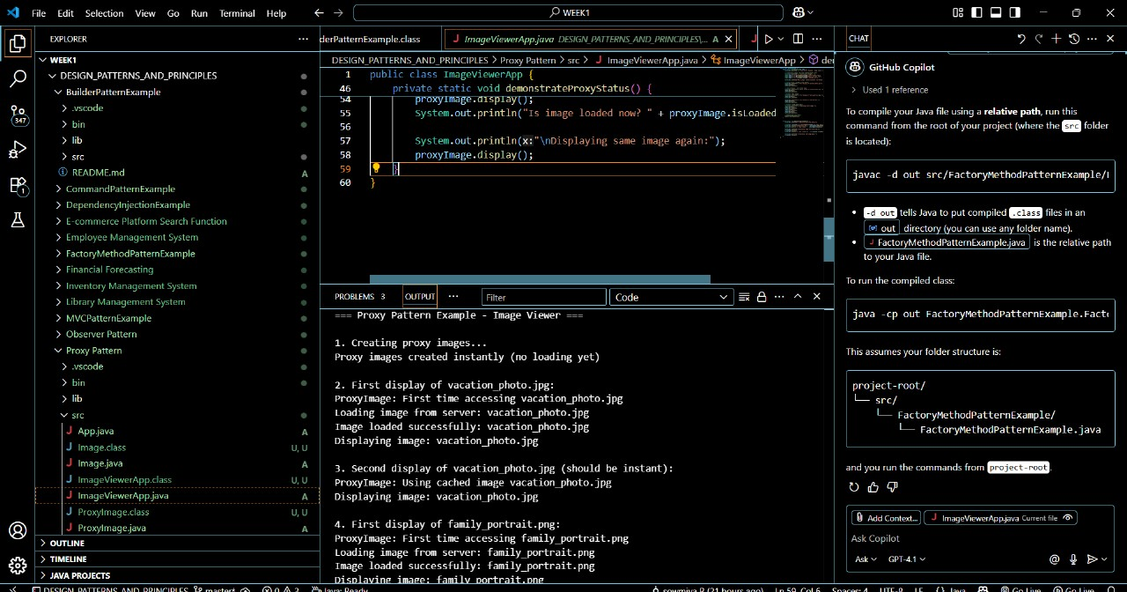

Exercise 7: Implementing the Observer Pattern
Scenario:
You are developing a stock market monitoring application where multiple clients need to be notified whenever stock prices change. Use the Observer Pattern to achieve this.
Steps:
- Create a New Java Project:
  - Create a new Java project named ObserverPatternExample.
- Define Subject Interface:
  - Create an interface Stock with methods to register, deregister, and notify observers.
- Implement Concrete Subject:
  - Create a class StockMarket that implements Stock and maintains a list of observers.
- Define Observer Interface:
  - Create an interface Observer with a method update().
- Implement Concrete Observers:
  - Create classes MobileApp, WebApp that implement Observer.
- Test the Observer Implementation:
  - Create a test class to demonstrate the registration and notification of observers.

StockMarketApp.java

import java.util.Map;

public class StockMarketApp {
public static void main(String[] args) {
System.out.println("=== Observer Pattern Example - Stock Market Monitor ===\n");

// Create the subject (stock market)
StockMarket stockMarket = new StockMarket();

// Create observers
System.out.println("1. Creating observers...");
MobileApp mobileApp1 = new MobileApp("StockTrader Pro", "user123");
MobileApp mobileApp2 = new MobileApp("InvestMobile", "investor456");
WebApp webApp1 = new WebApp("TradingPortal.com", "session789");
WebApp webApp2 = new WebApp("MarketWatch.net", "session101");
EmailAlert emailAlert = new EmailAlert("trader@example.com", 5.0);

// Register observers
System.out.println("\n2. Registering observers...");
stockMarket.registerObserver(mobileApp1);
stockMarket.registerObserver(webApp1);
stockMarket.registerObserver(emailAlert);

// Test stock price updates
System.out.println("\n3. Testing stock price updates...");
stockMarket.setStockPrice("AAPL", 150.00);

// Add more observers
System.out.println("\n4. Adding more observers...");
stockMarket.registerObserver(mobileApp2);
stockMarket.registerObserver(webApp2);

// More price updates
stockMarket.setStockPrice("GOOGL", 2500.00);
stockMarket.setStockPrice("AAPL", 155.50); // 3.67% increase

// Test significant price change (triggers email alert)
stockMarket.setStockPrice("TSLA", 800.00);
stockMarket.setStockPrice("TSLA", 720.00); // 10% decrease

// Test observer deregistration
System.out.println("\n5. Testing observer deregistration...");
stockMarket.deregisterObserver(mobileApp1);
stockMarket.deregisterObserver(emailAlert);

stockMarket.setStockPrice("GOOGL", 2450.00); // 2% decrease

// Final stock update with fewer observers
stockMarket.setStockPrice("AAPL", 160.00); // 2.9% increase

// Display final summary
System.out.println("\n6. Final Stock Summary:");
displayStockSummary(stockMarket);
}

private static void displayStockSummary(StockMarket stockMarket) {
System.out.println("Current Stock Prices:");
for (Map.Entry<String, Double> entry : stockMarket.getAllStockPrices().entrySet()) {
System.out.println(" " + entry.getKey() + ": $" + String.format("%.2f", entry.getValue()));
}
}
}
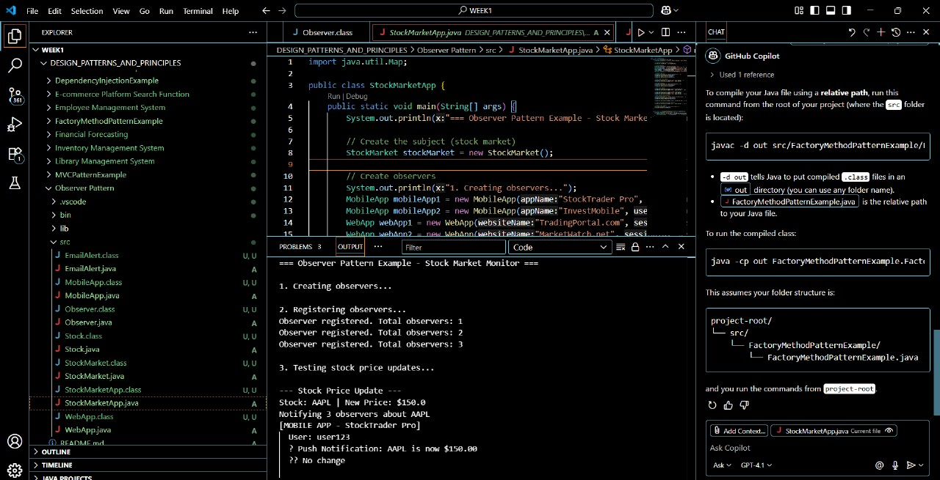

Exercise 8: Implementing the Strategy Pattern
Scenario:
You are developing a payment system where different payment methods (e.g., Credit Card, PayPal) can be selected at runtime. Use the Strategy Pattern to achieve this.
Steps:
- Create a New Java Project:
  - Create a new Java project named StrategyPatternExample.
- Define Strategy Interface:
  - Create an interface PaymentStrategy with a method pay().
- Implement Concrete Strategies:
  - Create classes CreditCardPayment, PayPalPayment that implement PaymentStrategy.
- Implement Context Class:
  - Create a class PaymentContext that holds a reference to PaymentStrategy and a method to execute the strategy.
- Test the Strategy Implementation:
  - Create a test class to demonstrate selecting and using different payment strategies.
PaymentSystemApp.java
import java.util.Scanner;
public class PaymentSystemApp {
public static void main(String[] args) {
System.out.println("=== Strategy Pattern Example - Payment System ===\n");

// Create payment context
PaymentContext paymentContext = new PaymentContext("ORD-12345");
paymentContext.setAmount(299.99);

// Demonstrate different payment strategies
demonstrateAutomaticPayments(paymentContext);

// Interactive demo
System.out.println("\n" + "=".repeat(50));
System.out.println("Interactive Payment Demo");
System.out.println("=".repeat(50));
interactivePaymentDemo();
}
private static void demonstrateAutomaticPayments(PaymentContext context) {
System.out.println("1. Testing Credit Card Payment:");
System.out.println("-".repeat(40));

// Create and test credit card payment
PaymentStrategy creditCard = new CreditCardPayment(
"1234567890123456",
"John Doe",
"12/25",
"123"
);

context.setPaymentStrategy(creditCard);
context.executePayment();

System.out.println("\n2. Testing PayPal Payment:");
System.out.println("-".repeat(40));

// Create and test PayPal payment
PaymentStrategy paypal = new PayPalPayment(
"john.doe@example.com",
"securepassword123"
);

context.setPaymentStrategy(paypal);
context.executePayment();

System.out.println("\n3. Testing Bank Transfer Payment:");
System.out.println("-".repeat(40));

// Create and test bank transfer payment
PaymentStrategy bankTransfer = new BankTransferPayment(
"12345678901",
"123456789",
"John Doe"
);

context.setPaymentStrategy(bankTransfer);
context.executePayment();
}
private static void interactivePaymentDemo() {
Scanner scanner = new Scanner(System.in);
PaymentContext context = new PaymentContext("ORD-" + System.currentTimeMillis());
// Get amount from user
System.out.print("Enter payment amount: $");
double amount = scanner.nextDouble();
scanner.nextLine(); // consume newline
context.setAmount(amount);

while (true) {
System.out.println("\nSelect Payment Method:");
System.out.println("1. Credit Card");
System.out.println("2. PayPal");
System.out.println("3. Bank Transfer");
System.out.println("4. Exit");
System.out.print("Choice: ");

int choice = scanner.nextInt();
scanner.nextLine(); // consume newline

PaymentStrategy strategy = null;

switch (choice) {
case 1:
strategy = createCreditCardStrategy(scanner);
break;
case 2:
strategy = createPayPalStrategy(scanner);
break;
case 3:
strategy = createBankTransferStrategy(scanner);
break;
case 4:
System.out.println("Thank you for using our payment system!");
scanner.close();
return;
default:
System.out.println("Invalid choice. Please try again.");
continue;
}

if (strategy != null) {
context.setPaymentStrategy(strategy);
boolean success = context.executePayment();

if (success) {
System.out.println("\n Transaction completed successfully!");
break;
} else {
System.out.println("\n Would you like to try a different payment method?");
}
}
}
scanner.close();
}
private static PaymentStrategy createCreditCardStrategy(Scanner scanner) {
System.out.print("Enter card number (16 digits): ");
String cardNumber = scanner.nextLine();
System.out.print("Enter cardholder name: ");
String name = scanner.nextLine();
System.out.print("Enter expiry date (MM/YY): ");
String expiry = scanner.nextLine();
System.out.print("Enter CVV (3 digits): ");
String cvv = scanner.nextLine();
return new CreditCardPayment(cardNumber, name, expiry, cvv);
}
private static PaymentStrategy createPayPalStrategy(Scanner scanner) {
System.out.print("Enter PayPal email: ");
String email = scanner.nextLine();
System.out.print("Enter password: ");
String password = scanner.nextLine();
return new PayPalPayment(email, password);
}
private static PaymentStrategy createBankTransferStrategy(Scanner scanner) {
System.out.print("Enter account number: ");
String accountNumber = scanner.nextLine();
System.out.print("Enter routing number (9 digits): ");
String routingNumber = scanner.nextLine();
System.out.print("Enter account holder name: ");
String accountHolder = scanner.nextLine();
return new BankTransferPayment(accountNumber, routingNumber, accountHolder);
}
}
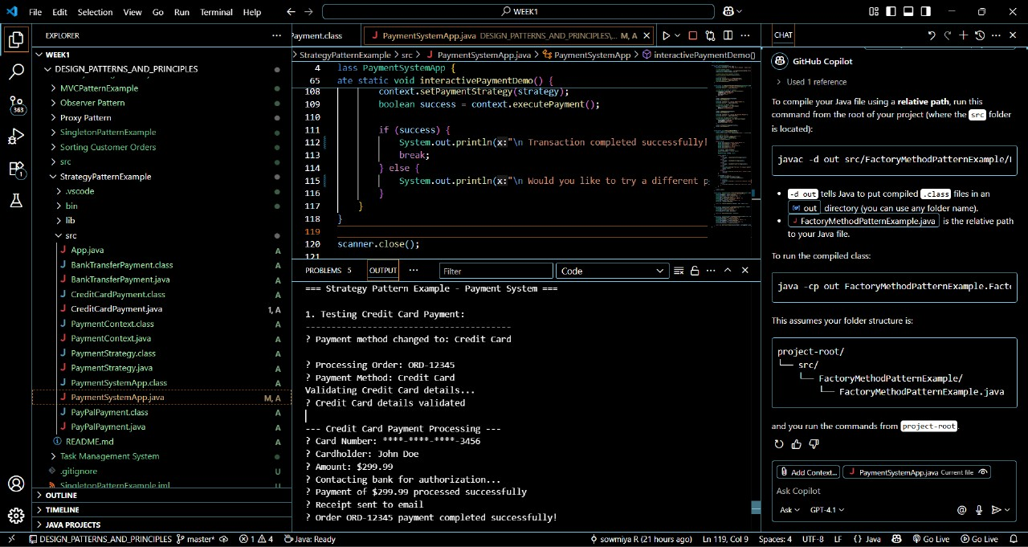

Exercise 9: Implementing the Command Pattern
Scenario: You are developing a home automation system where commands can be issued to turn devices on or off. Use the Command Pattern to achieve this.
Steps:
- Create a New Java Project:
  - Create a new Java project named CommandPatternExample.
- Define Command Interface:
  - Create an interface Command with a method execute().
- Implement Concrete Commands:
  - Create classes LightOnCommand, LightOffCommand that implement Command.
- Implement Invoker Class:
  - Create a class RemoteControl that holds a reference to a Command and a method to execute the command.
- Implement Receiver Class:
  - Create a class Light with methods to turn on and off.
- Test the Command Implementation:
  - Create a test class to demonstrate issuing commands using the RemoteControl.

Exercise 10: Implementing the MVC Pattern
Scenario:
You are developing a simple web application for managing student records using the MVC pattern.
Steps:
- Create a New Java Project:
  - Create a new Java project named MVCPatternExample.
- Define Model Class:
  - Create a class Student with attributes like name, id, and grade.
- Define View Class:
  - Create a class StudentView with a method displayStudentDetails().
- Define Controller Class:
  - Create a class StudentController that handles the communication between the model and the view.
- Test the MVC Implementation:
  - Create a main class to demonstrate creating a Student, updating its details using StudentController, and displaying them using StudentView.
Student.java

// Source code is decompiled from a .class file using FernFlower decompiler.
class Student {
private String name;
private String id;
private String grade;

public Student(String var1, String var2, String var3) {
this.name = var1;
this.id = var2;
this.grade = var3;
}

public String getName() {
return this.name;
}

public String getId() {
return this.id;
}

public String getGrade() {
return this.grade;
}

public void setName(String var1) {
this.name = var1;
}

public void setId(String var1) {
this.id = var1;
}

public void setGrade(String var1) {
this.grade = var1;
}
}
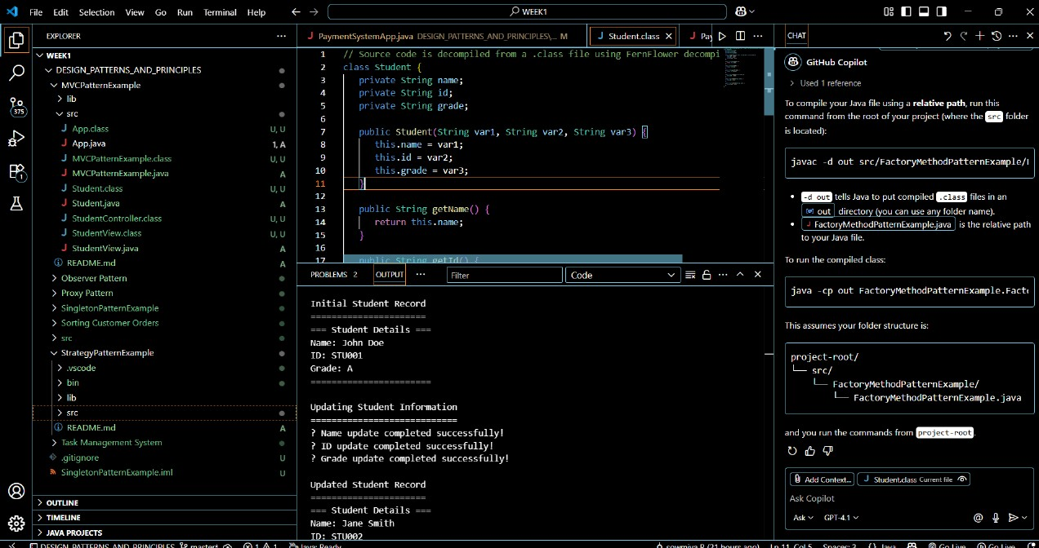

Exercise 11: Implementing Dependency Injection
Scenario:
You are developing a customer management application where the service class depends on a repository class. Use Dependency Injection to manage these dependencies.
Steps:
- Create a New Java Project:
  - Create a new Java project named DependencyInjectionExample.
- Define Repository Interface:
  - Create an interface CustomerRepository with methods like findCustomerById().
- Implement Concrete Repository:
  - Create a class CustomerRepositoryImpl that implements CustomerRepository.
- Define Service Class:
  - Create a class CustomerService that depends on CustomerRepository.
- Implement Dependency Injection:
  - Use constructor injection to inject CustomerRepository into CustomerService.
- Test the Dependency Injection Implementation:
  - Create a main class to demonstrate creating a CustomerService with CustomerRepositoryImpl and using it to find a customer.
DependencyInjectionExample.java

import java.util.List;

public class DependencyInjectionExample {

public static void main(String[] args) {
System.out.println("=== Dependency Injection Example ===\n");

// Demonstrate dependency injection with different implementations
demonstrateWithRealRepository();
System.out.println("\n" + "=".repeat(50) + "\n");
demonstrateWithMockRepository();
System.out.println("\n" + "=".repeat(50) + "\n");
demonstrateBenefitsOfDI();
}

private static void demonstrateWithRealRepository() {
System.out.println("--- Using Real Repository Implementation ---");

// Step 1: Create the repository implementation
CustomerRepository repository = new CustomerRepositoryImpl();

// Step 2: Inject the repository into the service (Constructor Injection)
CustomerService customerService = new CustomerService(repository);

// Step 3: Use the service to perform operations
System.out.println("\n1. Finding customer by ID:");
Customer customer = customerService.getCustomerById("CUST001");
if (customer != null) {
System.out.println("Found: " + customer);
}

System.out.println("\n2. Finding non-existent customer:");
Customer nonExistent = customerService.getCustomerById("CUST999");

System.out.println("\n3. Getting all customers:");
List<Customer> allCustomers = customerService.getAllCustomers();
allCustomers.forEach(c -> System.out.println("- " + c.getName()));

System.out.println("\n4. Creating new customer:");
try {
customerService.createCustomer("CUST005", "Charlie Wilson", "charlie@email.com", "555-0105");
} catch (Exception e) {
System.out.println("Error: " + e.getMessage());
}

System.out.println("\n5. Searching customers by name:");
List<Customer> searchResults = customerService.searchCustomersByName("John");
searchResults.forEach(c -> System.out.println("Search result: " + c.getName()));
}

private static void demonstrateWithMockRepository() {
System.out.println("--- Using Mock Repository Implementation ---");

// Step 1: Create a mock repository for testing
CustomerRepository mockRepository = new MockCustomerRepository();

// Step 2: Inject the mock repository into the service
CustomerService customerService = new CustomerService(mockRepository);

// Step 3: Use the service with mock data
System.out.println("\n1. Finding customer with mock repository:");
Customer mockCustomer = customerService.getCustomerById("TEST001");
if (mockCustomer != null) {
System.out.println("Mock customer: " + mockCustomer);
}

System.out.println("\n2. Getting all mock customers:");
List<Customer> mockCustomers = customerService.getAllCustomers();
mockCustomers.forEach(c -> System.out.println("- " + c.getName()));
}

private static void demonstrateBenefitsOfDI() {
System.out.println("--- Benefits of Dependency Injection ---");

System.out.println("\n✓ Loose Coupling:");
System.out.println(" - CustomerService doesn't depend on concrete implementation");
System.out.println(" - Can switch between real and mock repositories easily");

System.out.println("\n✓ Testability:");
System.out.println(" - Easy to inject mock objects for unit testing");
System.out.println(" - Service logic can be tested in isolation");

System.out.println("\n✓ Flexibility:");
System.out.println(" - Can change repository implementation without modifying service");
System.out.println(" - Supports multiple implementations (Database, File, Web Service, etc.)");

System.out.println("\n✓ Maintainability:");
System.out.println(" - Single Responsibility Principle followed");
System.out.println(" - Dependencies are explicit and managed externally");

System.out.println("\n✓ Reusability:");
System.out.println(" - Service can be reused with different repository implementations");
System.out.println(" - Repository implementations can be shared across services");

// Demonstrate error handling
System.out.println("\n--- Error Handling in Dependency Injection ---");
try {
CustomerService invalidService = new CustomerService(null);
} catch (IllegalArgumentException e) {
System.out.println("✓ Proper validation: " + e.getMessage());
}
}
}
