Name: Sowmiya.C
NM_ID: B713A7AF6DD10A2AECE46F3540545A83

Brand Name: Film Freak

Assignment 1: Blog Creation
Link: https://flimfreakbuddy.blogspot.com/2023/09/cinema-has-been-part-of-entertainment.html
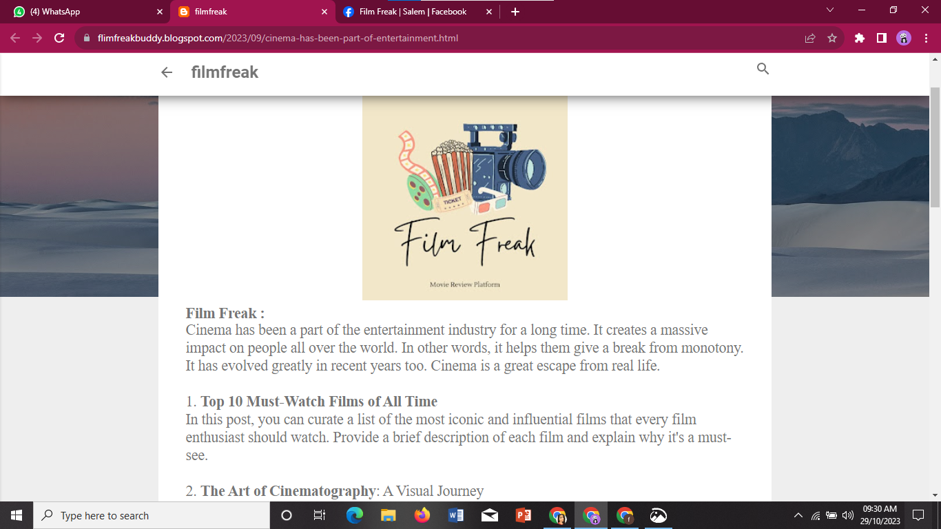

Assignment 2: Facebook Business Page Creation
Link: https://www.facebook.com/profile.php?id=61550578052441
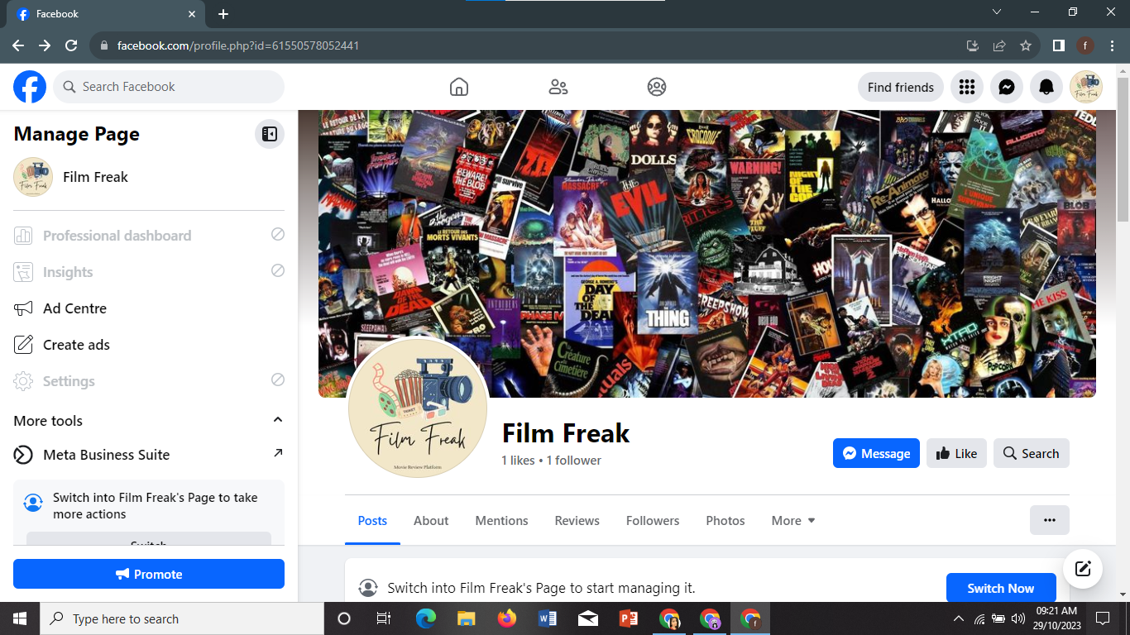

Assignment 3: Poster Creation


Assignment 4: News Letter Creation
