**EX NO:02.a PROJECT CREATION USING RATIONAL SOFTWARE**

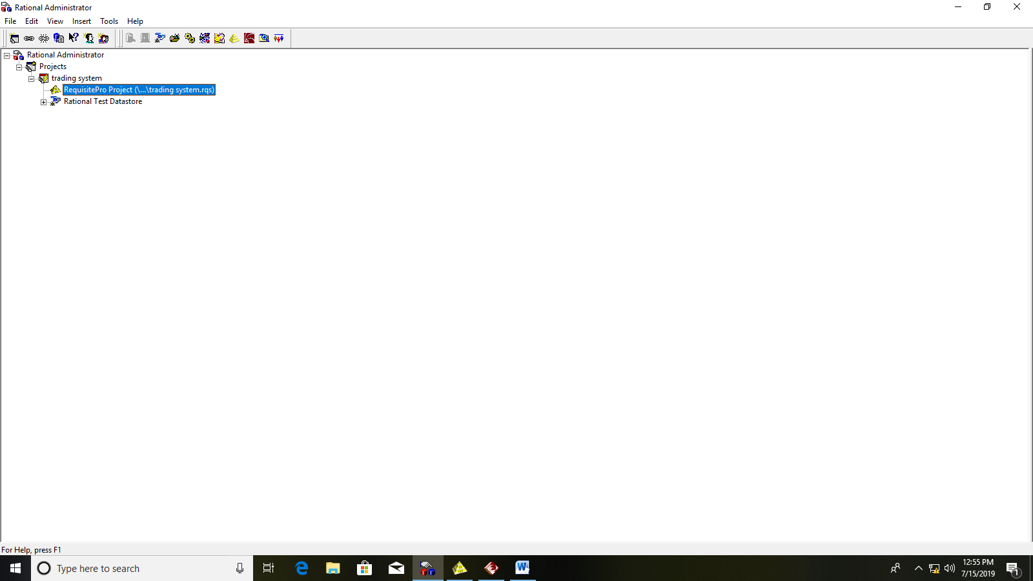

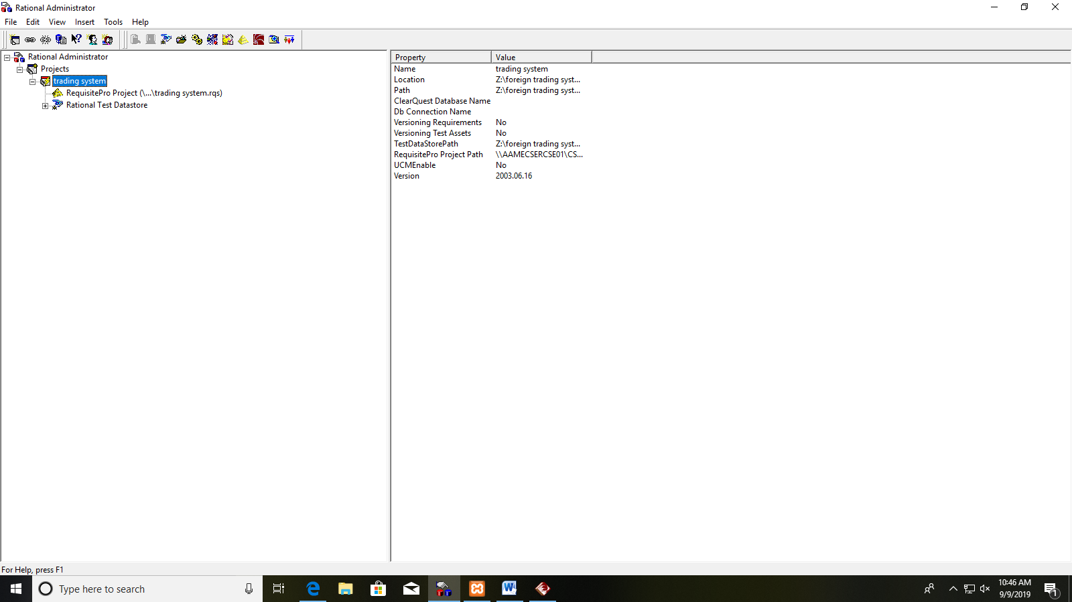

**EX NO:02.b CREATION OF PACKAGES AND REQUIREMENTS SPECIFICATION**

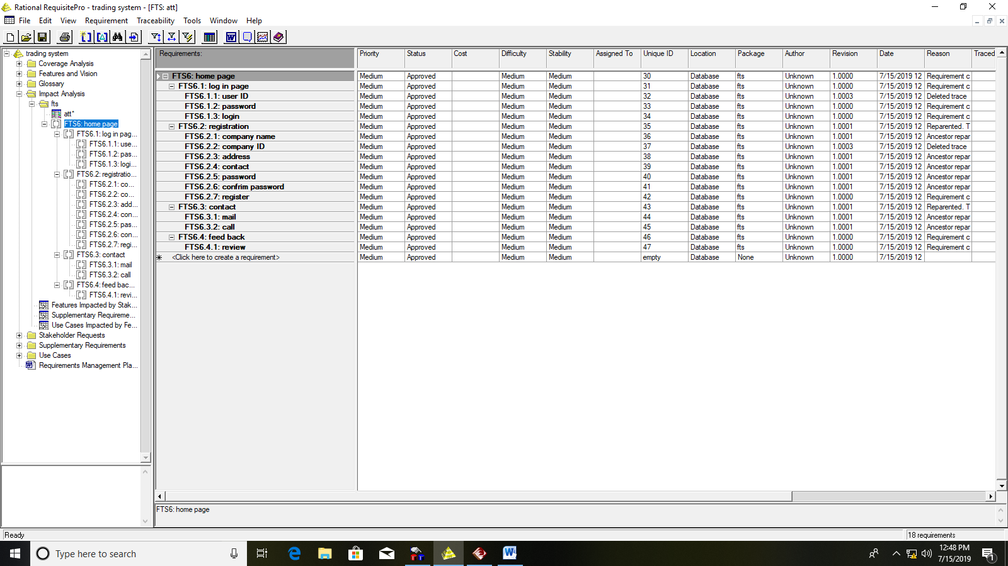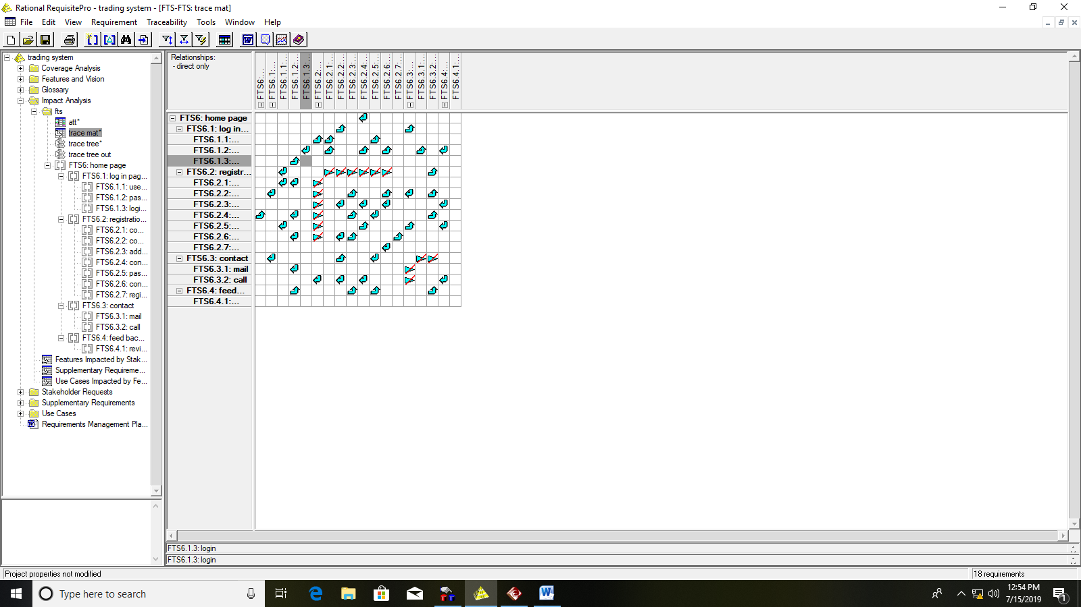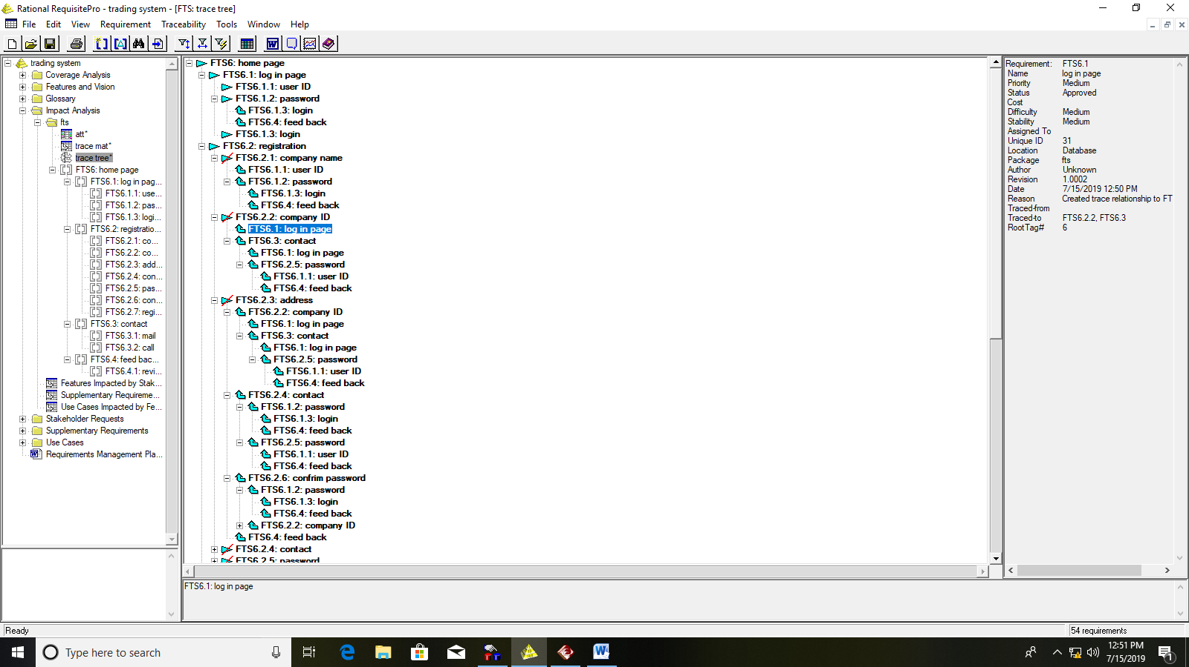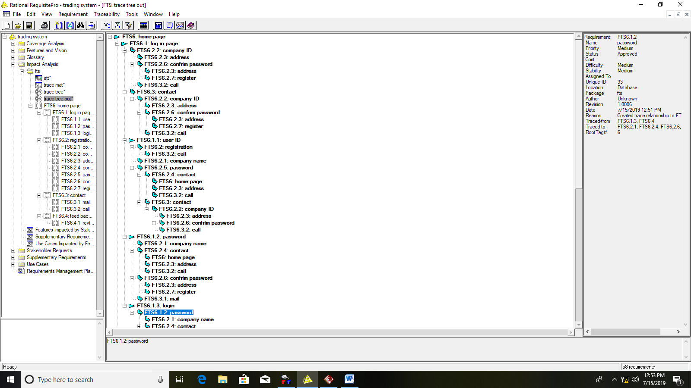

**EX NO:03 UML – USE CASE DIAGRAM**



**EX NO:04 UML – CLASS DIAGRAM**





**EX NO:05 UML – SEQUENCE AND COLLABORATION DIAGRAM**





**EX NO:06.a UML – STATE CHAT DIAGRAM**



**EX NO:06.b UML – ACTIVITY DIAGRAM**

