LAB EXPERIMENTS

COURSE: Cloud computing and big data for business applications.
COURSE CODE: CSA1519

13. Create a Virtual Machine with 1 CPU, 2GB RAM and 15GB storage disk using a Type 2 Virtualization Software using VMware workstation.
Aim
To create a Virtual Machine using VMware Workstation with 1 CPU, 2 GB RAM, and 15 GB storage.

Procedure
- Open VMware Workstation and select Create a New Virtual Machine.
- Choose Installer disc image file (ISO) and browse to select the OS ISO.
- Select the guest operating system type and version.
- Enter the required OS details such as username and password.
- Assign a name to the virtual machine and choose the storage location.
- Set Memory (RAM) to 2048 MB (2 GB).
- Set Processor configuration to 1 CPU.
- Choose Create a new virtual disk.
- Set the disk size to 15 GB.
- Select Store virtual disk as a single file.
- Complete the virtual machine creation.
- Start the virtual machine and follow the on-screen instructions to install the operating system.
- After installation, log in to the virtual machine and verify CPU, RAM, and disk allocation.

Output
Virtual machine created with 1 CPU, 2 GB RAM, and 15 GB storage and Operating system installed successfully inside the VM.
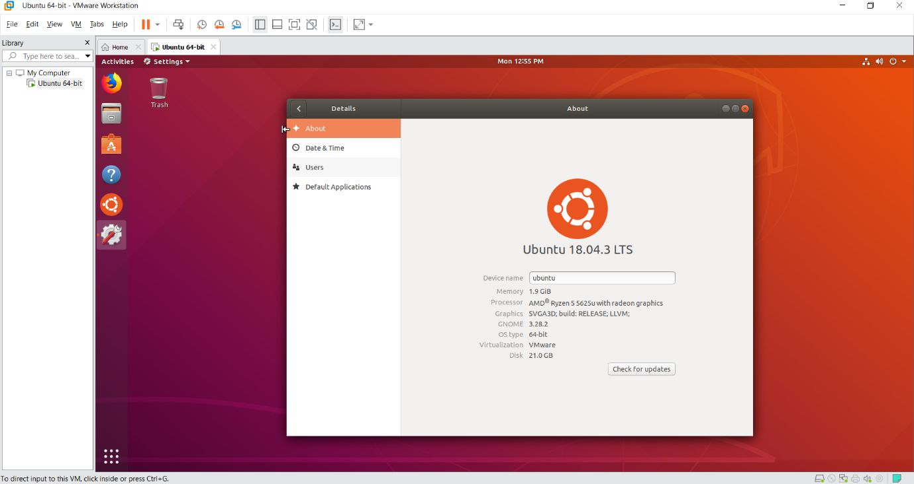

Result
Thus, a virtual machine was successfully created and configured using VMware Workstation with the specified system resources.

