LAB EXPERIMENTS

COURSE: Cloud computing and big data for business applications.
COURSE CODE: CSA1519

14. Create a Virtual Hard Disk and allocate the storage using VMware Workstation.
Aim
To create a Virtual Hard Disk and allocate storage using VMware Workstation.

Procedure
- Open VMware Workstation on the host system.
- Select an existing virtual machine or click Create a New Virtual Machine.
- Open Edit virtual machine settings.
- Click Add to add new hardware.
- Select Hard Disk and click Next.
- Choose SCSI as the disk type.
- Select Create a new virtual disk.
- Specify the required disk size (e.g., 15 GB).
- Select Store virtual disk as a single file or split into multiple files as required.
- Choose the location to save the virtual hard disk file.
- Click Finish to create and allocate the virtual hard disk.
- Start the virtual machine to verify the newly created disk.

Output
Virtual hard disk created successfully. Storage space allocated and attached to the virtual machine.
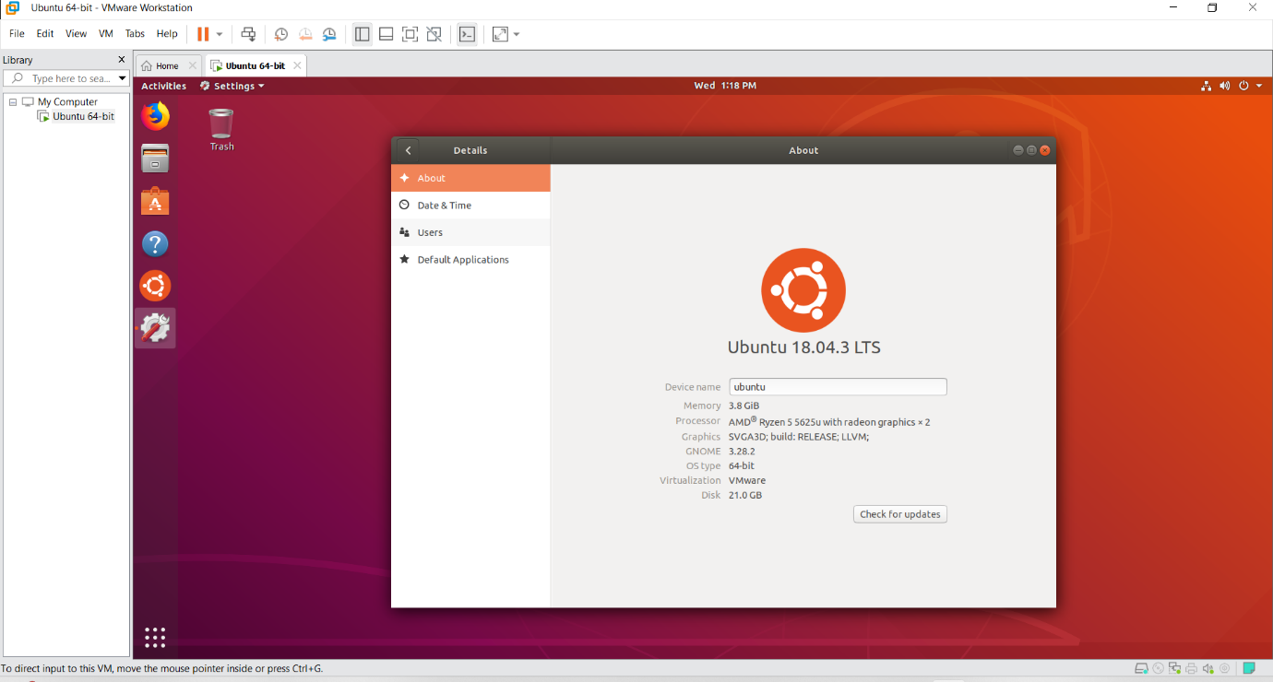

Result
Thus, a virtual hard disk was successfully created and storage was allocated using VMware Workstation.

