LAB EXPERIMENTS

COURSE: Cloud computing and big data for business applications.
COURSE CODE: CSA1519

15. Create a Snapshot of a VM and Test it by loading the Previous Version/Cloned VM using VMware workstation.
Aim
To create a snapshot of a virtual machine and test it by restoring the previous version using VMware Workstation.

Procedure
- Open VMware Workstation and select the required virtual machine.
- Ensure the virtual machine is powered ON or OFF.
- Click VM → Snapshot → Take Snapshot.
- Enter a snapshot name and description.
- Click Take Snapshot to save the current state of the virtual machine.
- Make changes inside the virtual machine (install software, modify files, or change settings).
- Shut down or keep the virtual machine running.
- Click VM → Snapshot → Snapshot Manager.
- Select the previously created snapshot.
- Click Go To restore the virtual machine to the earlier state.
- Confirm the snapshot restore operation.
- Verify that all changes made after the snapshot are reverted.

Output
System changes were reverted after restoring the snapshot. Virtual machine returned to its previous stable state.
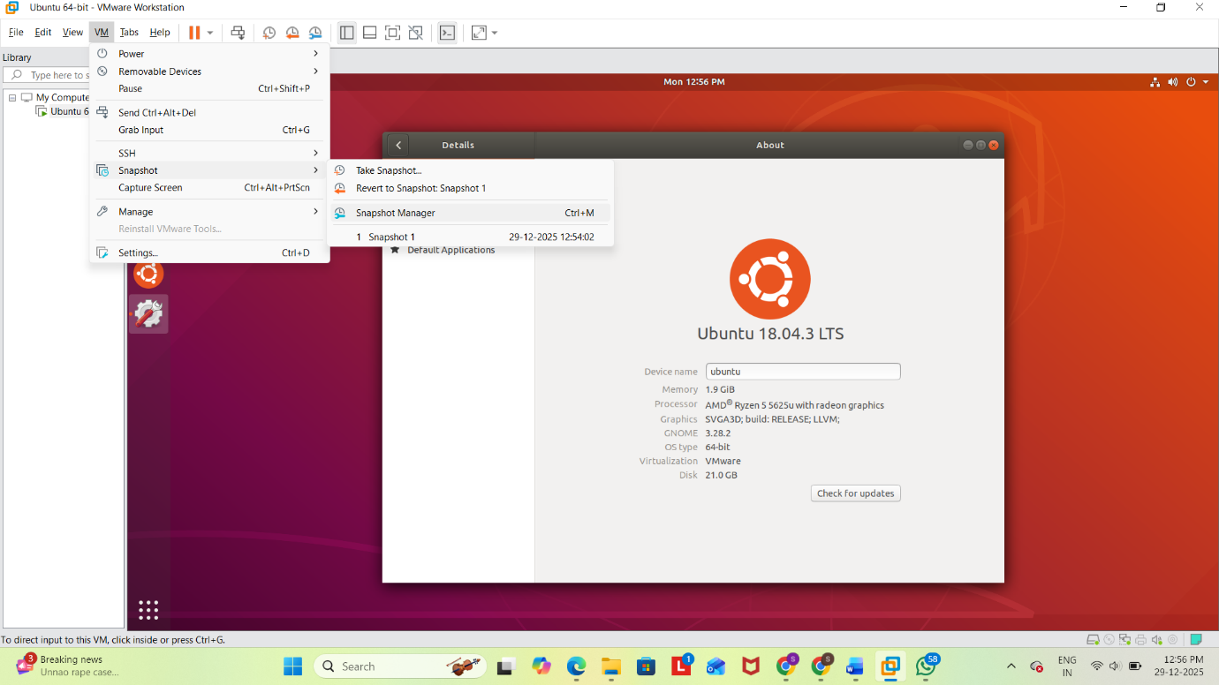
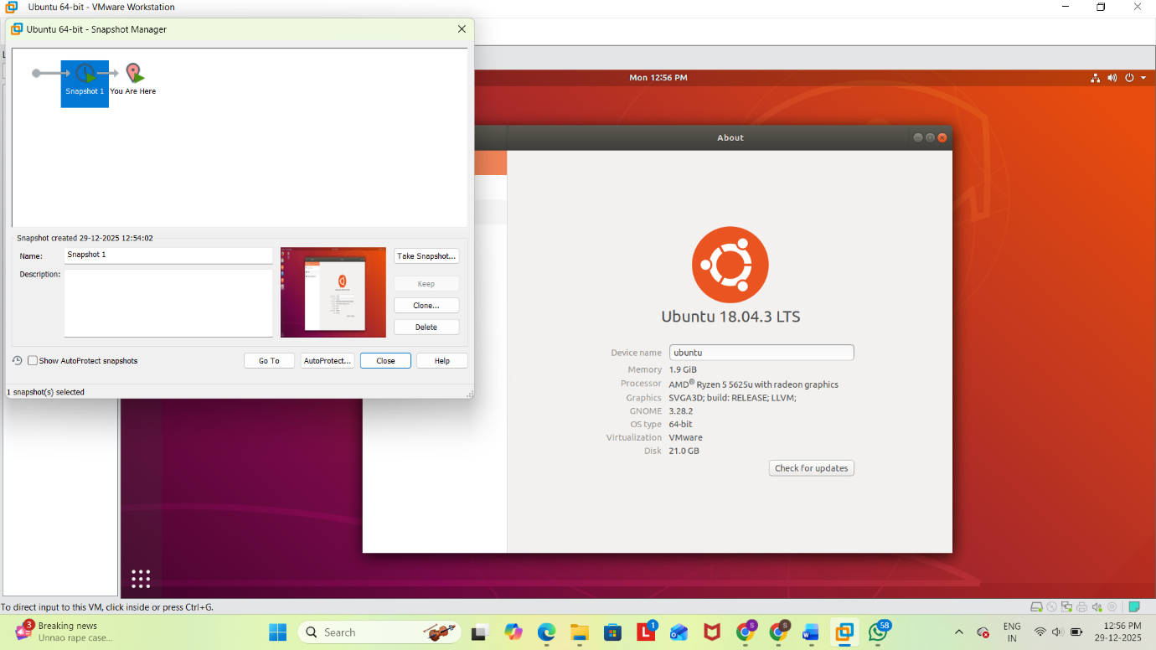

Result
Thus, a snapshot of the virtual machine was successfully created and tested by restoring the previous version using VMware Workstation.

