LAB EXPERIMENTS

COURSE: Cloud computing and big data for business applications.
COURSE CODE: CSA1519

16. Create a Cloning of a VM and Test it by loading the Previous Version/Cloned VM using VMware workstation.
Aim
To create a clone of a virtual machine and test it by loading the previous version / cloned VM using VMware Workstation.

Procedure
- Open VMware Workstation and select the virtual machine to be cloned.
- Power OFF the selected virtual machine.
- Click VM → Manage → Clone.
- Choose Clone from the current state or Clone from an existing snapshot.
- Select the Clone Type as Full Clone (recommended).
- Enter a name for the cloned virtual machine.
- Choose a storage location for the cloned VM.
- Click Finish to create the clone.
- After cloning is completed, the cloned virtual machine appears in the VMware library.
- Power ON the cloned virtual machine.
- Verify that the cloned VM boots successfully and operates independently from the original VM.
- Optionally, start the original VM to confirm both VMs run separately.

Output
Virtual machine cloning completed successfully and Cloned VM loaded and executed independently. Original VM remained unchanged.
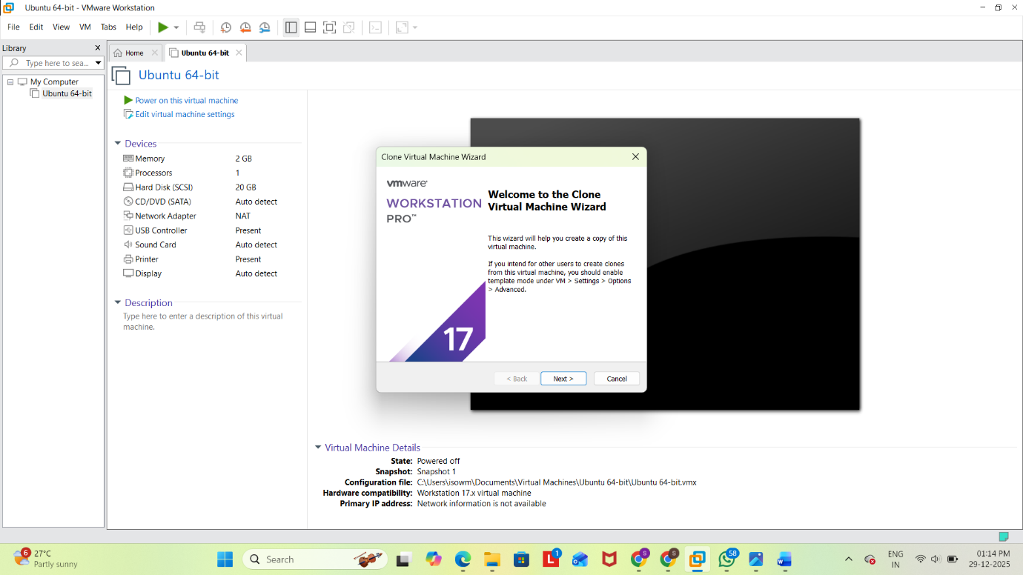
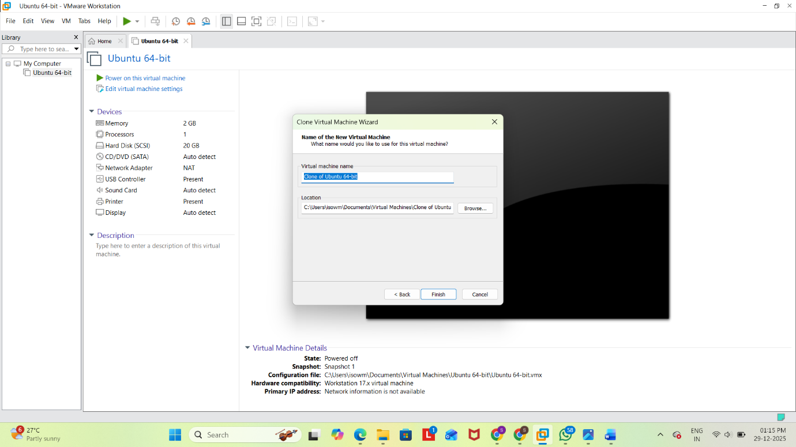
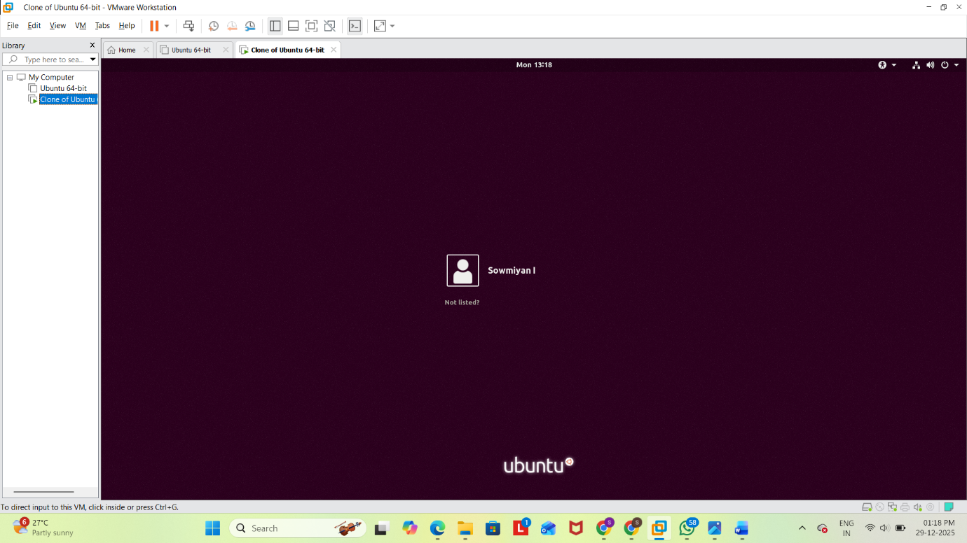

Result
Thus, a virtual machine clone was successfully created and tested by loading the cloned virtual machine using VMware Workstation.

