LAB EXPERIMENTS

COURSE: Cloud computing and big data for business applications.
COURSE CODE: CSA1519

17. Change Hardware compatibility of a VM (Either by clone/create new one) which is already created and configured using VMware workstation.
Aim
To change the hardware compatibility of an existing virtual machine using VMware Workstation.

Procedure
- Open VMware Workstation.
- Power OFF the virtual machine whose hardware compatibility needs to be changed.
- Select the virtual machine from the library.
- Click VM → Manage → Clone.
- Choose Clone from the current state.
- Select Full Clone.
- Click Next.
- Choose Change hardware compatibility for this virtual machine.
- Select the required VMware Workstation version / hardware compatibility level.
- Provide a name and storage location for the new virtual machine.
- Click Finish to create the cloned VM with updated hardware compatibility.
- Power ON the newly created VM.
- Verify that the virtual machine runs successfully with the updated compatibility.

Output
Hardware compatibility level of the virtual machine was successfully changed. The new/cloned virtual machine runs without errors.
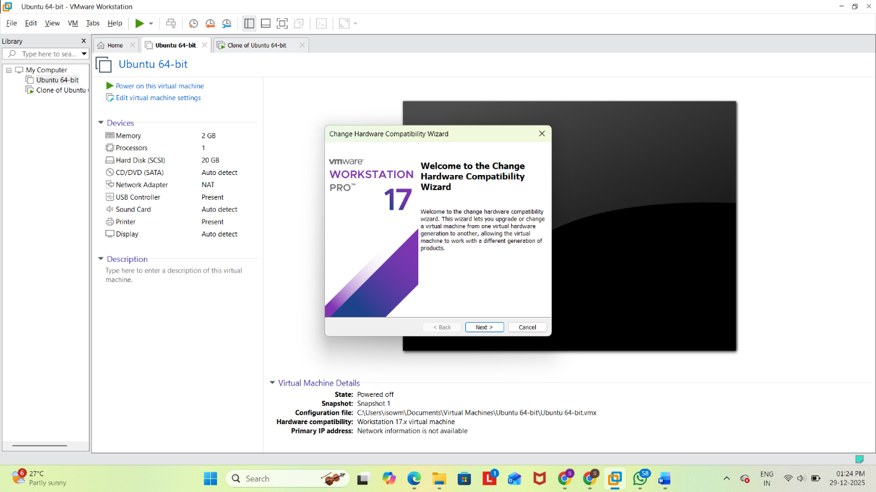
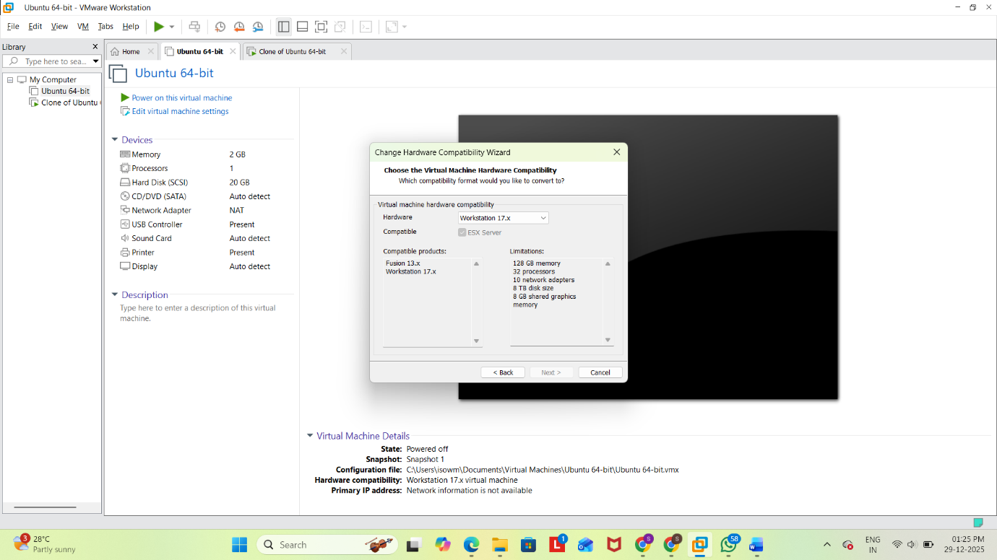
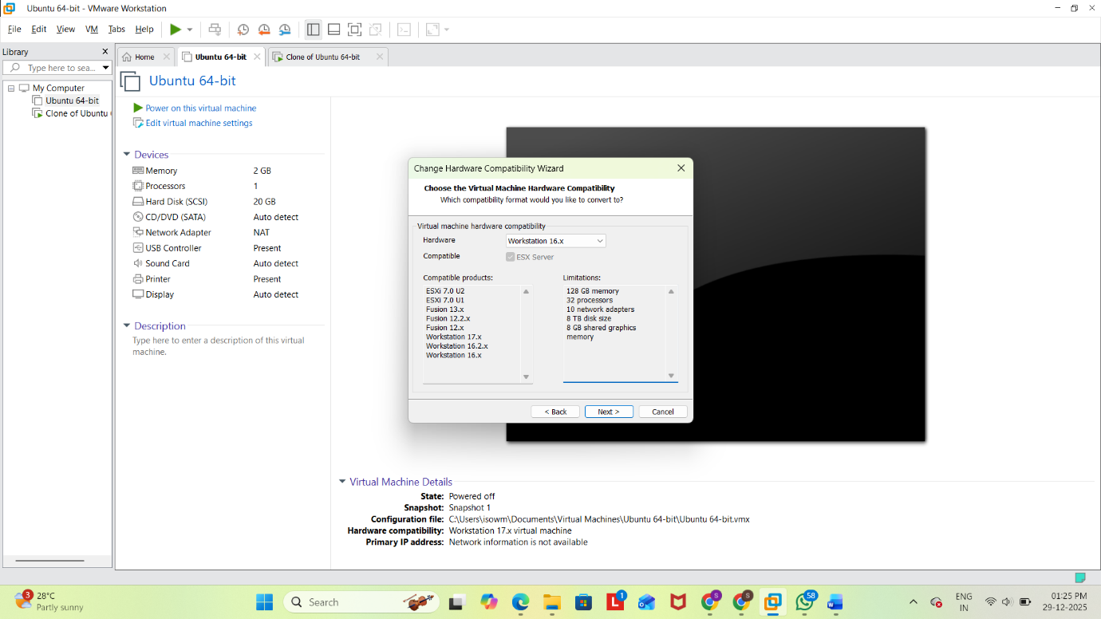
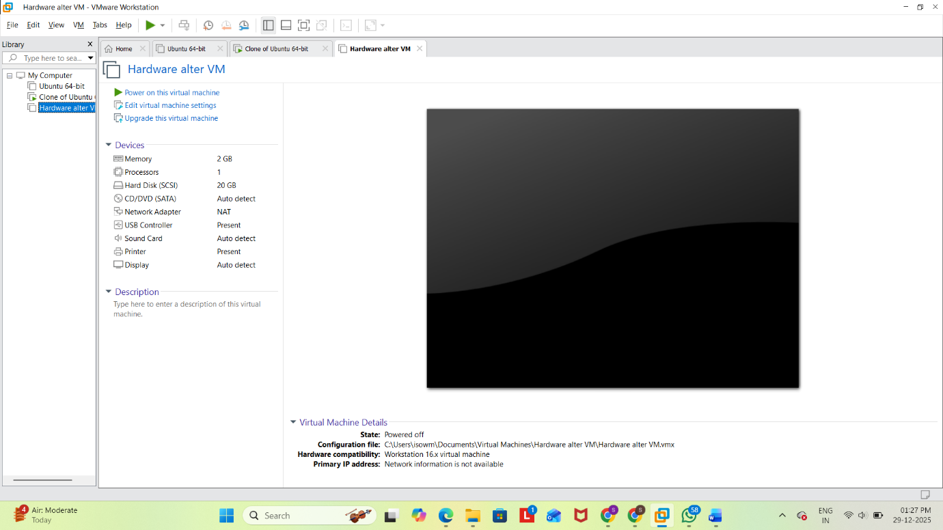

Result
Thus, the hardware compatibility of an already created virtual machine was successfully changed using VMware Workstation.

