LAB EXPERIMENTS

COURSE: Cloud computing and big data for business applications.
COURSE CODE: CSA1519

12. Demonstrate virtualization by Installing Type-2 Hypervisor in your device, create and configure VM image with a Host Operating system (Either Windows/Linux), using VMware workstation.
Aim
To demonstrate virtualization by installing a Type-2 Hypervisor (VMware Workstation) and creating, configuring, and running a Virtual Machine (VM) with a host operating system (Windows/Linux).

Procedure
- Ensure that hardware virtualization (Intel VT-x / AMD-V) is enabled in the system BIOS.
- Download and install VMware Workstation Player on the host system.
- Restart the system after installation is complete.
- Download the Windows or Linux (Ubuntu) operating system ISO file.
- Open VMware Workstation and select Create a New Virtual Machine.
- Choose Installer disc image file (ISO) and browse to select the downloaded OS ISO.
- Enter the required operating system details such as username and password.
- Assign a name to the virtual machine and select a storage location.
- Configure the virtual machine resources by allocating memory, processor cores, and disk size.
- Select Store virtual disk as a single file and complete the virtual machine creation.
- Start the virtual machine and follow the on-screen instructions to install the operating system.
- After installation, the virtual machine restarts automatically.
- Log in to the virtual operating system and verify system configuration such as CPU, RAM, and network connectivity.

Output
Host operating system running inside VM and VM operates independently of physical system.
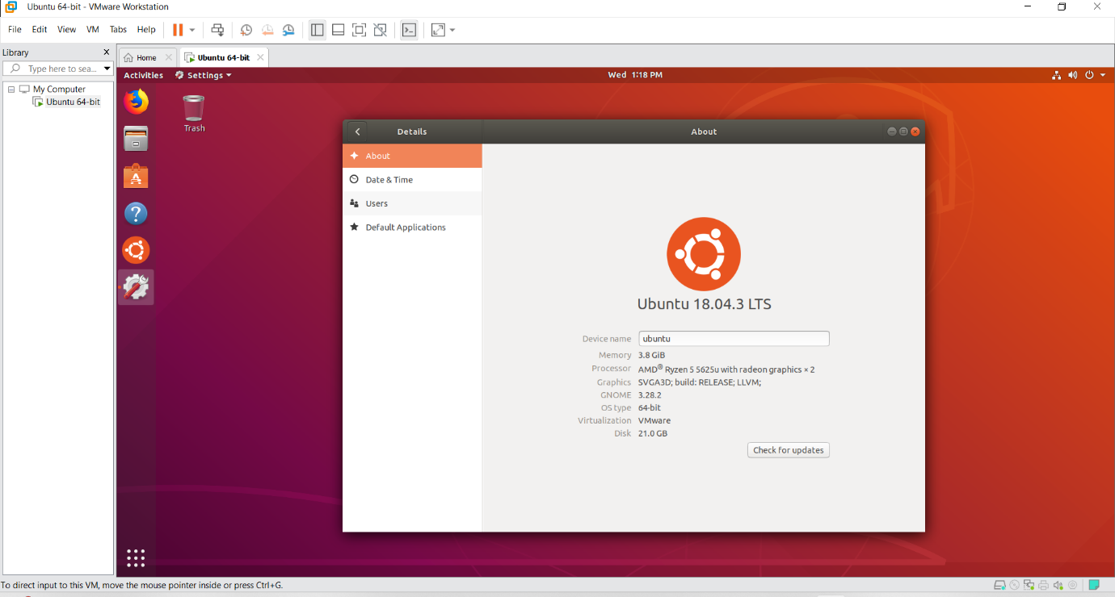

Result
Thus, virtualization was successfully demonstrated by installing a Type-2 Hypervisor (VMware Workstation) and creating and running a virtual machine with a host operating system.

