LAB EXPERIMENTS

COURSE: Cloud computing and big data for business applications.
COURSE CODE: CSA1519

10. Create a Cloning of a VM and Test it by loading the Previous Version/Cloned VM using virtual box.
Aim
To create a clone of a virtual machine and test it by loading the previous version / cloned VM using Oracle VirtualBox.

Procedure
- Open Oracle VirtualBox on the host system.
- Select the virtual machine to be cloned.
- Ensure the virtual machine is powered OFF.
- Right-click the virtual machine and select Clone.
- Enter a name for the cloned virtual machine.
- Select Clone Type as Full Clone.
- Choose Current machine state as the snapshot option.
- Click Finish to start the cloning process.
- After cloning completes, the cloned virtual machine appears in the VirtualBox list.
- Start the cloned virtual machine.
- Verify that the cloned VM boots successfully and runs independently.
- Optionally, start the original VM to confirm both machines operate separately.

Output
Virtual machine was cloned successfully. Cloned virtual machine loaded and operated independently. Original virtual machine remained unchanged.
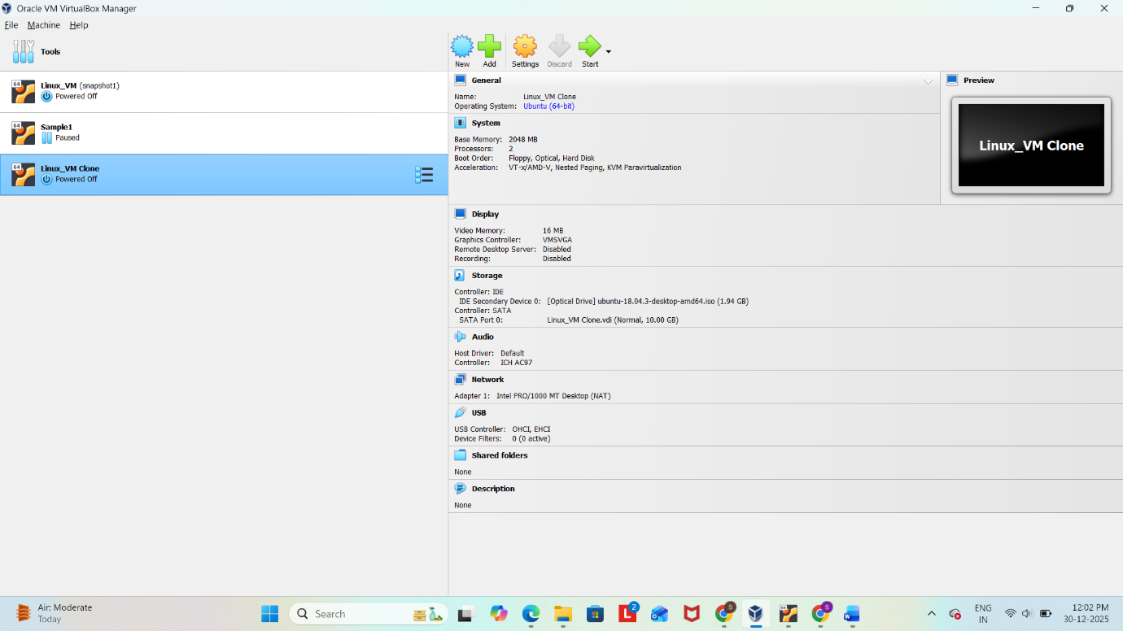
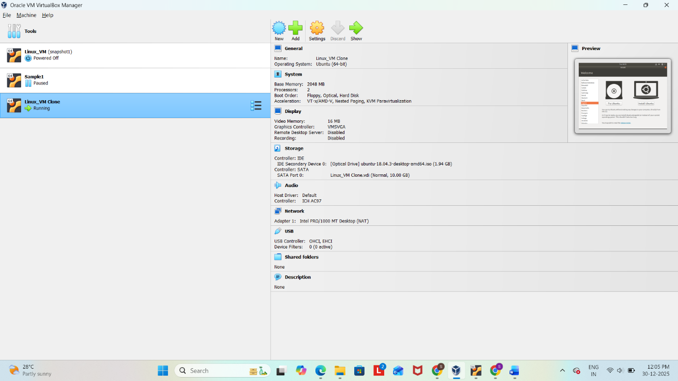

Result
Thus, a virtual hard disk was successfully created and storage was allocated using Oracle VirtualBox.

