LAB EXPERIMENTS

COURSE: Cloud computing and big data for business applications.
COURSE CODE: CSA1519

11. Change Hardware compatibility of a VM (Either by clone/create new one) which is already created and configured, using virtual box.
Aim
To change the hardware configuration / compatibility of an already created virtual machine using Oracle VirtualBox.

Procedure
- Open Oracle VirtualBox.
- Select the virtual machine whose hardware compatibility needs to be changed.
- Ensure the virtual machine is powered OFF.
- Right-click the virtual machine and select Clone.
- Enter a new name for the cloned virtual machine.
- Choose Full Clone.
- Select Current machine state.
- Click Finish to create the cloned VM.
- Select the cloned virtual machine.
- Open Settings of the cloned VM.
- Modify hardware settings such as Processor count, RAM size, Display memory and Storage controller.
- Save the settings.
- Start the cloned virtual machine and verify successful operation.

Output
Hardware configuration of the virtual machine was successfully changed. The new/cloned VM runs without errors.
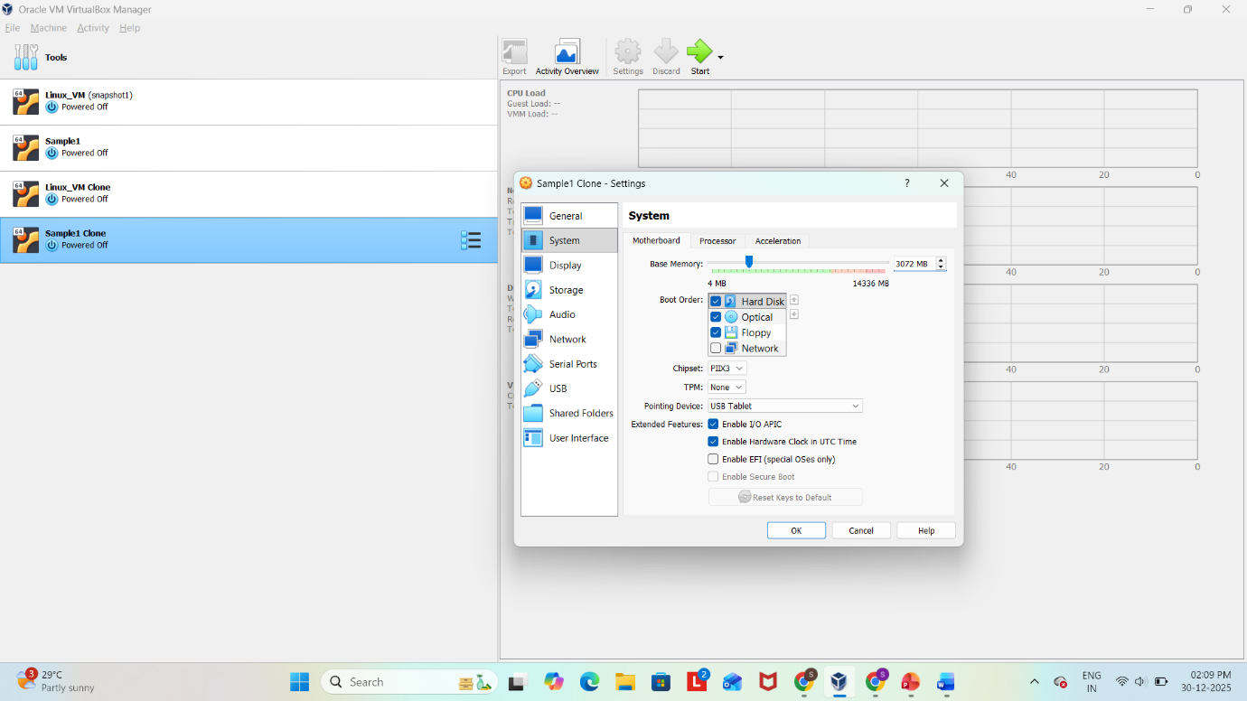
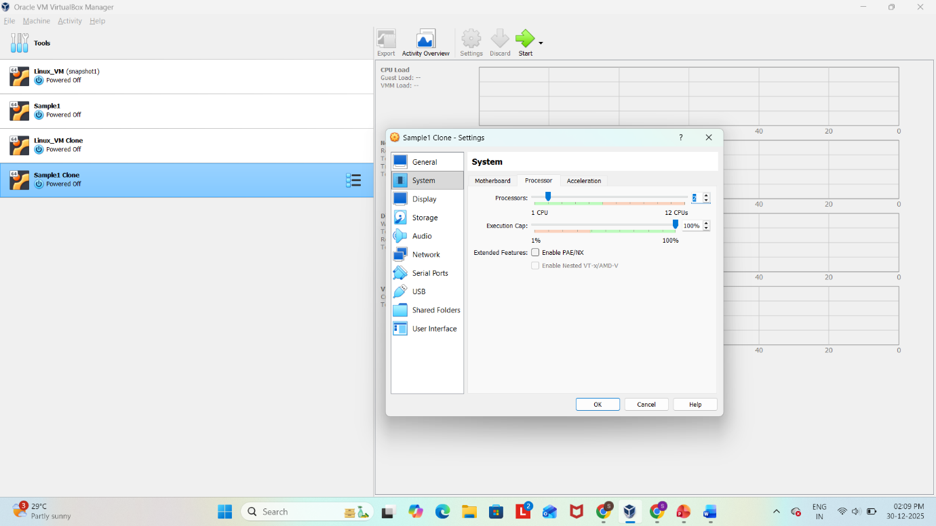
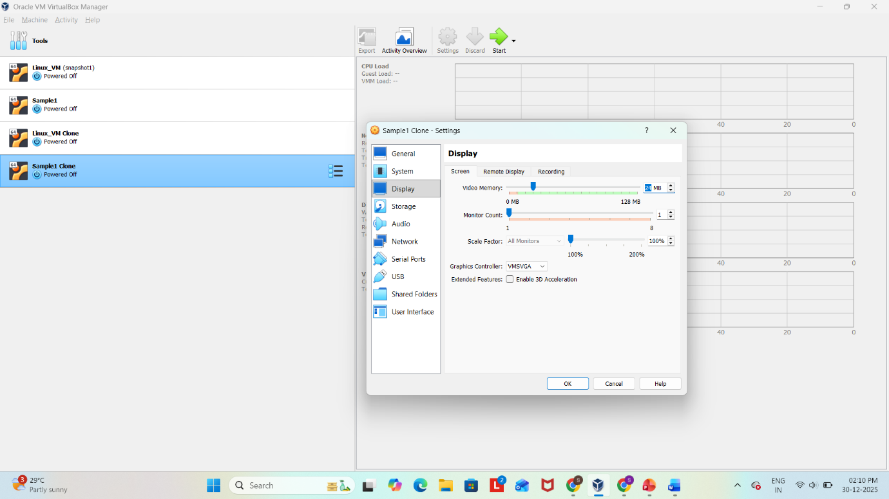
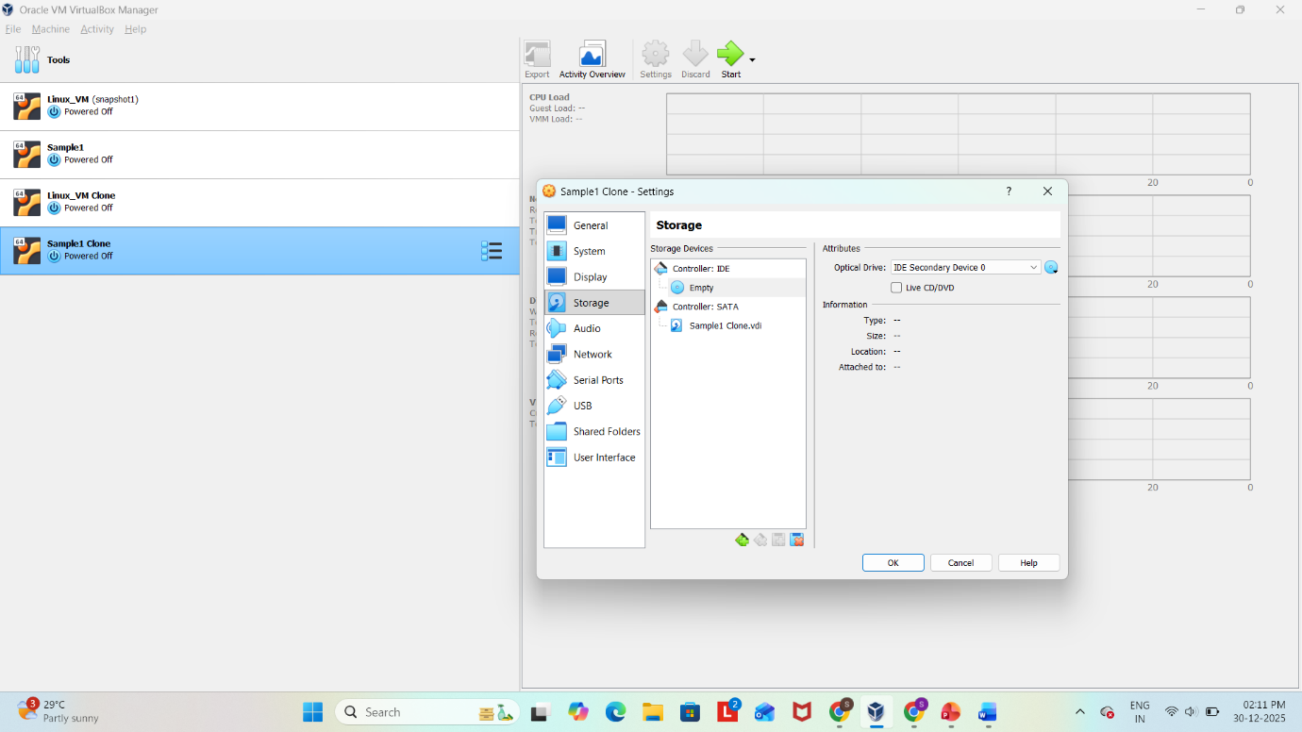
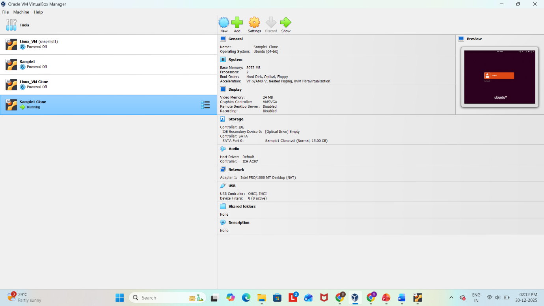

Result
Thus, the hardware compatibility/configuration of an already created virtual machine was successfully changed using Oracle VirtualBox.

