LAB EXPERIMENTS
COURSE: Cloud computing and big data for business applications.
COURSE CODE: CSA1519

06. Demonstrate virtualization by Installing Type-2 Hypervisor in your device, create and configure VM image with a Host Operating system (Either Windows/Linux) using virtual box.
Aim
To demonstrate virtualization by installing a Type-2 Hypervisor (Oracle VirtualBox) and creating and configuring a Virtual Machine (VM) with a host operating system (Windows/Linux).

Procedure
- Enable hardware virtualization in BIOS.
- Download and install Oracle VirtualBox.
- Install the VirtualBox Extension Pack.
- Download the required Windows/Linux ISO file.
- Open VirtualBox and click New.
- Enter VM name, select OS type and version.
- Allocate required memory (RAM).
- Create a new virtual hard disk.
- Select disk type as VDI.
- Choose storage as Dynamically allocated.
- Allocate disk size (20–40 GB).
- Finish VM creation.
- Start the VM and select the OS ISO file.
- Follow on-screen instructions to install the operating system.
- Log in to the virtual machine after installation.

Output
VirtualBox installed successfully, then Virtual machine created and configured. Operating system installed and running inside the VM.
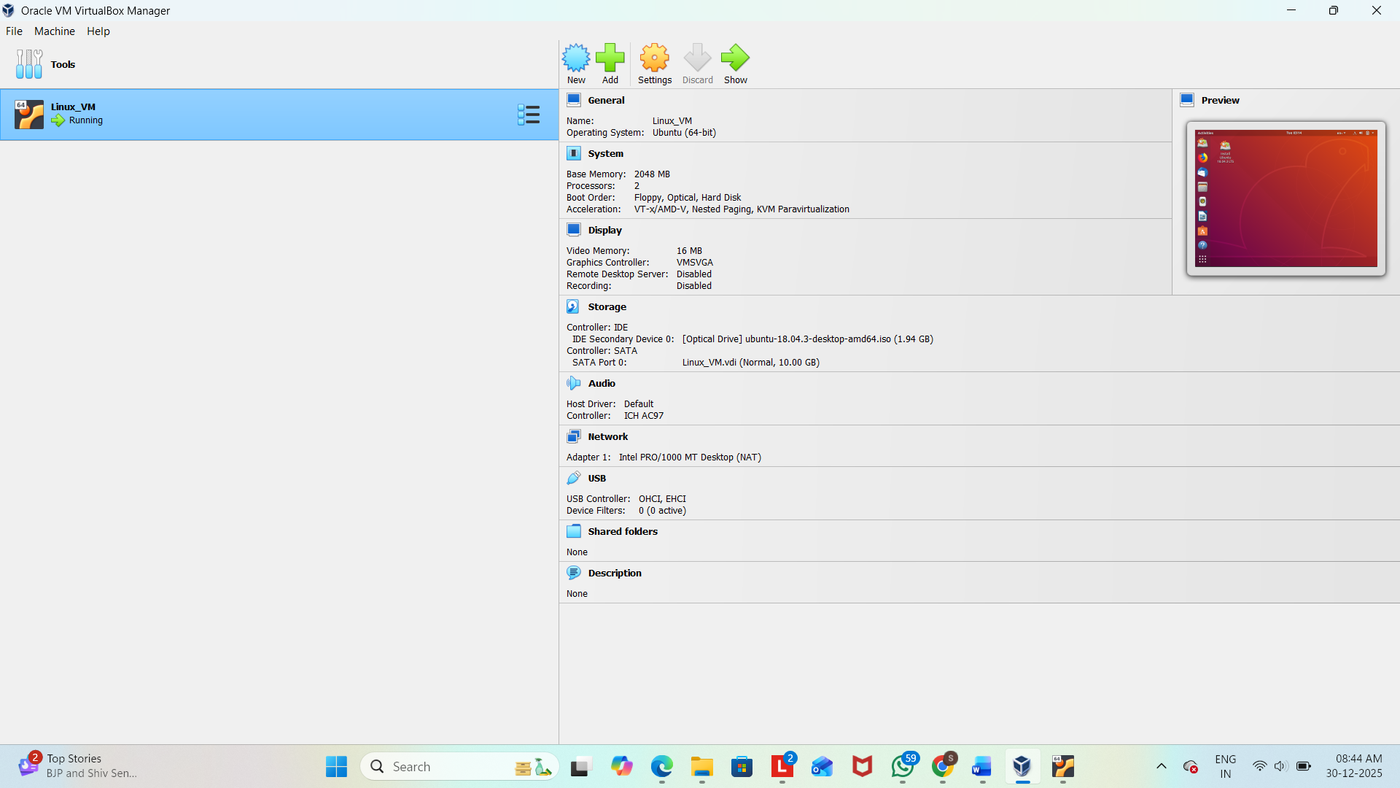

Result
Thus, virtualization was successfully demonstrated by installing a Type-2 Hypervisor (Oracle VirtualBox) and creating and running a virtual machine with a host operating system.

