LAB EXPERIMENTS

COURSE: Cloud computing and big data for business applications.
COURSE CODE: CSA1519

07. Create a Virtual Machine with 1 CPU, 2GB RAM and 15GB storage disk using a Type 2 Virtualization Software, using virtual box.
Aim
To create a Virtual Machine using Oracle VirtualBox with 1 CPU, 2 GB RAM, and 15 GB storage disk.

Procedure
- Ensure hardware virtualization (Intel VT-x / AMD-V) is enabled in BIOS.
- Install Oracle VirtualBox and the VirtualBox Extension Pack on the host system.
- Download the required Windows or Linux (Ubuntu) operating system ISO file.
- Open VirtualBox and click New.
- Enter the virtual machine name and select the operating system type and version.
- Allocate 2048 MB (2 GB) RAM to the virtual machine.
- Create a new virtual hard disk.
- Select VDI (VirtualBox Disk Image) as the disk type.
- Choose Dynamically allocated storage.
- Set the disk size to 15 GB.
- After VM creation, open Settings → System → Processor.
- Set the number of CPUs to 1.
- Go to Settings → Storage and attach the OS ISO file.
- Start the virtual machine and follow the on-screen instructions to install the operating system.
- After installation, log in to the virtual machine and verify CPU, RAM, and disk configuration.

Output
Virtual machine created successfully with 1 CPU, 2 GB RAM, and 15 GB storage. Operating system installed and running inside the VM.
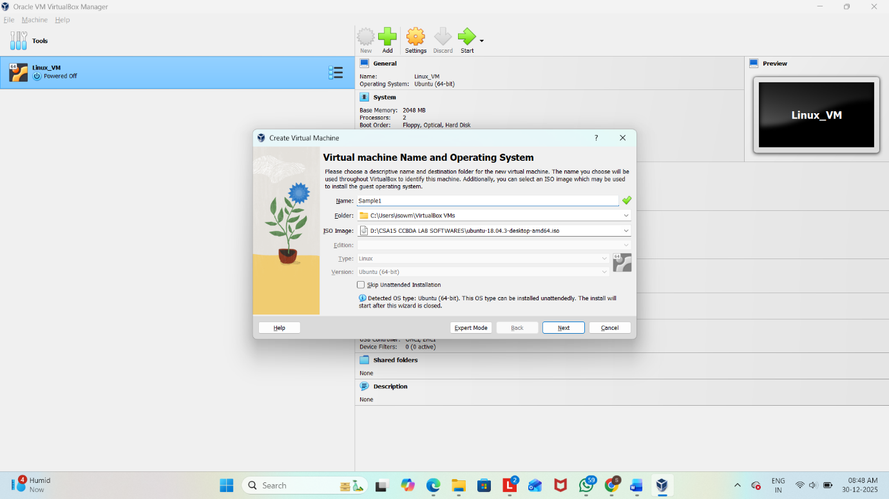
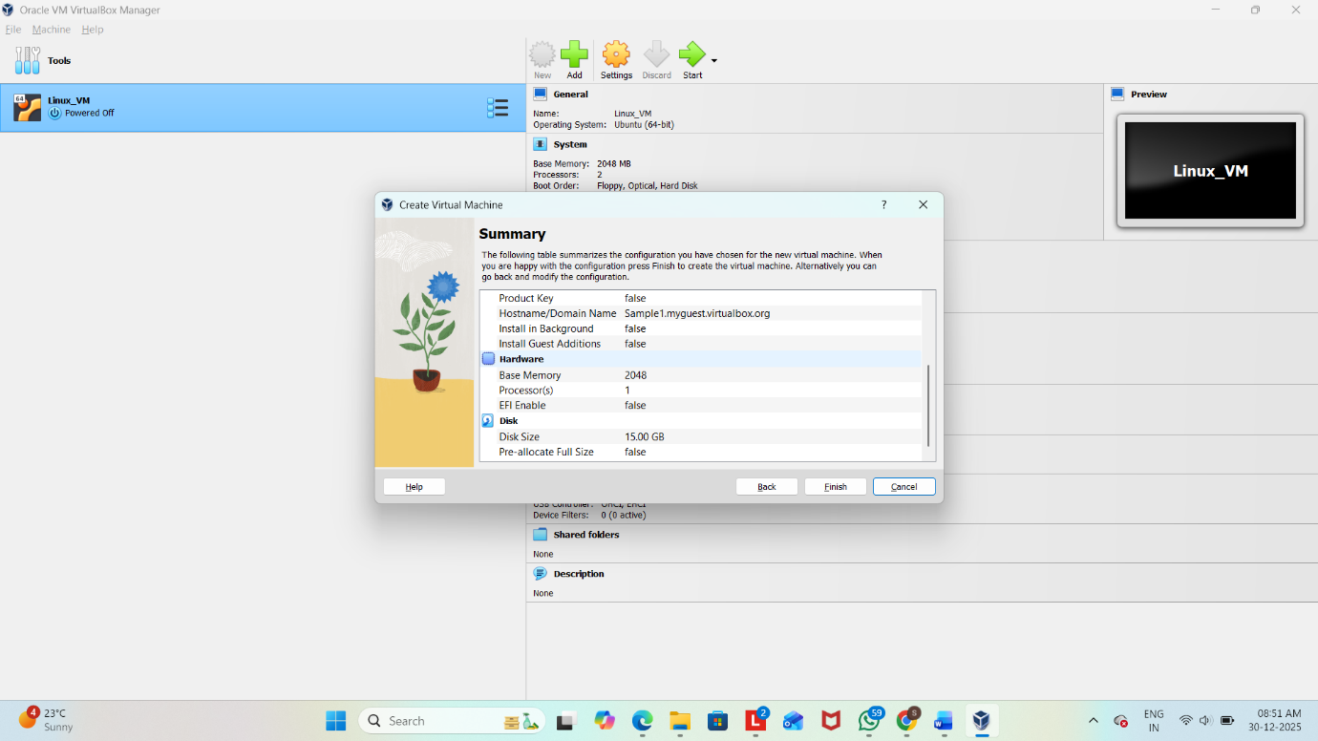
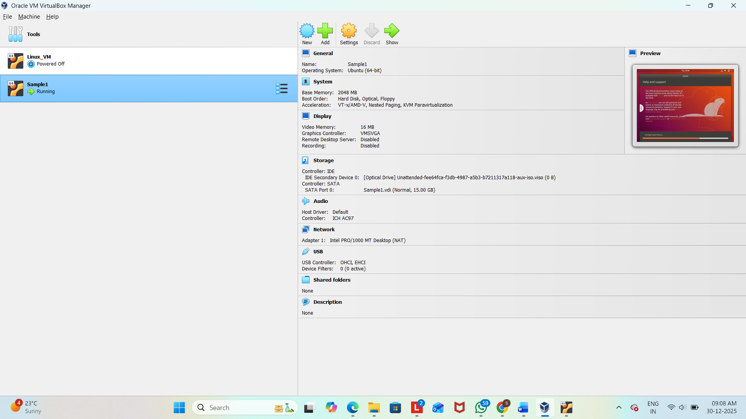

Result
Thus, a Virtual Machine was successfully created and configured using Oracle VirtualBox with the specified hardware resources.

