LAB EXPERIMENTS

COURSE: Cloud computing and big data for business applications.
COURSE CODE: CSA1519

08. Create a Virtual Hard Disk and allocate the storage using virtual box.
Aim
To create a Virtual Hard Disk and allocate storage using Oracle VirtualBox.

Procedure
- Open Oracle VirtualBox on the host system.
- Select an existing virtual machine or click New to create a new one.
- Click Settings for the selected virtual machine.
- Go to the Storage section.
- Under Controller, click Add Hard Disk.
- Select Create a new disk.
- Choose the disk file type as VDI (VirtualBox Disk Image).
- Select the storage type as Dynamically allocated or Fixed size.
- Specify the required disk size (e.g., 15 GB).
- Choose the location to store the virtual hard disk file.
- Click Create to allocate the storage.
- Start the virtual machine to verify the newly added virtual hard disk.

Output
Virtual hard disk created successfully. Storage space allocated and attached to the virtual machine
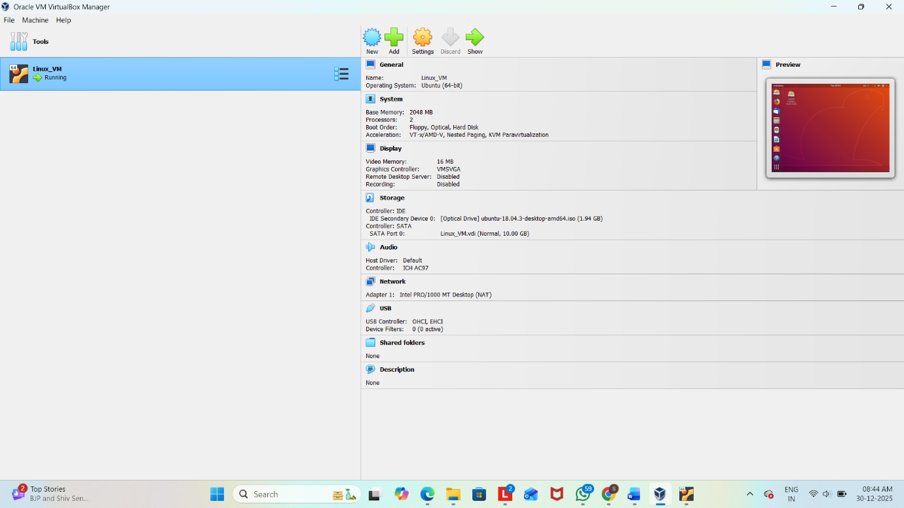

Result
Thus, a virtual hard disk was successfully created and storage was allocated using Oracle VirtualBox.

