LAB EXPERIMENTS

COURSE: Cloud computing and big data for business applications.
COURSE CODE: CSA1519

09. Create a Snapshot of a VM and Test it by loading the Previous Version/Cloned VM using virtual box.
Aim
To create a snapshot of a virtual machine and test it by restoring the previous version using Oracle VirtualBox.

Procedure
- Open Oracle VirtualBox on the host system.
- Select the required virtual machine from the list.
- Ensure the virtual machine is powered OFF or RUNNING.
- Click on the Snapshots option.
- Click Take Snapshot.
- Enter a snapshot name and description.
- Save the snapshot to capture the current state of the virtual machine.
- Start the virtual machine and make changes (install software or modify files).
- Power off the virtual machine.
- Open Snapshots again.
- Select the previously created snapshot.
- Click Restore Snapshot.
- Confirm the restore operation.
- Start the virtual machine and verify that the system has reverted to the earlier state.

Output
Snapshot created successfully. Changes made after snapshot were removed after restoring. Virtual machine returned to its previous stable state.
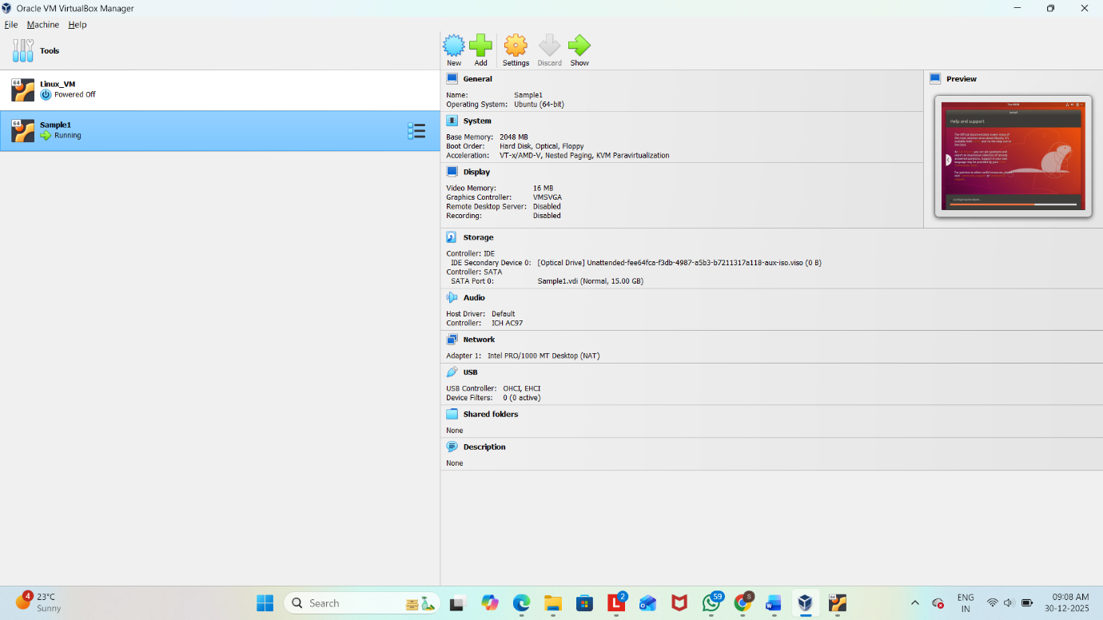
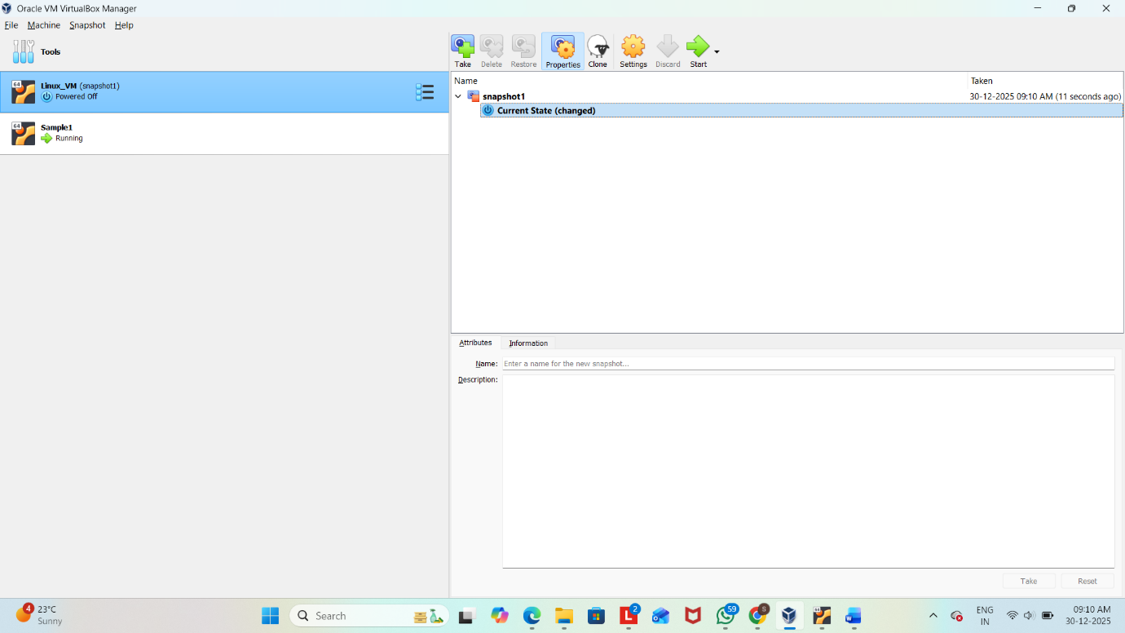

Result
Thus, a snapshot of the virtual machine was successfully created and tested by restoring the previous version using Oracle VirtualBox.

