LAB EXPERIMENTS

COURSE: Cloud computing and big data for business applications.
COURSE CODE: CSA1519

18. Demonstrate Infrastructure as a Service (IaaS) by creating a resources group using a Public Cloud Service Provider (Azure), configure with minimum CPU, RAM, and Storage.
Aim
To demonstrate Infrastructure as a Service (IaaS) by creating a Resource Group and configuring cloud resources with minimum CPU, RAM, and storage using Microsoft Azure.

Procedure
- Open a web browser and log in to the Azure Portal.
- From the Azure dashboard, select Resource groups.
- Click Create to create a new resource group.
- Enter a Resource Group Name.
- Select the required Region.
- Click Review + Create and then Create.
- After the resource group is created, open the resource group.
- Click Create → Virtual Machine.
- Select the created Resource Group.
- Enter the virtual machine name and choose the region.
- Select an operating system image (Windows or Linux).
- Choose a minimum VM size (example: Standard B1s).
- Configure minimum resources:
- CPU: 1 vCPU
- RAM: 1–2 GB
- Storage: 30 GB (default OS disk)
- Set administrator username and password.
- Review the configuration and click Create.
- Wait for deployment to complete.
- Verify that the VM appears inside the resource group.

Output
Resource group created successfully in Azure. Virtual machine deployed with minimum CPU, RAM, and storage. Cloud infrastructure resources allocated dynamically.
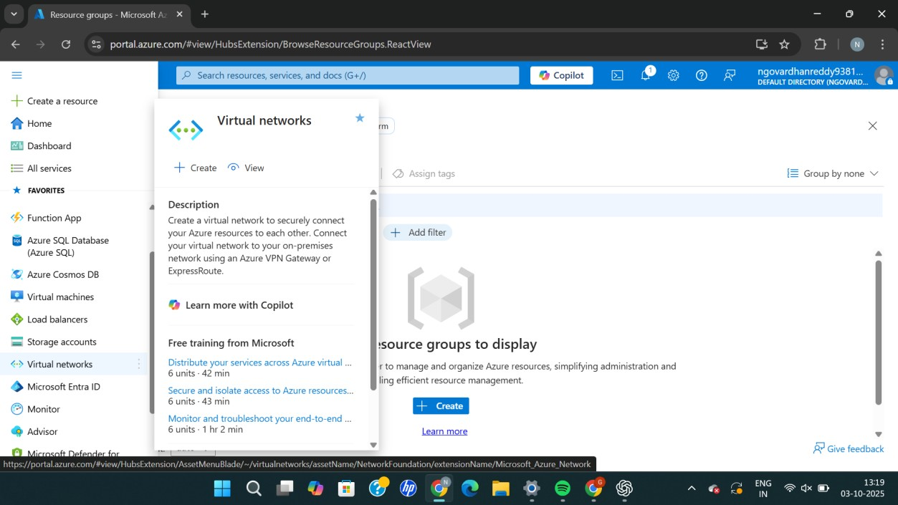
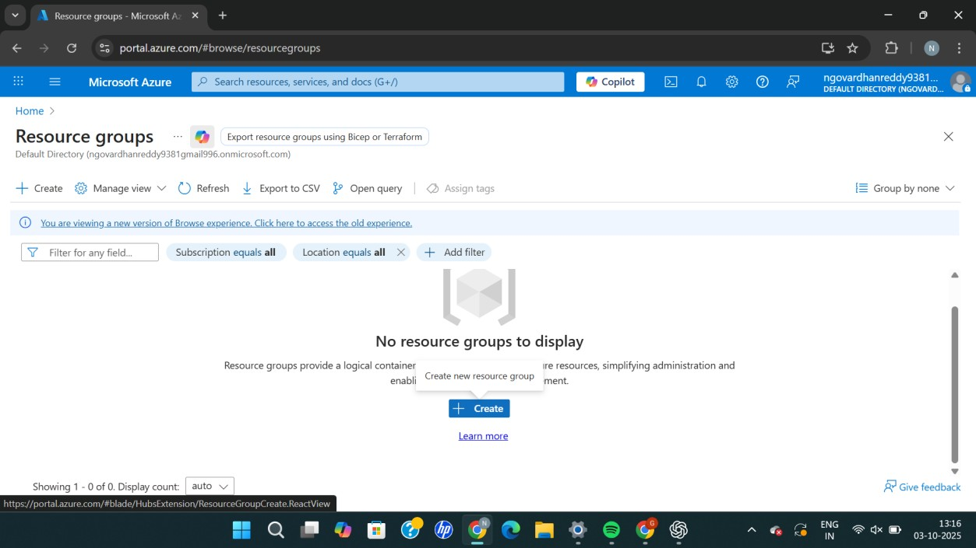
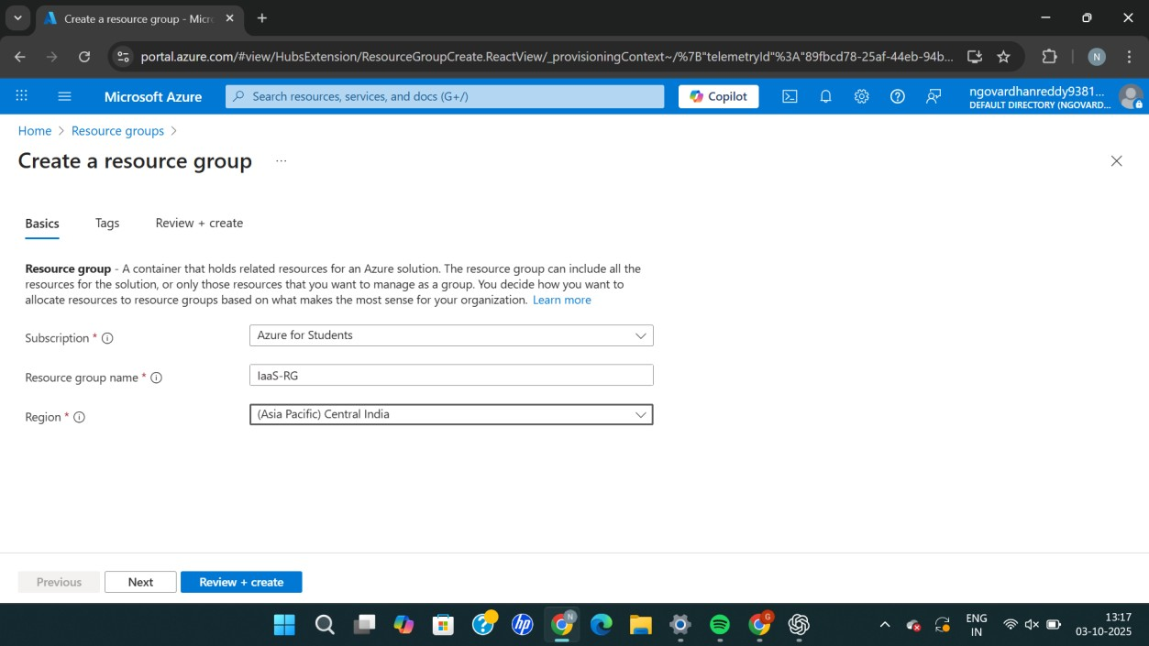
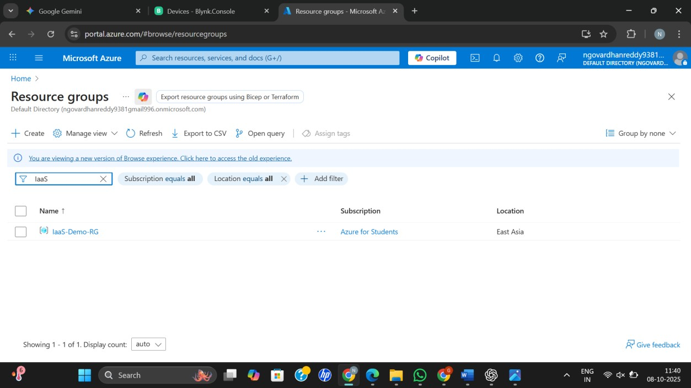

Result
Thus, Infrastructure as a Service (IaaS) was successfully demonstrated by creating a resource group and configuring minimum compute and storage resources using Microsoft Azure.

