LAB EXPERIMENTS

COURSE: Cloud computing and big data for business applications.
COURSE CODE: CSA1519

19. Demonstrate Infrastructure as a Service (IaaS) by creating a Virtual Machine using a Public Cloud Service Provider (Azure), configure with required memory and CPU.
Aim
To demonstrate Infrastructure as a Service (IaaS) by creating and configuring a Virtual Machine with the required CPU and RAM using Microsoft Azure.

Procedure
- Open a web browser and log in to the Azure Portal.
- From the Azure dashboard, click Create a resource.
- Select Virtual Machine.
- Choose the Subscription and Resource Group (create a new one if required).
- Enter the Virtual Machine Name and select the Region.
- Choose the operating system image (Windows or Linux).
- Select the VM size based on required resources.
- Example:
  - CPU: 1 vCPU
  - RAM: 1–2 GB (Standard B1s / B2s)
- Configure administrator username and password or SSH key.
- Review storage settings and keep default OS disk.
- Configure basic networking settings.
- Click Review + Create.
- Click Create to deploy the virtual machine.
- Wait for deployment to complete.
- Verify the VM status as Running in the Azure portal.

Output
Virtual machine created successfully in Azure. Required CPU and RAM allocated to the VM. VM is running and accessible from the Azure portal.
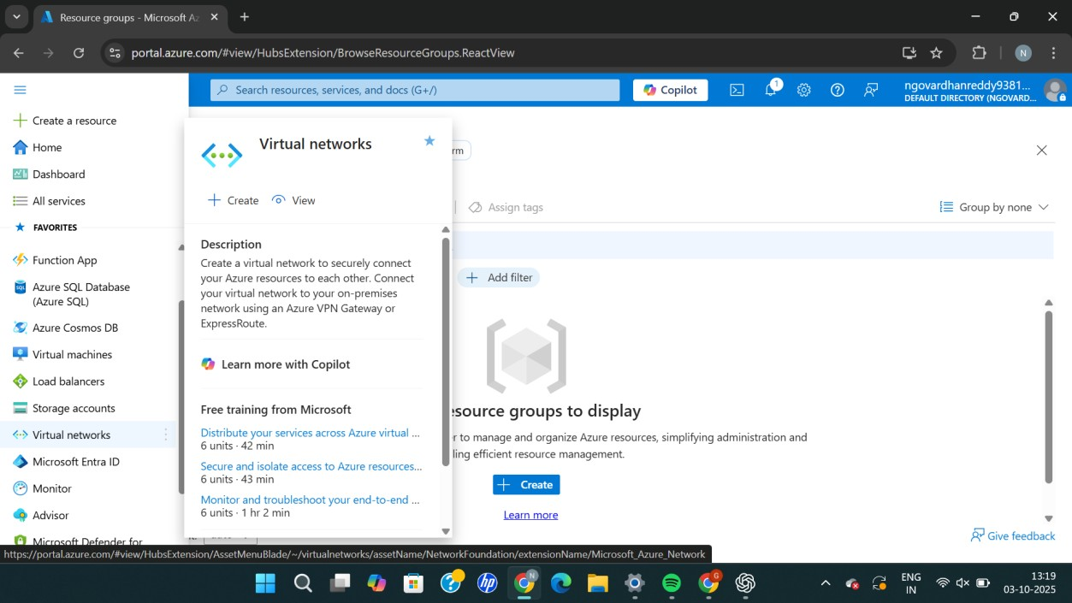
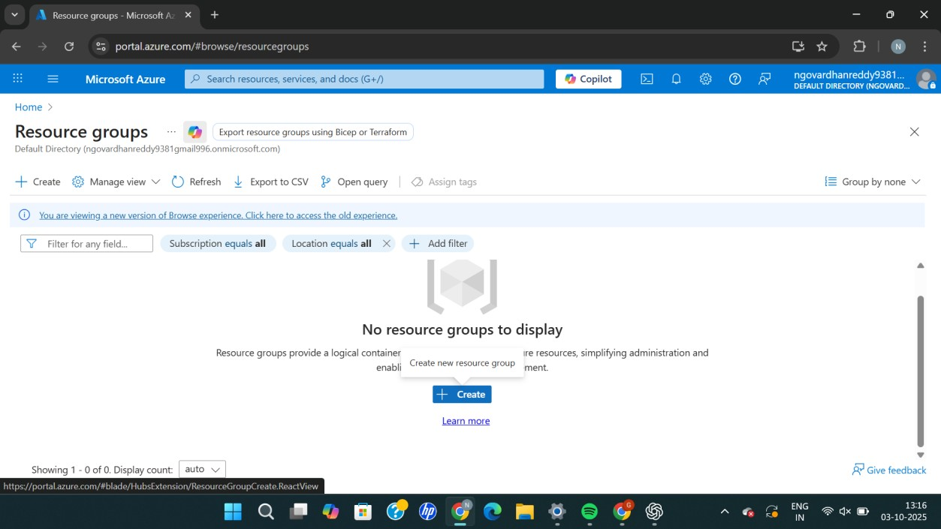
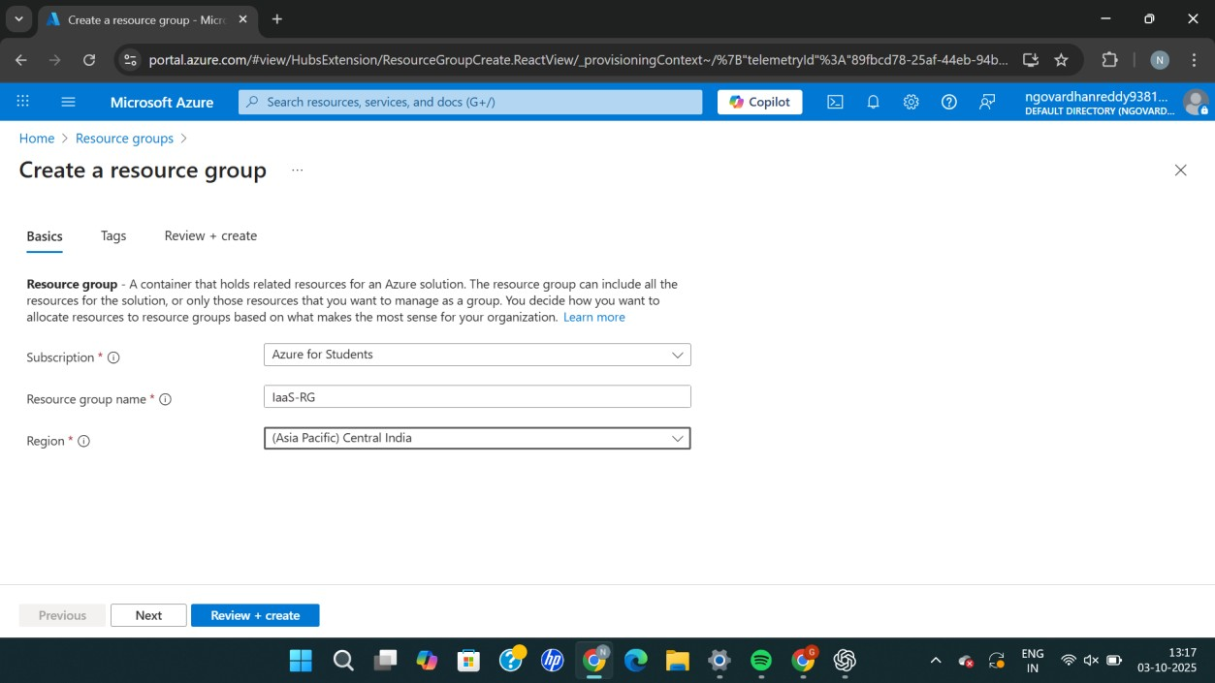
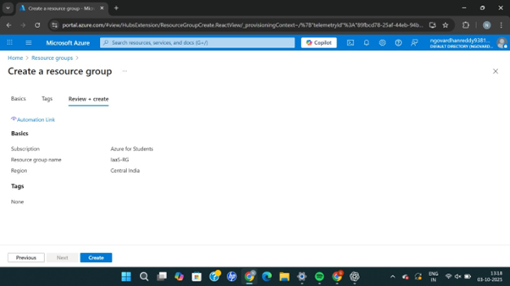
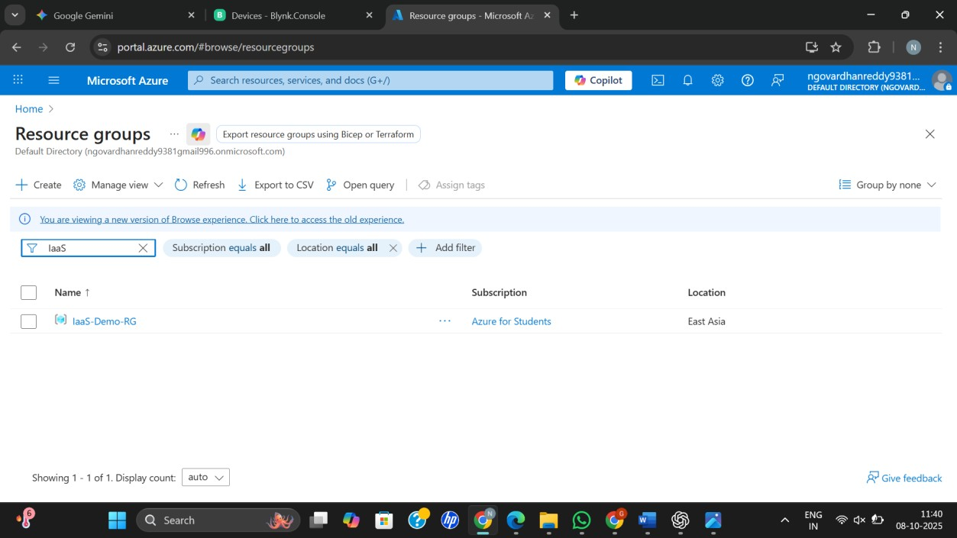

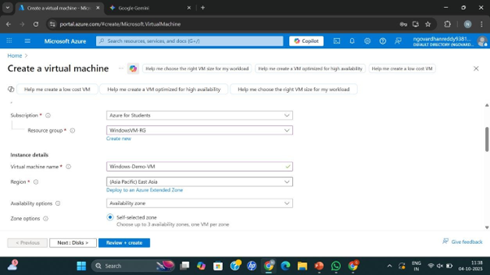
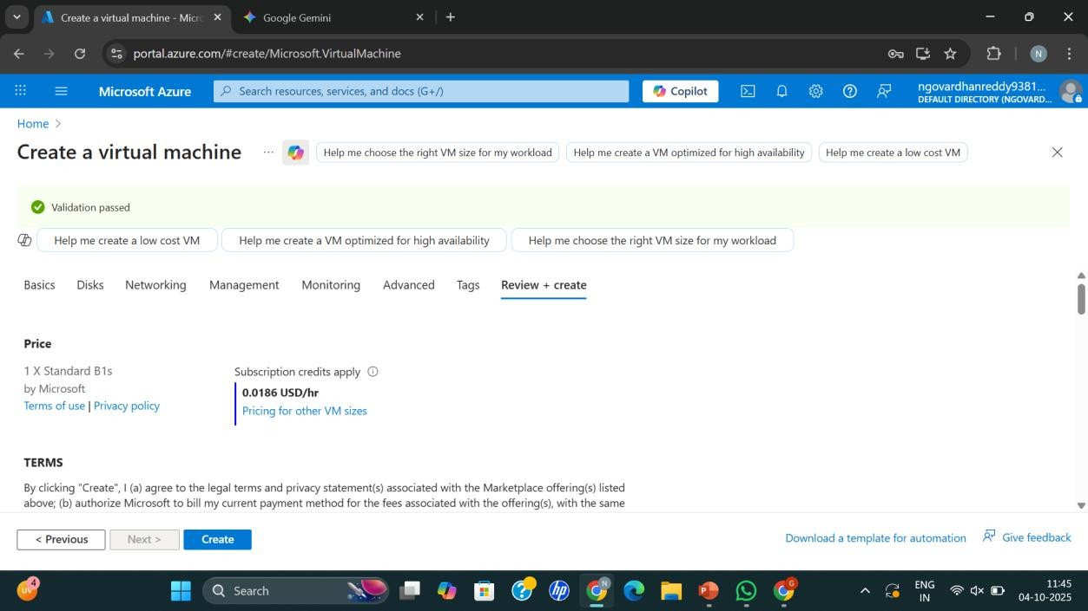

Result
Thus, Infrastructure as a Service (IaaS) was successfully demonstrated by creating and configuring a Virtual Machine with the required CPU and memory using Microsoft Azure.

