LAB EXPERIMENTS

COURSE: Cloud computing and big data for business applications.
COURSE CODE: CSA1519

20. Demonstrate Infrastructure as a Service (IaaS) by establishing the remote connection, launch the created VM image and run in your desktop using Azure.
Aim
To demonstrate Infrastructure as a Service (IaaS) by establishing a remote connection, launching the created Azure Virtual Machine, and running it on the local desktop.

Procedure
- Log in to the Azure Portal using a web browser.
- Navigate to Virtual Machines from the Azure dashboard.
- Select the already created Virtual Machine.
- Ensure the VM status is Running.
- Note the Public IP Address of the virtual machine.
- Click Connect from the VM overview page.
- For Windows Virtual Machine
- Select RDP and download the RDP file.
- Open the downloaded file using Remote Desktop Connection.
- Enter the VM username and password.
- Accept the security prompt to establish the connection.
For Linux Virtual Machine
- Open Command Prompt / Terminal.
- Connect using SSH command:
- ssh username@public-ip-address
- Enter the password or authenticate using SSH key.
- The virtual machine desktop/terminal opens on the local system.
- Perform basic operations such as opening applications or checking system configuration.
- Verify that the VM is running remotely on the desktop.

Output
Azure virtual machine launched successfully. Remote connection established using RDP/SSH. Virtual machine accessed and controlled from the local desktop.
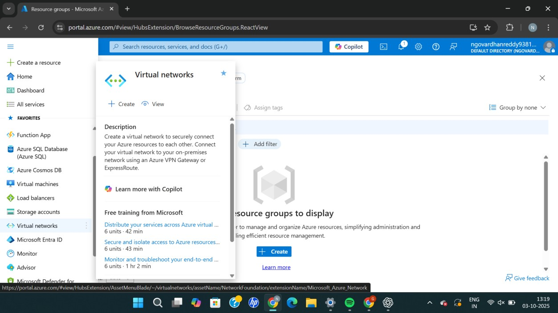
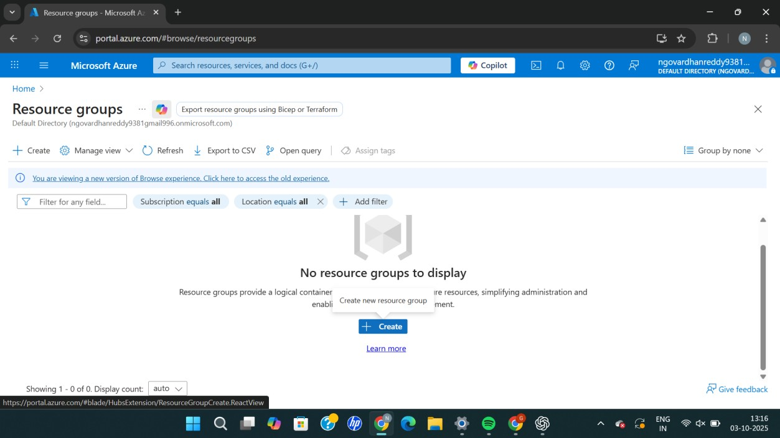
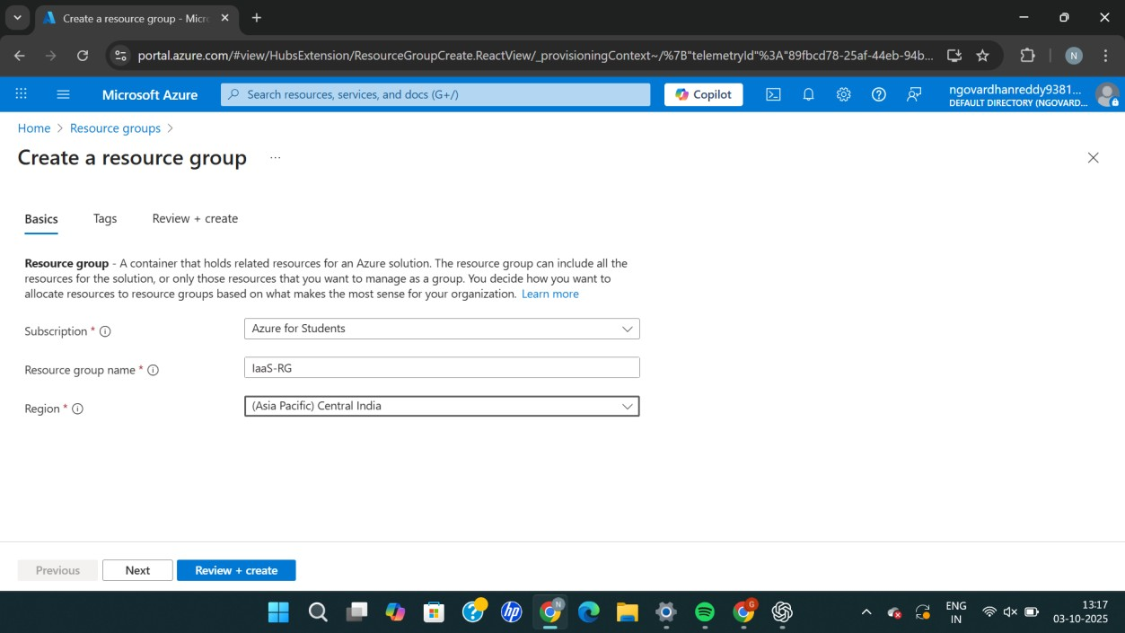
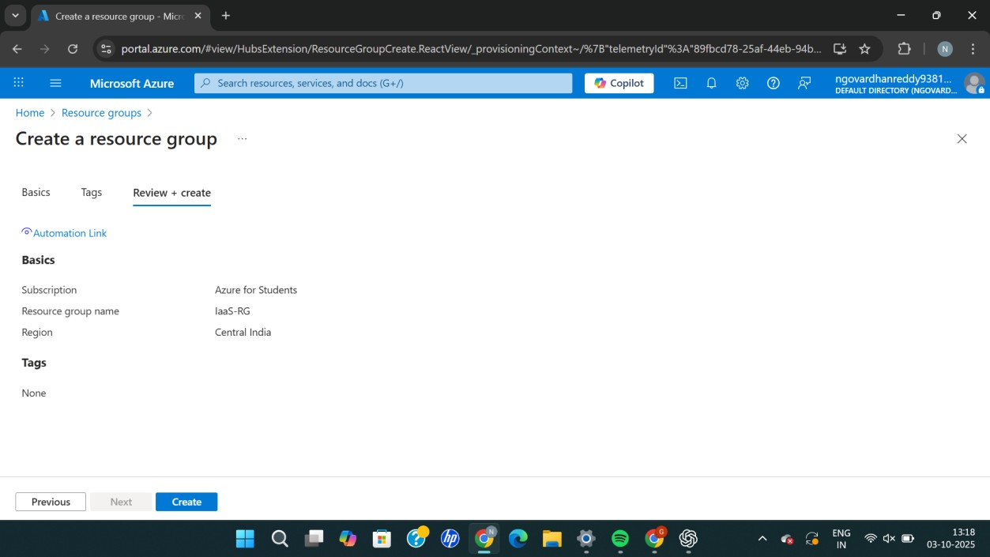
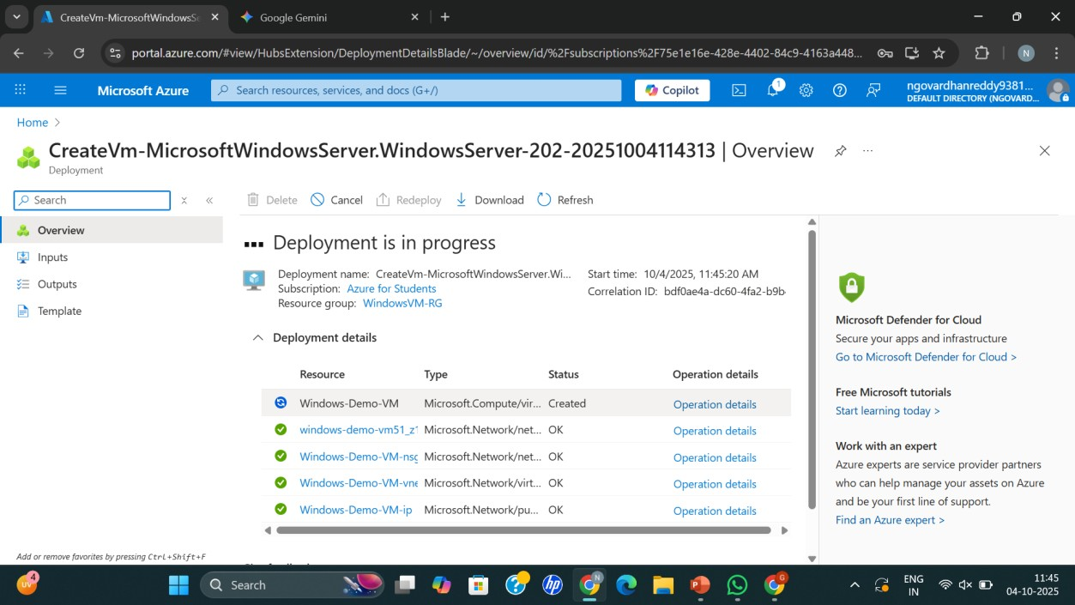
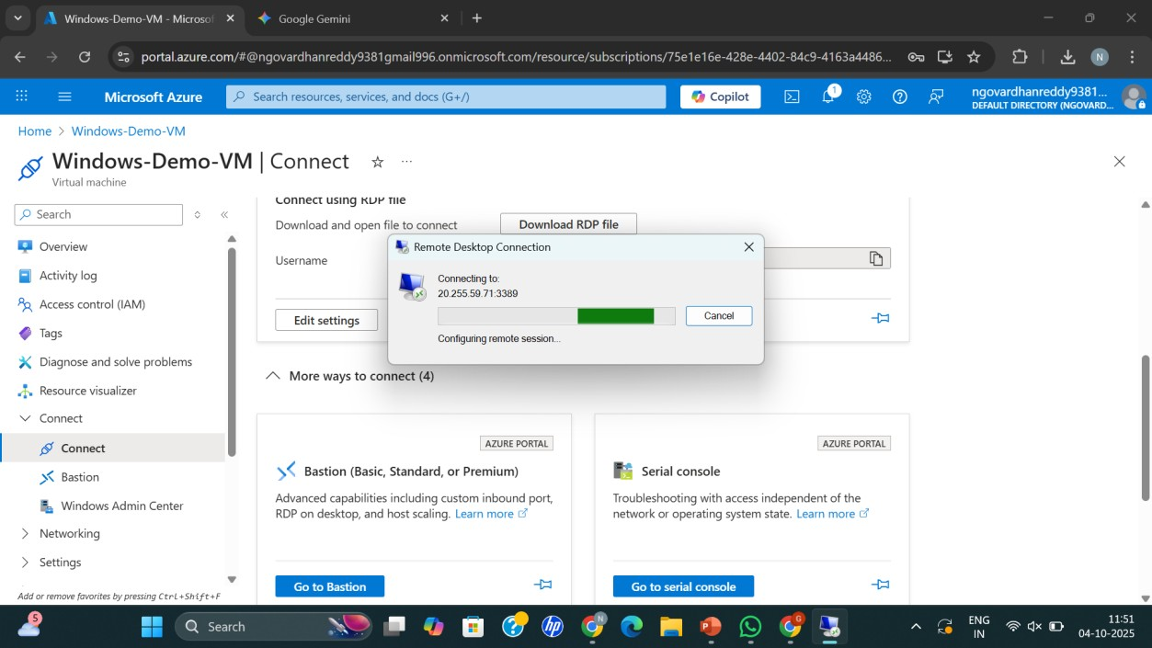
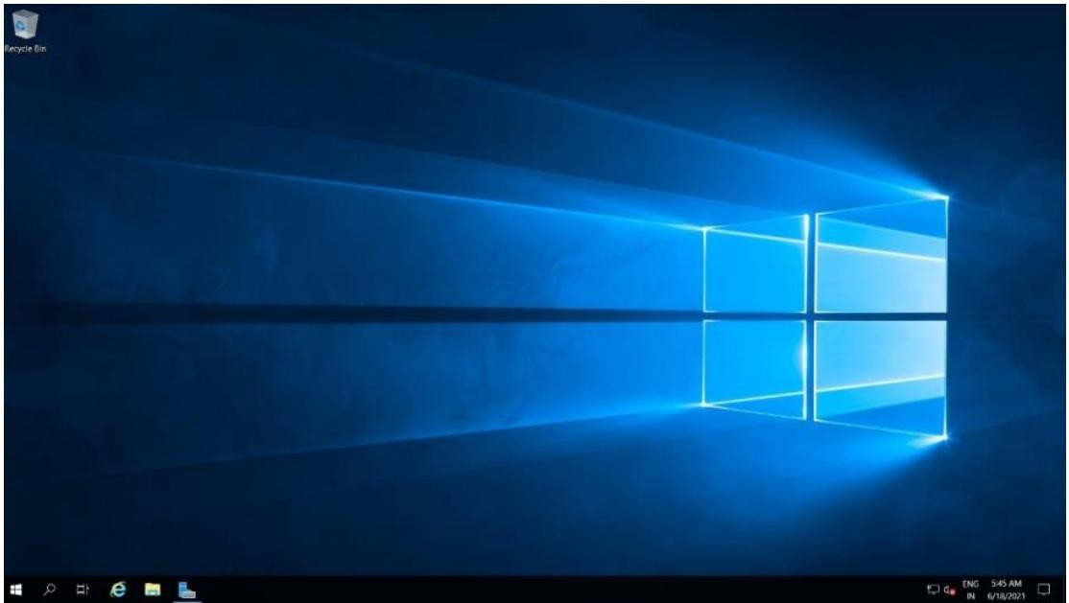

Result
Thus, Infrastructure as a Service (IaaS) was successfully demonstrated by remotely connecting to an Azure Virtual Machine and running it on the desktop system.

