LAB EXPERIMENTS

COURSE: Cloud computing and big data for business applications.
COURSE CODE: CSA1519

21. Demonstrate Platform as a Service (PaaS) create and configure a new VM Image in any Public Cloud Service Provider using Azure.
Aim
To demonstrate Platform as a Service (PaaS) by creating and configuring an application service using Microsoft Azure, where the underlying VM image and infrastructure are managed by the platform.

Procedure
- Log in to the Azure Portal using a web browser.
- From the Azure dashboard, click Create a resource.
- Select Web App under App Services.
- Choose the Subscription.
- Create or select an existing Resource Group.
- Enter a Web App Name.
- Select Publish as Code.
- Choose Runtime Stack (e.g., .NET, Java, Python, Node.js).
- Select the Operating System (Windows or Linux).
- Choose a Region.
- Select a Pricing Plan (Basic / Free tier).
- Click Review + Create.
- Click Create to deploy the PaaS service.
- Wait for deployment to complete.
- Open the created Web App.
- Click Browse to launch the application.
- Verify that the application runs successfully without managing VM settings.

Output
Azure App Service created successfully. Application deployed and executed. Underlying VM image and infrastructure handled automatically by Azure. No manual VM configuration required.
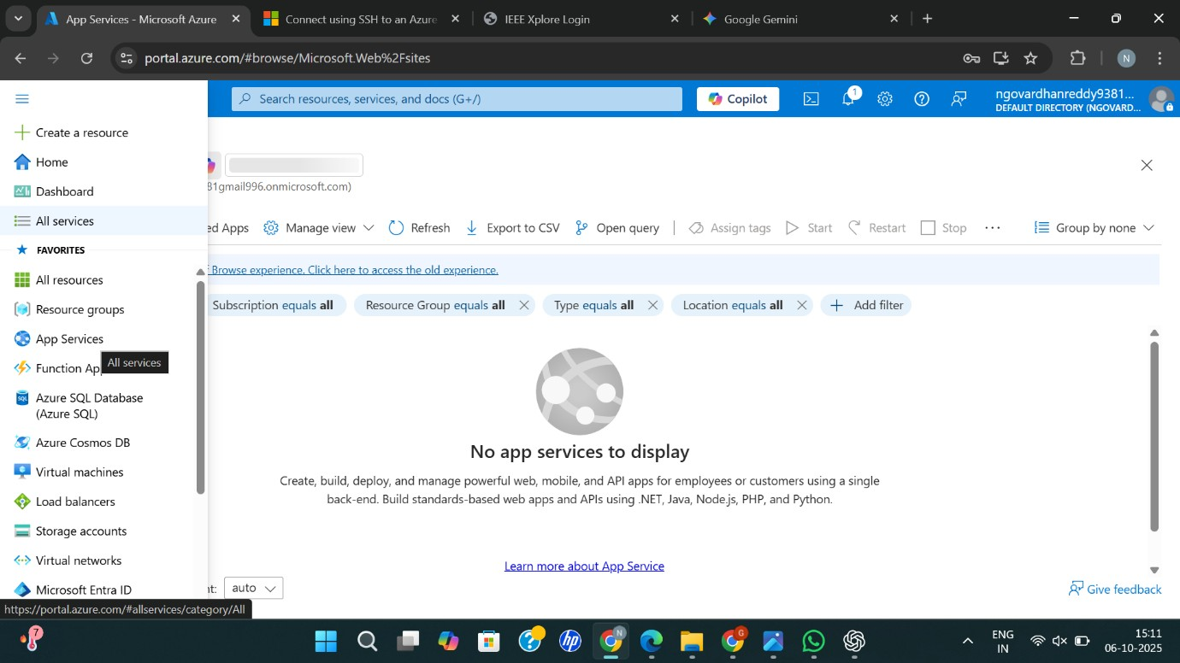
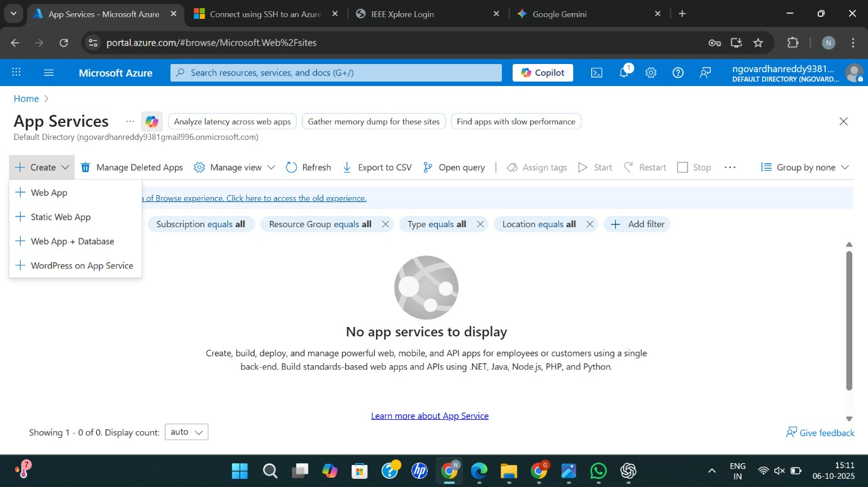
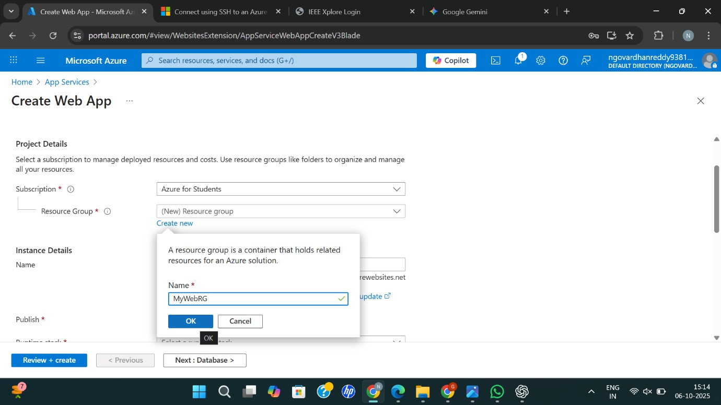
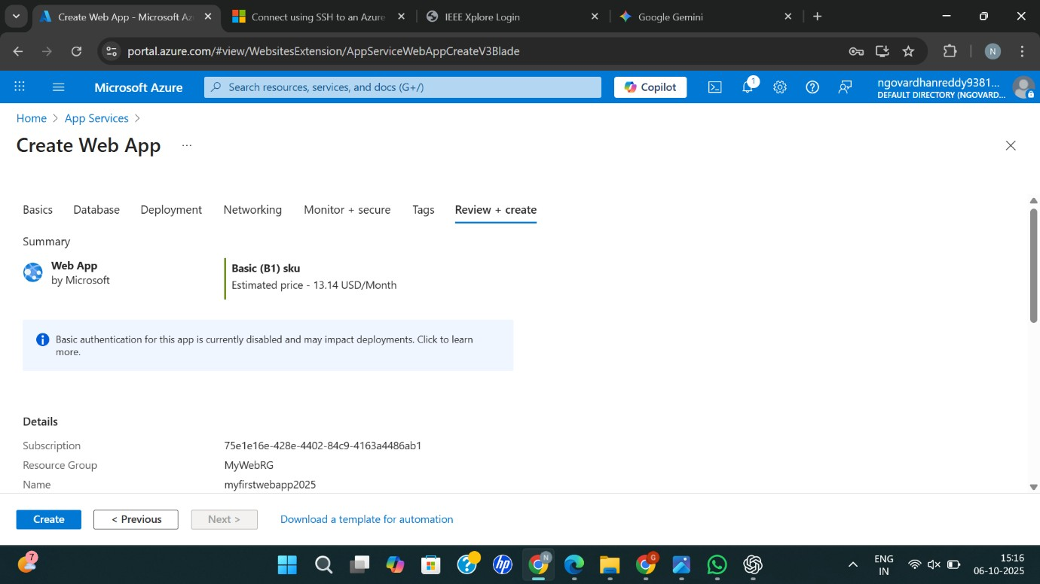
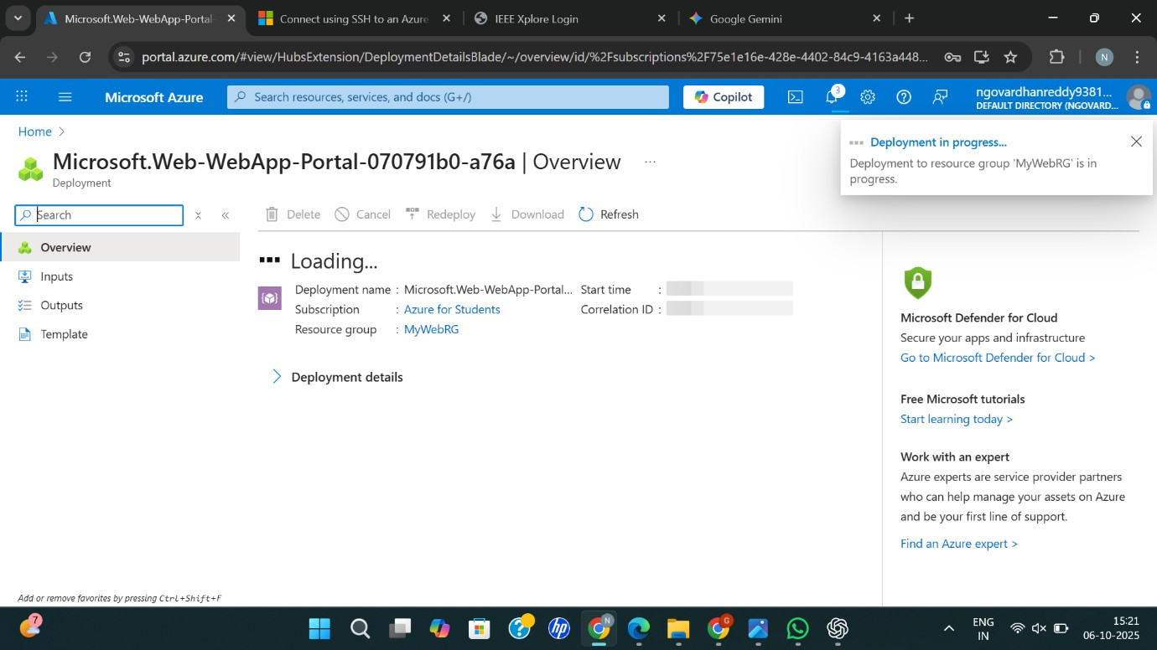
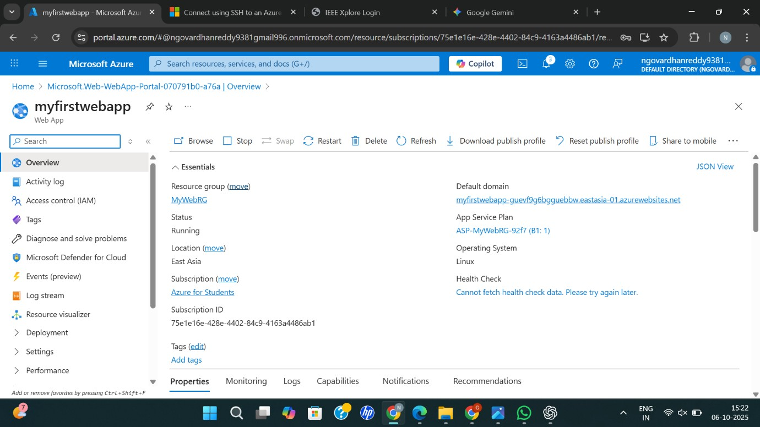
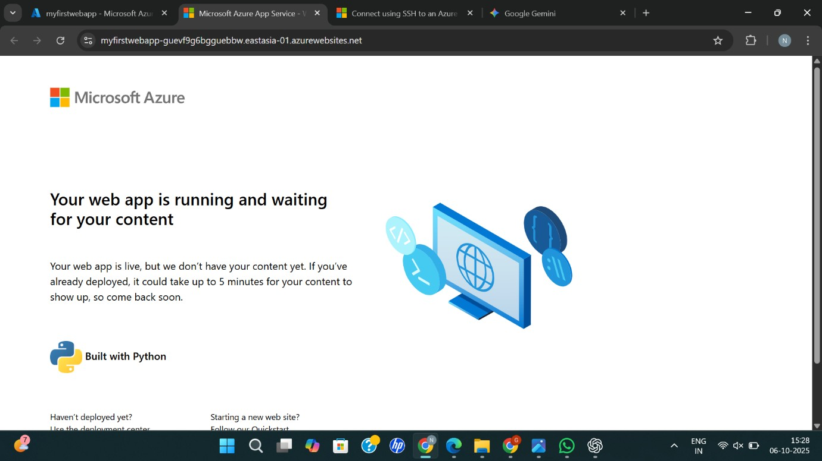
Result
Thus, Platform as a Service (PaaS) was successfully demonstrated by creating and configuring an application using Microsoft Azure, where the platform manages the virtual machine image and infrastructure.

