LAB EXPERIMENTS

COURSE: Cloud computing and big data for business applications.
COURSE CODE: CSA1519

22. Create a Simple Web Application using Java or Python and host it in any Public Cloud Service Provider (Azure/GCP/AWS) to demonstrate Platform as a Service (PaaS).
Aim
To create a simple web application using Python and host it on a Public Cloud Service Provider (Microsoft Azure) to demonstrate Platform as a Service (PaaS).

Procedure
- Create a simple Python web application using Flask.
- Save the application file as app.py.
- Create a requirements.txt file with required libraries.
- Log in to the Azure Portal.
- Click Create a resource.
- Select Web App (Azure App Service).
- Choose the Subscription.
- Create or select a Resource Group.
- Enter a unique Web App Name.
- Select Runtime Stack as Python.
- Choose Linux as the operating system.
- Select a Free or Basic App Service Plan.
- Click Review + Create, then Create.
- After deployment, open the created Web App.
- Use Deployment Center or App Service Editor to upload app.py and requirements.txt.
- Restart the Web App.
- Click Browse to open the application URL.
- Verify that the web page displays the output message.

Output
Azure App Service created successfully. Python web application deployed without managing VM or OS. Application accessible through a public URL. Infrastructure and VM image handled automatically by Azure.
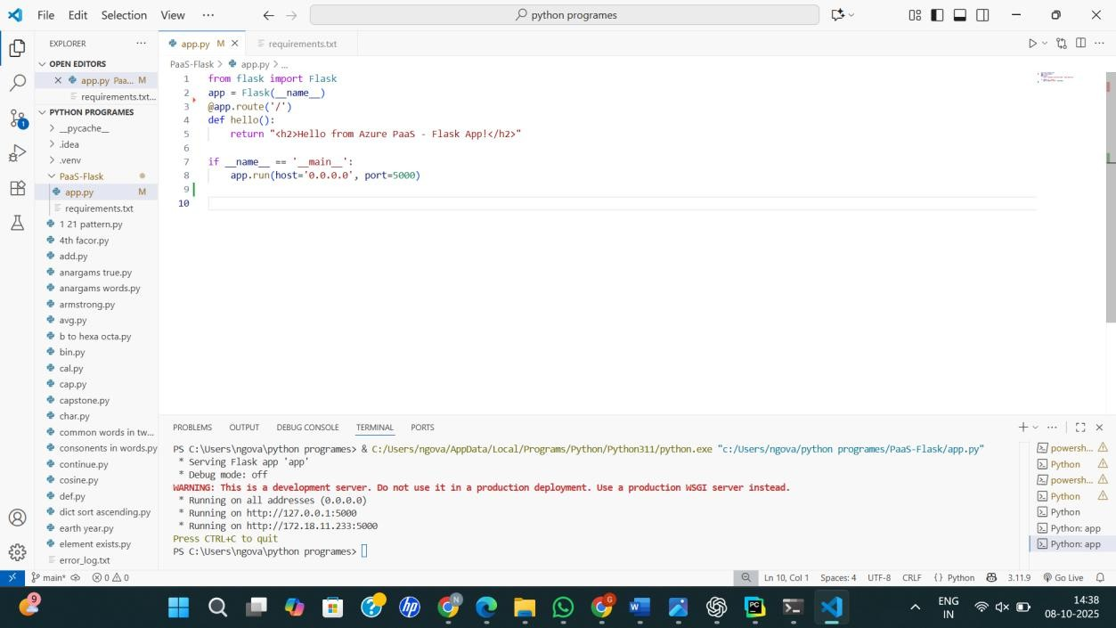
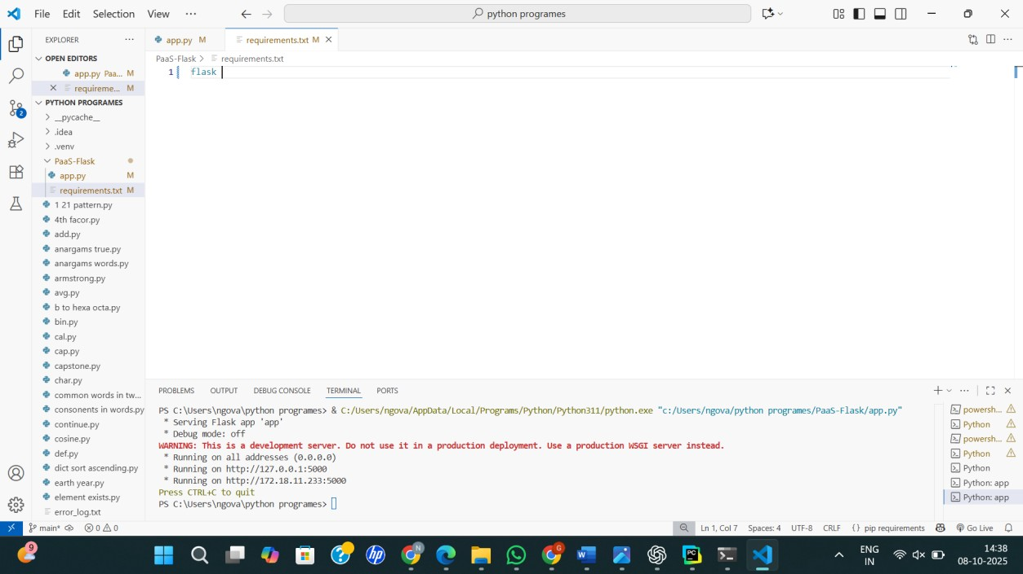

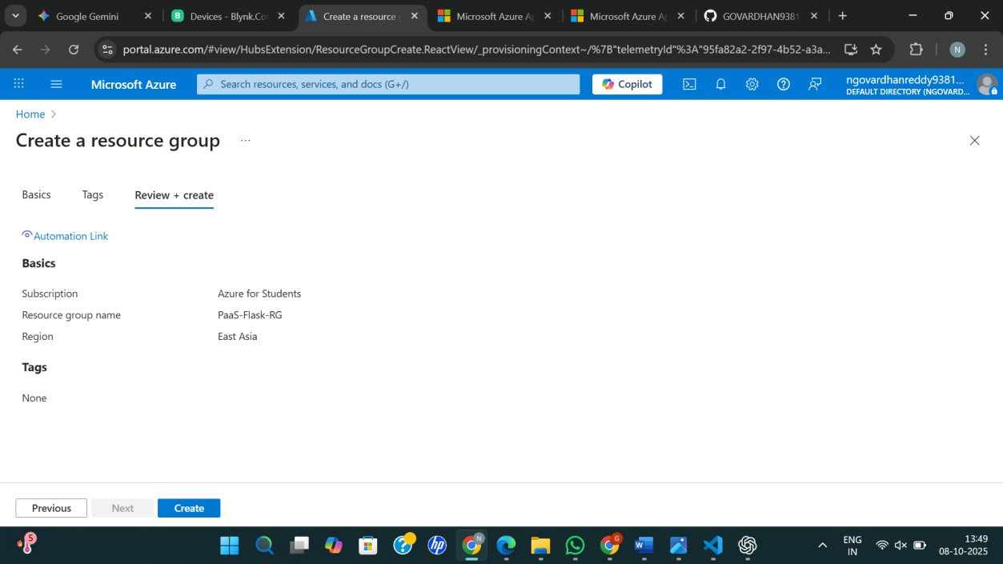
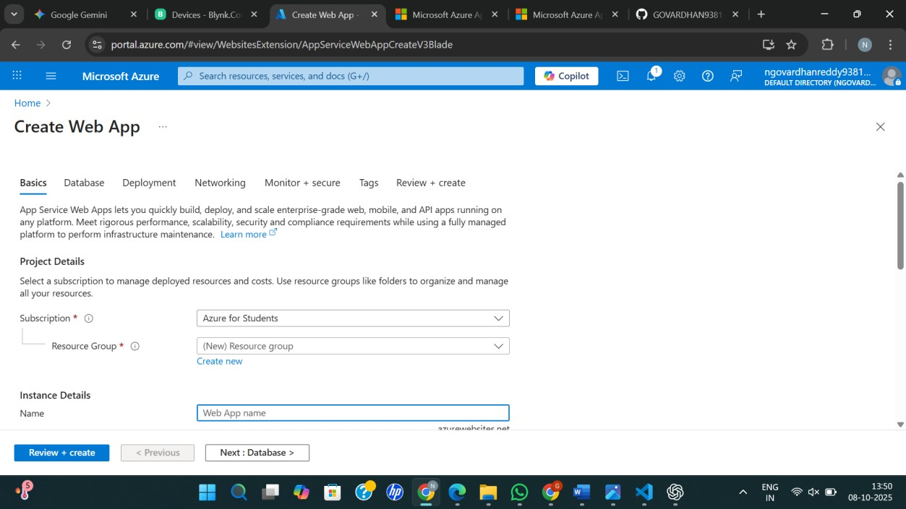

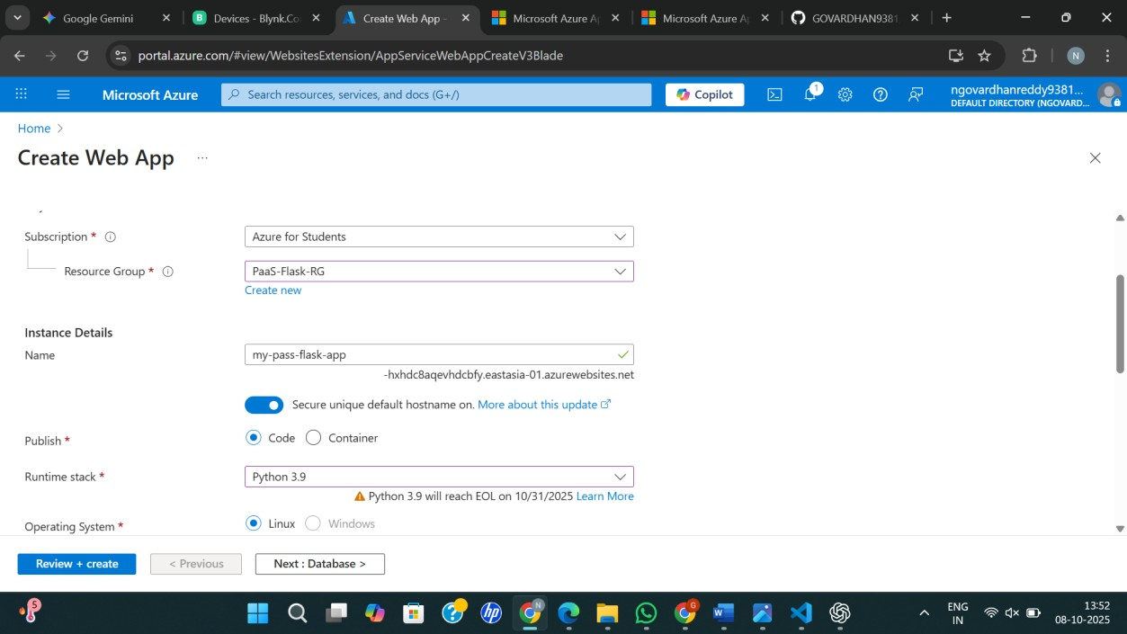
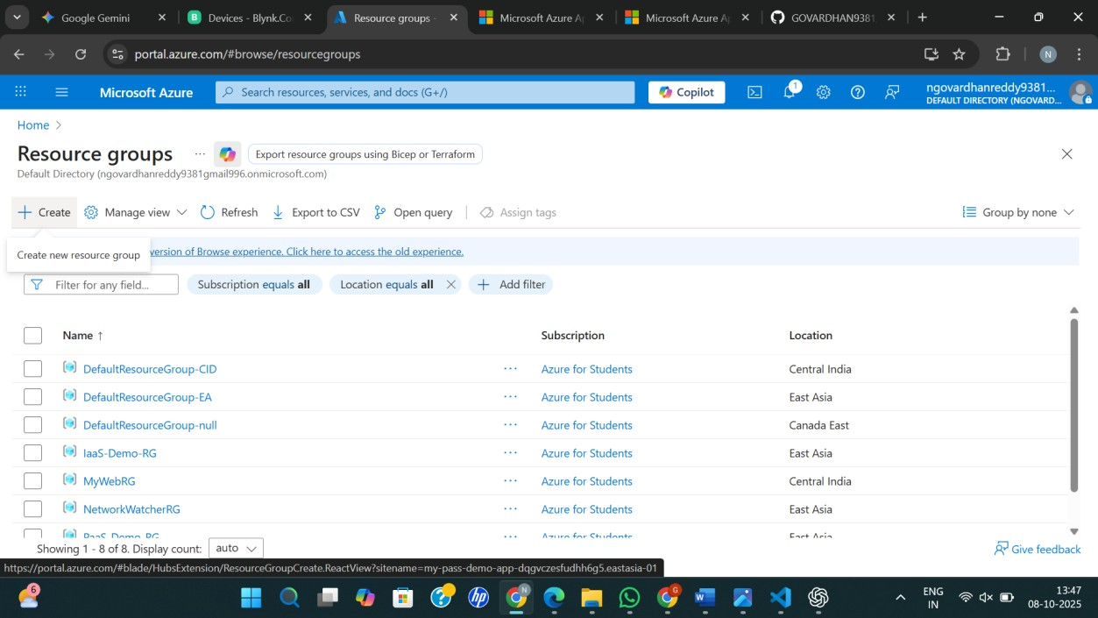

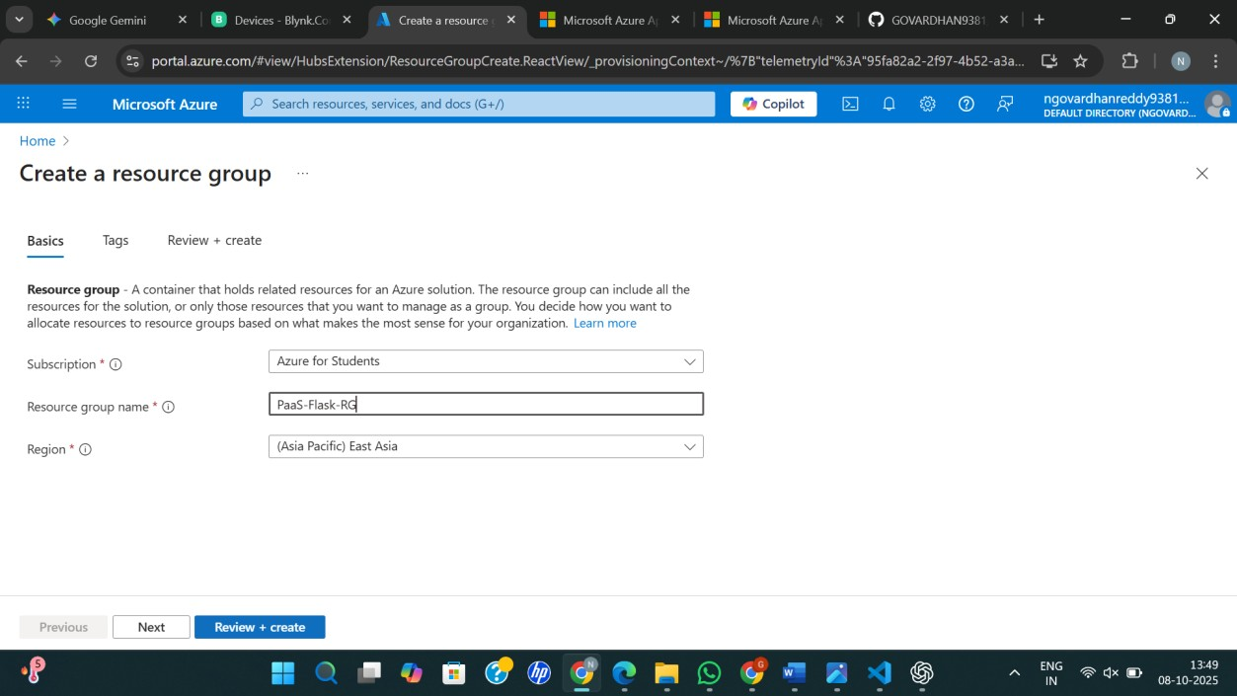
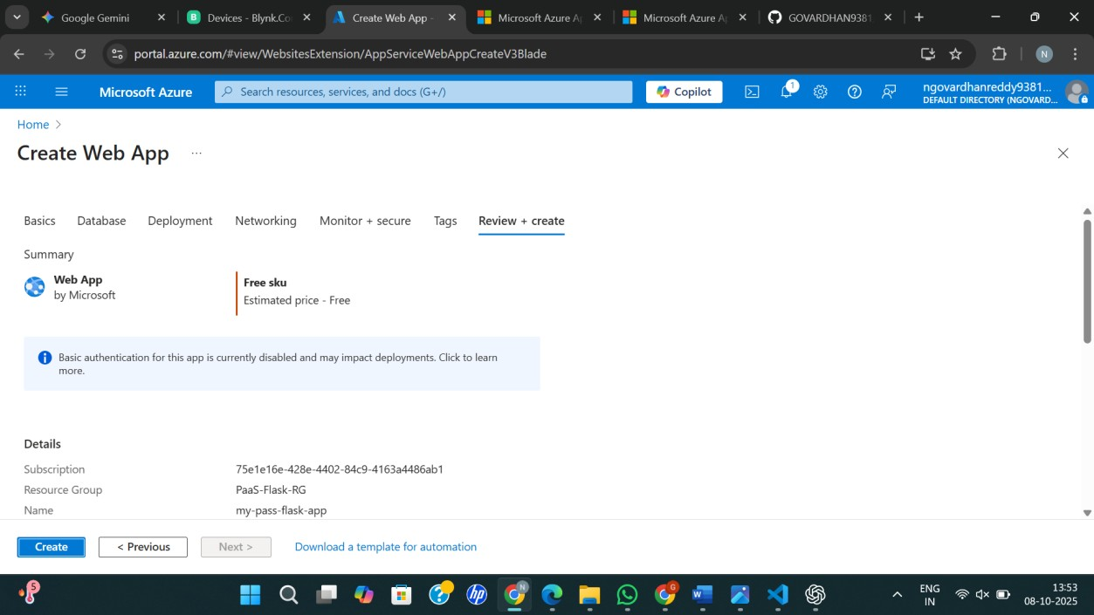
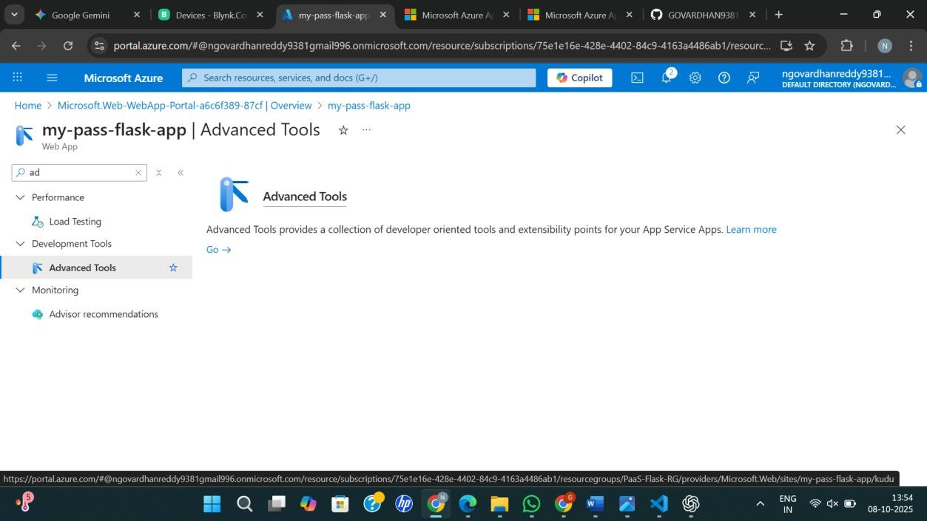

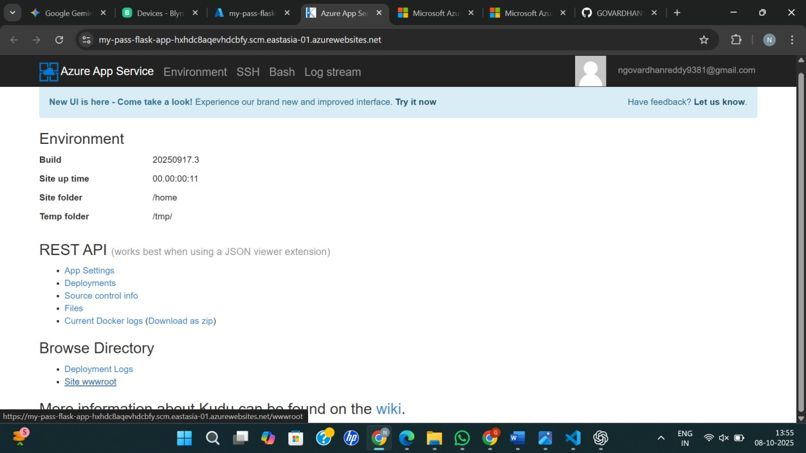
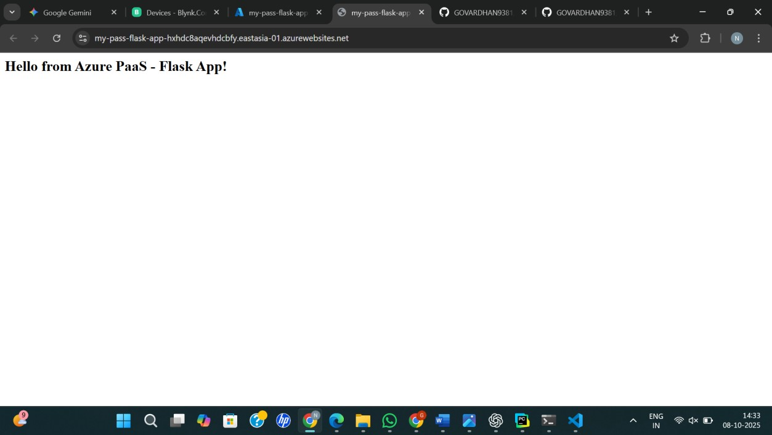

Result
Thus, Platform as a Service (PaaS) was successfully demonstrated by creating and hosting a simple Python web application on Microsoft Azure.

