LAB EXPERIMENTS

COURSE: Cloud computing and big data for business applications.
COURSE CODE: CSA1519

23. Demonstrate Storage as a Service (SaaS) create and configure a new VM Image in any Public Cloud Service Provider using Azure.
Aim
To demonstrate Storage as a Service (SaaS) by creating and configuring cloud storage resources using Microsoft Azure.

Procedure
- Log in to the Azure Portal using a web browser.
- From the Azure dashboard, click Create a resource.
- Select Storage Account.
- Choose the Subscription.
- Create or select a Resource Group.
- Enter a unique Storage Account Name.
- Select the required Region.
- Choose Performance as Standard.
- Select Redundancy (e.g., LRS – Locally Redundant Storage).
- Click Review + Create, then Create.
- After deployment, open the Storage Account.
- Select Containers under Data Storage.
- Click Create to create a new container.
- Enter a container name and set access level.
- Upload files (documents/images) to the container.
- Verify that data is stored and accessible from Azure.
Optional verification using VM (if required by lab):
- Open an existing Azure Virtual Machine.
- Access the storage account using its endpoint or Azure portal.
- Verify read/write access to the stored data.

Output
Azure Storage Account created successfully. Blob container configured and files uploaded. Data stored securely in the cloud. Storage accessed without managing physical hardware.
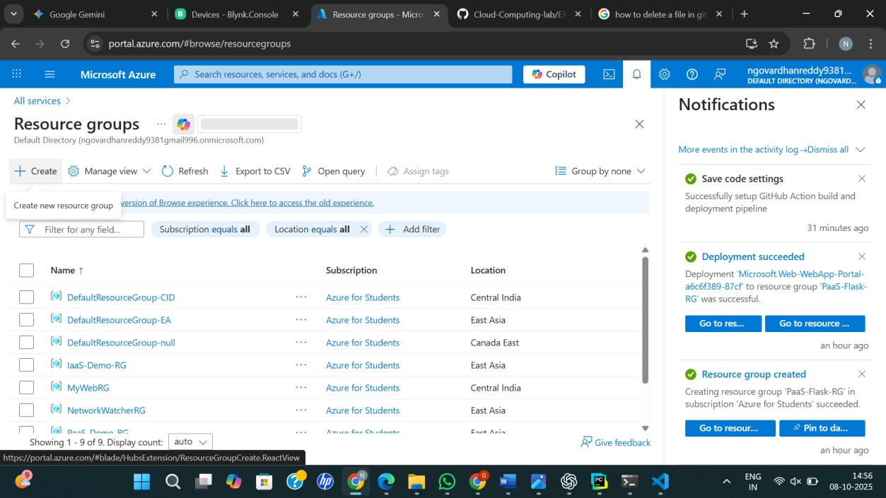
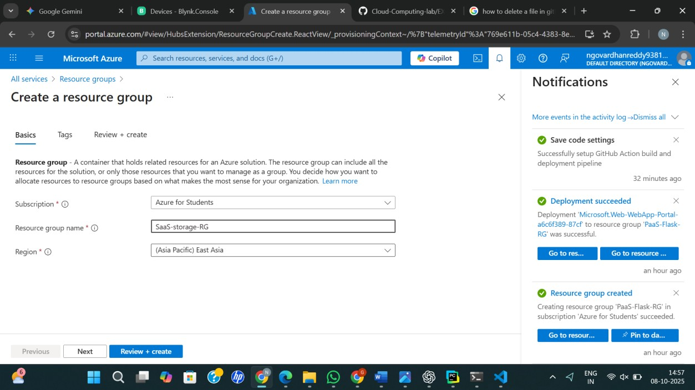

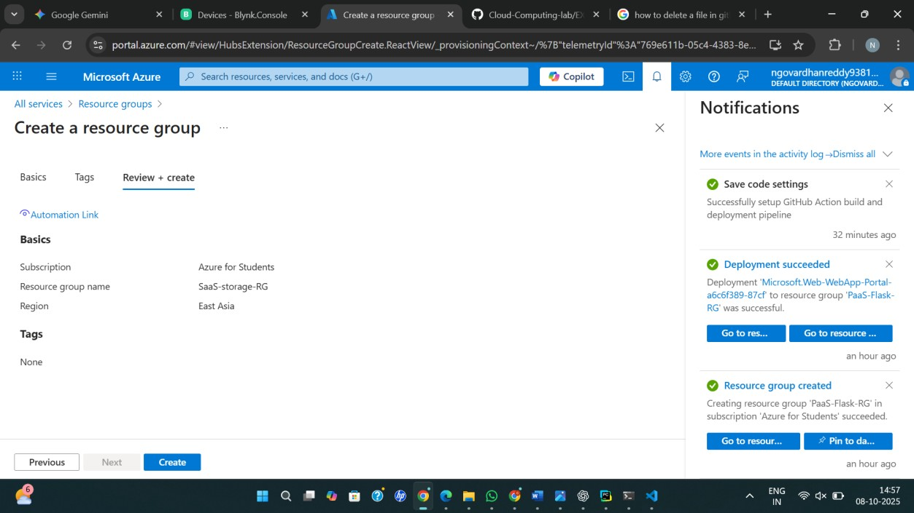
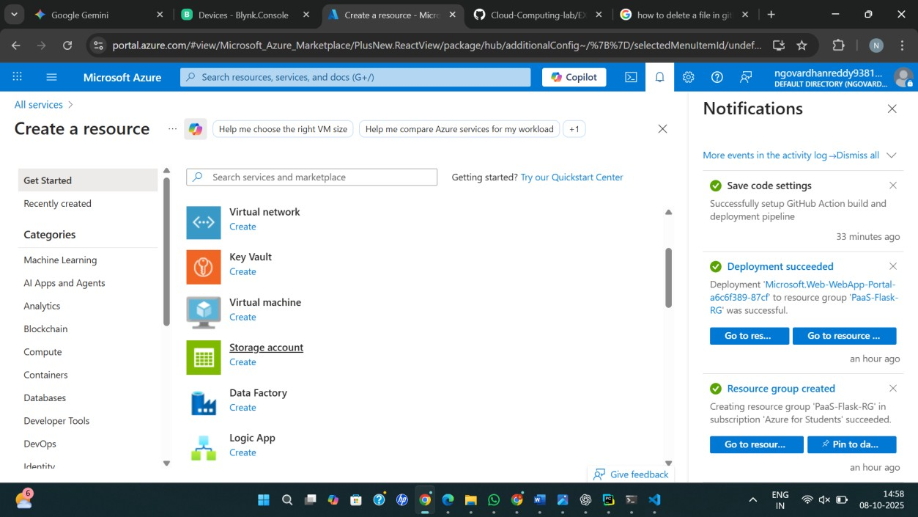

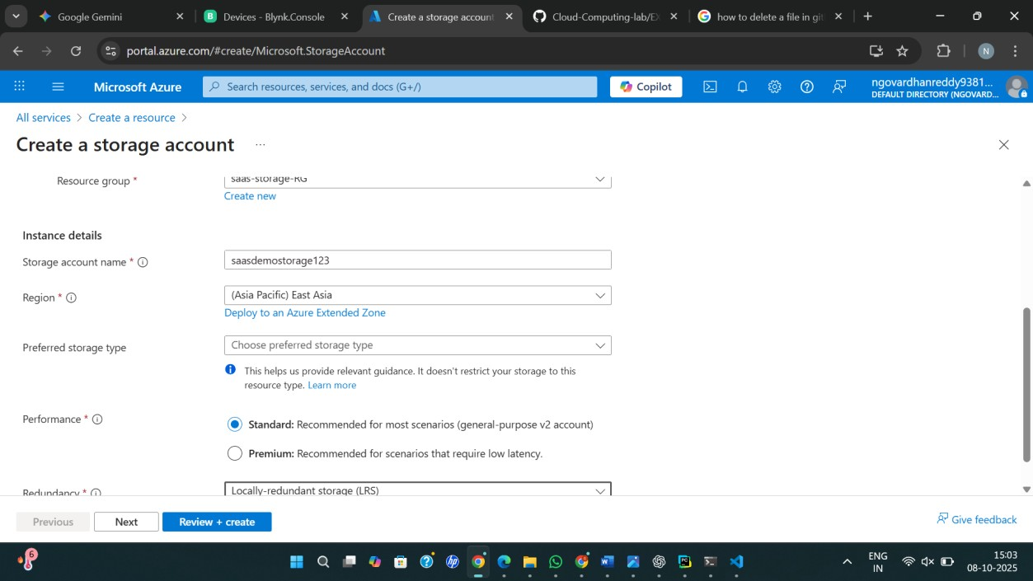
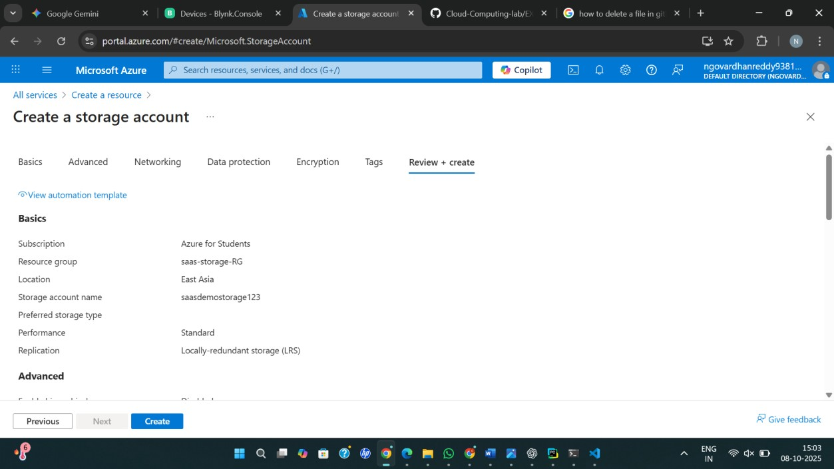
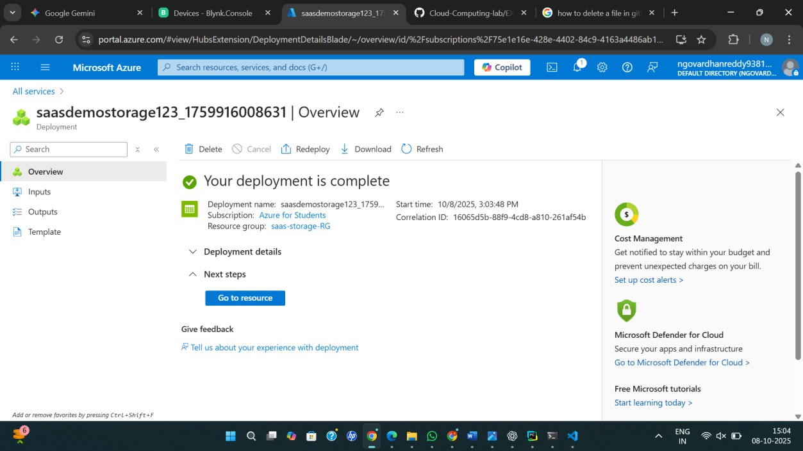

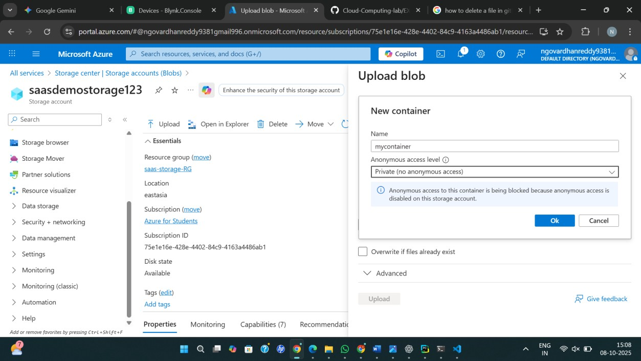
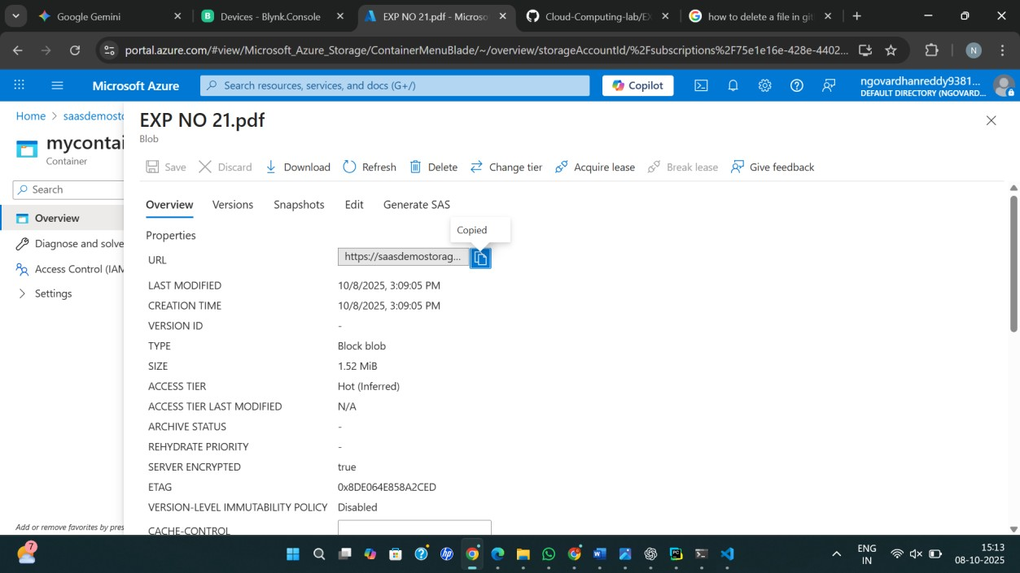

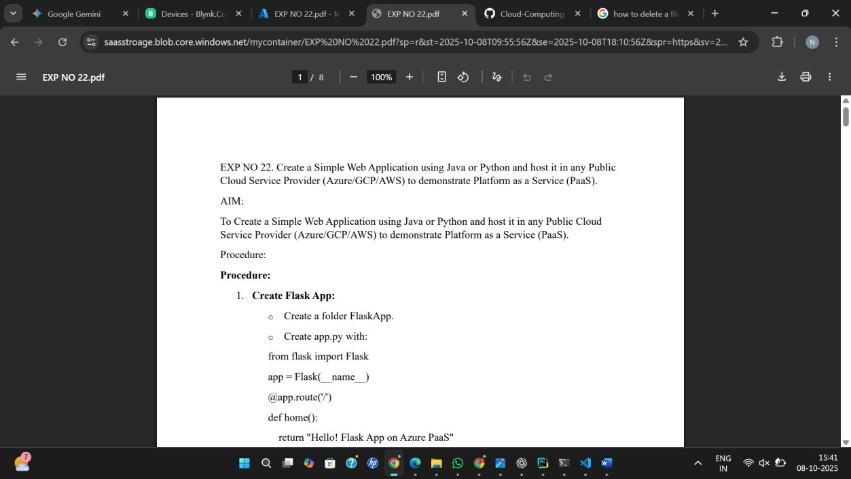

Result
Thus, Storage as a Service (STaaS) was successfully demonstrated by creating and configuring Azure cloud storage resources.

