LAB EXPERIMENTS

COURSE: Cloud computing and big data for business applications.
COURSE CODE: CSA1519

24. Create a Storage service using any Public Cloud Service Provider (Azure/GCP/AWS) and check the public accessibility of the stored file to demonstrate Storage as a Service.
Aim
To demonstrate Storage as a Service (STaaS) by creating a cloud storage service, uploading a file, and verifying its public accessibility using a Public Cloud Service Provider (Microsoft Azure).

Procedure
- Log in to the Azure Portal using a web browser.
- Click Create a resource and select Storage Account.
- Choose the Subscription.
- Create or select a Resource Group.
- Enter a unique Storage Account Name.
- Select the required Region.
- Choose Performance as Standard.
- Select Redundancy as LRS.
- Click Review + Create, then Create.
- After deployment, open the created Storage Account.
- Under Data storage, select Containers.
- Click Create to create a new container.
- Enter a container name.
- Set Public access level to Blob (anonymous read access).
- Click Create.
- Open the container and click Upload.
- Upload a sample file (image/text file).
- Select the uploaded file and copy its URL.
- Open the copied URL in a new browser tab.
- Verify that the file is accessible without login.

Output
Azure Storage Account created successfully. File uploaded to blob container. Public access enabled. Stored file accessed through a public URL.
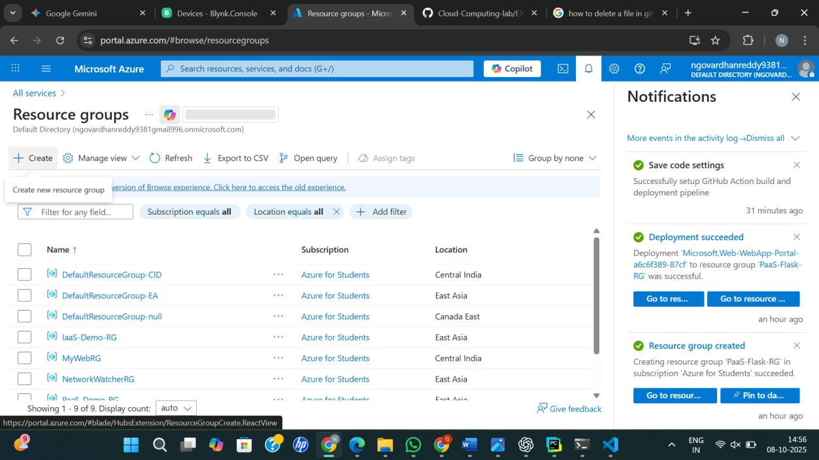
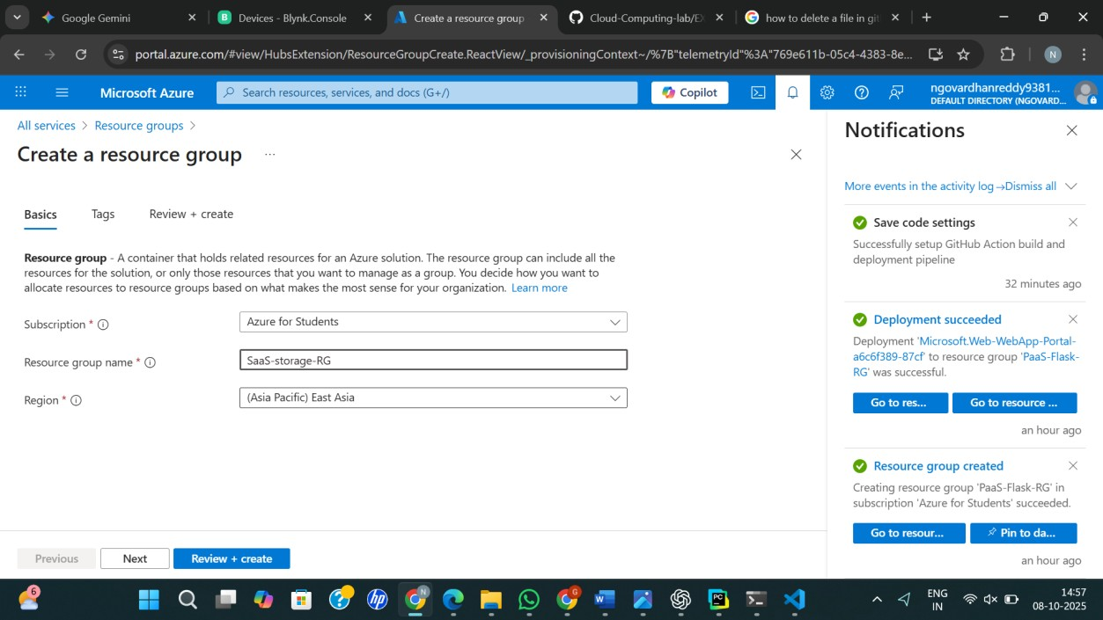

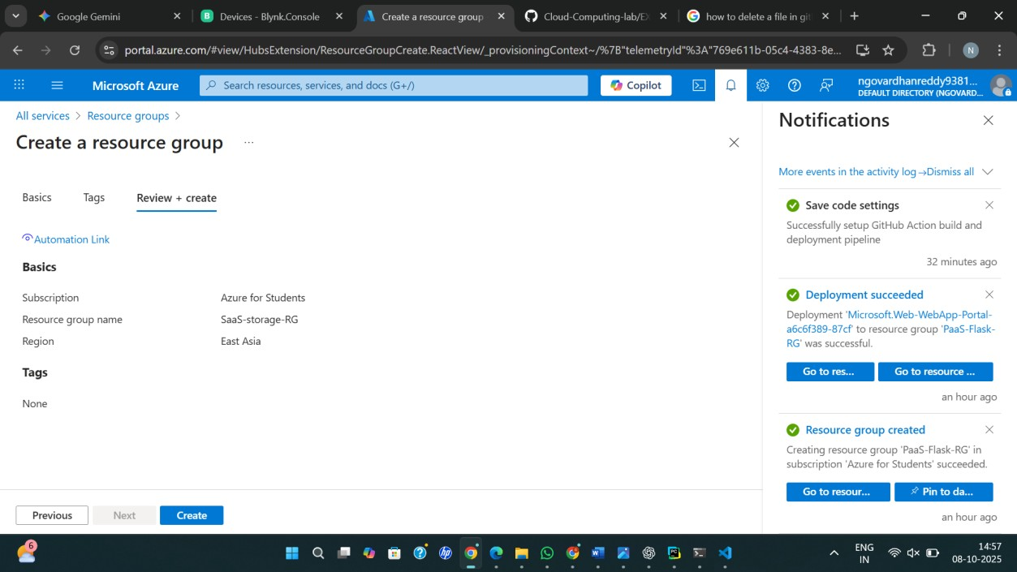
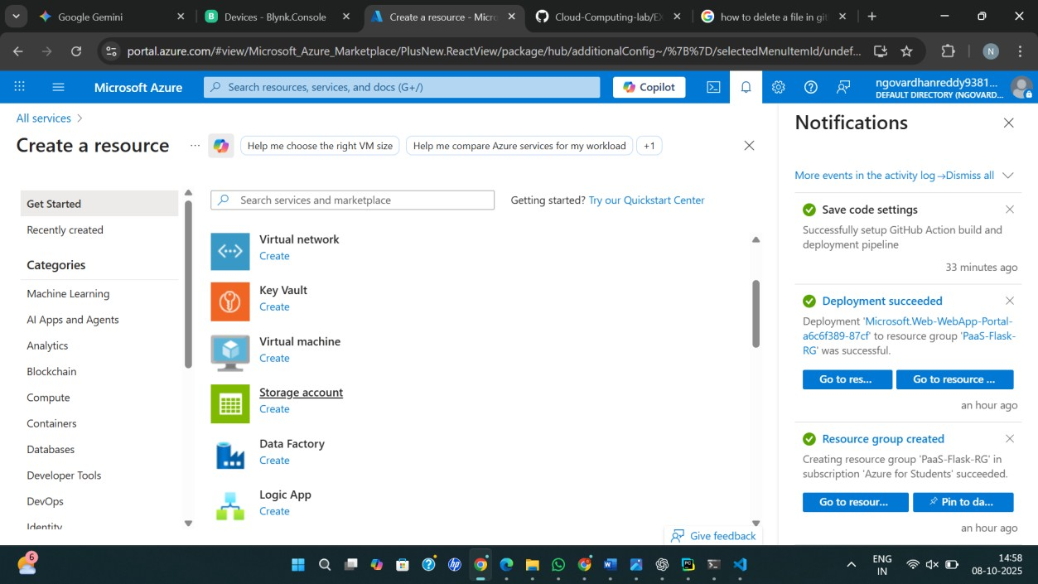

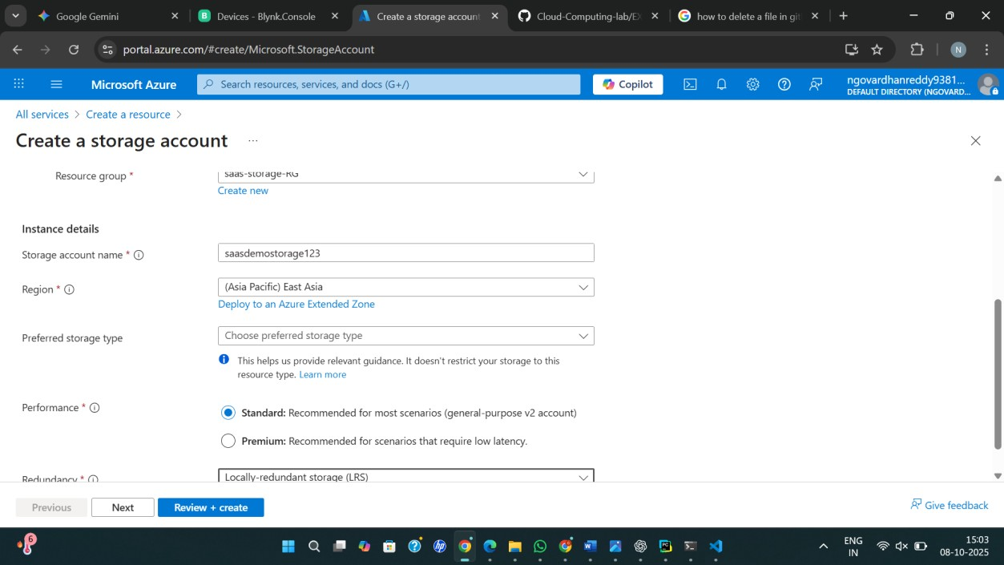
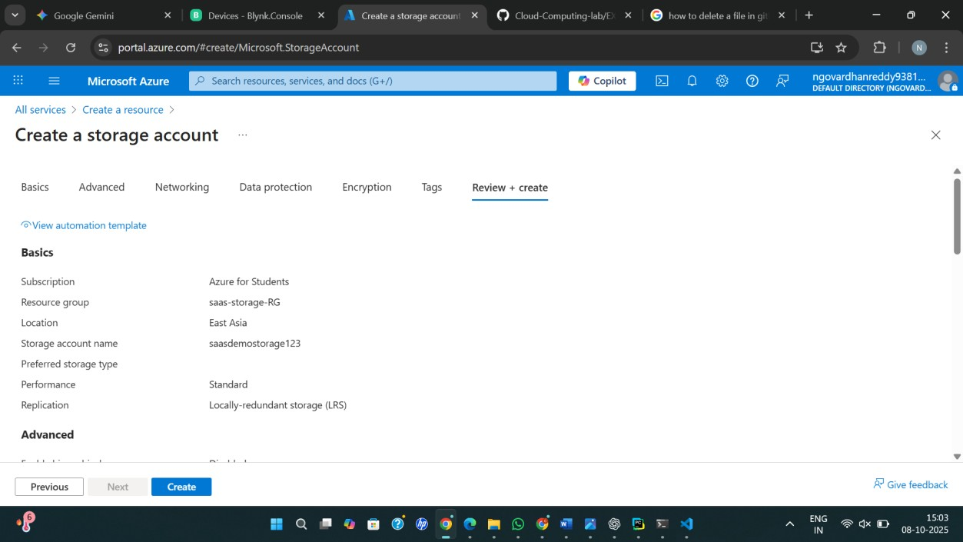
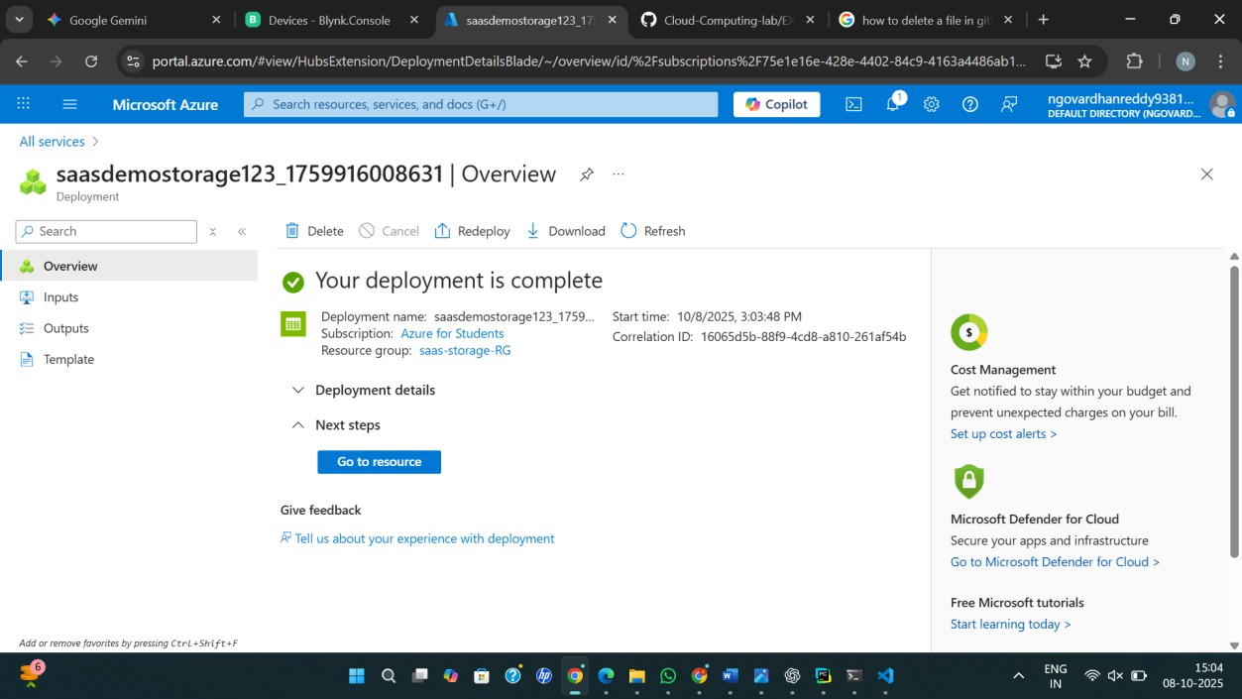

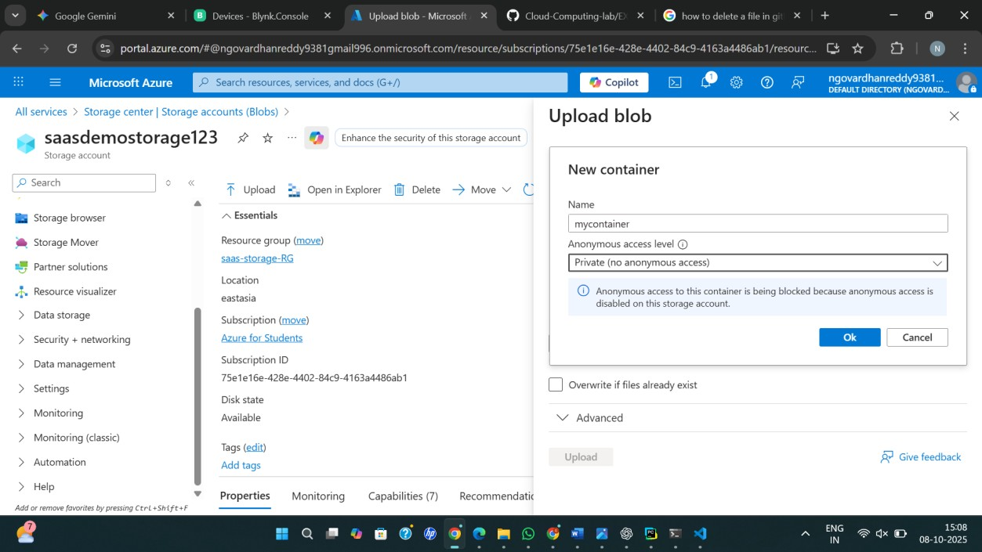
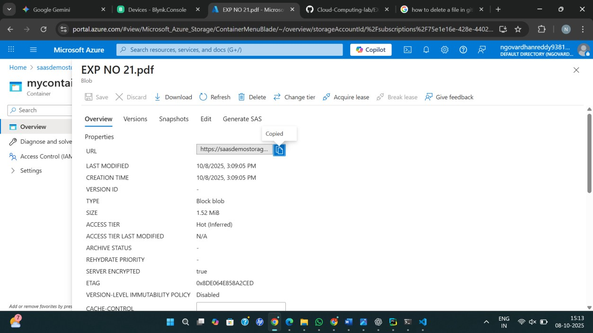

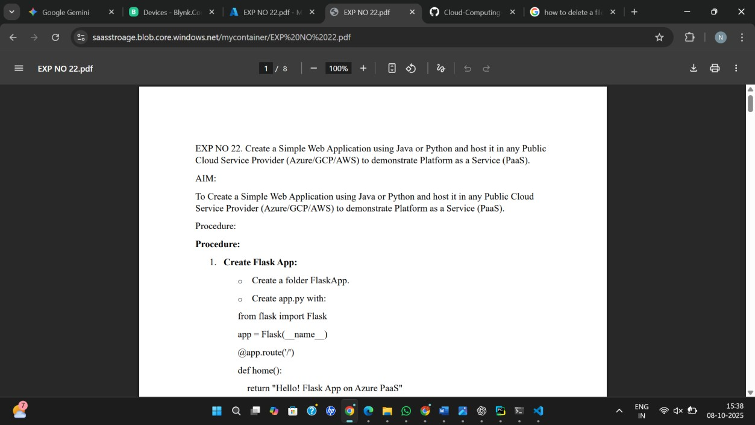

Result
Thus, Storage as a Service (STaaS) was successfully demonstrated by creating a cloud storage service and verifying public accessibility of the stored file using Microsoft Azure.

