LAB EXPERIMENTS

COURSE: Cloud computing and big data for business applications. NAME: Sowmiyan. I
COURSE CODE: CSA1519 REG NO: 192373014

1) Create a simple cloud software application and provide it as a service using
any Cloud Service Provider to demonstrate Software as a Service (SaaS).
Aim:
To develop a Hospital Management System using Zoho Creator and deploy it as Software as a Service (SaaS).

Procedure
- Created a new application in Zoho Creator.
- Designed Patient Details, Doctor Details, and Appointment Details forms.
- Implemented auto-calculation and lookup fields to link patient and doctor data.
- Tested the application with sample records.
- Published the application and enabled web access.

Output
A cloud-based Hospital Management System accessible through a web browser, allowing users to manage patient, doctor, and appointment information online.
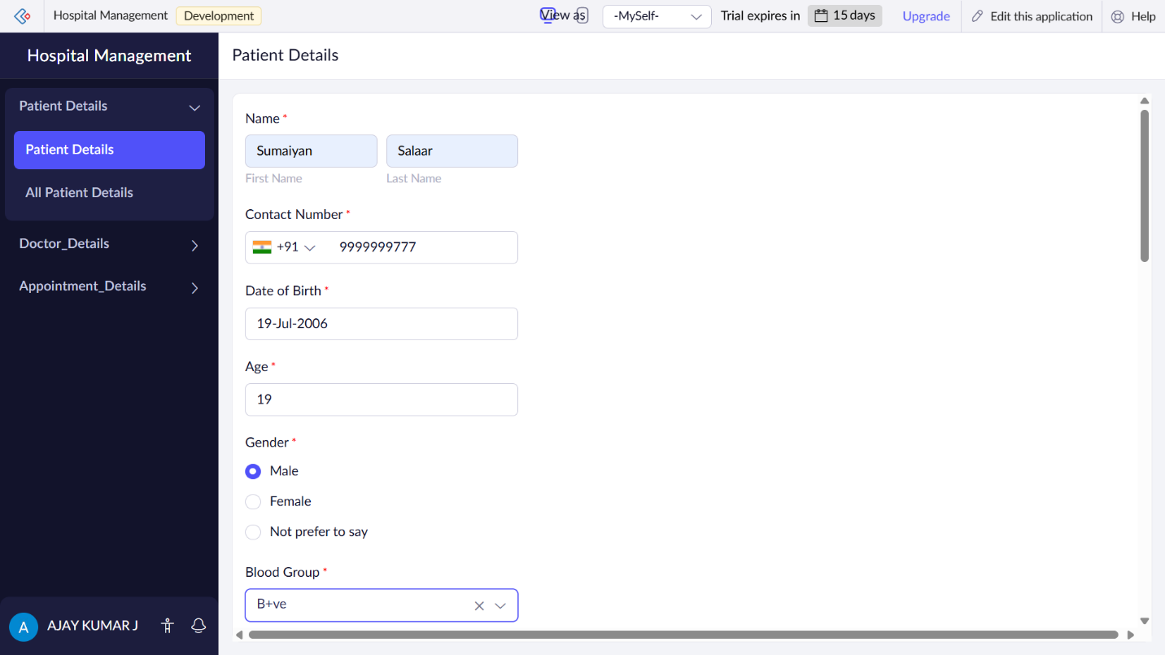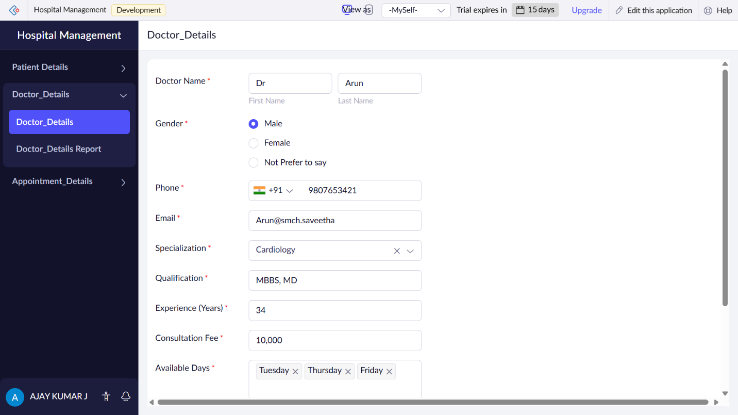
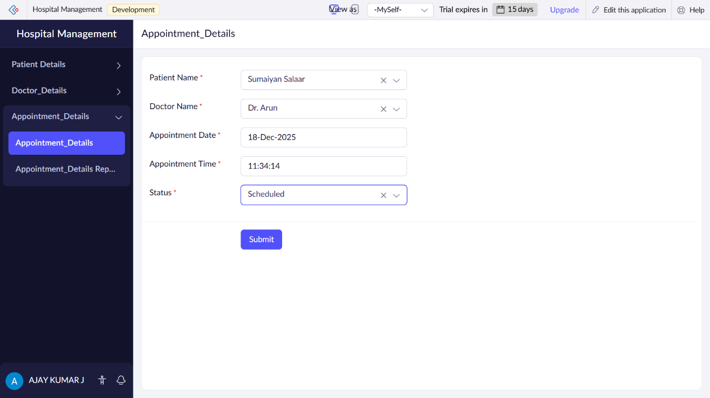

Result
The Hospital Management System was successfully developed and deployed as a SaaS application, accessible anytime via the internet without local installation.

