ASSIGNMENT -10.2

1.CONCAT :

COMMAND :



OUTPUT:

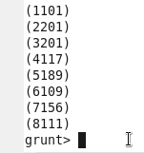

2.TOKENIZE :

COMMAND:



OUTPUT:

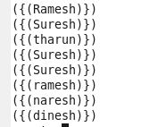

3.SUM

COMMAND:

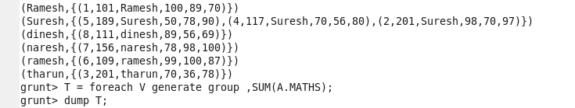

OUTPUT:

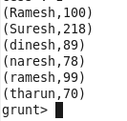

4.MAX :

COMMAND:



OUTPUT:

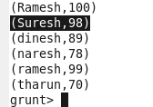

5.MIN:

COMMAND:

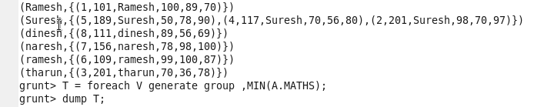

OUTPUT:

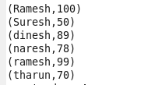

6.DISTINCT:

COMMAND:



OUTPUT:

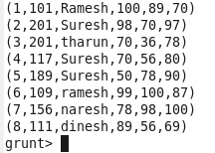

7.STORE

COMMAND:



OUTPUT:

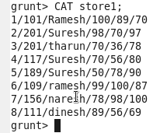

8.FLATTEN:

COMMAND:



OUTPUT:

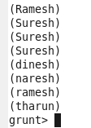

9.LIMIT:

COMMAND:

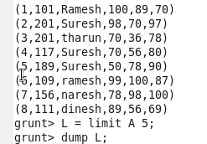

OUTPUT:

