**10.5.1 Write a pig script to find the top 20 destination people travel the most: Based on the given data.**

**COMMAND:**

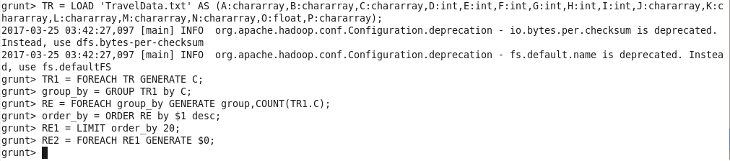

**OUTPUT:**

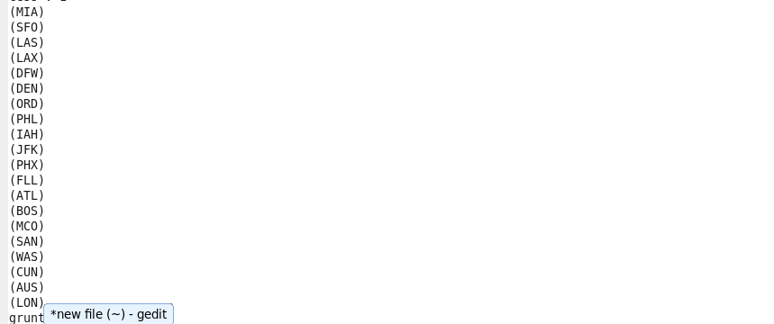

**10.5.2. Write a pig script to find the top 20 locations from where people travel the most.**

**COMMAND:**

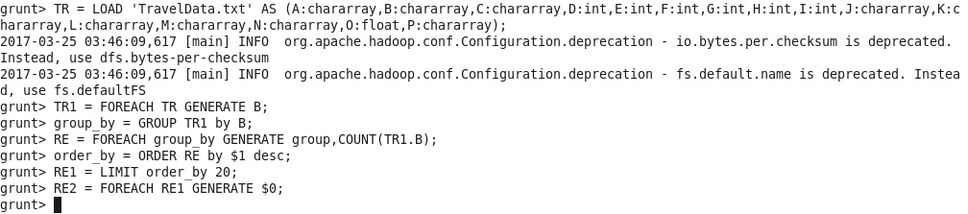

**OUTPUT:**

