**10.6.1 Write a pig script to find the minimum temperature observed in a given weather station in a particular year.**

**Grouping by station and getting the minimum temperature using min command.**

**COMMAND :**

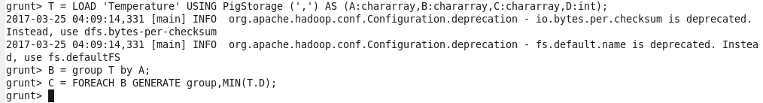

**OUTPUT:**



**10.6.2 Write a pig script to find the number of readings given by each weather station according to the dataset. Grouping by station and finding the count of the station using group by and count command.**

**COMMAND:**

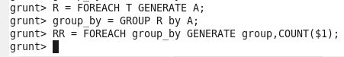

**OUTPUT:**



**10.6.2.Write a pig script to find the maximum temperature observed in a given weather station in a particular year.**

**Grouping by station and getting the maximum temperature using group by and max command.**

**COMMAND:**

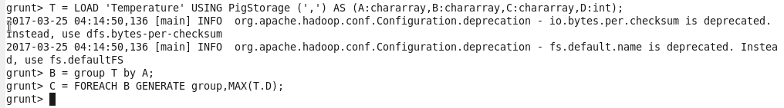

**OUTPUT:**

