**ASSIGNMENT - 11.4**

1. Write a pig script to find the count of each Hashtag in the dataset.

**CODE 1 :**

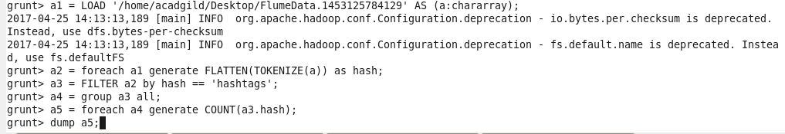

**OUTPUT :**

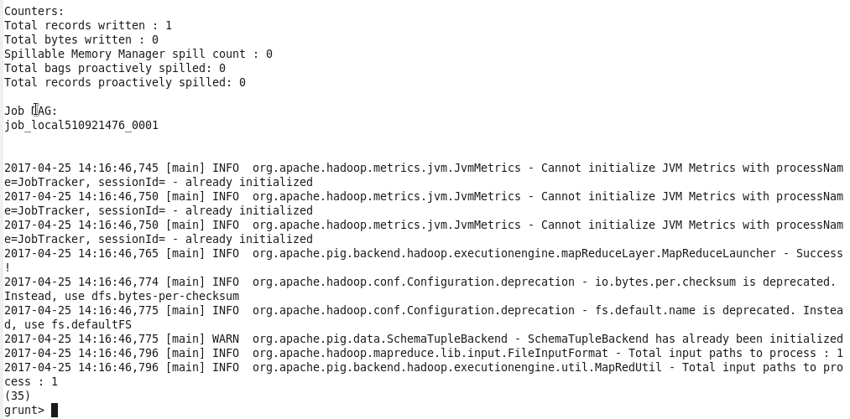

**CODE 2 :**

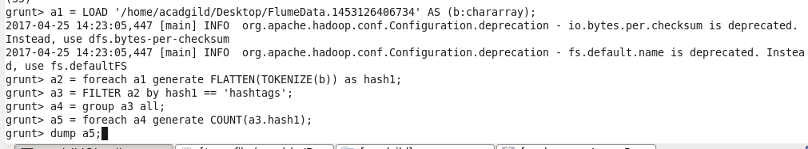

**OUTPUT :**

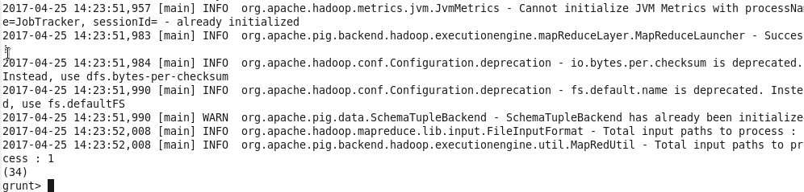

**CODE 3 :**

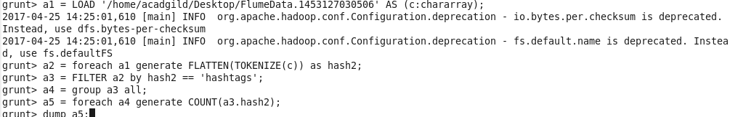

**OUTPUT:**

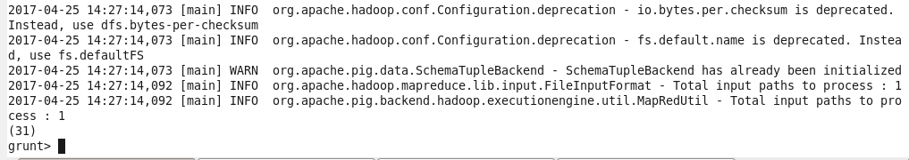

**CODE 4 :**

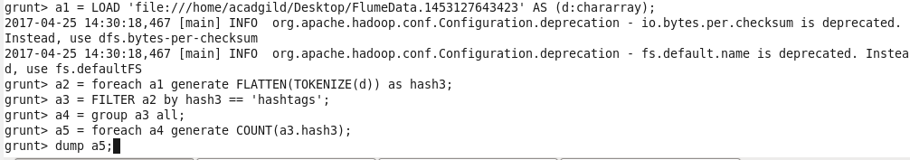

**OUTPUT:**

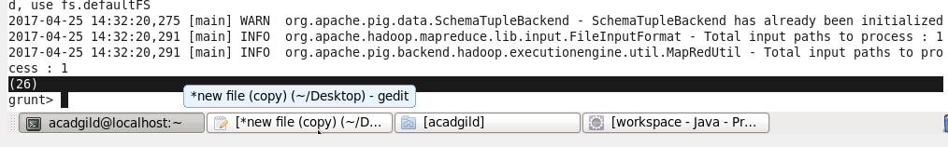

**CODE 5 :**

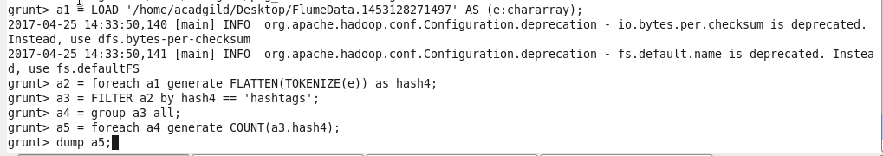

**OUTPUT :**

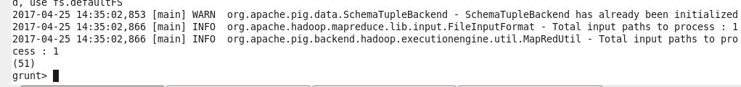

**CODE 6 :**

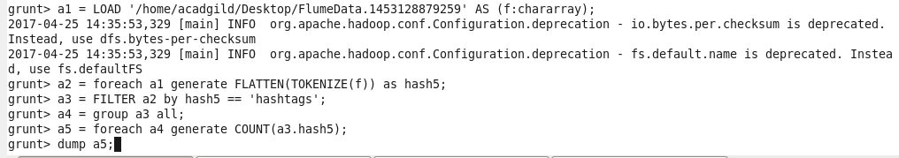

**OUTPUT :**

