Assignment-11.6

Find the top five kinds of GoogleKnowlege_Occupation people who were guests in the show, in a particular time period i.e., between '1/11/99' and 6/11/99. You need to write an UDF to compare the dates.

**User Defined Function:**

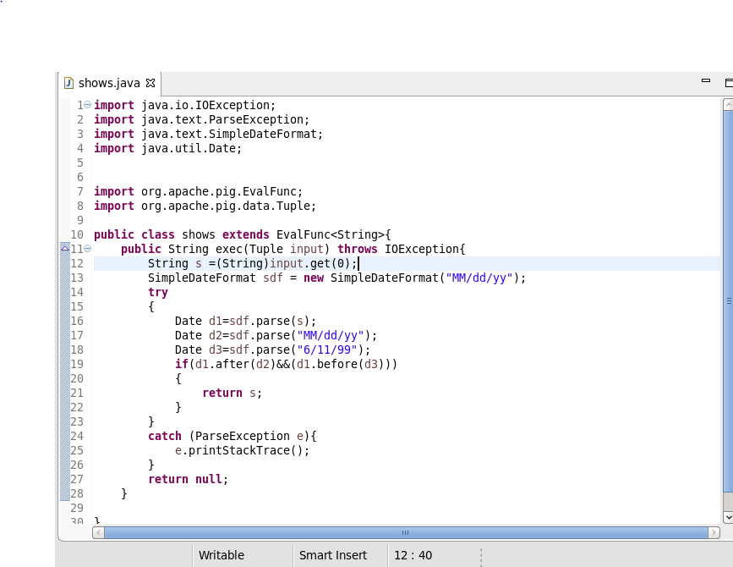

**Pig script –**

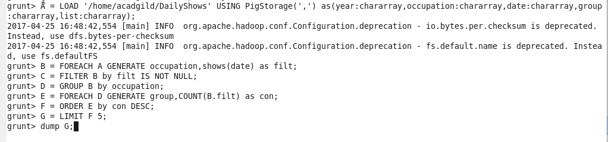

**Output:**

