**ASSIGNMENT – 12.2**

1. **Create a flume agent that streams data from Twitter and stores it in the HDFS cluster.**

**Flume-ng:**

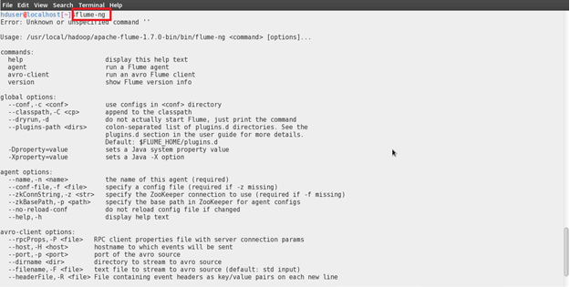

**Twitter Apps: Creating Application In Twitter**

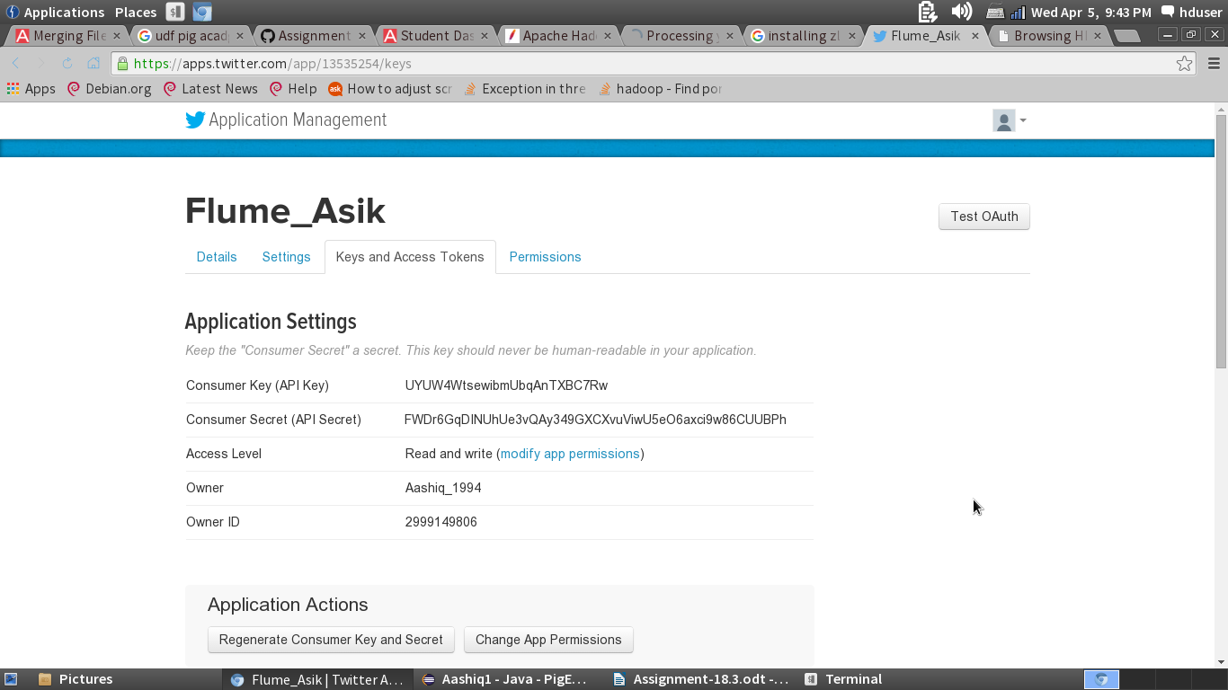

**Configuration File:**

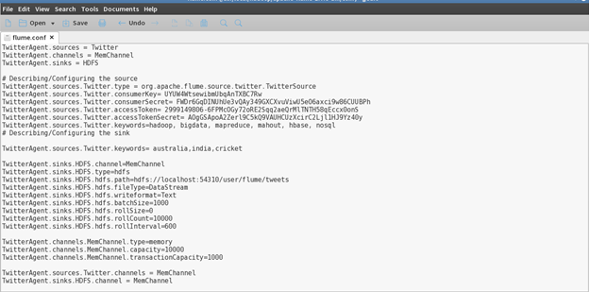

**Command to fetch the data:**

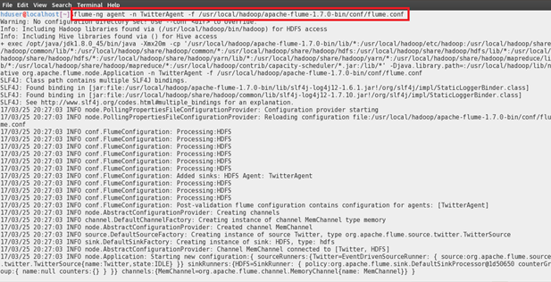

**Processing the data:**

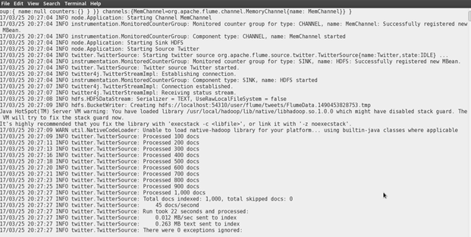

**Data is Written is HDFS:**

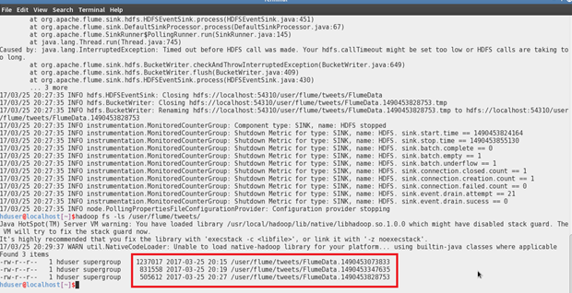

**Web-UI :**

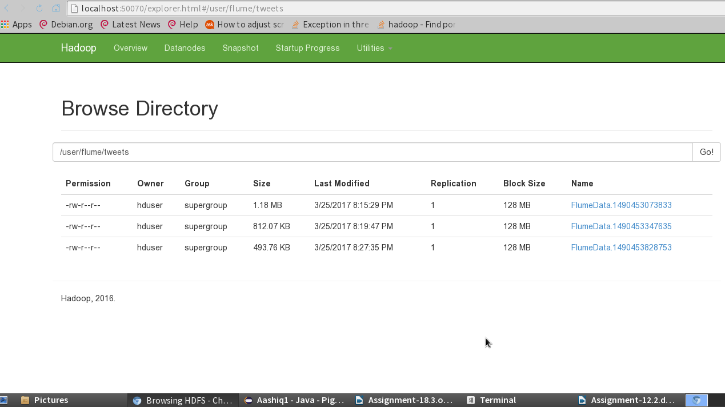

**Sample Data:**

